控制設計 HW3 林俊佑 E14056499

Part1:

Q1:

(a)

plant_up = 1;

plant_down=[1 1];

plant = tf(plant_up,plant_down);

figure(1)

rlocus(plant);

%by rlocus find k= 5

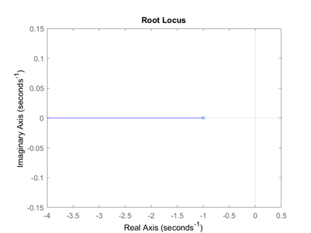

(b)

%必迴路轉開迴路才可做後續計算

plant_open = feedback(plant*5,1,-1);

figure(2)

step(plant_open)

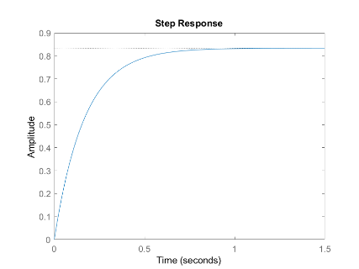

%as the result i can found e = 0.17

(c)

syms s t

f = ilaplace(5/(s^2+6*s));

%get y = 5/6 - (5*exp(-6*t))/6

(d)

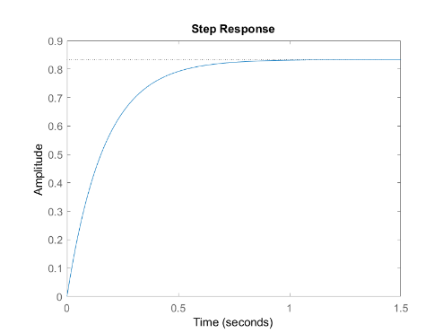

Q2

%first set z = 0.01-> can't change to 0.1

plant2 = series(tf([1 0.1],[1 0.01]),plant);

figure(3)

rlocus(plant2);

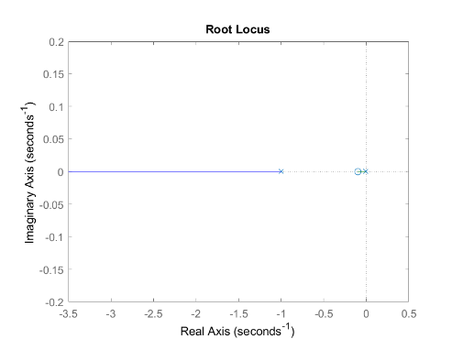

%as it set K=5 s==-6 -> K=5 s==-6

plant2_open = feedback(plant2*5,1,-1);

figure(4)

step(plant2_open)

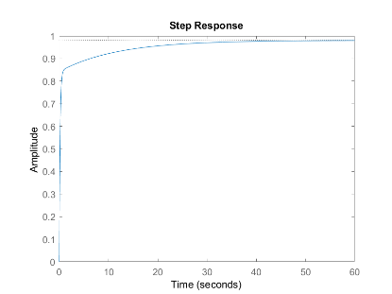

%for z=0.1 p=0.01 k=5 find the answer

Q3

plant3=series(tf([1 0.02],[1 0]),plant);

figure(5)

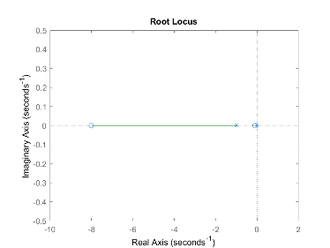

rlocus(plant3)

%get s=-6 K=5.05

plant3_open = feedback(plant3*5.05,1,-1);

figure(6)

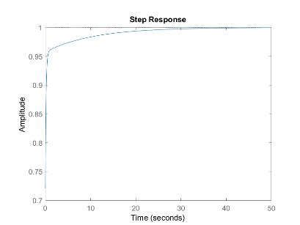

step(plant3_open);

%as it know error is = 0 when k=5.05 z=0.02

Q4

%Q4 set z1=0.1 z2=8

plant4=series(tf(conv([1 0.1],[1 8]),[1 0]),plant);

figure(6)

rlocus(plant4)

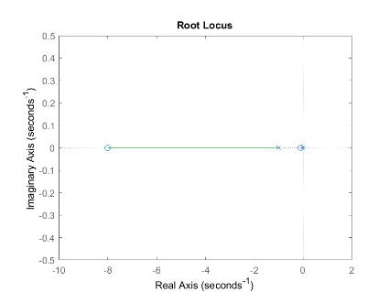

%find whem s= -6 K=2.58

plant4_open = feedback(plant4*2.58,1,-1);

figure(7)

step(plant4_open);

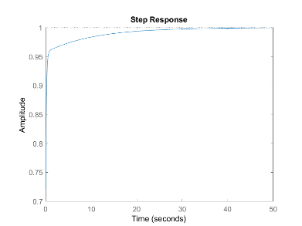

%error step = 0

figure(8)

step(plant4_open*tf(1,[1 0]));

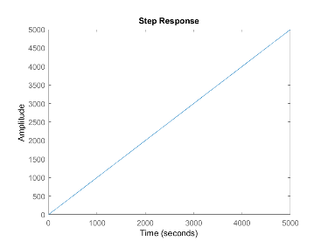

%as it get error for ramp = 0.5;

%finally when K=2.58,z1=0.1,z2=8 🡪 e1=0 e2=0.5 s=-6

PART2

(1)

Let input = 0;

Output = $\frac{Gp\left(s\right)}{1+Gp\left(s\right)Gc\left(s\right)}N(s)$

To make y(∞) = 0 ,because $\lim_{s→∞}SY\left(s\right)=\frac{1}{Gc\left(0\right)}$,so Gc(0) = ∞;

(2)

Set I controller as Gc(s) = 1/s;(it is equal to infinity when s=0)

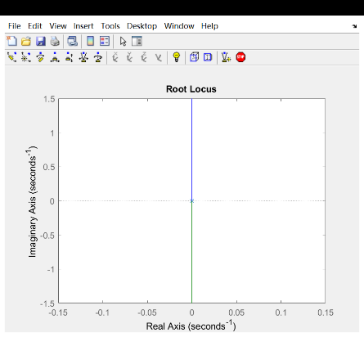

However, when we draw the root locus for Gc*Gp in this case, we found it will not be stable exactly.

(3)

Set PID controller as Gc(s) = K(s+z)/s; (it is equal to infinity when s=0)

After set z=1 and draw a picture we finally get

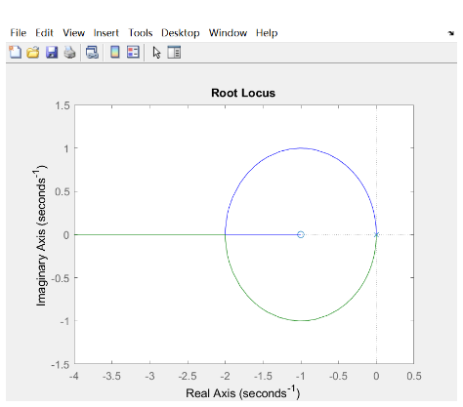

A glance at the chart provides the crystal truth that the system is stable in each number of gain.

Therefore, with the result of (1) we can say this kind of controller is Okay;