**控制系統設計Project2**

**組員**

**機械系 蔡旻霖 E14051075**

**機械系 林俊佑 E14056499**

**Step1:Analyze the system by drawing its Bode plot for**

${ G}_{C}$**(s) = 1 ?**

**Phase margin = -180 deg**

**Gain margin = 21dB**

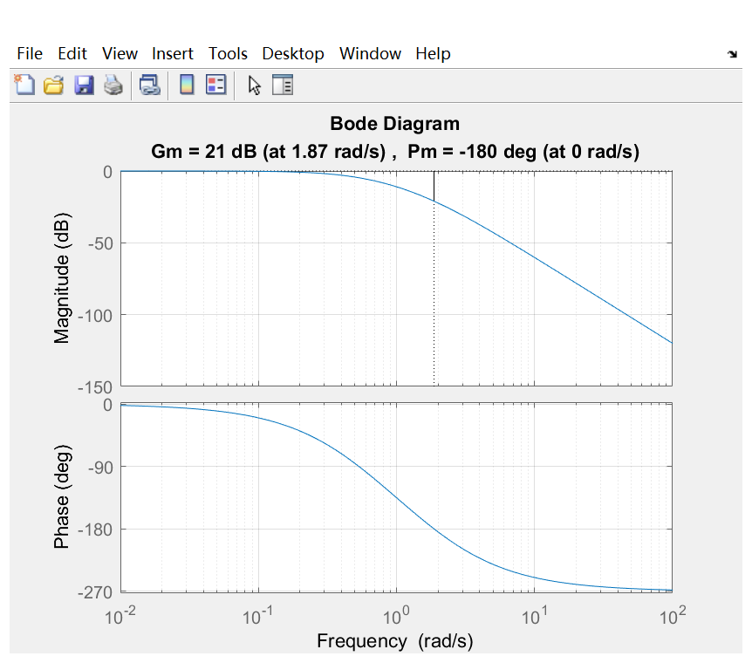

**We can get the answer in this figure**

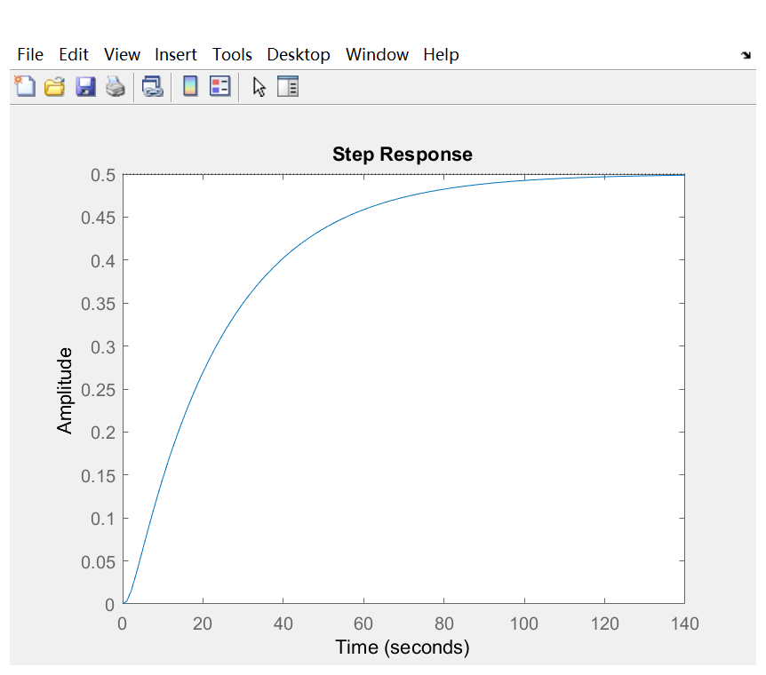**The feature of this figure : It is a stable system because the margin line is between 0 and -180 ,we can get this feature in the step figure, too.**

**On the other hand, by the margin line**

**Between 0 and -180, we can easily find**

**The kind of system are too stable to have**

**Low error(we can know it from big distance**

**Between each margin line)**

**Prar2 紀錄**

**P controller**

$error= \frac{1}{1+\lim_{s→0}{G\left(s\right)*k}}$

let error = 0.1, k>=27

as the result k should higher than 27 then the system can be stable

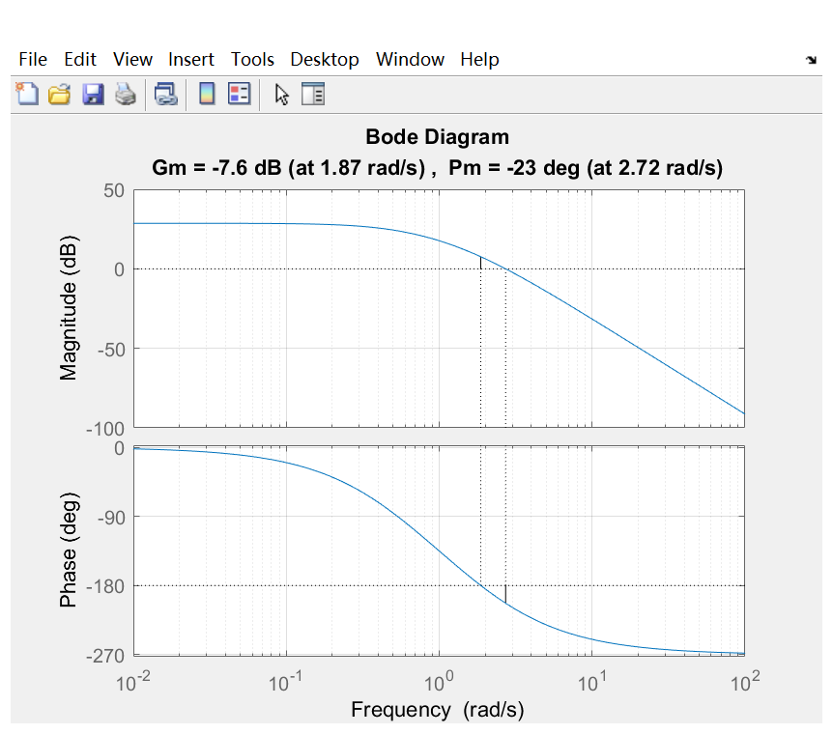

However, when k=27 the system is unstable so we should find another answer

是否可以藉由調整K讓PM符合要求?

Ans : 不可以。若讓K值往上調整，新的0db line 將往下平移，只會造成PM越來越小，達不到要求(PM=50°)。

**Phase lead control**

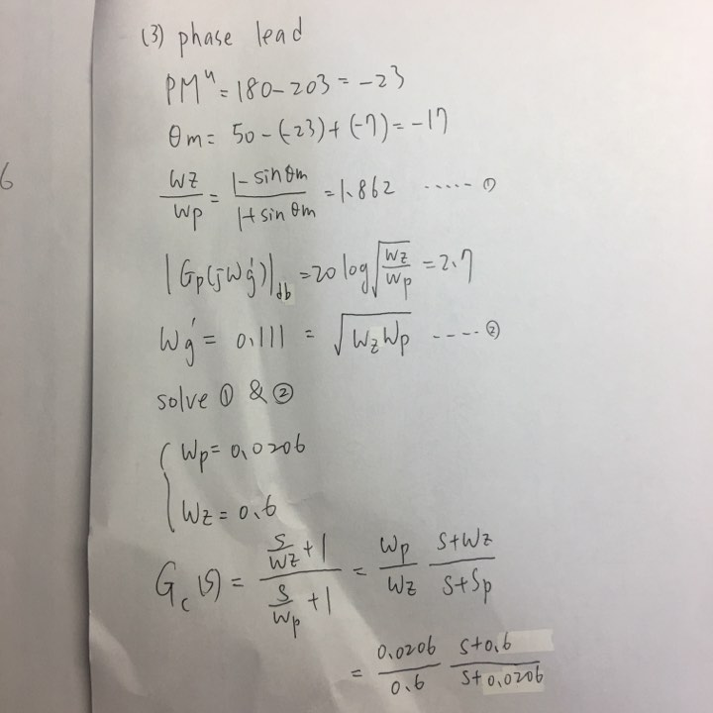

透過計算得到Wp = 0.0206 , Wz = 0.6 丟程式繪圖K沿用p control結果

clc;clear;close all;

Gp=zpk([],[-0.5 -1 -2],27);

wp=0.0206;

wz=0.6;

Gc=zpk([-wz],[-wp],wp/wz);

G=series(Gp,Gc);

figure(1)

margin(Gp)

grid

figure(2)

margin(G)

grid

sys=feedback(G,1);

figure(3)

step(sys)

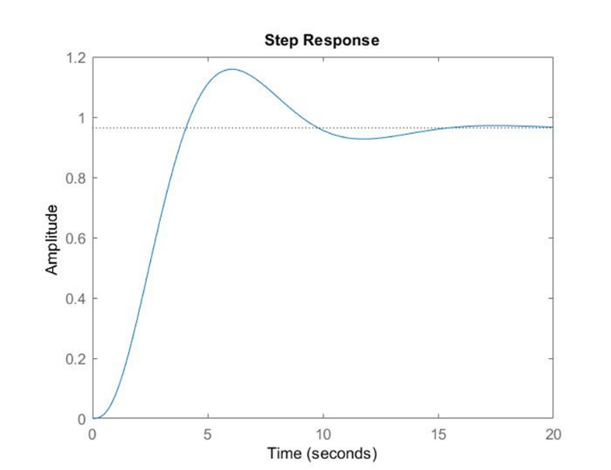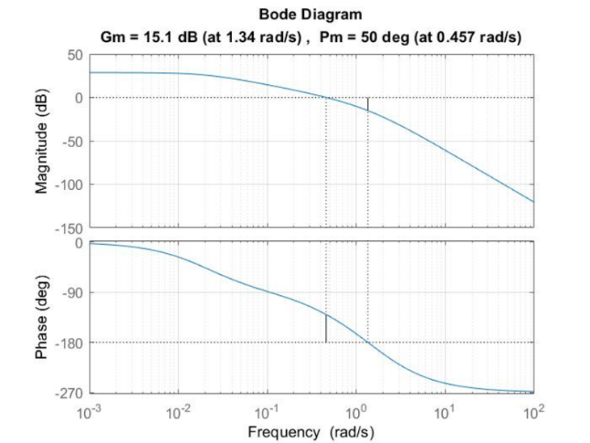

可以發現穩定度

和誤差值

以及響應時間都是可以接受的

**Phase lag control**

${PM}^{c}= {175}^{°}+|G_{p}(j{w'}_{g})→|G_{p}(j{w'}_{g})$ = -125

, || = -9.28

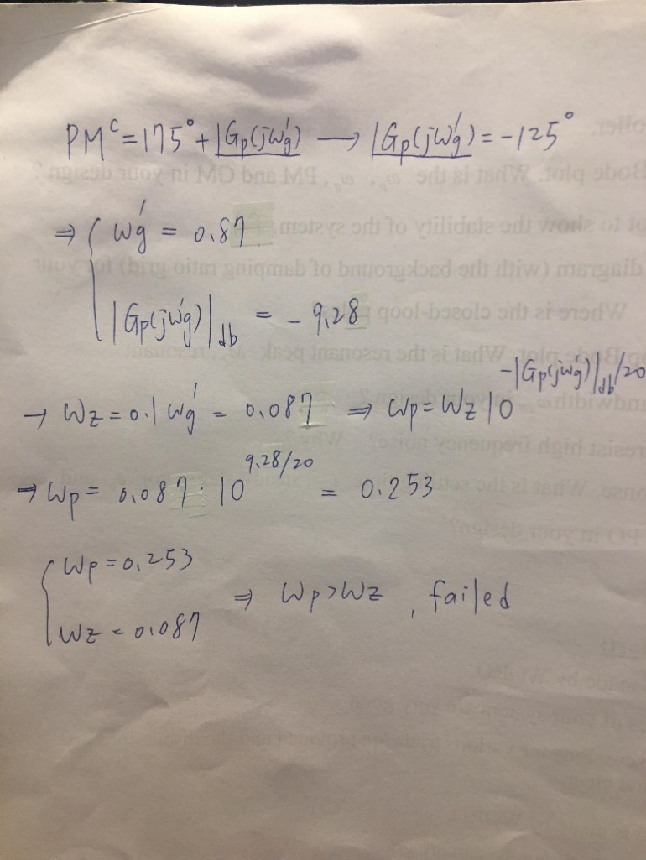

As Wp > Wz so this kind of controller can not used on the system.

* Wz should bigger than Wp, or it will not be phase lag.

**Lead lag control**

clc;clear;close all;

Gp=zpk([],[-0.5 -1 -2],27);

wp=17.33;

wz=0.6;

wz2 = 0.7;

wp2 = 0.06;

Gc=zpk([-wz],[-wp],1);

Gc2=zpk([-wz2],[-wp2],1);

G1=series(Gc2,Gc);

G = series(Gp,G1);

figure(2)

margin(G)

grid

sys=feedback(G,1);

figure(3)

step(sys)

把一個lead 串聯一個lag 兩者結合後用調整角度的方法一直試 k沿用P controller 的 result.

最後試出

Wp1 = 17.33 Wp2 = 0.06

Wz1 = 0.6 Wz2 = 0.7

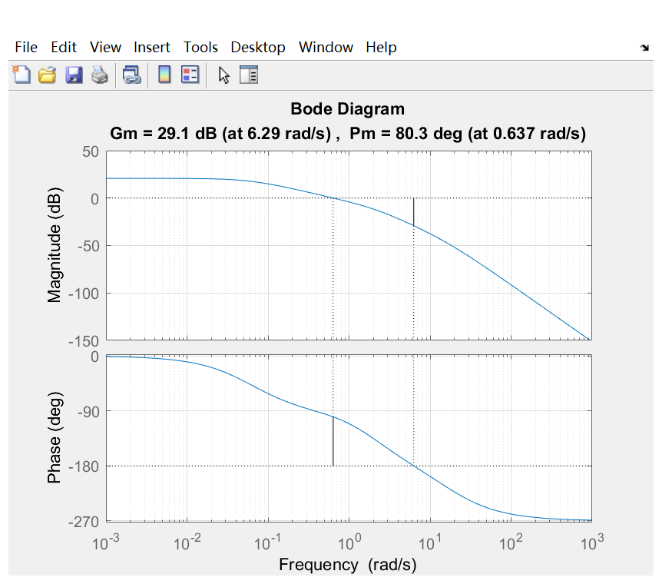

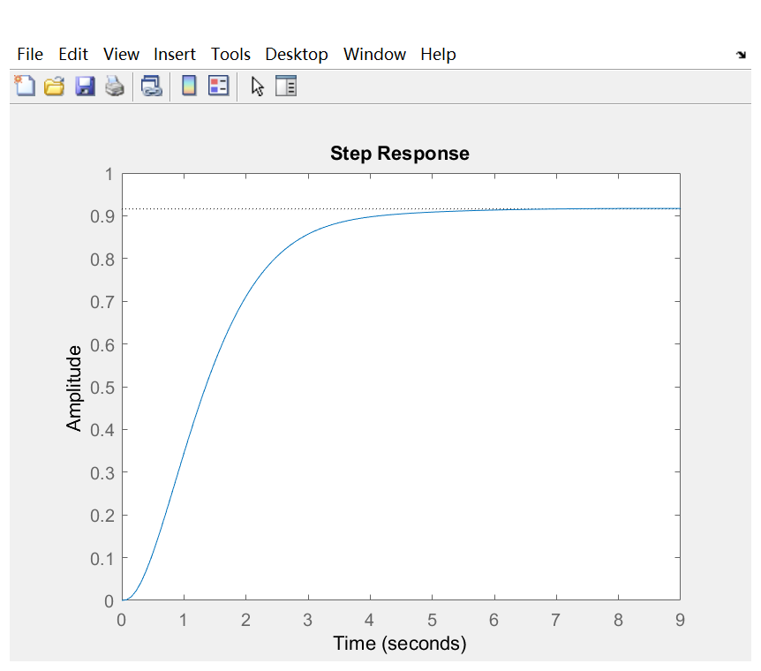

但PM降不下來所以最後捨棄

**Prar3 Conclusion**

1. **My best controller**

**0.034333 (s+0.6)**

**---------------------- *27**

**(s+0.0206)**



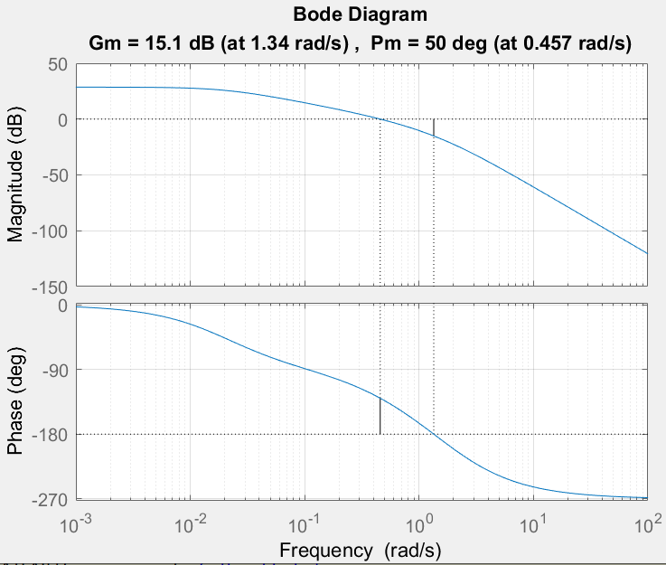

Wp = 0.0206

Wz = 0.6

PM = 50deg

GM =15.1dB

**(3)**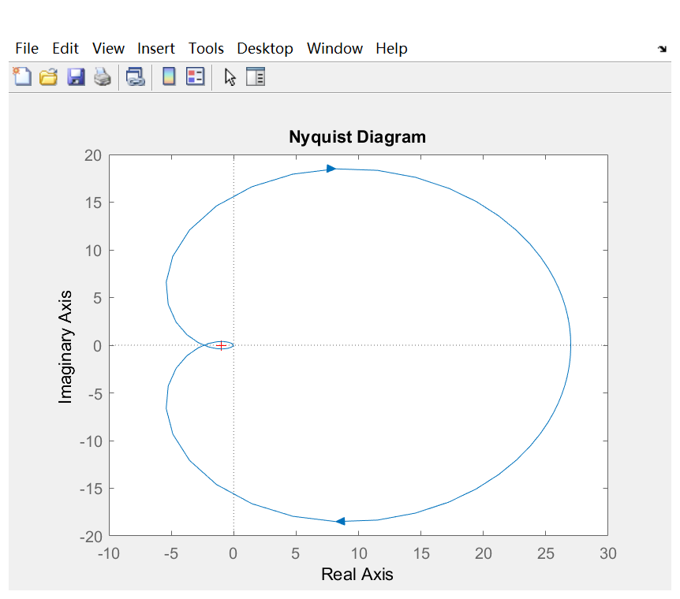

**根據奈氏圖的原則, 本系統是穩定的。**

**(4)**

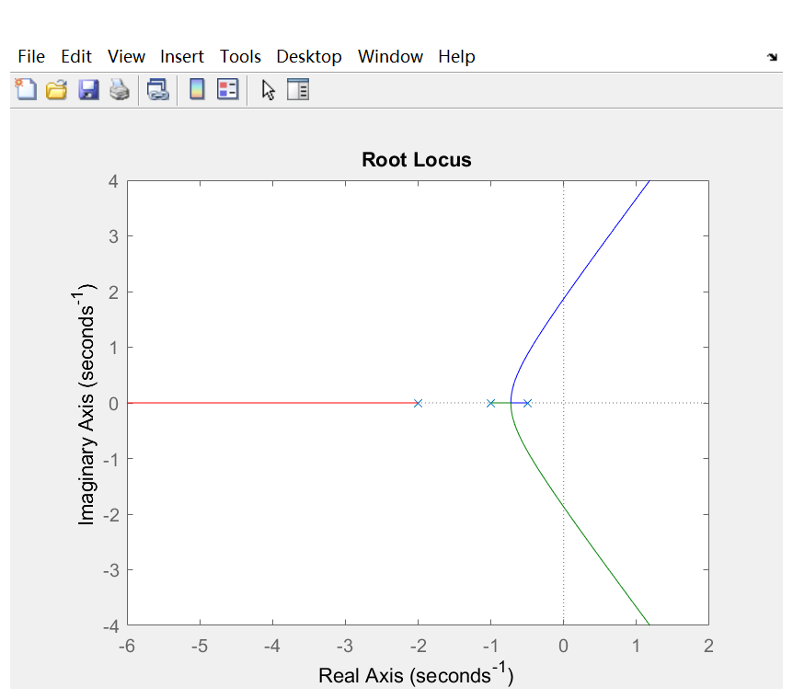

**Close loop pole 在 -2,-1,-0.5**

**(5)**



**Resonant peak:28.6**

**Resonant frequency:0.01**

**Bandwidth:0.46 and 1.36 so it is 0.9**

**No, because we do not move many that the system will be unstable.**

**(6)**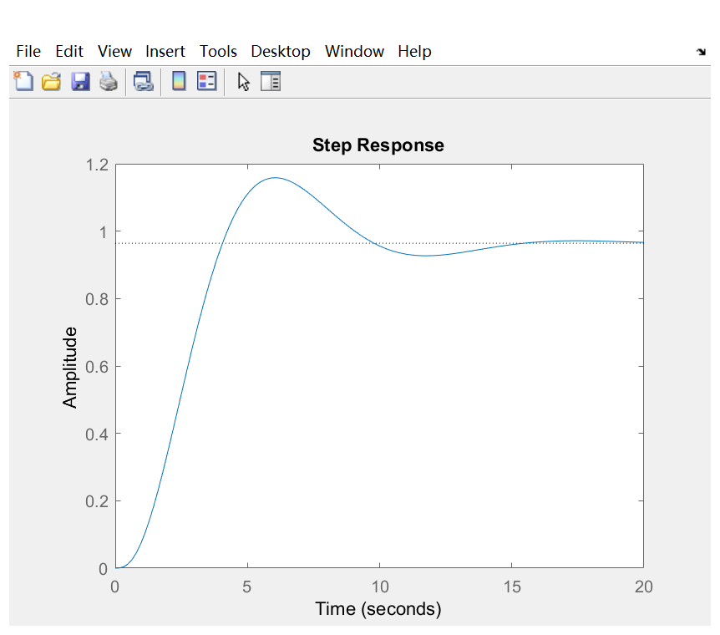

**Ts = 15**

**error0 = 0.033**

**percent overshoot 0.16**