The writeup should include 2-4 pages worth of text describing your work, and should address
the “why” behind your efforts in addition to the “what”. It’s especially important to articulate the
questions about the data you’re hoping to answer through analysis. How you structure the
writeup is up to you, but in general you should include:
- The names of all team members, along with a brief overview of how each person
contributed
- A description of the data set, including any preprocessing you did to get the data into a
usable format
- A short writeup for each task, summarizing the techniques you used, as well as any
conclusions you were able to draw
- An overview of the code you wrote and existing tools you used, along with instructions
on how to run the code
- Description of challenges you encountered when working with the data, and how you
were able to overcome them (or not!)
- Descriptions of any insights into the data or domain that you obtained through your work
- Ideas for future exploration of the data, including interesting questions raised by your
analysis

Team members: Leon Ge, Phuong Nguyen
Leon contributed to the processing of states eviction data, geocoding and the project write up
Phuong contributed to the processing of weather data and association and the project write up

We used the pre-approved eviction dataset as our main data, we picked out specifically data that included county and states, and the number of eviction filings. We also noticed some other interesting datasets available but found it to be difficult to use or inaccurate data, such as estimation. For the weather, we were not able to find historical data on the accuweather API, so we actually needed to download from NOAA website using a portal, which was not hard to work with since it allowed for download into a csv format.

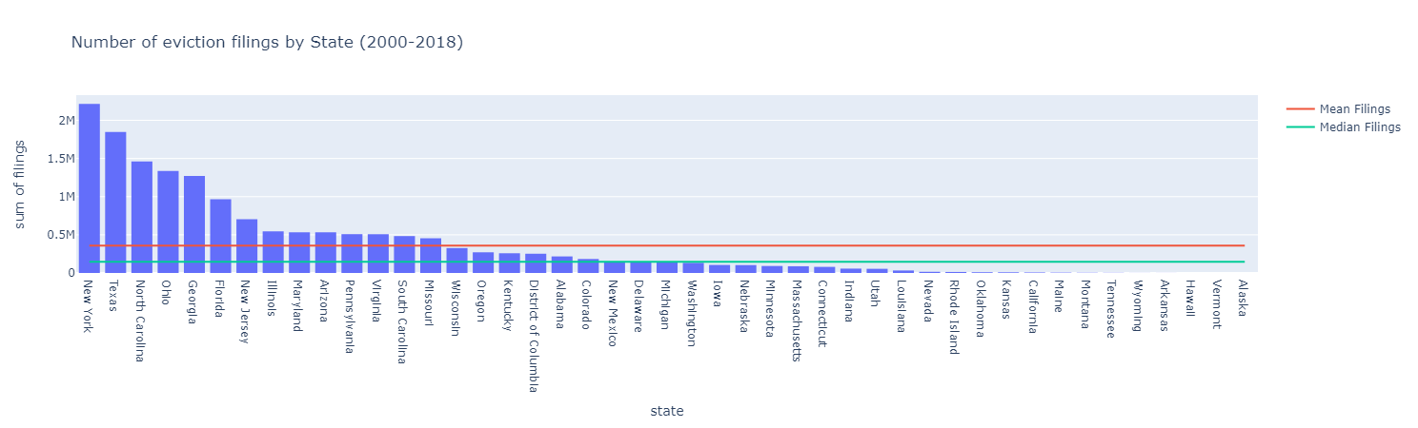
Task 1.
For task one, I wanted to show which states has a higher-than average eviction filings, so one of the easier way to see is to plot a histogram with a line for mean and median.
From this, it is easy to see that New York and Texas has the highest number of eviction filings from 2000 to 2018. It is also interesting to note that both the mean and the median is lower than I expected.

Although you can see which states have the highest eviction, I think it might also be interesting to see a visual map of where the evictions are happening, so I also made a heat map based on geo-coded county data.
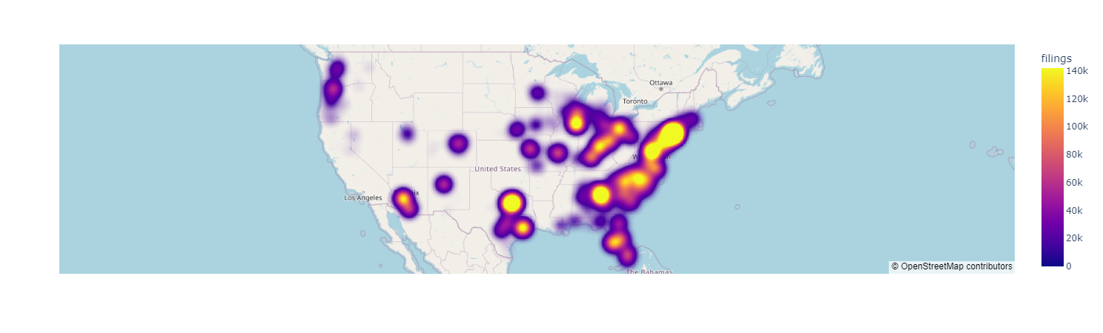
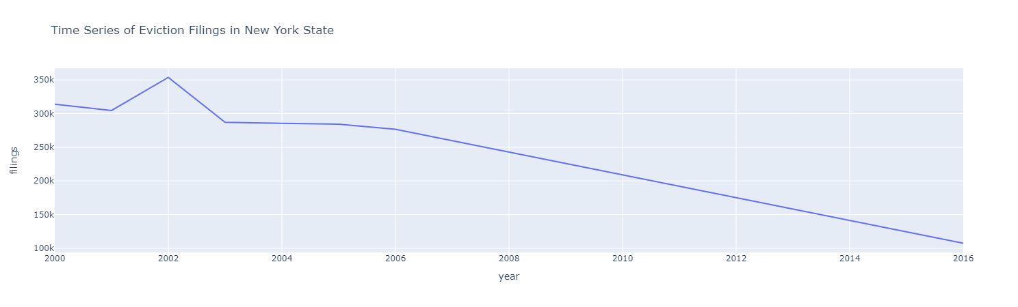
One other thing after this is that I plotted a timeseries of the number of filings over 2000-2018 for the state of New York. It’s interesting to see that the number of filings has actually decreased from 2002.
For the code I have written for these tasks, I mostly used plotly and pandas. I also wrote code using the geocoding library. To run the code, running the notebook should work. One of the more challenging part of writing the code is the geocoding, it was difficult for me to figure out how to format the address so that the geocoder and understand then give me a correct result. Other than that, everything else was pretty smooth.

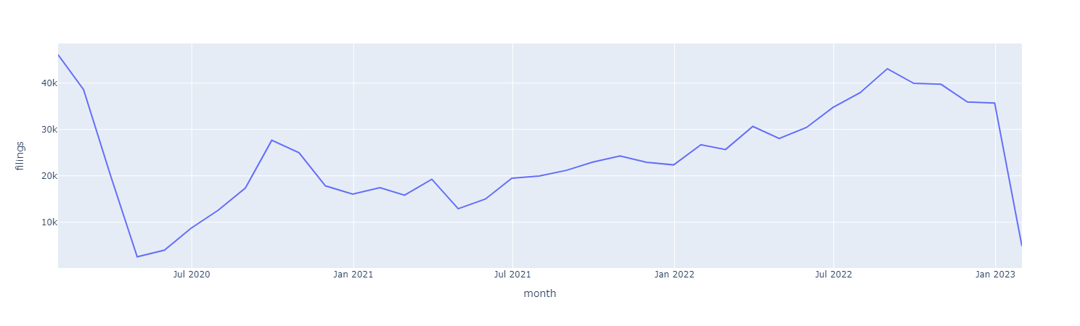
I also contributed to the task involving correlating number of eviction filing to weather data. I made a time series plot of all the eviction filings data available from 2020 to 2022. Now it seems like the number of evictions dipped very hard during covid, which is also interesting to see.

