ATLS 5519 IOS Development Project 3 plan – Tower Defense Game

Luis Hierro

This app will be a game; its purpose is purely entertainment. The game will be about keeping enemies at bay from your fort, your job will be to shoot the drones that keep coming in your direction (right side of the screen). I’m planning on using the cocos 2d framework to develop this app since the framework is simple to use and there is lot of documentation available for it.

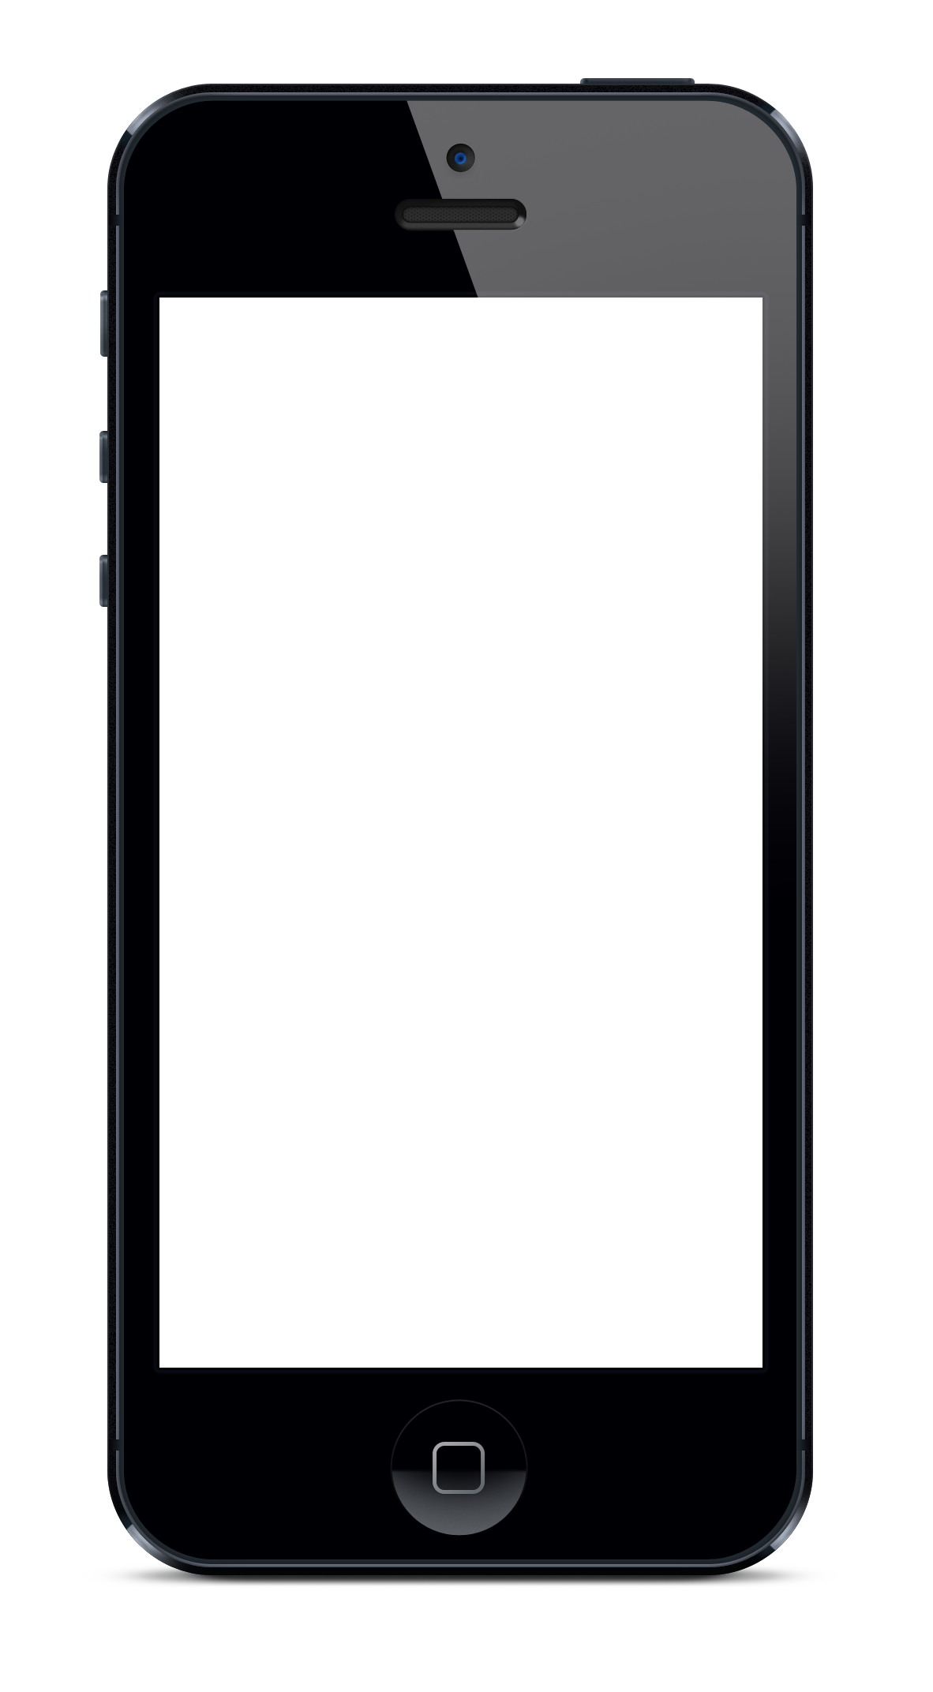The app will be simple there will be only three types of objects on screen: Player, Enemies and Projectiles. All the player has to do is tap the screen in order to shoot. Enemies will disappear on contact with bullets. The app will only support landscape mode.

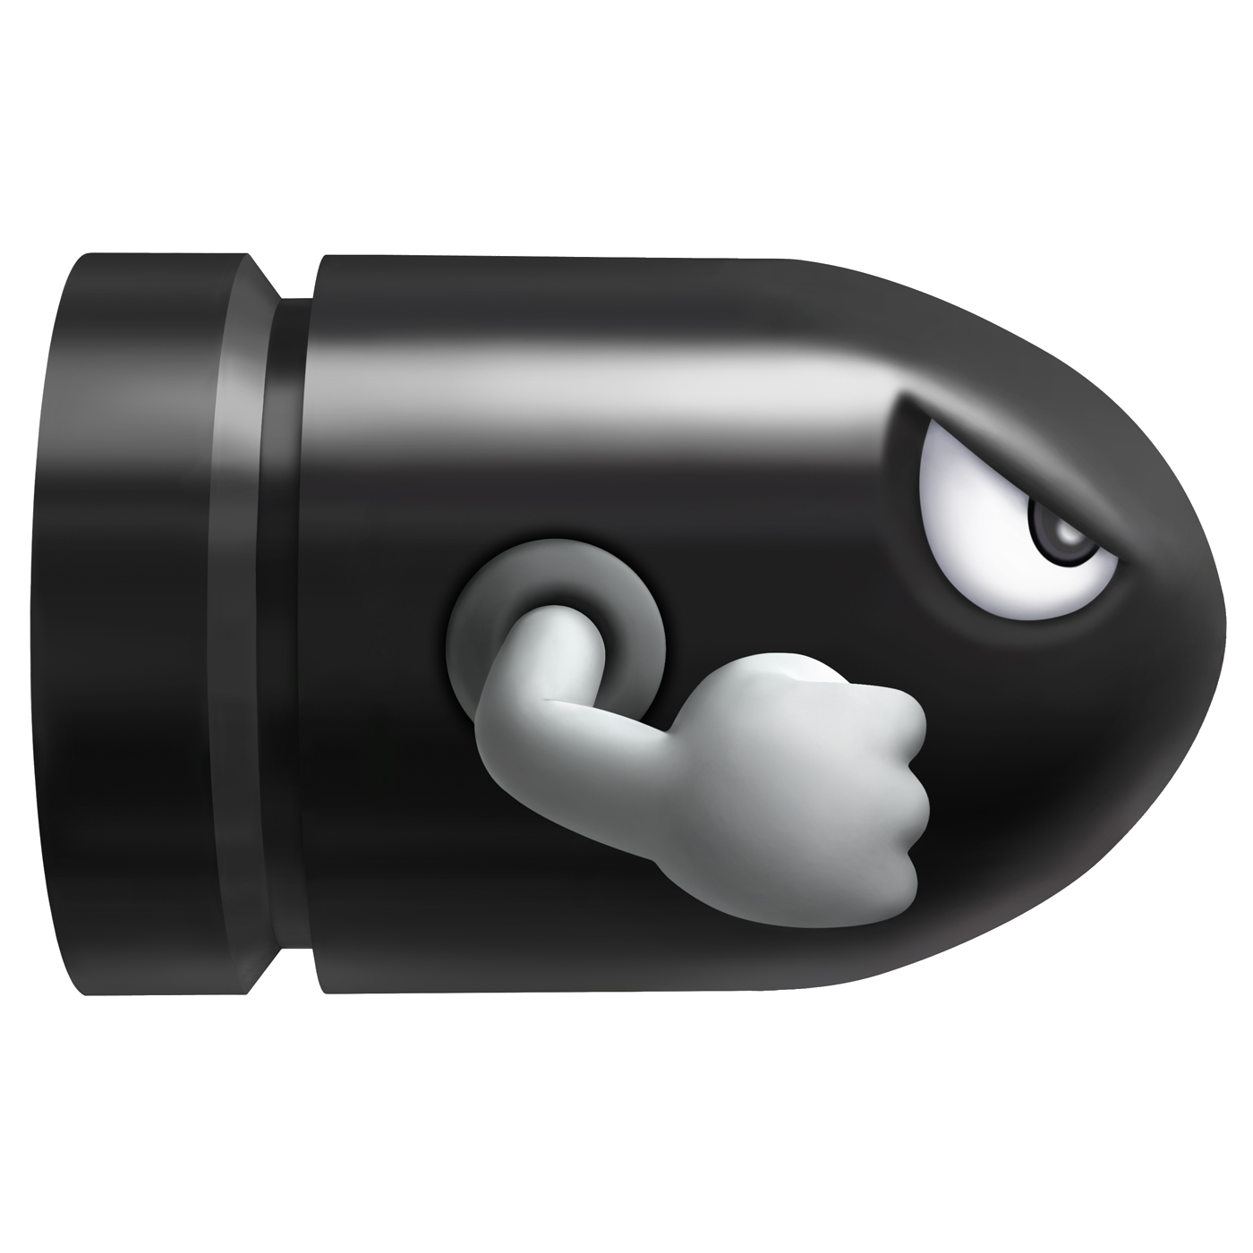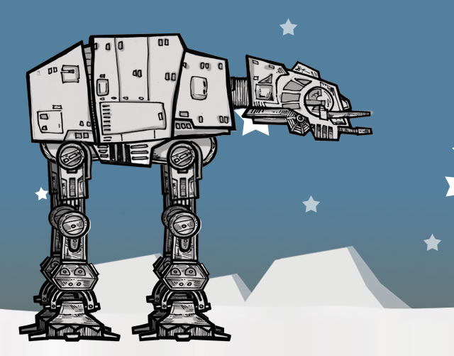

Design:

Pseudo Code and program flow:

There will be three main methods in this game, the Enemies method the Bullets method and the Timer method.

The enemies method will be in charge of making the enemies appear in increasing number as time progresses. The bullet function will keep track of the movement of the bullets. Finally the timer method will keep track of time and the score.

Pseudo Code:

Start Enemies

Start Bullets

Start timer

While app is Running

If Bullets.positions ==Enemmies.position

[Timer increaseScore]

[Enemies IncreaseSpeed]

Else

[Enemies continue]

[Bullets continue]

If Player touches screen

[Bullets addProjectile]

Loop Again

App will be tested on simulator then on device for accuracy of projectile trajectory. App will rely heavily on user input (gestures). I will also test rotation on both landscape positions to make sure they don’t affect trajectory of objects.