https://app.notion.com/p/08-09-3b7081d88ae18059a588e88748ba62e6
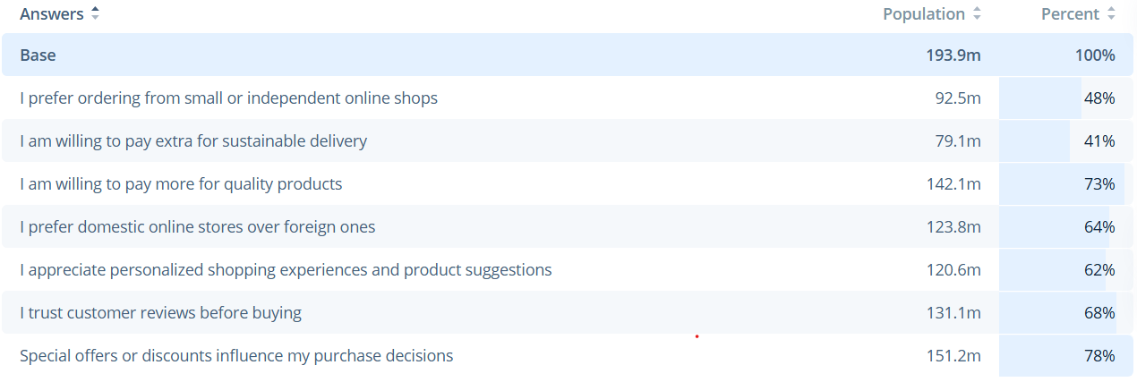
- E-Commerce›
- Digital Shopping Behaviour
Share of Millennials doing specific activities while online shopping in selected countries worldwide in 2024
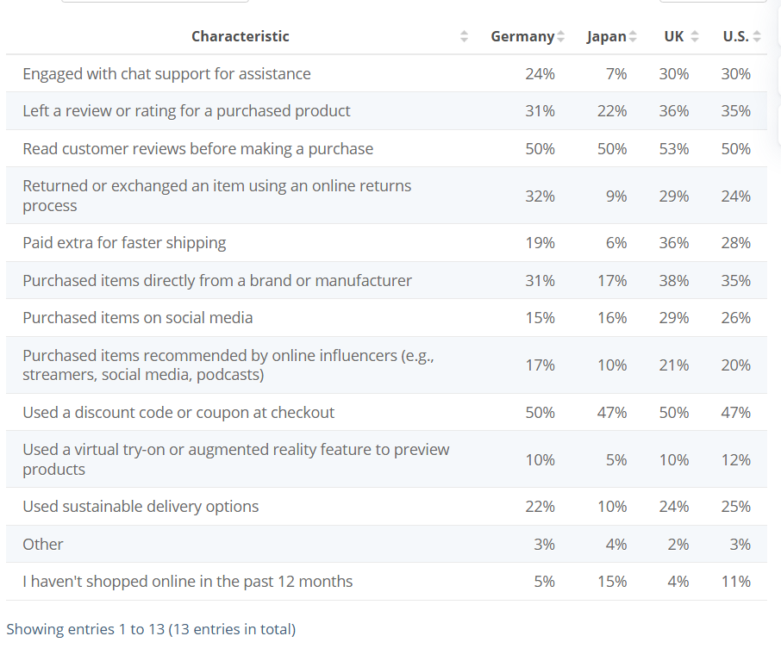
Elements of user-generated content (UGC) most likely to convince consumers to buy a product in 2024
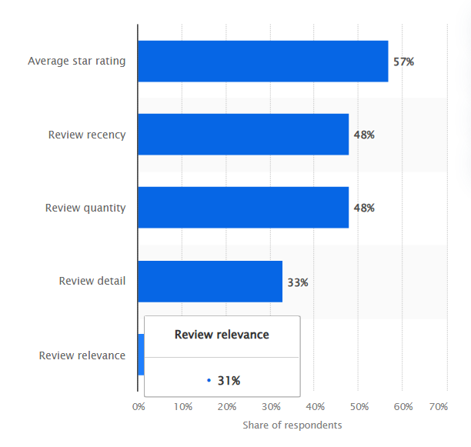
Main aspects shoppers searched for in user-generated content (UGC) in 2024
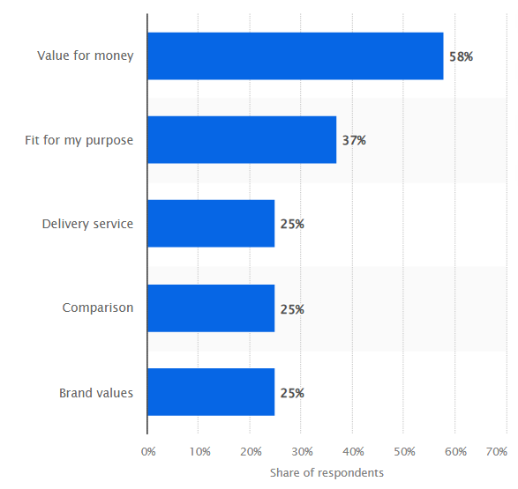
Types of content used in finalizing B2B purchase decisions in the U.S. in 2024
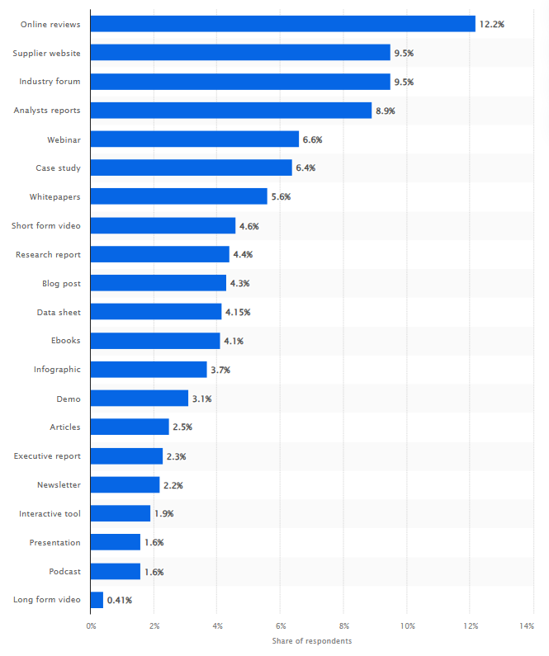

Types of content used in finalizing B2B purchase decisions in the EMEA region in 2025
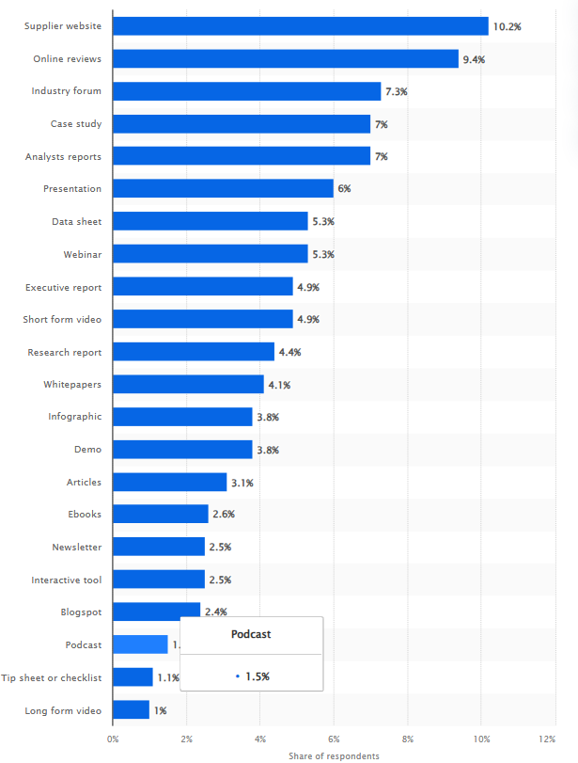

Social content influencing online shoppers’ purchasing decisions worldwide in 2026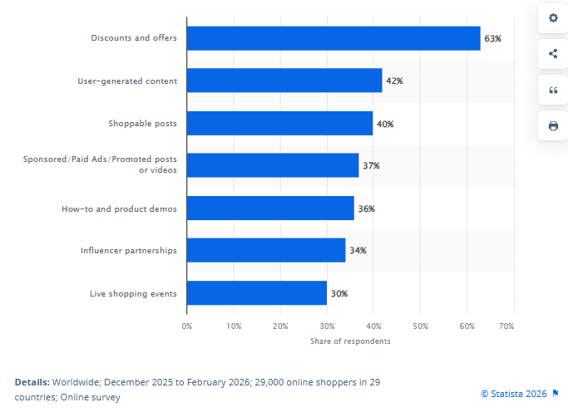
Share of generation Z influenced to purchase by online content worldwide in 2024, by content type
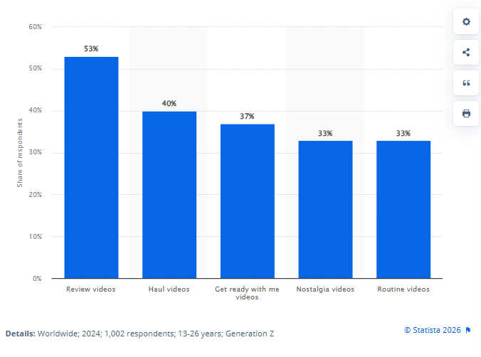
Main aspects of creator content that influences purchasing decisions worldwide in 2024
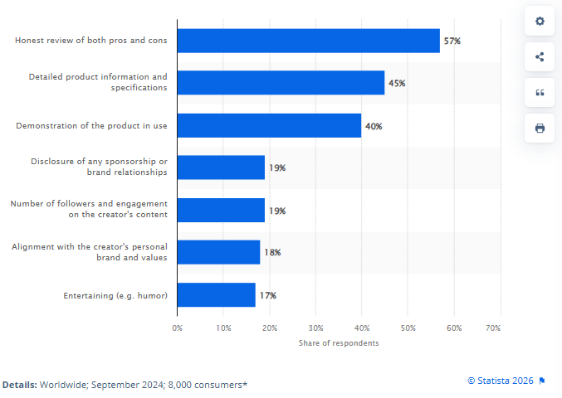
Premium
Percentage of consumers believing in content creators' good faith and buying products they featured in the United States as of May 2024, by generation
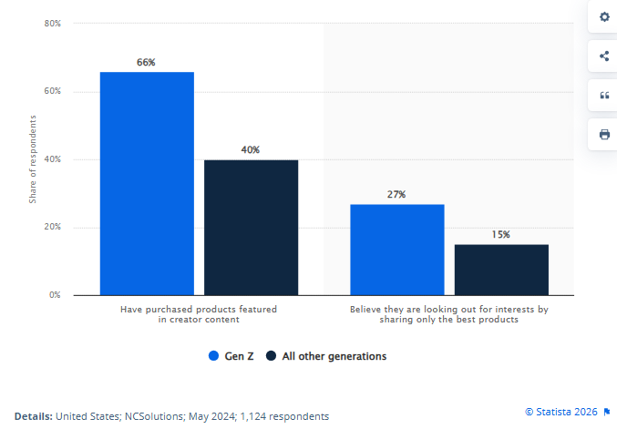
Percentage of consumers believing in content creators' good faith and buying products they featured in the United States as of May 2024, by generation
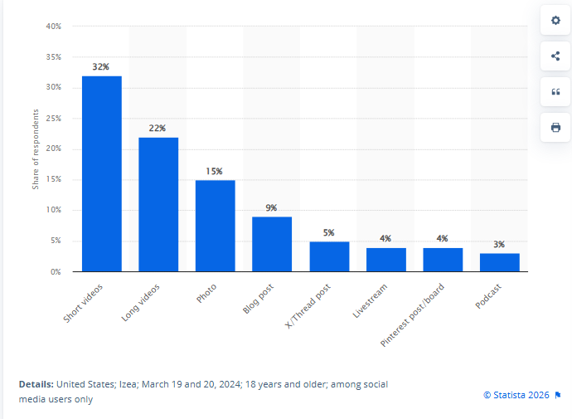
Type of influencer content that most influenced social media users from the United States to purchase a product on Amazon as of March 2024

Main uses of generative artificial intelligence (GenAI) during product discovery and pre-purchase decisions in the United States in 2026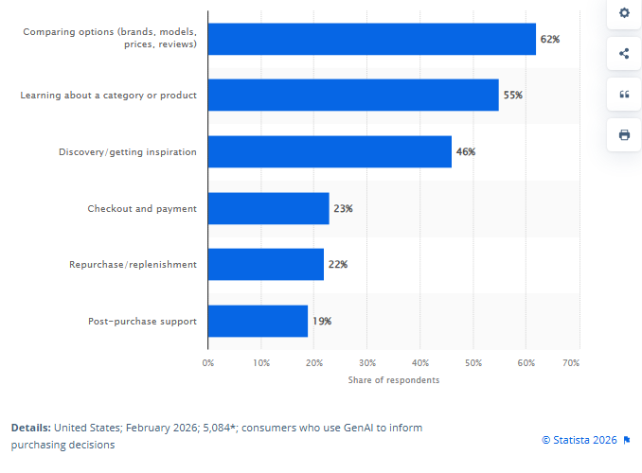
Share of shoppers considering user-generated content (UGC) valuable in 2024, by age group
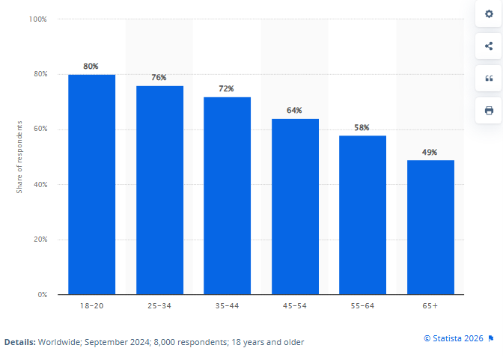

Share of Chinese consumers from the Generation Z who make purchasing decisions for their households as of June 2025, by category
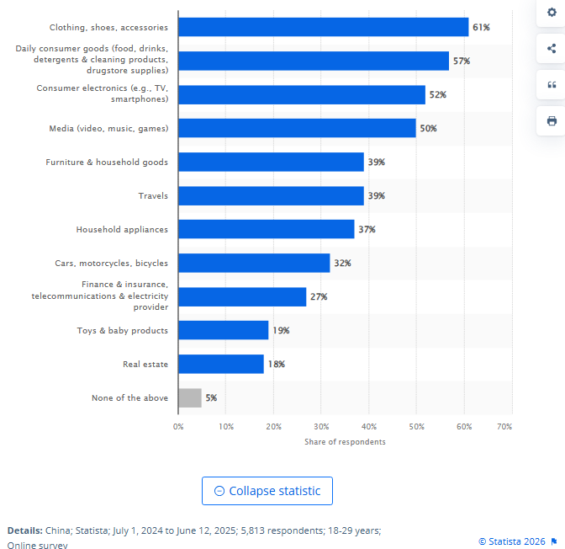Frequency of using conversational AI tools in assisting making purchase decisions in selected European countries as of January 2026
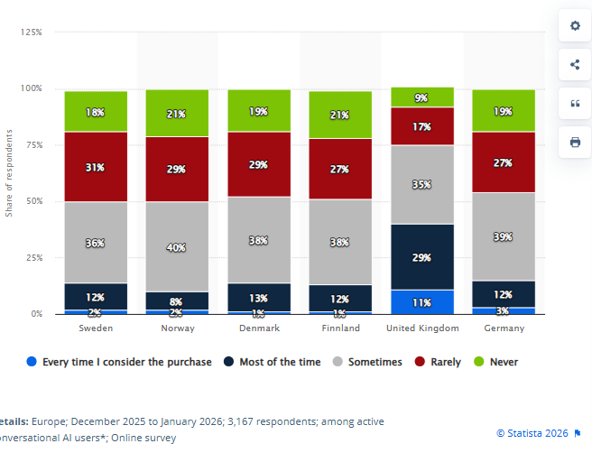
Social commerce revenue in Spain from 2018 to 2029, by platform(in million U.S. dollars)
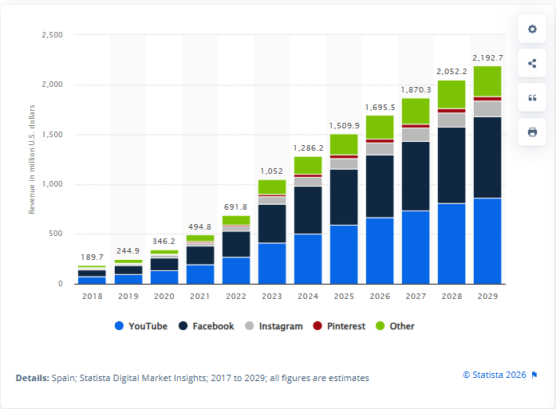

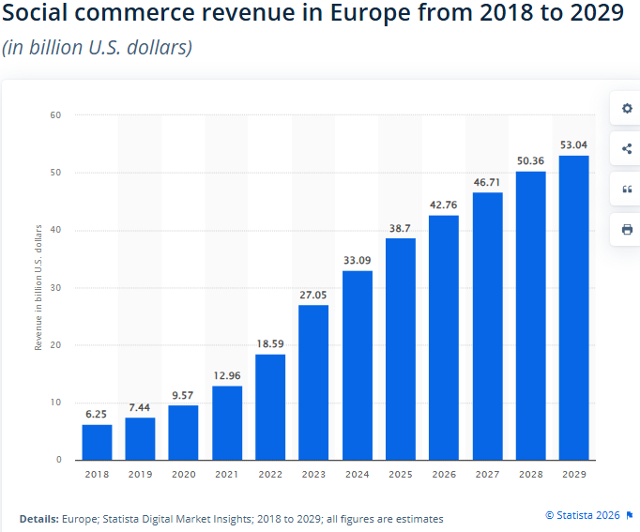
Average share of social media users who create content in selected countries in 2026, by platform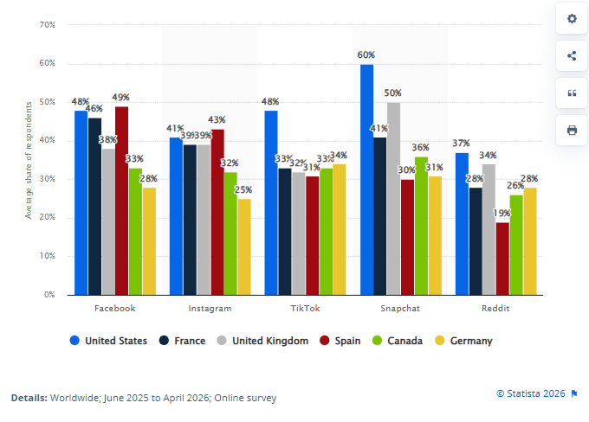
Share of shoppers considering user-generated content (UGC) valuable in 2024, by age group
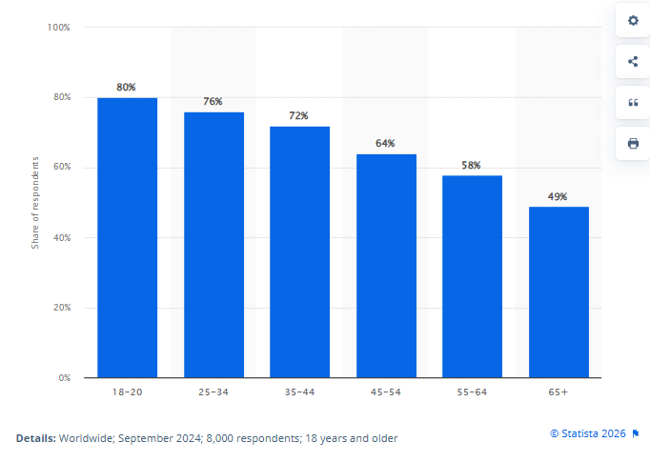

Share of consumers using social media platforms to search for product information and reviews worldwide in 2024, by generation
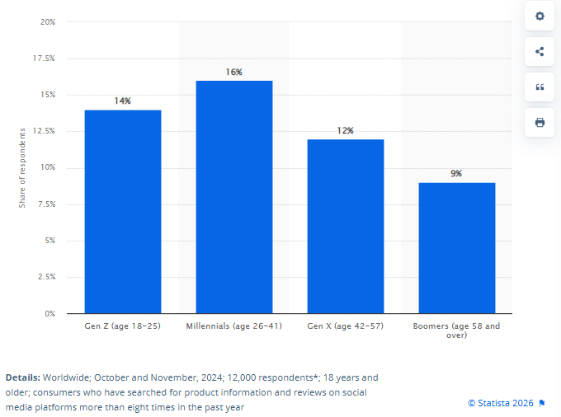
Social media usage among Generation Z in the United States as of June 2024, by brand
U.S. Gen Z social network usage 2024, by brand
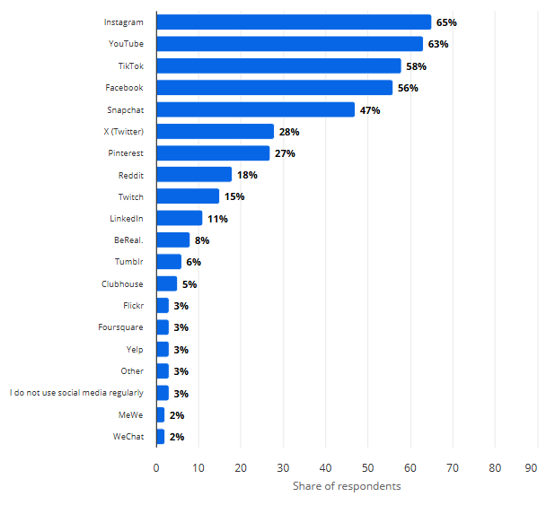

Share of Generation Z doing specific activities while online shopping in the United States in 2024
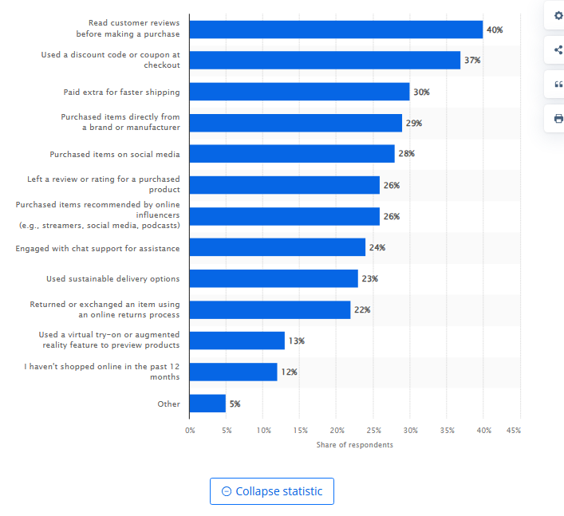
Types of items purchased via social media in South Korea as of February 2025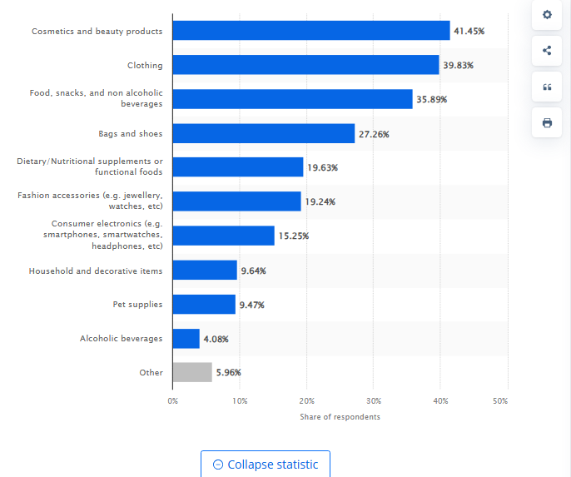

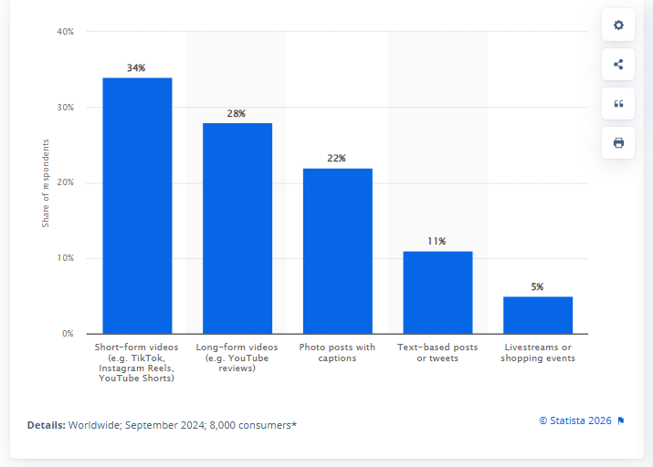Main type of social media content most helpful for product discovery worldwide in 2024

Number of international students enrolled in higher education institutions in South Korea in 2024, by study level
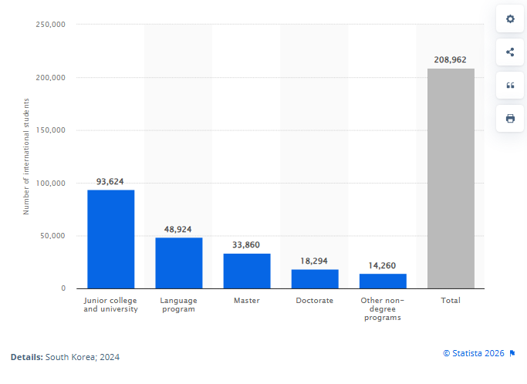

검색 → 상세조회 → 저장 → 매장방문 → 리뷰작성1,000 방문자
→ 장소조회 600
→ 저장 180
→ 쿠폰/길찾기 클릭 90
→ 방문인증 45
→ 리뷰작성 20

외식 / 카페 / 뷰티·퍼스널케어 / 생활서비스
소비금액 × 외국인 수 × 플랫폼 영향 가능 비중
GMV opportunity / 고객 소비 기반

매장 프로모션
제휴매장 수 × 월 광고/프로모션비 × 12개월
앰배서더 캠페인
월 캠페인 건수 × 평균 캠페인 단가 × 12개월
예약/구매 제휴
월 전환건수 × 평균 거래액 × 수수료율 × 12개월
B2B 데이터/인사이트
계약 브랜드 수 × 연간 이용료

플랫폼 A는 설립 X년차 매출 X억,
플랫폼 B는 설립 X년차 매출 X억,
플랫폼 C는 X억을 달성했으며,
세 기업 모두 리뷰·탐색 트래픽을 광고/예약/중개/B2B로 수익화했다.

따라서 ‘리뷰·탐색 트래픽을 수익화할 수 있느냐’는 시장에서 이미 검증되어 있다.

GLOU는 같은 구조를 외국인 resident라는 특정 고객군에서 검증한다.

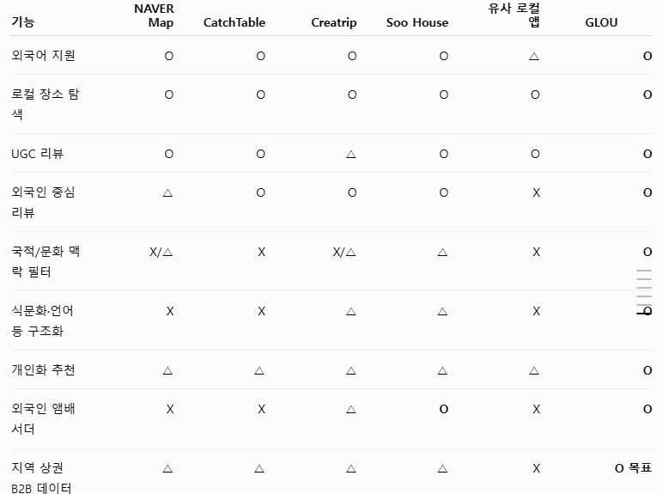

혁신의숲에서 설립 3~7년 정도 된 플랫폼을 찾아
매출 1억 → 4억 → 12억
MAU 3만 → 10만
투자 Seed → Pre-A
