**CS 5394**

**Advanced Software Engineering Project**

Software Requirements Specification

**“Minesweeper”**

By

Liang Wang

Robert Preston

Harika Gullapalli

(5394_RR1)

Table of Contents

1. Introduction 3

1.1 Purpose 3

1.2 Scope 3

2. Functional Requirements 4

2.1 Grid GUI 4

2.2 Difficulty Level 4

2.3 Reveal cell 4

2.4 Flags 4

2.5 Elapsed Time 5

2.6 Reset 5

2.7 Game Status 5

3. Non-functional Requirements 6

3.1 Response time 6

4. Design/implementation constraints 6

5. Wireframes 6

6. References 6

# 1. Introduction

## Purpose

This document is a requirements specification for the Minesweeper project in the course CS 5394 . The purpose of the document is to clearly define the goals of the project and to state what functionality shall be implemented in the final system. This will include functional and non-functional requirements as well.

## Scope

The Minesweeper is a single-player puzzle video game. At the beginning of the game, a 2D grid of identically looking tiles (or cells) is presented to the player. Cell's content is hidden. Each cell can either contain a mine or not. The goal is opening all cells that doesn’t contain a mine. When opening a hidden cell with a mouse click, if the cell contains a mine, the game is lost. If the cell doesn’t contain a mine, either a number appears on the cell - the number of mines in the cells around it or it will be a blank cell. If a cell hiding a mine is revealed, or 999 seconds have passed, the player loses the game. If all the cells not containing a mine are revealed, the player wins the game.

Playing Minesweeper involves a fair amount of logic. A clever player will use the numbered cells to deduce the location of mines. For assistance, most implementations of Minesweeper allow the player to mark or flag possible mine locations. Higher difficulties of Minesweeper involve a greater degree of deductive reasoning as the mine density (number of mines over number of cells) increases. Oftentimes, mines cannot be deterministically located, and so the player must resort to guessing.

# 2. Functional Requirements

## Grid GUI

Minesweeper game will have 2D grid of identically looking cells presented to the player. The player shall be able to click a button to start or reset a new game using the existing board setup. Every cell inside the grid is clickable and it can be either safe cell or a hidden mine.

## Difficulty Level

The player shall be able to select a new game based on the Beginner, Intermediate, and Expert difficulty levels. For each difficulty level, we will have different dimensions for the 2D grid.

## Reveal cell

A player shall be able to select a hidden cell to reveal it by using left mouse click.

The first cell you reveal is never a bomb/mine.

A revealed cell should show either:

* + 1. A numeric value from 1-8, indicating the number of adjacent mines within a 3x3 square with the revealed cell at the center.
    2. A blank space, indicating no adjacent mines within the said 3x3 square. If a blank space is revealed, the game should automatically reveal all adjacent cells within the 3x3 square of that revealed cell, and repeat this process for any newly-revealed blank spaces. A player shall not be able to select a cell again once it has been revealed.
    3. A mine.

## Quick Reveal

A player shall be able to middle-click a number to reveal its adjacent squares.

## Flags

* + 1. Game shall have an active flag counter displayed in the application. This will indicate the available flags remaining for the player to toggle onto hidden cells. The flag counter should decrease when a flag is placed onto a hidden cell and increase when a flag is removed or a flagged cell is revealed, with a maximum amount of flags available being equal to the number of mines on the board.
    2. A player shall also be able to toggle a flag on and off a hidden cell without revealing it, and have it disappear when the cell is revealed. The player shall not be able to place a flag onto a hidden cell if there are no flags available per the flag counter. User shall use right mouse click on an empty cell to flag it.

## Elapsed Time

This requirement will inform the user about the time spent on the game in seconds format starting when the first cell is revealed and ending when the game ends or 999 seconds have passed.

## Reset

If a user clicks on Reset button, then the game will restart and clear the existing status of the game. This includes clearing the 2D grid, reset the flags counter and elapsed timer.

## Game Status

Game status shall be displayed to the user.

# 3. Non-functional Requirements

## Response time

The average response time between click and reaction must be less than 0.1 seconds.

# 4. Design/implementation constraints

The game must be implemented in java using the MVC schema.

# 5. Wireframes

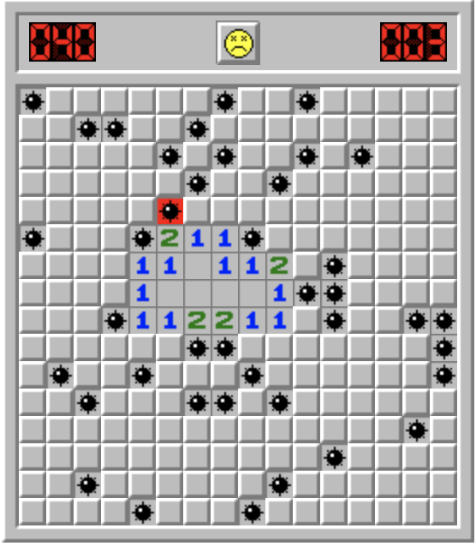

# 6. References

<http://minesweeperonline.com/>