**Water Level Indicator and water quality sensor using Arduino A PROJECT REPORT**

***Submitted by***

Aditya Konwar [ RA2211004010407] Aashi Agrawal [ RA2211004010410]

**Semester – V Academic Year: 2024–25**



**DEPARTMENT OF ELECTRONICS AND COMMUNICATION ENGINEERING**

**College of Engineering and Technology** **SRM Institute of Science and Technology**

SRM Nagar, Kattankulathur – 603203, Chengalpattu District, Tamil Nadu.

# ABSTRACT

In many regions, water scarcity, inefficient management, and compromised water quality lead to significant resource wastage and health concerns. Often, water storage tanks overflow due to lack of monitoring, while undetected contaminants compromise water safety. To address these issues, we propose an automated water level and quality monitoring system using Arduino. This system continuously monitors water levels and checks for key quality parameters, activating or deactivating the pump as needed to maintain optimal levels and ensuring water remains safe for use. By automating these processes, we reduce manual intervention, prevent wastage, and contribute to sustainable water management in both residential and industrial environments**.**

The system integrates ultrasonic/float-based water level sensors with pH and turbidity sensors to assess both quantity and quality in real time. The data collected is processed by the Arduino microcontroller, which then triggers relevant actions, such as switching the water pump or alerting the user via visual/audible indicators. The modular design ensures flexibility, allowing the system to be adapted for different tank sizes, water sources, and quality requirements. This makes it a cost-effective solution compared to conventional water management systems.

In addition to efficiency, the proposed model emphasizes sustainability and user convenience. By preventing unnecessary overflow, it conserves electricity used by pumps and minimizes water wastage, directly contributing to resource conservation. Furthermore, its ability to detect unsafe water conditions provides an early warning system to safeguard public health. With minimal maintenance and easy deployment, the project demonstrates a practical IoT-ready framework that can be scaled for smart homes, agricultural irrigation, and community-level water management systems.

**OBJECTIVES**

* **The primary aim is to create a cost-effective system that automates water management**, reducing human effort, avoiding tank overflow, and preventing unnecessary water wastage.
* **To develop a simplified system architecture that enhances reliability and ease of implementation**, making it suitable for both small-scale household use and larger-scale applications.
* **To ensure sustainable water use and improve conservation efforts** by automating water level control in residential, agricultural, and industrial settings, thereby promoting efficient utilization of resources.
* **To ensure the quality of water remains clean and safe for use** by monitoring key parameters such as pH and turbidity, and providing alerts in case of contamination.

.

# CHAPTER 1 INTRODUCTION

Water scarcity and quality degradation are pressing global issues that impact both human well- being and the environment. Efficient water management, including monitoring water levels and maintaining water quality, is essential in ensuring the sustainable use of water resources. However, in many systems, these aspects are often neglected or manually controlled, leading to wastage and quality issues.

This report presents an automated system designed to monitor and control water levels and assess water quality, using an Arduino microcontroller as the core component. The water level indicator system prevents tank overflow by automatically managing the pump based on real-time data. Using sensors, the system detects water levels, and the Arduino processes this information to activate or deactivate the pump as required, ensuring optimal usage and minimal wastage.

In addition to level control, the system incorporates water quality monitoring using sensors that track essential parameters such as pH, turbidity, and temperature. This data allows for real-time analysis of water quality, providing immediate alerts when levels fall below safe thresholds. By integrating these two systems—water level control and water quality monitoring—this project offers a comprehensive solution for sustainable water management, particularly in residential, industrial, and agricultural settings.

Through automation, this Arduino-based system reduces the need for manual intervention, enhancing resource efficiency and contributing to water sustainability.

# CHAPTER 2 LITERATURE SURVEY

1. **Water Quality Monitoring System Using Arduino**

*Published in:* International Journal of Engineering Research and Technology, Vol. 5, Issue 7, 2016.

*Authors:* Anurag Gautam, Rohit Kumar, and Alok Ranjan, Department of Electronics Engineering, Institute of Engineering and Technology, Lucknow.

This paper presents a water quality monitoring system based on Arduino to assess various water quality parameters like pH, temperature, and turbidity. The system utilizes sensors to detect changes in water quality in real-time and provides continuous monitoring through an Arduino microcontroller, which processes the sensor data and sends alerts when water quality drops below acceptable levels. This paper informed our project’s approach to water quality monitoring by demonstrating how Arduino can be used to collect and analyze data. In our project, we expand upon this by integrating additional sensors to provide a comprehensive solution for water quality and level management.

1. **IoT-Based Water Quality Monitoring System Using Arduino and pH Sensor**

*Published in****:*** 2019 International Journal of Recent Technology and Engineering, Vol. 8, Issue 3, 2019.

*Authors****:*** Priya Sharma and Nikhil Gupta, Department of Computer Science and Engineering, JSS Academy of Technical Education, Noida.

In this study, the authors propose an IoT-based water quality monitoring system that uses Arduino, a pH sensor, and a turbidity sensor. The data is processed and displayed through an online platform, allowing users to remotely monitor water quality. The authors suggest this system for both residential and agricultural applications. The data collected on pH and turbidity provides insights into water quality variations and enables proactive responses. This paper highlights the importance of continuous monitoring, which we applied in our project to enhance water management, allowing not only for quality monitoring but also level control through automation.

1. **Automatic Water Level Indicator and Controller Using Arduino**

*Published in:* 2018 International Journal of Science, Engineering, and Technology Research, Vol. 7, Issue 5, 2018.

*Authors:* Rahul Sinha, Manish Patel, and Deepika Rao, Department of Electrical and Electronics Engineering, Hindustan Institute of Technology and Science, Chennai**.**

This paper introduces an Arduino-based automatic water level indicator and controller that monitors the water level in a tank and automatically controls the motor to prevent overflow and ensure optimal water use. Ultrasonic sensors are used to detect the water level, while the Arduino microcontroller processes this data and turns the pump on or off accordingly. This paper helped shape our water level management system by demonstrating the benefits of automation. By combining this approach with our water quality monitoring system, we aim to create a more holistic and efficient water management solution.

# CHAPTER 3 SYSTEM DESCRIPTION

**HARDWARE SPECIFICATIONS**

* 1. **Arduino Uno**

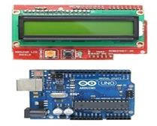

**Fig3.1: Arduino Uno**

It is an easy USB interface. This allows interface with USB as this is like a serial device. The chip on the board plugs straight into your USB port and supports on your computer as a virtual serial port. The benefit of this setup is that serial communication is an extremely easy protocol the microcontroller brain which is the ATmega328 chip. It has more number of hardware features like timers, external and internal interrupts, PWM pins and multiple sleep modes.

* 1. **Lcd**

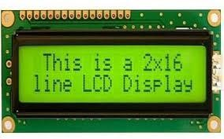

**Fig3.2: Lcd 2X16**

A liquid-crystal display (LCD) is a flat-panel display or other electronically modulated optical device that or reflector to produce images in color or monochrome. LCDs are available to display arbitrary images (as in a general-purpose computer display) or fixed images

with low information content, which can be displayed or hidden, such as preset words, digits, and seven-segment displays, as in a digital clock.

* 1. **Water Depth Sensor**

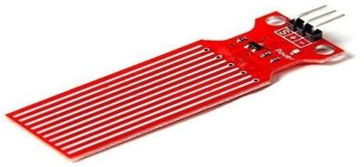

**Fig3.3: Water Depth Sensor**

A **water depth sensor** is a sensor that measures the depth or level of water by detecting the pressure exerted by the water above it, typically functioning as a pressure transducer.

* 1. **Turbidity Sensor**

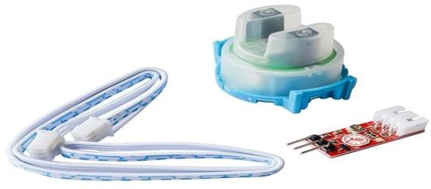

**Fig3.4: Turbidity sensor**

A **turbidity sensor** is a sensor that measures the cloudiness or haziness of a liquid by detecting the amount of light scattered by suspended particles in the water

.

* 1. **Buzzer**

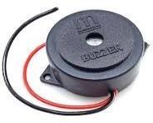

**Fig 3.5: Turbidity sensor**

A **buzzer** is an audio signaling device that produces sound when activated, typically used to alert users through tones or alarms in various systems.

* 1. **Breadboard**

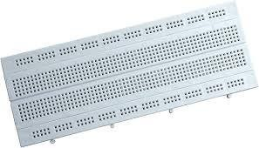

**Fig 3.6: Breadboard**

A breadboard is a construction base for prototyping electronics, allowing components to be connected without soldering by inserting their leads into interconnected holes.

* 1. **LED**

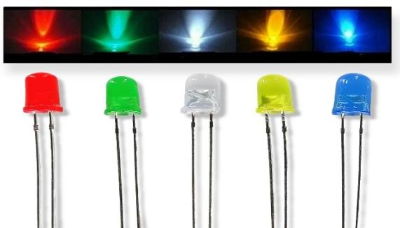

**Fig 3.7: LED**

An **LED** (Light Emitting Diode) is a semiconductor device that emits light when an electric current passes through it, commonly used as an indicator in electronic circuits.

* 1. **Jumper wires**

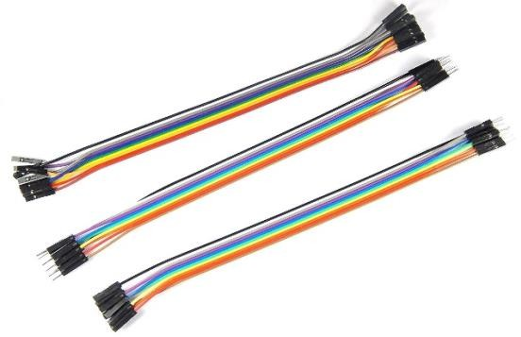

**Fig3.8: Jumper wires**

Jumper wires are electrical wires with connector pins at each end, used to make connections between components on a breadboard or other prototyping surfaces without the need for soldering.

**SOFTWARE SPECIFICATIONS**

**Arduino ide**

Arduino is an open-source platform used for building electronics projects. Arduino consists of both a physical programmable circuit board (often referred to as a microcontroller) and a piece of software, or IDE (Integrated Development Environment) that runs on your computer, used to write and upload computer code to the physical board. The Arduino platform has become quite popular with people just starting

, and anyone interested in creating interactive objects or environments. Arduino can interact with buttons, LEDs, motors, speakers, GPS units, cameras, the internet, and even your smart-phone or your TV! This flexibility combined with the fact that the Arduino software is free, the hardware boards are pretty cheap, and both the software and hardware are easy to learn has led to a large community of users who have contributed code and released instructions for a huge variety of Arduino-based projects

There are many varieties of Arduino boards (explained on the next page) that can be used for different purposes. Some boards look a bit different from the one below, but most Arduinos have the majority of these components in common.

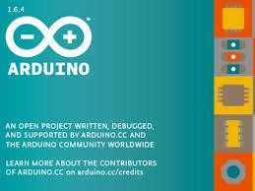

**Fig3.9: Arduino Ide**

**Circuit Diagram of Water level Indicator using arduino**

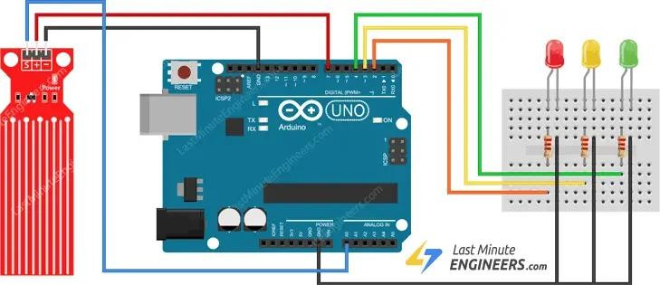

**Fig3.10: Circuit Diagram of Water level Indicator using Water Depth Sensor**

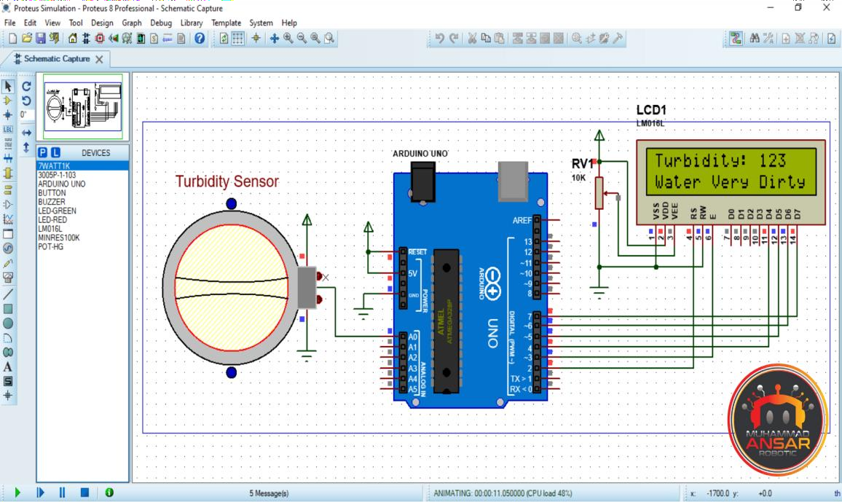

**Fig3.11: Circuit diagram of Water Quality Monitoring using Turbidity sensor and arduino**

# CHAPTER 4 METHODOLOGY

**Steps to integrate water level sensor with Arduino**

Step1: The flex sensors are mounted on the glove and they are fitted along the length of each of the fingers.

Step2: Depending upon the bend of hand movement different signals corresponding to x-axis, y- axis and z-axis are generated.

Step3: Flex sensors outputs the data stream depending on the degree and amount of bend produced, when a sign is gestured

Step4: The output data stream from the flex sensor, tactile sensor and the accelerometer are fed to the Arduino microcontroller, where it is processed and then converted to its corresponding digital values.

Step5: The microcontroller unit will compare these readings with the pre-defined threshold values and the corresponding gestures are recognized and the corresponding text is displayed.

Step6: The text output obtained from the sensor based system is sent to the text-to-speech synthesis module.

Step7: The TTS system converts the text output into speech and the synthesized speech is played through a speaker.

**Steps to integrate the turbidity sensor with Arduino**

Step 1: Connect the turbidity sensor to the Arduino, ensuring the sensor probe is positioned in the water sample to detect its clarity or cloudiness.

Step 2: The turbidity sensor measures the amount of light scattered by suspended particles in the water, generating an analog signal based on turbidity levels.

Step 3: The analog signal from the turbidity sensor is fed into the Arduino's analog input pin, where

it’s processed to reflect water clarity.

Step 4: The Arduino converts the analog signal into digital values, with lower values indicating higher turbidity (cloudier water) and higher values indicating lower turbidity (clearer water).

Step 5: The microcontroller compares the digital readings with predefined threshold values to determine the quality of the water. If the turbidity exceeds safe levels, it triggers an alert.

Step 6: An LED indicator displays water quality status: green for safe levels, yellow for moderate turbidity, and red for high turbidity, signaling poor water quality.

Step 7: If turbidity reaches a critical threshold, a buzzer is activated to alert users, prompting action to address water quality issues. Additionally, the data can be displayed on an LCD or transmitted for remote monitoring if integrated with an IoT platform.

**Software model development**

**Arduino-IDE Codes for water level Indicator and water quality**

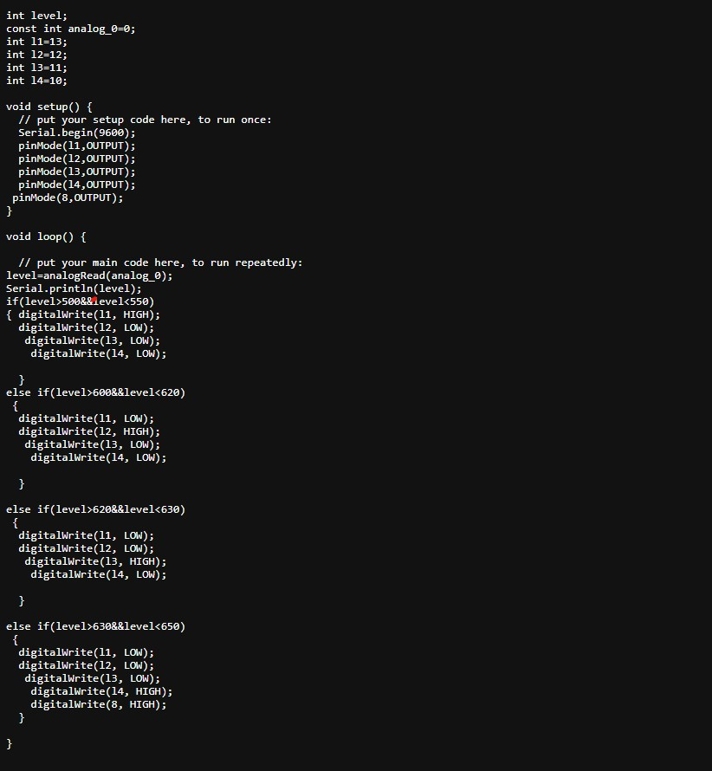

**Fig4.1: Arduino-IDE Code of water level indicator using Arduino**

**Arduino-IDE code for water quality using Arduino and Turbidity Sensor**

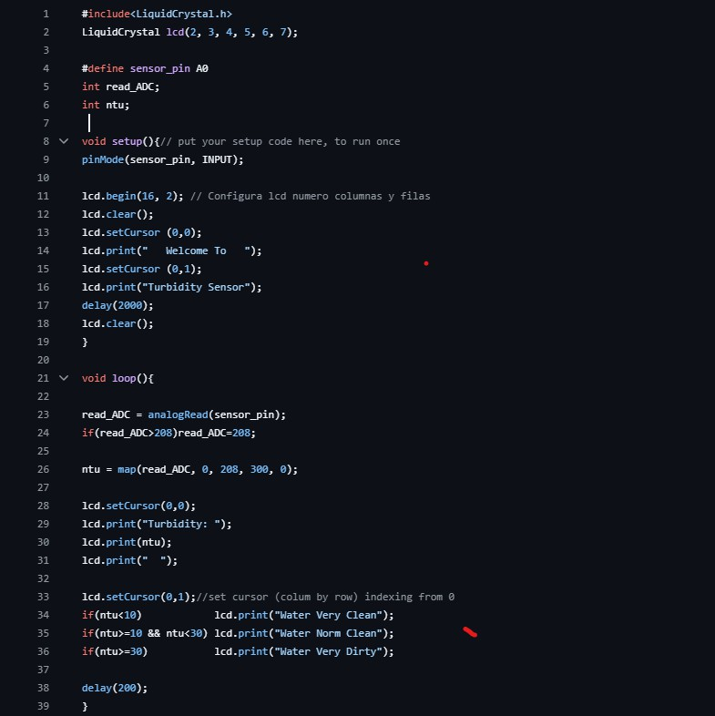

**Fig4.2: Arduino-IDE code for water quality using Arduino and Turbidity Sensor**

**Hardware model development**

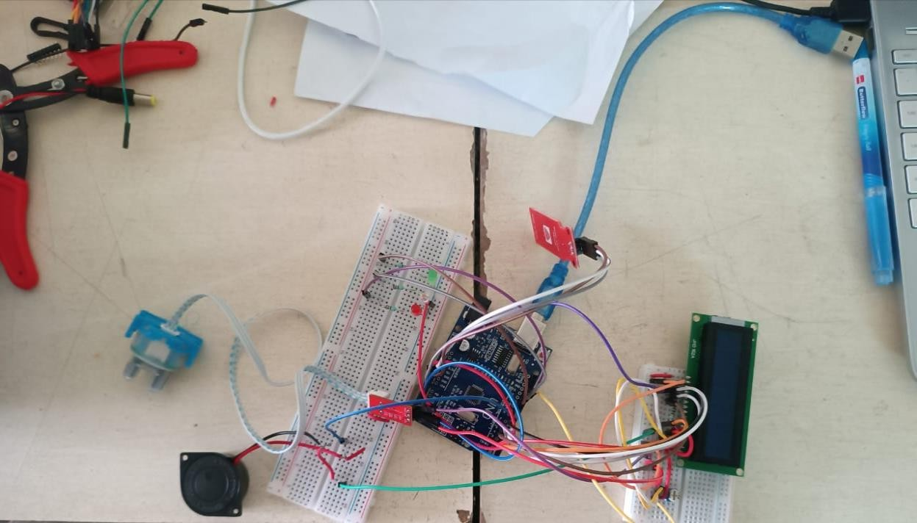

**Fig4.3: Working Model of Water Level Indicator and Water Quality Monitoring System using Arduino**

The image above shows the hardware setup of a water level indicator and water quality monitoring system using an Arduino microcontroller. This system is designed to measure and monitor both the water level and the turbidity (clarity) of water in real-time, providing essential data to users through visual indicators and an LCD display.

This system, designed for simplicity and efficiency, can be used in both residential and industrial settings to prevent water wastage and ensure water quality, contributing to better water resource management.

# CHAPTER 5 CONCLUSION

In this project, an automated system for water level and water quality monitoring using Arduino has been proposed. The system successfully integrates sensors to detect both the water level and the turbidity of water, ensuring efficient water management and quality monitoring. The water level indicator prevents overflow by activating or deactivating the pump, while the turbidity sensor continuously measures the clarity of the water, alerting the user when quality drops below acceptable thresholds. Through the use of an Arduino microcontroller, this system processes sensor data and provides real-time visual feedback via an LCD display and LED indicators. The addition of a buzzer enhances the system's functionality by providing audible alerts for critical conditions. Overall, this system offers a reliable, low-cost solution for monitoring water resources, ensuring both efficient management and safe water quality.

# REFERENCES

1. **Water Level Indicator Using Arduino,**

<https://www.instructables.com/Water-Level-Indicator-Using-Arduino-1/>

1. **Water Quality Using Arduino and Turbidity Sensor,**

https://marobotic.com/2023/10/27/water-quality-using-arduino-and-turbidity-sensor/