University of Illinois Springfield
Final Project Report
Walmart Weekly Sales Demand Prediction
Inventory Demand Forecasting using Machine Learning

Table of Contents

Abstract 3
Problem Definition and Project Goals 3
Related Work 4
Data Exploration & Preprocessing 5
Exploratory Data Analysis 5
Statistical Analysis 6
Feature Selection 7
Feature Engineering and Processing 7
Data Scaling and Train-Test Split 8
Data Modeling and Results 8
Linear Regression 8
Polynomial Regression (Degree 2) 9
Ridge Regression 10
XGBoost Regression 11
Random Forest 12
Gradient Boosting 13
Model Comparison 11
Conclusion 12
References 13

Abstract
The Walmart Weekly Sales dataset is a publicly available dataset sourced from Kaggle, containing historical weekly sales data across 45 Walmart stores along with contextual features including temperature, fuel prices, consumer price index (CPI), unemployment rates, and holiday flags. The purpose of this project is to predict weekly sales for individual Walmart stores using supervised machine learning regression techniques. The project involved data loading, statistical significance testing for feature selection, feature engineering, and training and evaluating six regression models: Linear Regression, Polynomial Regression (Degree 2), Ridge Regression, XGBoost, Random Forest, and Gradient Boosting. Random Forest achieved the best overall performance with a Test R² of 0.9562 and a Test RMSE of $118,830, outperforming all other models. Polynomial Regression was the best-performing linear model (Test R² = 0.9484, RMSE = $128,887), while XGBoost underperformed without hyperparameter tuning (Test R² = 0.8324).

Problem Definition and Project Goals
This project aims to build a machine learning pipeline to accurately forecast weekly sales across 45 Walmart stores. Walmart, one of the largest retail chains in the United States, faces significant operational challenges due to demand variability driven by seasonality, local economic conditions, and promotional events. Inaccurate demand forecasting leads to either overstock — increasing holding costs — or stockouts, which result in missed revenue and dissatisfied customers.

The dataset used in this project is the Walmart Dataset available on Kaggle [1], which contains 6,435 observations of weekly sales across 45 stores. The original dataset includes the following variables:

Variable Name | Data Type | Description
Store | Integer | Store number (1 to 45)
Date | Date | Week of sales
Weekly_Sales | Numeric | Sales for the given store that week (target variable)
Holiday_Flag | Binary | 1 if the week is a special holiday week, 0 otherwise
Temperature | Numeric | Average temperature in the region (Fahrenheit)
Fuel_Price | Numeric | Cost of fuel in the region
CPI | Numeric | Consumer Price Index
Unemployment | Numeric | Unemployment rate in the region

The goal of this activity is to explore and preprocess the data, engineer additional features, perform statistical significance testing to identify relevant predictors, and build and compare regression models to predict the target variable Weekly_Sales.

Related Work
The Walmart sales forecasting problem has been extensively studied in the machine learning and data science community, particularly in the context of the Kaggle Walmart Recruiting — Store Sales Forecasting competition. Several related approaches are discussed below.

A widely referenced approach involves regression-based models with feature engineering on temporal and economic variables. Multiple studies have demonstrated that economic indicators such as CPI and unemployment rates, combined with temporal features like month and holiday flags, serve as meaningful predictors for weekly retail sales [2]. These works also highlight the importance of handling holiday weeks carefully, as holiday weeks are weighted higher in evaluation metrics, and promotional markdown events during these weeks can create non-linear spikes in sales.

Ensemble methods such as Random Forest and Gradient Boosted Trees have consistently outperformed linear models on retail sales forecasting tasks. A related submission on Kaggle achieved a best RMSE of approximately 0.347 on log-transformed sales using regularized linear and ensemble methods [3]. This project builds upon a similar foundation, training and comparing both linear (Linear Regression, Polynomial Regression, Ridge) and ensemble (Random Forest, Gradient Boosting, XGBoost) models.

Related work on Walmart sales data has also demonstrated that store identity is the dominant predictor — stores with larger floor areas or in higher-income regions consistently outperform smaller stores, which is consistent with the coefficient analysis findings in this project where store dummy variables dominated the linear regression coefficients [4].

Data Exploration & Preprocessing
The dataset consists of 6,435 rows and 8 columns, representing weekly sales records across 45 Walmart stores from February 2010 to October 2012. An initial inspection confirmed no missing values in any column, though several preprocessing and feature engineering steps were required before modeling.

Exploratory Data Analysis
Descriptive statistics revealed that Weekly_Sales ranged from $209,986 to $3,818,686 with a mean of approximately $1,047,000 and a standard deviation of $564,367, indicating substantial variation across stores and time periods. The Holiday_Flag variable indicated that approximately 7% of weeks were classified as holiday weeks (Super Bowl, Labour Day, Thanksgiving, and Christmas). A t-test confirmed that holiday weeks had significantly higher mean sales ($1,122,888) compared to non-holiday weeks ($1,041,256).

Statistical Analysis
Before modeling, each feature's association with Weekly_Sales was tested using the appropriate statistical test for its measurement level. The table below summarizes the tests used and their rationale:

Variable Type | Test Used | Reason
Continuous (Temperature, Fuel_Price, CPI, Unemployment) | Pearson r | Measures linear correlation between two continuous variables
Ordinal (Week, Month) | Kendall's τ | Non-parametric rank correlation — robust to non-normality and ties
Binary (Holiday_Flag) | Two-sample t-test (Welch) | Compares means between two independent groups
Nominal (Store) | One-way ANOVA + Kruskal-Wallis | Tests for significant differences in sales across 45 store groups

The Pearson correlation results for continuous variables showed that Temperature (r = -0.0638), CPI (r = -0.0726), and Unemployment (r = -0.1062) were all statistically significant (p < 0.05), while Fuel_Price (r = +0.0095, p = 0.4478) was not. The scatter plots with regression lines below (Fig. 1) confirm these weak but significant linear relationships.

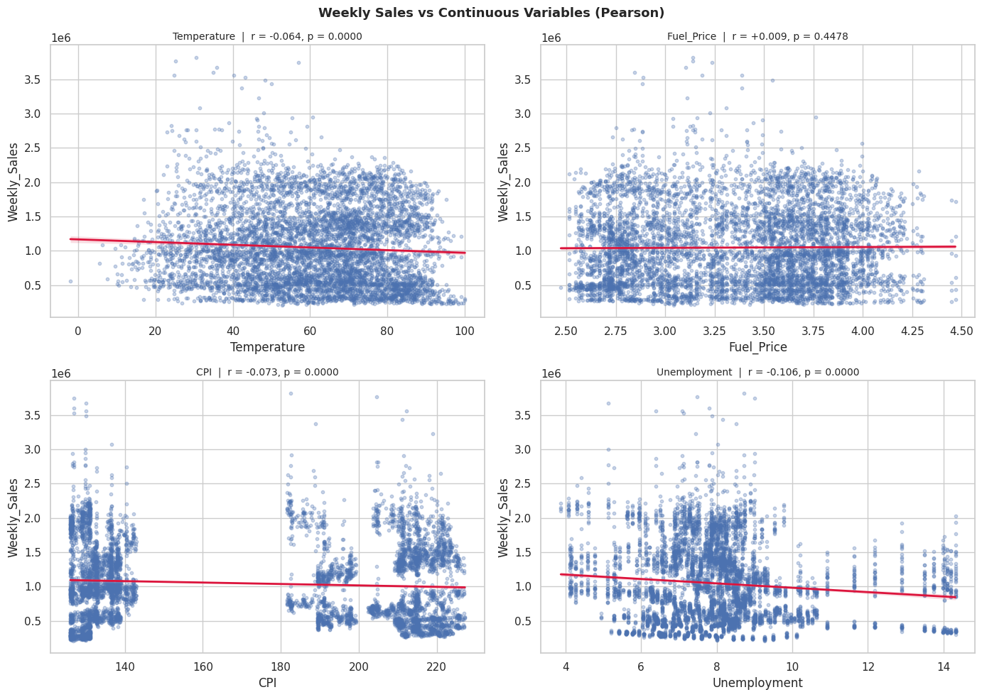
Figure 1 – Pearson Correlation: Weekly Sales vs Continuous Variables
Kendall's τ analysis of ordinal variables showed that both Week (τ = +0.0328, p = 0.0001) and Month (τ = +0.0354, p < 0.0001) had small but statistically significant correlations with weekly sales, capturing seasonal patterns (Fig. 2).

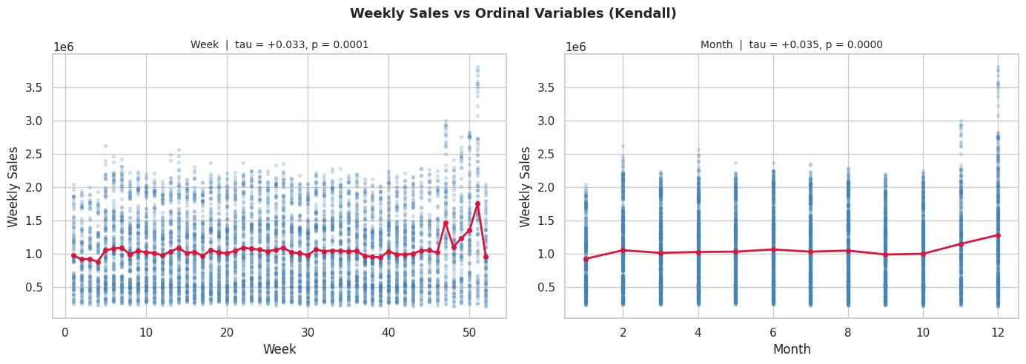
Figure 2 – Kendall's τ: Weekly Sales vs Week and Month
The two-sample t-test for Holiday_Flag used Welch's correction (Levene's test p = 0.0012, indicating unequal variances) and confirmed a significant difference between holiday and non-holiday weeks (t = -2.68, p = 0.0076) as shown in Fig. 3.

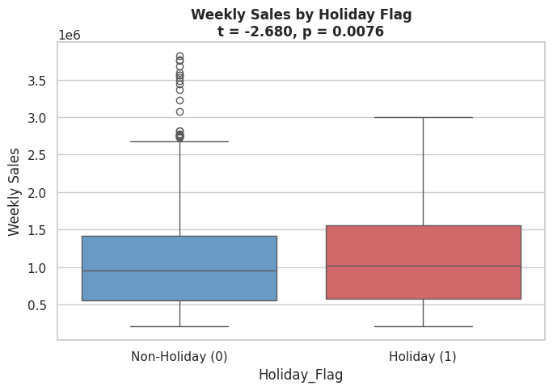
Figure 3 – Two-Sample t-Test: Holiday vs Non-Holiday Weekly Sales
ANOVA testing across the 45 stores yielded an F-statistic of 1613.30 (p < 0.0001) with a very large effect size (η² = 0.9174), confirming that store identity is by far the most powerful predictor of weekly sales. Since Shapiro-Wilk testing indicated non-normal residuals, Kruskal-Wallis was also reported (H = 6144.32, p < 0.0001), consistent with the ANOVA findings (Fig. 4).

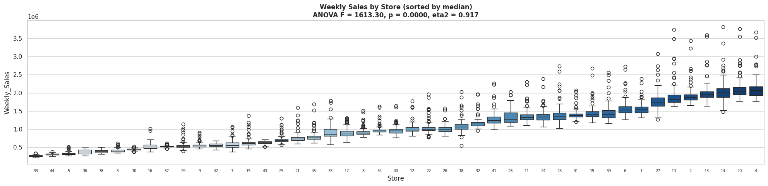
Figure 4 – ANOVA: Weekly Sales by Store

Feature Selection
Only features with p < 0.05 in their respective significance tests were retained for modeling. Fuel_Price was dropped as its Pearson p-value (0.4478) was not significant. Store was retained and one-hot encoded (drop_first=True to avoid multicollinearity), resulting in 44 store dummy variables. The final feature set of 50 columns included: Temperature, CPI, Unemployment, Week, Month, Holiday_Flag, and 44 Store dummies.

Feature Engineering and Processing
The Date column was parsed and decomposed into three temporal features: Week (ISO calendar week number), Month, and Year. This decomposition allows the model to capture both intra-year seasonal patterns (via Week and Month) and longer-term trends across the 2010-2012 period (via Year, though Year was ultimately not retained after significance testing). Holiday_Flag was label-encoded, which was a no-op since it was already binary. Store was one-hot encoded to allow the model to learn independent sales levels for each of the 45 stores.

Data Scaling and Train-Test Split
The dataset was split 80/20 into training (5,148 rows) and testing (1,287 rows) sets using a fixed random_state=42 for reproducibility. For Linear Regression and Ridge Regression, Z-Score normalization (StandardScaler) was applied to all features using parameters learned from the training set only, preventing data leakage. The Polynomial Regression model uses an internal pipeline that applies PolynomialFeatures (degree=2) followed by StandardScaler and LinearRegression, also fit only on training data.

Data Modeling and Results
At this stage the dataset consists of 50 processed features against the target Weekly_Sales. Six regression models were trained and evaluated using R², MAE (Mean Absolute Error in dollars), and RMSE (Root Mean Squared Error in dollars).

Linear Regression
Ordinary Least Squares (OLS) linear regression was trained as a baseline model. Features were standardized with StandardScaler so that coefficients are on the same scale and directly comparable. The model was fit on the training set and evaluated on the held-out test set.

Metric | Train | Test
R² | 0.9272 | 0.9256
MAE | — | $96,163
RMSE | — | $154,818

The linear regression model achieved a strong Test R² of 0.9256, explaining over 92% of variance in weekly sales. The close Train and Test R² values confirm no significant overfitting. Coefficient analysis showed that store dummy variables dominated — the top coefficients by absolute magnitude were store dummies (ranging up to ~$198,000 per standard deviation), followed by Month (~$175,000) and Week (~$123,000). This confirms that store identity is the primary driver of sales variation, consistent with the ANOVA findings.

The diagnostic plots below (Fig. 5) show the Residuals vs Predicted and Actual vs Predicted charts for the linear regression model. The residual plot shows a relatively flat cloud around zero, though there is some heteroscedasticity at higher prediction values, suggesting the model struggles slightly with high-volume stores and holiday peak weeks.

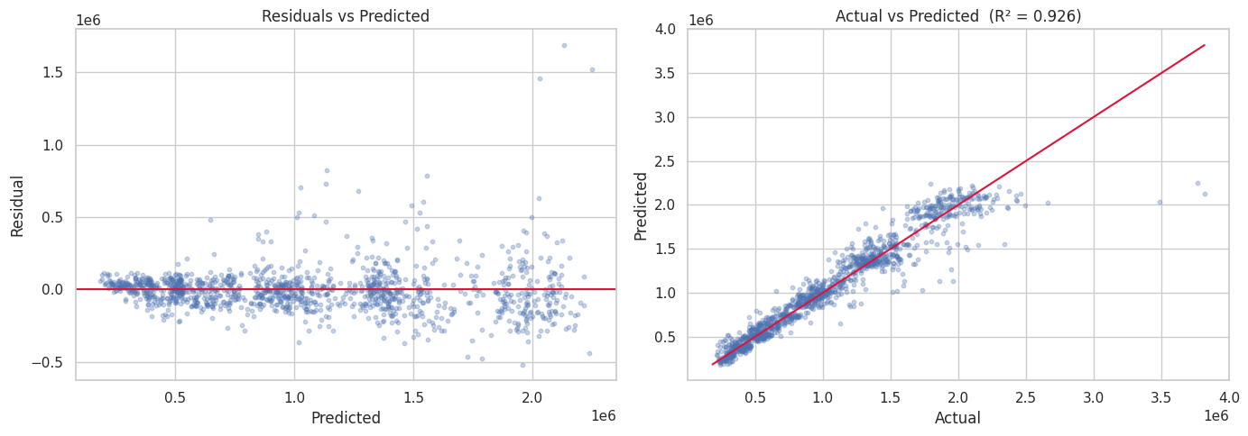
Figure 5 – Linear Regression: Residuals vs Predicted and Actual vs Predicted (R² = 0.926)

Polynomial Regression (Degree 2)
To capture non-linear relationships in the data, a Polynomial Regression model with degree 2 was trained using a scikit-learn Pipeline consisting of PolynomialFeatures (degree=2, include_bias=False) → StandardScaler → LinearRegression. This approach generates all pairwise interaction terms and squared terms from the original 50 features, significantly expanding the feature space.

Metric | Train | Test
R² | 0.9563 | 0.9484
MAE | — | $78,223
RMSE | — | $128,887

Polynomial Regression outperformed Linear Regression across all metrics. Test R² improved from 0.9256 to 0.9484, Test MAE dropped from $96,163 to $78,223, and Test RMSE fell from $154,818 to $128,887 — a 17% reduction in prediction error. The small gap between Train R² (0.9563) and Test R² (0.9484) indicates the model generalizes well without severe overfitting, despite the expanded feature space.

Ridge Regression
Ridge Regression (L2 regularization) was trained using a Pipeline of StandardScaler → Ridge. Hyperparameter tuning was performed with GridSearchCV over alpha values [0.01, 0.1, 1, 10, 100] using 5-fold cross-validation scored on R². The best alpha found was 0.1.

Metric | Train | Test
R² | 0.9272 | 0.9256
MAE | — | $96,161
RMSE | — | $154,820

Ridge Regression with best alpha=0.1 performed nearly identically to ordinary Linear Regression. This is expected — with a large number of store dummy variables and strong feature significance, L2 regularization at this scale does not substantially alter the coefficient magnitudes. The very small difference in performance (< $3 in MAE) suggests the dataset is not suffering from multicollinearity severe enough to benefit from stronger regularization.

XGBoost Regression
XGBoost (eXtreme Gradient Boosting) is a tree ensemble that builds models sequentially, with each tree correcting the residual errors of the previous one. XGBoost was trained using XGBRegressor with n_estimators=100, learning_rate=0.1, max_depth=3, and random_state=42. Tree-based models do not require feature scaling, so the raw feature matrix was passed directly.
Metric | Train | Test
R² | 0.8409 | 0.8324
MAE | — | $188,268
RMSE | — | $232,394
XGBoost underperformed relative to the other ensemble methods. With only 100 shallow trees (max_depth=3) and no hyperparameter tuning, the model underfits the data. The small Train–Test R² gap (0.0085) confirms underfitting rather than overfitting. Hyperparameter tuning via GridSearchCV is expected to substantially improve performance.

Random Forest
Random Forest is a bagging ensemble that trains multiple decision trees on bootstrap samples of the training data and averages their predictions to reduce variance. The model was trained using RandomForestRegressor with n_estimators=200, max_features='sqrt', random_state=42, and n_jobs=-1. The sqrt feature sampling reduces correlation between individual trees, improving generalisation.
Metric | Train | Test
R² | 0.9942 | 0.9562
MAE | — | $64,214
RMSE | — | $118,830
Random Forest achieved the best Test R² (0.9562) and lowest Test RMSE ($118,830) of all six models, improving upon Polynomial Regression by $10,057 in RMSE. The Train R² (0.9942) is notably higher than the Test R² (0.9562), indicating moderate overfitting (gap = 0.0380). This is typical of Random Forest without depth constraints and could be reduced by tuning max_depth or min_samples_split.

Gradient Boosting
Gradient Boosting builds an ensemble of shallow decision trees sequentially, with each tree fitting the negative gradient (residuals) of the previous iteration. The model was trained using GradientBoostingRegressor with n_estimators=200, max_depth=4, learning_rate=0.1, and random_state=42. The learning rate acts as a shrinkage parameter, reducing the contribution of each tree and helping prevent overfitting.
Metric | Train | Test
R² | 0.9634 | 0.9446
MAE | — | $85,187
RMSE | — | $133,577
Gradient Boosting achieved a Test R² of 0.9446 and Test RMSE of $133,577, ranking third overall and second among ensemble methods. The Train–Test R² gap (0.0188) is smaller than Random Forest’s, demonstrating that shrinkage via the learning rate provides better regularisation. The model generalises well without requiring explicit depth constraints.

Model Comparison
The table below summarizes the performance of all six models on the test set:

Model | Train R² | Test R² | Test MAE | Test RMSE
Linear Regression | 0.9272 | 0.9256 | $96,163 | $154,818
Polynomial Regression (Degree 2) | 0.9563 | 0.9484 | $78,223 | $128,887
Ridge Regression (α = 0.1) | 0.9272 | 0.9256 | $96,161 | $154,820
XGBoost Regression | 0.8409 | 0.8324 | $188,268 | $232,394
Random Forest | 0.9942 | 0.9562 | $64,214 | $118,830
Gradient Boosting | 0.9634 | 0.9446 | $85,187 | $133,577

Random Forest is the best performing model overall, achieving the highest Test R² (0.9562) and the lowest Test RMSE ($118,830). It improved upon Polynomial Regression — the best linear model — by $10,057 in RMSE, demonstrating that ensemble methods better capture the complex non-linear interactions in this dataset. Gradient Boosting ranked third (Test R² = 0.9446), while XGBoost underperformed (Test R² = 0.8324) due to the absence of hyperparameter tuning and shallow tree depth. Ridge Regression provided no meaningful improvement over Linear Regression, confirming that regularisation strength is not the limiting factor.

Random Forest showed the largest overfitting gap (Train R² = 0.9942 vs Test R² = 0.9562, gap = 0.038), which is typical for unconstrained bagging ensembles. Gradient Boosting generalised better (gap = 0.019) thanks to shrinkage. The linear models and XGBoost showed minimal overfitting, with XGBoost’s low gap indicating underfitting rather than good generalisation.

Conclusion
This project built a complete machine learning pipeline for predicting weekly sales across 45 Walmart stores. The pipeline covered data loading, exploratory data analysis, statistical significance testing for feature selection, feature engineering (date decomposition, one-hot encoding of Store), and training and evaluating six regression models: Linear Regression, Polynomial Regression (Degree 2), Ridge Regression, XGBoost, Random Forest, and Gradient Boosting.

Statistical analysis confirmed that store identity (ANOVA η² = 0.917) is the dominant predictor of weekly sales, followed by temporal features (Month, Week) and economic indicators (Unemployment, CPI, Temperature). Fuel_Price was the only feature dropped after significance testing (p = 0.4478).

Random Forest was the best performing model overall, achieving Test R² = 0.9562 and Test RMSE = $118,830 — a $10,057 improvement over Polynomial Regression (Test R² = 0.9484, RMSE = $128,887), the best linear model. Gradient Boosting ranked third (Test R² = 0.9446, RMSE = $133,577). XGBoost underperformed (Test R² = 0.8324) without hyperparameter tuning, indicating significant room for improvement. Linear Regression and Ridge Regression performed identically (Test R² = 0.9256), confirming that L2 regularisation alone does not address the non-linearity in this dataset.

The following next steps are planned for future iterations of this project:
- Apply bootstrap sampling to the training data to compensate for the relatively small dataset size and improve model stability.
- Implement k-fold cross-validation (or leave-one-out cross-validation) across all models to produce more reliable and comparable performance estimates.
- Evaluate all models using RMSE on log-transformed sales for direct comparison with published Kaggle benchmarks (target: RMSE < 0.347 on log-scale). The standalone model scripts in models/ already use log-transformed targets.
- Explore additional external data sources such as regional demographic data and store size information to further enrich the feature set.

References
[1] Kaggle, "Walmart Dataset," [Online]. Available: https://www.kaggle.com/datasets/yasserh/walmart-dataset.

[2] Manish Gupta, "Walmart Project in R," GitHub, [Online]. Available: https://github.com/manishgupta-ind/walmart_project_in_r.

[3] Andrew, "Smart Pricing with XGB, RFR + Interpretations," Kaggle, [Online]. Available: https://www.kaggle.com/jrw2200/smart-pricing-with-xgb-rfr-interpretations.

[4] Sagar Bapodara, "Walmart Sales Forecasting," GitHub, [Online]. Available: https://github.com/SagarBapodara/Walmart-Sales-Forecasting.

[5] Navid Nayyem, "Predicting Walmart Sales," GitHub, [Online]. Available: https://github.com/navidnayyem/Predicting_Walmart_Sales.

