University of Illinois Springfield
Final Project Report
Walmart Weekly Sales Demand Prediction
Inventory Demand Forecasting using Machine Learning

Table of Contents

Abstract 3
Problem Definition and Project Goals 3
Related Work 4
Data Exploration & Preprocessing 5
Exploratory Data Analysis 5
Statistical Analysis 6
Feature Selection 7
Feature Engineering and Processing 7
Data Scaling and Train-Test Split 8
Data Modeling and Results 8
Linear Regression 8
Polynomial Regression (Degree 2) 9
Ridge Regression 10
Model Comparison 11
Conclusion 12
References 13

Abstract
The Walmart Weekly Sales dataset is a publicly available dataset sourced from Kaggle, containing historical weekly sales data across 45 Walmart stores along with contextual features including temperature, fuel prices, consumer price index (CPI), unemployment rates, and holiday flags. The purpose of this project is to predict weekly sales for individual Walmart stores using supervised machine learning regression techniques. The project involved data loading, statistical significance testing for feature selection, feature engineering, and training and evaluating three regression models: Linear Regression, Polynomial Regression (Degree 2), and Ridge Regression. Among the three models, Polynomial Regression achieved the best performance with a Test R² of 0.9484 and a Test RMSE of $128,887, demonstrating that capturing non-linear relationships between features significantly improves predictive accuracy.

Problem Definition and Project Goals
This project aims to build a machine learning pipeline to accurately forecast weekly sales across 45 Walmart stores. Walmart, one of the largest retail chains in the United States, faces significant operational challenges due to demand variability driven by seasonality, local economic conditions, and promotional events. Inaccurate demand forecasting leads to either overstock — increasing holding costs — or stockouts, which result in missed revenue and dissatisfied customers.

The dataset used in this project is the Walmart Dataset available on Kaggle [1], which contains 6,435 observations of weekly sales across 45 stores. The original dataset includes the following variables:

Variable Name | Data Type | Description
Store | Integer | Store number (1 to 45)
Date | Date | Week of sales
Weekly_Sales | Numeric | Sales for the given store that week (target variable)
Holiday_Flag | Binary | 1 if the week is a special holiday week, 0 otherwise
Temperature | Numeric | Average temperature in the region (Fahrenheit)
Fuel_Price | Numeric | Cost of fuel in the region
CPI | Numeric | Consumer Price Index
Unemployment | Numeric | Unemployment rate in the region

The goal of this activity is to explore and preprocess the data, engineer additional features, perform statistical significance testing to identify relevant predictors, and build and compare regression models to predict the target variable Weekly_Sales.

Related Work
The Walmart sales forecasting problem has been extensively studied in the machine learning and data science community, particularly in the context of the Kaggle Walmart Recruiting — Store Sales Forecasting competition. Several related approaches are discussed below.

A widely referenced approach involves regression-based models with feature engineering on temporal and economic variables. Multiple studies have demonstrated that economic indicators such as CPI and unemployment rates, combined with temporal features like month and holiday flags, serve as meaningful predictors for weekly retail sales [2]. These works also highlight the importance of handling holiday weeks carefully, as holiday weeks are weighted higher in evaluation metrics, and promotional markdown events during these weeks can create non-linear spikes in sales.

Ensemble methods such as Random Forest and Gradient Boosted Trees have consistently outperformed linear models on retail sales forecasting tasks. A related submission on Kaggle achieved a best RMSE of approximately 0.347 on log-transformed sales using regularized linear and ensemble methods [3]. This project builds upon a similar foundation, currently using regularized regression (Ridge) and polynomial feature expansion, with ensemble methods planned for future iterations.

Related work on Walmart sales data has also demonstrated that store identity is the dominant predictor — stores with larger floor areas or in higher-income regions consistently outperform smaller stores, which is consistent with the coefficient analysis findings in this project where store dummy variables dominated the linear regression coefficients [4].

Data Exploration & Preprocessing
The dataset consists of 6,435 rows and 8 columns, representing weekly sales records across 45 Walmart stores from February 2010 to October 2012. An initial inspection confirmed no missing values in any column, though several preprocessing and feature engineering steps were required before modeling.

Exploratory Data Analysis
Descriptive statistics revealed that Weekly_Sales ranged from $209,986 to $3,818,686 with a mean of approximately $1,047,000 and a standard deviation of $564,367, indicating substantial variation across stores and time periods. The Holiday_Flag variable indicated that approximately 7% of weeks were classified as holiday weeks (Super Bowl, Labour Day, Thanksgiving, and Christmas). A t-test confirmed that holiday weeks had significantly higher mean sales ($1,122,888) compared to non-holiday weeks ($1,041,256).

Statistical Analysis
Before modeling, each feature's association with Weekly_Sales was tested using the appropriate statistical test for its measurement level. The table below summarizes the tests used and their rationale:

Variable Type | Test Used | Reason
Continuous (Temperature, Fuel_Price, CPI, Unemployment) | Pearson r | Measures linear correlation between two continuous variables
Ordinal (Week, Month) | Kendall's τ | Non-parametric rank correlation — robust to non-normality and ties
Binary (Holiday_Flag) | Two-sample t-test (Welch) | Compares means between two independent groups
Nominal (Store) | One-way ANOVA + Kruskal-Wallis | Tests for significant differences in sales across 45 store groups

The Pearson correlation results for continuous variables showed that Temperature (r = -0.0638), CPI (r = -0.0726), and Unemployment (r = -0.1062) were all statistically significant (p < 0.05), while Fuel_Price (r = +0.0095, p = 0.4478) was not. The scatter plots with regression lines below (Fig. 1) confirm these weak but significant linear relationships.

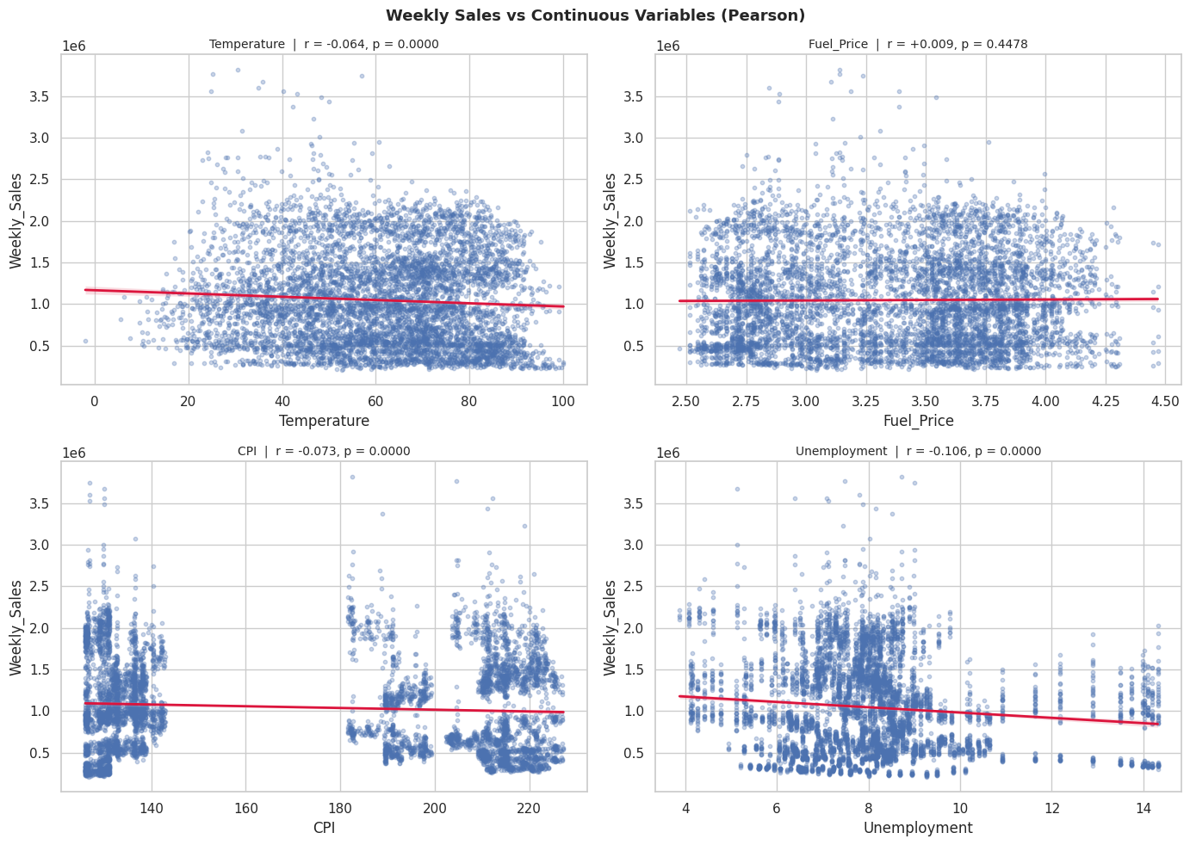
Figure 1 – Pearson Correlation: Weekly Sales vs Continuous Variables
Kendall's τ analysis of ordinal variables showed that both Week (τ = +0.0328, p = 0.0001) and Month (τ = +0.0354, p < 0.0001) had small but statistically significant correlations with weekly sales, capturing seasonal patterns (Fig. 2).

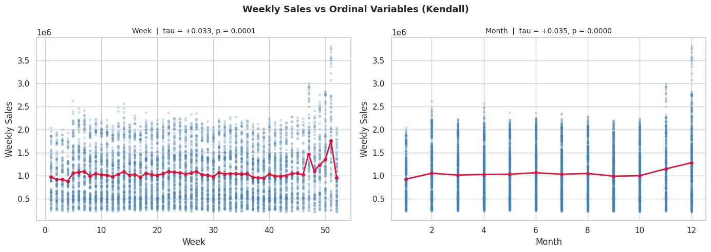
Figure 2 – Kendall's τ: Weekly Sales vs Week and Month
The two-sample t-test for Holiday_Flag used Welch's correction (Levene's test p = 0.0012, indicating unequal variances) and confirmed a significant difference between holiday and non-holiday weeks (t = -2.68, p = 0.0076) as shown in Fig. 3.

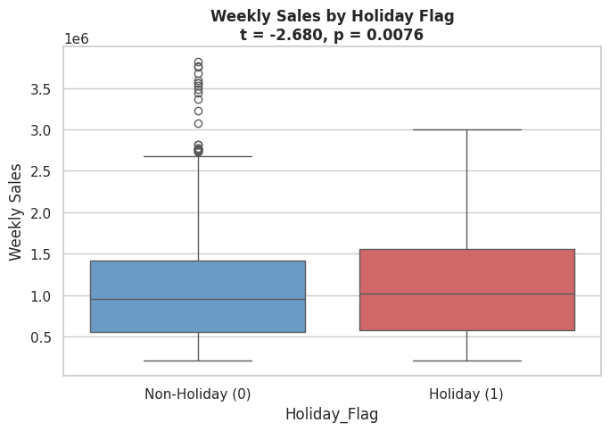
Figure 3 – Two-Sample t-Test: Holiday vs Non-Holiday Weekly Sales
ANOVA testing across the 45 stores yielded an F-statistic of 1613.30 (p < 0.0001) with a very large effect size (η² = 0.9174), confirming that store identity is by far the most powerful predictor of weekly sales. Since Shapiro-Wilk testing indicated non-normal residuals, Kruskal-Wallis was also reported (H = 6144.32, p < 0.0001), consistent with the ANOVA findings (Fig. 4).

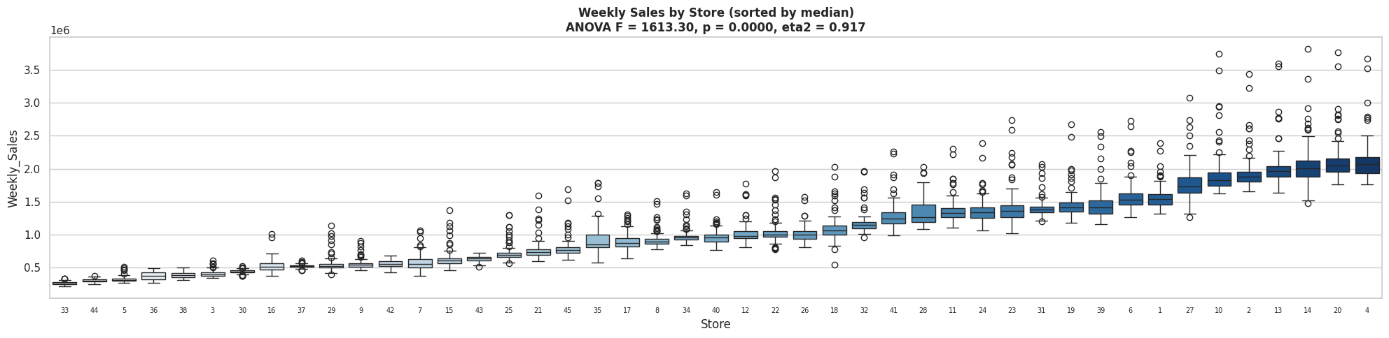
Figure 4 – ANOVA: Weekly Sales by Store

Feature Selection
Only features with p < 0.05 in their respective significance tests were retained for modeling. Fuel_Price was dropped as its Pearson p-value (0.4478) was not significant. Store was retained and one-hot encoded (drop_first=True to avoid multicollinearity), resulting in 44 store dummy variables. The final feature set of 50 columns included: Temperature, CPI, Unemployment, Week, Month, Holiday_Flag, and 44 Store dummies.

Feature Engineering and Processing
The Date column was parsed and decomposed into three temporal features: Week (ISO calendar week number), Month, and Year. This decomposition allows the model to capture both intra-year seasonal patterns (via Week and Month) and longer-term trends across the 2010-2012 period (via Year, though Year was ultimately not retained after significance testing). Holiday_Flag was label-encoded, which was a no-op since it was already binary. Store was one-hot encoded to allow the model to learn independent sales levels for each of the 45 stores.

Data Scaling and Train-Test Split
The dataset was split 80/20 into training (5,148 rows) and testing (1,287 rows) sets using a fixed random_state=42 for reproducibility. For Linear Regression and Ridge Regression, Z-Score normalization (StandardScaler) was applied to all features using parameters learned from the training set only, preventing data leakage. The Polynomial Regression model uses an internal pipeline that applies PolynomialFeatures (degree=2) followed by StandardScaler and LinearRegression, also fit only on training data.

Data Modeling and Results
At this stage the dataset consists of 50 processed features against the target Weekly_Sales. Three regression models were trained and evaluated using R², MAE (Mean Absolute Error in dollars), and RMSE (Root Mean Squared Error in dollars).

Linear Regression
Ordinary Least Squares (OLS) linear regression was trained as a baseline model. Features were standardized with StandardScaler so that coefficients are on the same scale and directly comparable. The model was fit on the training set and evaluated on the held-out test set.

Metric | Train | Test
R² | 0.9272 | 0.9256
MAE | — | $96,163
RMSE | — | $154,818

The linear regression model achieved a strong Test R² of 0.9256, explaining over 92% of variance in weekly sales. The close Train and Test R² values confirm no significant overfitting. Coefficient analysis showed that store dummy variables dominated — the top coefficients by absolute magnitude were store dummies (ranging up to ~$198,000 per standard deviation), followed by Month (~$175,000) and Week (~$123,000). This confirms that store identity is the primary driver of sales variation, consistent with the ANOVA findings.

The diagnostic plots below (Fig. 5) show the Residuals vs Predicted and Actual vs Predicted charts for the linear regression model. The residual plot shows a relatively flat cloud around zero, though there is some heteroscedasticity at higher prediction values, suggesting the model struggles slightly with high-volume stores and holiday peak weeks.

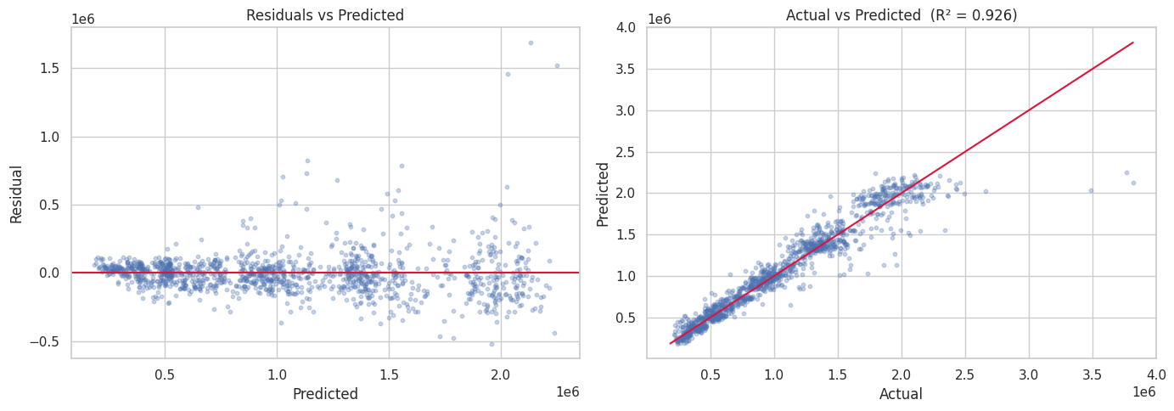
Figure 5 – Linear Regression: Residuals vs Predicted and Actual vs Predicted (R² = 0.926)

Polynomial Regression (Degree 2)
To capture non-linear relationships in the data, a Polynomial Regression model with degree 2 was trained using a scikit-learn Pipeline consisting of PolynomialFeatures (degree=2, include_bias=False) → StandardScaler → LinearRegression. This approach generates all pairwise interaction terms and squared terms from the original 50 features, significantly expanding the feature space.

Metric | Train | Test
R² | 0.9563 | 0.9484
MAE | — | $78,223
RMSE | — | $128,887

Polynomial Regression outperformed Linear Regression across all metrics. Test R² improved from 0.9256 to 0.9484, Test MAE dropped from $96,163 to $78,223, and Test RMSE fell from $154,818 to $128,887 — a 17% reduction in prediction error. The small gap between Train R² (0.9563) and Test R² (0.9484) indicates the model generalizes well without severe overfitting, despite the expanded feature space.

Ridge Regression
Ridge Regression (L2 regularization) was trained using a Pipeline of StandardScaler → Ridge. Hyperparameter tuning was performed with GridSearchCV over alpha values [0.01, 0.1, 1, 10, 100] using 5-fold cross-validation scored on R². The best alpha found was 0.1.

Metric | Train | Test
R² | 0.9272 | 0.9256
MAE | — | $96,161
RMSE | — | $154,820

Ridge Regression with best alpha=0.1 performed nearly identically to ordinary Linear Regression. This is expected — with a large number of store dummy variables and strong feature significance, L2 regularization at this scale does not substantially alter the coefficient magnitudes. The very small difference in performance (< $3 in MAE) suggests the dataset is not suffering from multicollinearity severe enough to benefit from stronger regularization.

Model Comparison
The table below summarizes the performance of all three models on the test set:

Model | Train R² | Test R² | Test MAE | Test RMSE
Linear Regression | 0.9272 | 0.9256 | $96,163 | $154,818
Polynomial Regression (Degree 2) | 0.9563 | 0.9484 | $78,223 | $128,887
Ridge Regression (α = 0.1) | 0.9272 | 0.9256 | $96,161 | $154,820

Polynomial Regression is the best performing model, achieving the highest Test R² and the lowest MAE and RMSE. It improved upon Linear Regression by capturing non-linear and interaction effects between features, particularly between store identity, temporal features, and economic conditions. Ridge Regression provided no meaningful improvement over Linear Regression for this dataset, indicating that regularization strength is not the limiting factor — model flexibility is.

None of the three models showed severe overfitting. The largest Train-Test R² gap was 0.0079 (Polynomial Regression), which is acceptable. This suggests that the feature set — dominated by store dummies which are fixed identifiers rather than noisy continuous variables — is well-suited to regression without heavy regularization.

Conclusion
This project built a complete machine learning pipeline for predicting weekly sales across 45 Walmart stores. The pipeline covered data loading, exploratory data analysis, statistical significance testing for feature selection, feature engineering (date decomposition, one-hot encoding of Store), and training and evaluating three regression models.

Statistical analysis confirmed that store identity (ANOVA η² = 0.917) is the dominant predictor of weekly sales, followed by temporal features (Month, Week) and economic indicators (Unemployment, CPI, Temperature). Fuel_Price was the only feature dropped after significance testing (p = 0.4478).

Polynomial Regression (Degree 2) was the best performing model, achieving Test R² = 0.9484 and Test RMSE = $128,887, outperforming both Linear Regression (Test R² = 0.9256, RMSE = $154,818) and Ridge Regression (Test R² = 0.9256, RMSE = $154,820). The improvement from polynomial features confirms the presence of meaningful non-linear relationships in the data that linear models cannot capture.

The following next steps are planned for future iterations of this project:
- Apply bootstrap sampling to the training data to compensate for the relatively small dataset size and improve model stability.
- Implement k-fold cross-validation (or leave-one-out cross-validation) across all models to produce more reliable and comparable performance estimates.
- Train Random Forest and Gradient Boosting regressors with hyperparameter tuning, which are expected to further improve performance by better capturing complex feature interactions.
- Evaluate all models using RMSE on log-transformed sales to allow direct comparison with published Kaggle benchmarks (target: RMSE < 0.347 on log-scale).
- Explore additional external data sources such as regional demographic data and store size information to further enrich the feature set.

References
[1] Kaggle, "Walmart Dataset," [Online]. Available: https://www.kaggle.com/datasets/yasserh/walmart-dataset.

[2] Manish Gupta, "Walmart Project in R," GitHub, [Online]. Available: https://github.com/manishgupta-ind/walmart_project_in_r.

[3] Andrew, "Smart Pricing with XGB, RFR + Interpretations," Kaggle, [Online]. Available: https://www.kaggle.com/jrw2200/smart-pricing-with-xgb-rfr-interpretations.

[4] Sagar Bapodara, "Walmart Sales Forecasting," GitHub, [Online]. Available: https://github.com/SagarBapodara/Walmart-Sales-Forecasting.

[5] Navid Nayyem, "Predicting Walmart Sales," GitHub, [Online]. Available: https://github.com/navidnayyem/Predicting_Walmart_Sales.

