Lab 3. BLASTing through the kingdoms of life

Goal: Use the BLAST tool to identify an unknown DNA sequence.

Steps:
- Open and read the BLAST tutorial: https://digitalworldbiology.com/BLAST/slide1.html
- I have added some nucleotide sequences to Canvas in the Lab 3 assignment, under the DNA Sequence Analysis module (filename is Lab_3_Sequences.fasta). Go ahead and download them to your computer.
- Open the .fasta file in the text editor of your choice.
- Select one of the unknown sequences from the sequence data set, copy the DNA sequence. Paste your sequence in the BLAST text box.
**Be sure to copy the entire sequence including the > symbol and the name.
- Identify the sequence using BLAST, and answer the questions on the BLAST worksheet

You should be aware that the NCBI web changes regularly. Although the information in this document is current, the NCBI web page may appear slightly different.

- How long is the sequence that was used to search the database? Include the units.

420 nucleotides

- Download your results, for later use. From the “Download” dropdown menu, select “FASTA (aligned sequences)”. Place the file in your project folder.

- Which sequence matches your query the best? What data support this conclusion?

Saccharomyces 23S RNA narnavirus, complete genome
Sequence ID: NC_004050.1
The identities are 420/420 (100%) with 0/420 Gaps. E value is 0.

- What organism is the mostly likely source of the sequence?

Saccharomyces 23S RNA narnavirus – a virus associated with Saccharomyces yeast

- What is the common name for this organism?

Yeast narnavirus

- What phylum contains this organism?

Lenarviricota

- What is the accession number for the best-matching sequence?

NC_004050.1

- Estimate the number of sequences with an E-value less than 0.01.

Two sequences

- If possible, give the names of at least three different organisms with significant E-values. If there are fewer than three significant E-values, give the names of the significant matches. Record the name of the organism, the common name, and the E-value.

Saccharomyces 23S RNA narnavirus
common name: yeast narnavirus
E = 0.0

Saccharomyces 23S RNA narnavirus (ORF1) gene
common name: yeast narnavirus
E = 0.0

- Look at the first matching sequence in the table. For that subject sequence, determine the length of the alignment, in nucleotides, and the fraction of nucleotides that match your query sequence.

Length of alignment: 420 nucleotides
Fraction match: 420/420 (100%)

- Look at the alignment to the first-matching sequence and determine the length of the alignment and the fraction of nucleotides that match your sequence. Draw a picture to represent the alignment between the two sequences and include the starting and ending map positions for both sequences.

Query ------------------------------------
Subject ------------------------------------
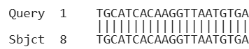
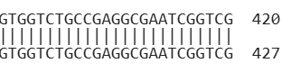

- Enter the sequence (copy / paste) or upload a file to BLASTx. Did your sequence match any known proteins? Which protein?

Yes, my sequences matched proteins:

Nuclear Protein NP_660177.1 – “RNA-dependent RNA polymerase”
UJQ92643.1 – “putative RNA-dependent RNA polymerase”

- What is the difference between BLAST and BLASTx?

BLAST allows DNA sequence matching to DNA databases by looking at nucleotide alignment.

BLASTx translates a given DNA sequence into the possible proteins. The proteins are then compared to protein databases to look for matches.

- Use GenBank, PubMed, Gene, and HomoloGene records to find the possible function of the protein that's specified by your DNA sequence. Describe what's known about the role of this protein in the organism that provided the DNA.

NP_660177.1 - RNA-dependent RNA polymerase (RdRp) from Saccharomyces 23S RNA narnavirus. This enzyme’s primary function is to replicate viral RNA. GenBank indicates that this protein has a conserved catalytic core domain typical of RdRps found in positive-sense single-stranded RNA viruses. This suggests it has an essential role in viral genome replication and transcription.

UJQ92643.1 – Also an RNA-dependent RNA polymerase and serves the same function for viral RNA replication. This protein, however, is from an environmental sample.

- Is this sequence expressed? How do you know?

Yes, it is expressed. GenBank results support that this DNA sequence is transcribed, then translated into a protein. Since this protein is critical for viral replication, it further indicates required expression in the naravirus.

- If your sequence is expressed, where is it expressed?

It is expressed inside of infected yeast cells, where the virus replicates. The naravirus is an RNA virus, meaning its replication is the host’s cytoplasm.

- Is there a specific time during development when this gene is expressed?

During active infection and replication, when the virus needs to replicate its RNA genome.

- Is anything known about factors that cause your sequence to be expressed?

Yes. Expression of the viral RNA-dependent RNA polymerase gene is induced by viral infection of a host cell (yeast).

- In RStudio, write a script that does the following:
  - Read your downloaded BLAST results into RStudio. I recommend using the package ‘Biostrings’. The code chunk below will install Biostrings.

1. if (!requireNamespace("BiocManager", quietly = TRUE))
2. install.packages("BiocManager")
3. BiocManager::install("Biostrings")
A function you can use to read in .fasta files is below, but there are others.

1. readDNAStringSet()

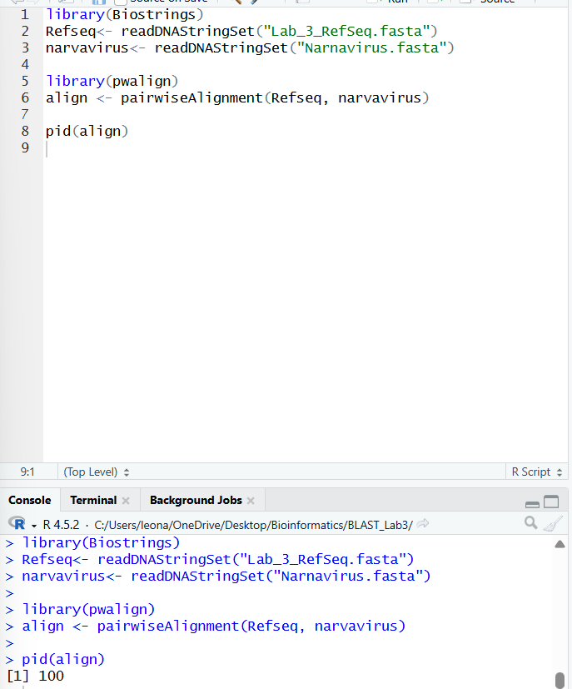
  - Do a Pairwise Sequence Alignment between the first sequence in your results and the Query sequence from your BLAST search. I recommend using the R package ‘pwalign’, but other R packages can do this as well.

  - In your submission, include your R script (or R markdown) and the percent identity of your two sequences.

Percent identity: 100%

