Lab 10, Working with protein data in R

Goals: Learn how to translate DNA data to protein, annotate proteins with GO terms, predict protein structure, and pull protein structure from available databases.

What you will learn:
- Working with the R packages UniprotR, protti, and r3dmol
- Working with protein data in R
- Determining the GO terms and associated diseases for a protein
- Visualizing protein 3-dimensional structures
- Exporting protein data for downstream analysis

A note on the use of AI for this assignment: I have intentionally had you not use AI so far in this course. That was done so that you can work on building your coding skills and the basics of how to interpret code that I wrote. You cannot judge the accuracy of code written by an AI generator unless you also know the syntax of the language. However, I recognize that AI code writing is the future, and you should all be comfortable coding in at least the R language at this point. Therefore, you have two options to complete this R-based lab assignment. You may either A) complete all the coding below on your own, or B) complete the coding sections only using the AI code generator of your choice. If you choose option B, you must tell the code generator to not include any text comments in the code (lines including a # symbol). You will then need to add those comment lines on your own that tell me what each line of code does and why the output does or does not make sense. Submit in Canvas both the AI-generated code file and your version with comment lines added. For option B, some portions will still need to be completed manually, such as writing on the lab what the diseases are associated with a gene and doing the GitHub push commands.

Type A or B here to select the option that you will use for this assignment: ___

- Set up your working directory, P project, and script for the lab.
Install the following R packages:
UniprotR
protti
You may also need to install GenomicAlignments from BiocManager in order to get UniprotR to load correctly:
BiocManager::install("GenomicAlignments")

If possible, install this package as well. It’s for visualizing protein structures, but we have other ways of doing that if it won’t install:
r3dmol

More info on UniprotR:
https://github.com/Proteomicslab57357/UniprotR

Note: you may see some stuff about B-factors as you work through this exercise. These are the ‘atomic displacement factor’, which is related to the energy required to fold a protein, and can be used to identify the flexibility of atoms, side chains, or even whole regions of a protein.

- Choose one of your sequences from Lab 6 that you translated into an amino acid sequence. You will need to write the amino acid sequence to a .fasta file, using this function in Biostrings::writeXStringSet() or a similar function.

Search for this protein in UniProt using the protein BLAST: https://www.uniprot.org/blast

Choose the top 5 matches and save the UniProt accession numbers to a .txt file in your GitHub folder. Each accession number must be on its own line of the file.

If for some reason you get no matches, use the following two accession numbers to move forward in the exercise:
"P0A799" "P08839"

- Read this text file into R using the appropriate function. Likely one of these:
read.csv()
read.txt()

- Format your list of accession numbers into a character string

- Get the Gene Ontology (GO) terms using this function: GetProteinGOInfo()
and save them to a variable

- Plot your results using PlotGoInfo()

- There is a ‘handy visualization for publications’ code chunk in the UniprotR GitHub page. Use this code chunk to save a plot of your GO terms to your GitHub repository

- What are some interesting GO terms for your gene?

Cajal body, Gemini of Cajal bodies, perikaryon, COPI-coated vesicle.

- Use GetPathology_Biotech() and Get.diseases() to find information on any diseases or pathologies associated with your gene. List an example for each below:

Q16637 - Spinal muscular atrophy 1 (SMA1), Spinal muscular atrophy 2 (SMA2), Spinal muscular atrophy 3 (SMA3), Spinal muscular atrophy 4 (SMA4)

A0A2R9BFV3 - No disease/pathology information
A0A2I3TMK9 - No disease/pathology information found
Q5RE18 - No disease/pathology information found
A0A2I3HCL7 - No disease/pathology information found

- Now we are going to access structural information using the protti package. Use fetch_uniprot() to get information on the UniProt Accessions for your samples. That function will give you a dataframe of information on these accessions. One column, called ‘xref_pdb’ is a list of the Protein DataBase (pdb) IDs for these samples, if they exist.

Q16637 – 1G5V, 1MHN, 2LEH, 4A4E, 4A4G, 4GLI, 4QQ6
Q5RE18 – N/A
A0A2I3HCL7 – N/A
A0A2I3TMK9 – N/A
A0A2R9BFV3 – N/A

- Use fetch_pdb() to pull any available structural information from the Protein DataBase. If none are available from your data, use these two: "1ZMR", "2HWG"

I was able to pull structural data for 1G5V and 1MHN.

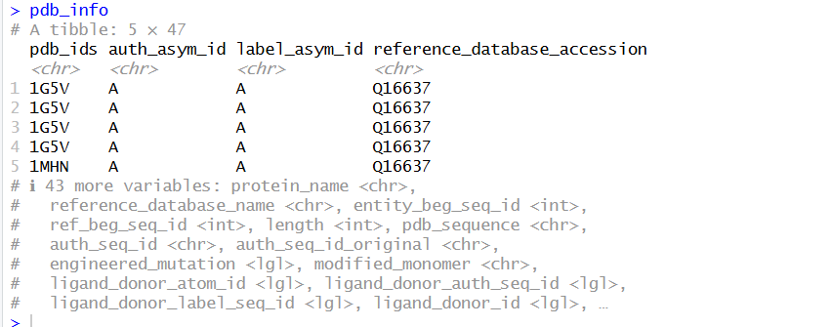

More information is here:
https://cran.r-project.org/web/packages/protti/vignettes/protein_structure_workflow.html

- Use fetch_alphafold_prediction() to get information on any available 3D structures for your gene. Here you can either try to use the r3dmol package to visualize the 3D structure of the protein, or go to the Alpha Fold website and type in the Alpha Fold accession number, which will bring up the 3D structure:

https://alphafold.ebi.ac.uk/

Save a photo of the 3D structure to your GitHub folder

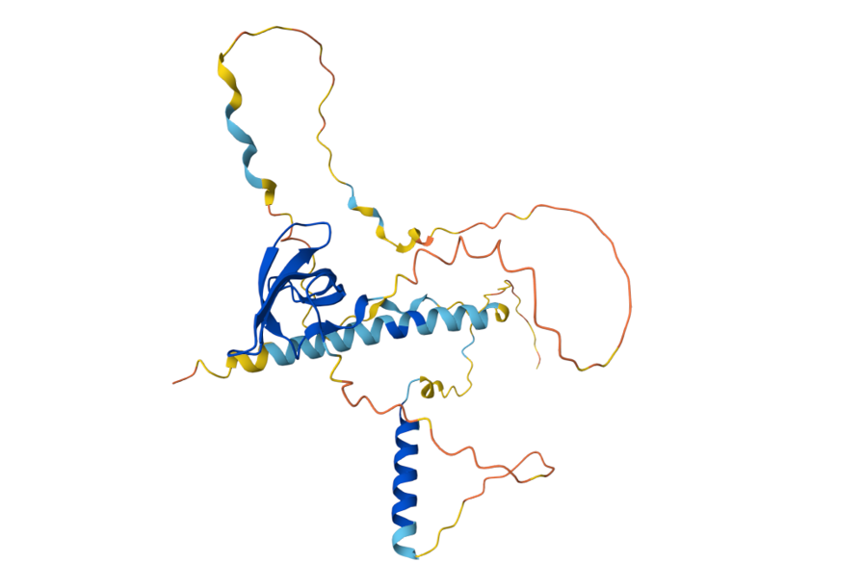

- Push your Lab_10 working directory to GitHub!

