Your name: ___Leona Simkin_______________________

Lab 9, Whole genome assembly
Goal: Learn how to assemble a genome from short-read illumina sequence data. We will be using .fastq read data for the bacterium Thermus thermophilus. We are using bacterial data because it’s small enough to run on a small computer. The same commands and tools can be used to assemble larger vertebrate genomes. If you are assembling a genome for an organism with lots of repetitive elements, then you will need to do additional steps, such as aligning the assembled contigs with a paired-end read data file.

Make sure you work through this lab at the same time as you work through the provided code files. They are meant to be used together.

What you will learn:
- Reference-based genome assembly
- Using command-line tools
- Writing bash/zsh scripts
- Running command-line tools
- Genome assembly

We will be using the FGCU supercomputer cluster to because it is much faster and the tools you need are already installed on the cluster. That way you don’t need to install those tools on your computers. If you wish to install these tools (picard, samtools, bowtie2, and gatk), you are welcome to do so, and most can be installed with homebrew. The data that we are working with are small enough that you should be able to run the assembly locally. This lab can be completed either with the supercomputer or on your own machines.

I have provided a shell script that can be run on your machines. If you want to run it on the cluster, you will need to modify the provided slurm script with the commands that you want to run on the cluster, and then rsync the necessary files and script to the cluster to run it there. Once the job is completed on the cluster, the files can then be moved back to your machine with rsync.

Setting up the genome

- Download the provided .zip files that contain the read data and reference genome. Make a working directory folder and place the .zip files there. Unzip them. In your Linux/Mac terminal window, navigate to your working directory. Use ls to view the contents of the directory and copy/paste the output in your shell here.

fastq
ncbi_dataset
__MACOSX
fastq.zip
Lab9_GenomeAssembly (1).docx
ncbi_dataset (2).zip
README.md

- Use a shell command to figure out how many sequences are in the genome assembly for this bacterium. List the number of sequences below: 4 sequences

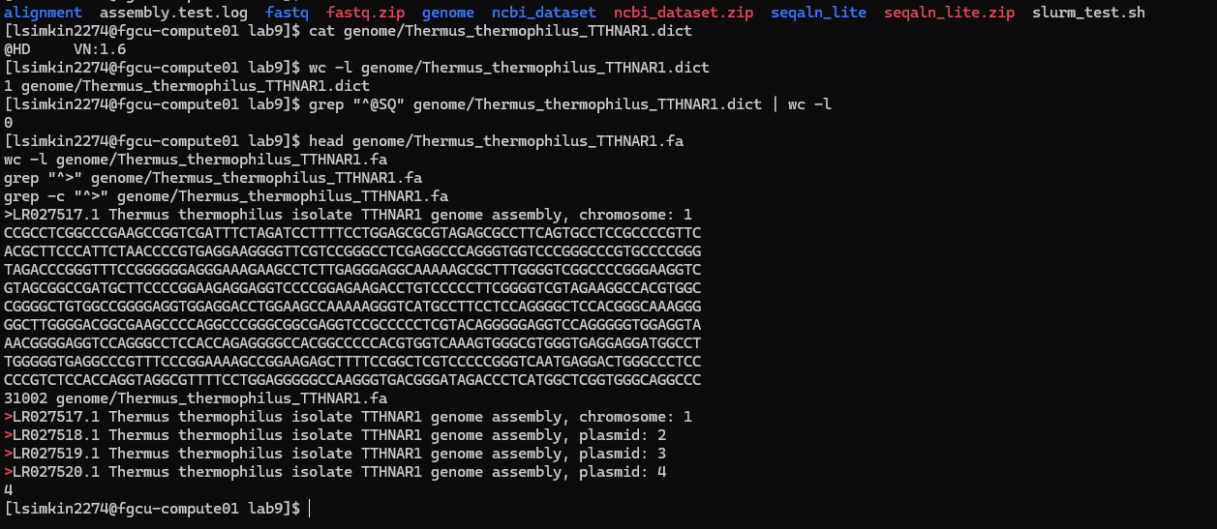

- What cellular structures contain the genomic information (hint: look at the sequence names)?

Chromosome and plasmids

- Why do we have to index a genome before mapping reads? (hint: figure out what Genome Indexing is).

Indexing a genome allows faster and more efficient read mapping. When the genome is indexed, the alignment program, such as Bowtie2, can scan the index (all possible reads) quickly to place a read, rather than scanning the whole genome each time.

- A popular aligner tool is bowtie2. The output from bowtie is a .bam file? What is a .bam file?

A .bam file is a binary alignment map; it contains raw data of genome sequencing. It is the compressed version of a .sam (sequence alignment map) file

Get sequence reads

- Use ls to view the contents of the fastq/ directory and copy/paste the output from your shell here.

SRR5324768_pass_1.fastq.gz
SRR5324768_pass_2.fastq.gz

- What are the read lengths?

SRR5324768_pass_1.fastq – 101 characters
SRR5324768_pass_2.fastq – 101 characters

- What do the 4 lines for each read in a .fastq file indicate?

- The read header/identifier
- The raw nucleotide sequence
- A separator line – a spacer between sequence and quality information
- Quality score

- Look at the read names for pass_1 and pass_2. What information is the same, and what is different?

The read names are almost identical since they come from the same DNA. The difference is that pass 1 is the forward read, while pass 2 is the reverse read.

- How do you explain the differences in the read names between the two files?

The DNA was read twice, from opposite ends to produce a forward and reverse read.

Alignment Time

- Use ls to view the contents of the alignment/ directory and copy/paste the output from your shell here.

- This set of commands involves the use of pipes. What are pipes?

A pipe symbol : | is used to connect commands so the output of one goes directly into the next. This allows for the use of multiple tools without the need for separate files.

- How many reads are in the .fastq files?
1003212/4 = 250803
Each .fastq file has 250,803 reads

- How many reads aligned concordantly?

173,371 aligned concordantly exactly 1 time
3,347 aligned concordantly more than 1 time

A total of 176,718 read pairs aligned concordantly

- What is the meaning of 'concordantly' and 'discordantly'?

Concordantly means the paired end reads aligned as expected based on the reference genome.
Discordantly means the paired reads aligned in an unexpected way.

- Pileup format is a text-based format for summarizing the base calls of aligned reads to a reference sequence. What do the dots mean?

The base in the read matches the reference base on the forward strand.

- What do the commas mean?

The base in the read matches the reference base on the reverse strand.

- What does uppercase mean?

They represent bases from reads aligned to the forward strand.

- What does lowercase mean?

They represent bases from reads aligned to the reverse strand.

- What does an asterisk mean?

A deleted base in a read compared to the reference sequence.

- What do colors mean?

The colors help visually identify matches, mismatches, insertions, and deletions or other variabilities between strands.

- What does the underline mean?

It is a way to highlight a position or base in the alignment.

Variant calls with GATK

- Use ls to view the contents of the variants/ directory and copy/paste the output in your shell here. SRR5324768.vcf and SRR5324768.vcf.idx

- Open the .vcf file using less. Scroll down past the headers using the arrow key. Look in the REF and ALT columns (4th and 5th) - what are the meanings of these columns and how do you interpret them (particularly LR027517.1:574 and LR027517.1:578)?

The REF column has the reference base(s) - nucleotide that is present in the reference genome. The ALT column shows the alternate allele(s) s in the sample genome if it differs at the same position. LR027517.1:574 and LR027517.1:578 are the exact chromosome and positions at while the reference genome base differs from the samples.

- Look in the sample-level information (columns 9 and 10): why is GT always 1? Check the .vcf manual for more information: https://samtools.github.io/hts-specs/VCFv4.1.pdf

GT is the genotype. Since bacteria are haploid, there is only one possible genotype, so GT is always 1. 0 = reference and 1 = alternate

- What would you expect the possibilities for GT to be if this were a human genome?

If it were a human genome the GT values could be 0/1 – heterozygous, 0/0 – homozygous reference, and 1/1 – homozygous alternative.

- What does AD mean and why is it always 0? (hint: try Google)

AD is allelic depth and represents the number of reads supporting the reference and alternate alleles.

- What is the range for DP (just scroll up and down and give a reasonable ballpark answer)?

Approximately 9-35

- What does DP mean?

DP is the depth of coverage, which is the number of sequencing reads covering a particular genomic position.

- What do you think this .vcf file be useful for in the future, if it was for your project?

Yes, I think it would be very useful to compare to other possible samples/organisms. This information could help assess the function of certain genes across species or possibly be helpful for disease study.

