Bioinformatics, BSC 4434C/6932, Midterm 2 Name: Leona Simkin
Take-home practical

Write your name at the top right of this page.

This midterm is out of 100 points. 80 of those points were from the in-class exam sheet that you already completed. The remaining 20 are from this take-home, open-book practical exam distributed on Canvas that is due on Thursday, 9 April, at 5:00 pm.

This practical is largely based on coding in R and/or bash, so will be similar to the labs that you have completed. As Bioinformaticians, we often re-use code, and you are welcome to do so here. I recognize that much of the code will be identical to both that of your classmates and to the code you’ve already written. That is fine. For every few lines of code that work together to complete a similar task, you must write a comment line describing what your code is doing. This must be your own work. See the answer key to Lab 3 as an example. The “#” at the start of a line of code makes it a comment line in both R and bash.

A note on the use of AI for this assignment: I have intentionally had you not use AI until Lab 10. That was done so that you can work on building your coding skills and the basics of how to interpret code that I wrote. You cannot judge the accuracy of code written by an AI generator unless you also know the syntax of the language. However, I recognize that AI code writing is the future, and you should all be comfortable coding in both R and bash at this point. Therefore, you have two options to complete the coding-based portions of this practical. You may either A) complete all the coding below on your own, or B) complete the coding sections only using the AI code generator of your choice. If you choose option B, you must tell the code generator to not include any text comments in the code (lines including a # symbol). You will then need to add those comment lines on your own that tell me what each line of code does and why the output does or does not make sense. Submit in Canvas both the AI-generated code file and your version with comment lines added. For option B, all writing the answers to the questions in this handout will still need to be answered without the use of AI.

Type A or B here to select the option that you will use for this assignment: B – Although I attempted to write the code myself, I used some assistance from ChatGPT for sections of the code. I added comment lines to show my understanding.

You are welcome to work together on this practical. However, the work that you submit must be your own. Submitting identical work will be considered plagiarism and you will receive zero points for this part of the exam.

Push all your scripts and results plots to your Bioinformatics GitHub page. At the end of this document there is space for you to add a link to your GitHub page for this assignment. Make sure that the GitHub repository is public (otherwise I can’t access it).

To make a GitHub repository public, go to your repository on the website, click ‘settings’, scroll to the bottom under ‘Danger Zone’ and click ‘Change visibility’, then ‘change to public’. There will be a few more steps to verify that you want to make this change.

On Canvas: submit only this document

The questions in this practical are on the following page. Answer the questions in this document, not in your code.
Take Home practical questions:

Per the previous page, the code to complete these tasks must be written in a script. You may write an R script, a bash script, or both. The answers to the questions must be written below each question, in this document. Submit this document to Canvas.

Your research lab is conducting a project on the phylogenetics and protein function in metazoans. There is a file on Canvas containing a DNA alignment from your sequencing efforts called metazoa_alignment.5k.fasta that you will use to answer questions 1-5, and another called metazoa_alignment.gene.fasta that you will use for questions 6-10.
Download both files to your working directory. Work through the questions below. Please use a different text color than black so that it is easier for me to read and grade.

Ten points come from questions 1-5, and the other ten from questions 6-10.

- The data in your alignment are from an mRNA sequencing project. The mRNAs were converted to cDNA for sequencing using next-generation Illumina technology. After assembly, the cDNAs contigs were concatenated and aligned. Estimate the phylogenetic tree from this alignment. Use the phylogenetic tree tool that is most appropriate given the dataset that you have been provided. Add a comment describing why you chose this phylogenetic software. Note: you must provide the script commands used to estimate the phylogenetic tree (e.g., a bash command for RAxML or the .xml file if using BEAST). Provide the .log files as well.

I chose to use RAxML to estimate the phylogenetic tree. I chose this software because I believe it is most appropriate given the assignment and data provided. I did not use BEAST since Bayesian analysis would require specifications and constraints that were not provided/known. Since the main goal is to establish phylogenetic relationships between species, a maximum-likelihood based method using RAxML-NG efficiently finds the best tree.

In PowerShell, I used Ubuntu and RAxML-NG to estimate the phylogenetic tree and calculate bootstrap

#!/bin/bash
#Perform full tree estimation and bootstrapping analysis on the alignment file
raxml-ng --all --msa metazoa_alignment.5k.fasta --model GTR+G --prefix metazoa_raxml --seed 2 --threads 2 --bs-metric fbp,tbe

- Root the tree on the branch leading to Plakina jani and Grantia compressa.

I rooted the tree in R, using the ape package. I used Plakina jani and Grantia compressa as the outgroup to root the tree appropriately.

#load ape package
library(ape)

#load in tree file
tree <- read.tree("metazoa_raxml.raxml.support")

#root tree using specified outgroup
rooted_tree <- root(tree, outgroup = c("Plakina_jani", "Grantia_compressa"),
resolve.root = TRUE)

#save rooted tree as a tree file for further analysis/visualization
write.tree(rooted_tree, file = "metazoa_raxml_rooted.treefile")

- Find a way to measure how “good” your tree is. Is this a good tree or a bad one? How can you tell? Are there some parts of the tree that are better than others?

The tree is fairly weak overall, and the bootstrap values indicate low support. Since the values I got were all lower than 50, this indicates a higher level of uncertainty of the tree.

- There are six groups of taxa in your tree (Lophotrochozoa, Ecdysozoa, Xenambulacraria, Chordata, Cnidaria, and Porifera). Does your tree support the monophyly of these clades? What evidence supports or does not support your conclusion?

Cnidaria appears to be monophyletic because Plumapathes pennacea and Antipathes caribbeana grouped together. Porifera was also monophyletic because Plakina jani and Grantia compressa formed a clade. Chordata appeared monophyletic as Petromyzon marinus, Lepisosteus oculatus, Latimeria chalumnae, Xenopus tropicalis, and Homo sapiens all clustered together.
In contrast, Lophotrochozoa, Ecdysozoa, and Xenambulacraria monophyly was not supported by the tree because certain members of those taxa were separated into different parts of the tree.

- Plot your rooted tree in the tree visualizer of your choice (I recommend FigTree or one of these R packages: ape, ggtree, treeio, tidytree), and export a pdf or similar file (e.g., png, jpeg). Include this file in your submission.
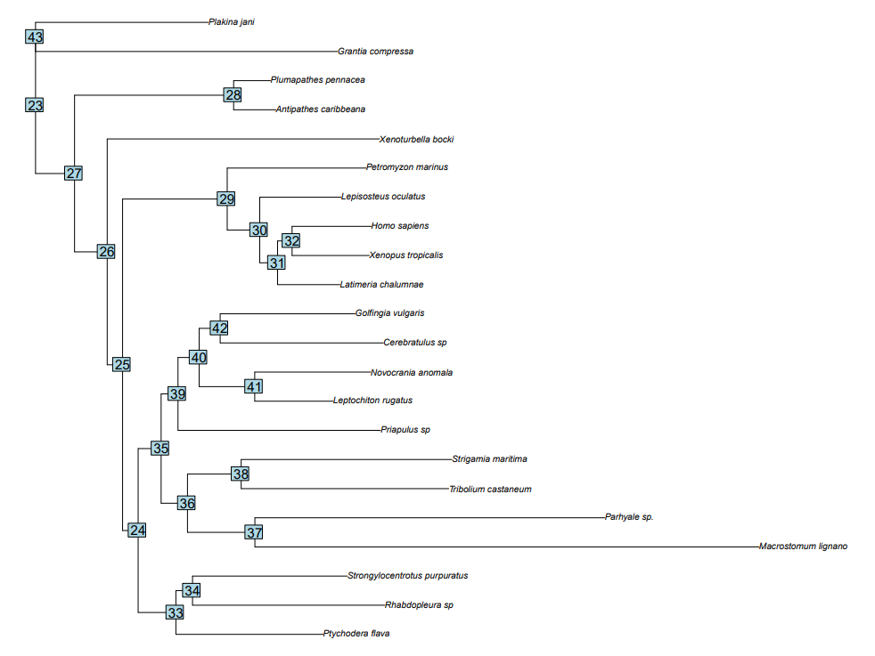
- Next, you will investigate protein function. You have been provided the data from one of the mRNAs. Your goal is to investigate the function of the protein. Use the metazoa_alignment.gene.fasta file for questions 6-10.

- Look at the samples in your alignment. What biological/genetic process might have resulted in some samples having so many dashes in the alignment? What evidence led you to that conclusion?

Some samples have many dashes in the alignment, likely due to alternative splicing or possibly incomplete transcript sequences. Several sequences contain large blocks of gaps, which is more consistent with missing transcript regions or exon differences rather than point mutations.

- Load your file into R. Find the gene from Homo sapiens in your alignment. Translate that sequence to protein. Write it to a .fasta file.

- Use a database to figure out what your protein is. Click on the record for the best match. What is the name of the gene?

I used BLASTp and found that accession NP_001119603.1 is the best match. The name of the gene is: DNA polymerase subunit gamma-1.

- Locate the closest match to your sample in the UniProt database. Find the UniProt accession number. Using an R script, find the GO sub-ontologies for this gene. List at least one term from each of the three sub-ontologies. Plot the GO info and provide the plot in your submission.

- Upload to GitHub all your scripts (R and/or bash), and two figures (tree and GO info). There is no need to upload the alignment files if you don’t want to.

In the space below, add a link to your GitHub repository containing your code and figures:

