Lab 4, Multiple Sequence Alignments (MSA)

Download one of the. fasta files provided in Canvas. There are five to choose from. Open the file in a text editor.

- How many samples (sequences) are there in the file?

19 sequences

- Is this DNA, RNA, or protein data? How can you tell?

DNA: nucleotides (A, C, G, T) there is no uracil.

- How long is sequence for the first sample in the file (how many nucleotides or amino acids long)? This can be calculated in your favorite text editor or programming language.

1469 nucleotides

Navigate to the Clustal Omega web server: https://www.ebi.ac.uk/jdispatcher/msa/clustalo
Select the appropriate sequence type, and uploading your file using the ‘choose file’ button.
Note that there are many different kinds of output formats. These are different ways of displaying the data if you wanted to download it for use in another software or analysis. One of the endlessly confusing parts of bioinformatics are the many different file types for doing mostly the same things. Today we can stick with the default file type. Click ‘submit’.

- How long is the alignment? Is it the same length as that first sample in the .fasta file? If they’re not the same length, why might that be?

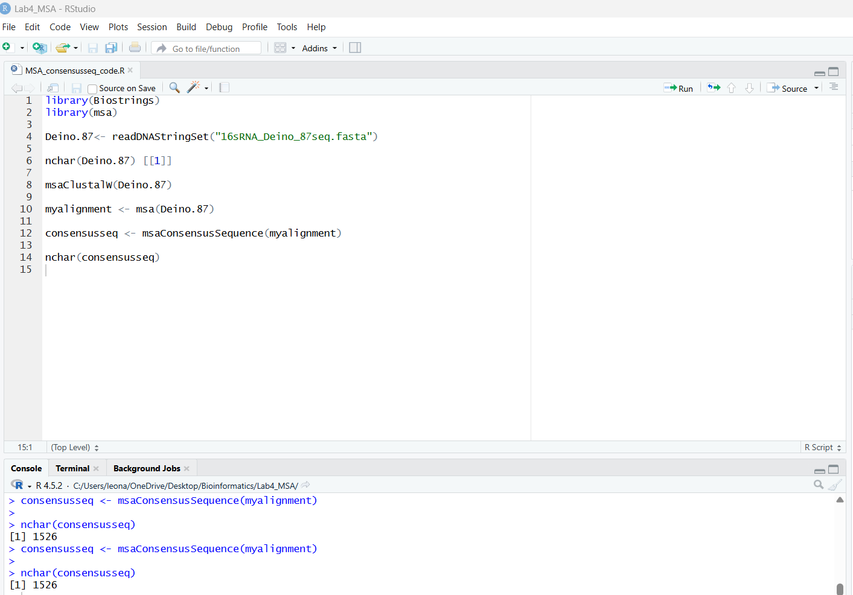
The consensus is 1526. It is longer than the first sample. This may be because various sequences are longer than others used in the alignment – Clustal Omega inserts gaps to better align similar regions. This allows for a longer consensus (average) sequence than that of just the first sample.

- Optional: if you want to download the alignment for further use or visualization, it can then be loaded into R, or the free software jalview: https://www.jalview.org/

- Look at the Phylogenetic Tree tab. We haven’t talked about these in class yet, but essentially, samples that are joined by shorter lines are more closely related. Which two samples in your tree are most closely related?

ref|NR_137420.1 and gb|JQ608330.2 are most closely related.

- Go to the Results Files tab and download the Percent Identity Matrix. This is a .txt file that should open in a text editor. Choose the two samples that were most closely related in the phylogenetic tree. How closely related are they? Include the units.

The two samples have 100% identity in the percent identity matrix generated by Clustal Omega.

