**Download Links:**

Download Apache: <http://www.apachelounge.com/download/>

Download PHP: <http://windows.php.net/download/>

Download MySql: <http://dev.mysql.com/downloads/mysql/>

Download Microsoft Visual Studio: [https://www.visualstudio.com](https://www.visualstudio.com/)

Download MediaWiki: <https://www.mediawiki.org/wiki/Download>

**1. Apache**

* Download **Version:** Apache 2.4 VC14 Windows Binaries and Modules win_64
* Extract zip file to **Location:** C:\Apache2.4
* Create website root folder to **Location:** C:\localhost
* Download **Extension:** C++ Redistributable Visual Studio 2015 (Apache download page)
* Edit **File:** C:\Apache2.4\conf\httpd.conf

----------------------------------------------------------------------------------------------------------------------------------------------

*Change:*

----------------------------------------------------------------------------------------------------------------------------------------------

Default Content:

DocumentRoot "c:/Apache24/htdocs"

<Directory "c:/localhost">

Edited Content:

DocumentRoot "c:/localhost"

<Directory "c:/localhost">

----------------------------------------------------------------------------------------------------------------------------------------------

----------------------------------------------------*------------------------------------------------------------------------------------------*

*Check:*

----------------------------------------------------------------------------------------------------------------------------------------------

ServerRoot "c:/Apache24"

Listen 80

----------------------------------------------------------------------------------------------------------------------------------------------

* Save httpd.conf

**2.** **Setup PHP**

* Download **Version:** PHP 5.6 PHP 5.6 (5.6.22) VC11 x64 Thread Safe (2016-May-26 18:22:23)(click zip)
* Extract zip file to **Location:** C:\php-5.6.22
* Edit **File:** C:\Apache2.4\conf\httpd.conf

----------------------------------------------------------------------------------------------------------------------------------------------

*Add at the end:*

----------------------------------------------------------------------------------------------------------------------------------------------

LoadModule php5_module "c:/php-5.6.22/php5apache2_4.dll"

AddHandler application/x-httpd-php .php

# configure the path to php.ini

PHPIniDir "C:/php-5.6.22"

----------------------------------------------------------------------------------------------------------------------------------------------

----------------------------------------------------------------------------------------------------------------------------------------------

*Search “*DirectoryIndex*” Change*

----------------------------------------------------------------------------------------------------------------------------------------------

Default Content:

DirectoryIndex index.html

Edited Content:

DirectoryIndex index.php

----------------------------------------------------------------------------------------------------------------------------------------------

----------------------------------------------------------------------------------------------------------------------------------------------

*Search “*SeverName*” Change*

----------------------------------------------------------------------------------------------------------------------------------------------

Default Content:

#ServerName [www.example.com:80](http://www.example.com/)

Edited Content:

ServerName localhost

----------------------------------------------------------------------------------------------------------------------------------------------

* Save httpd.conf
* **Cmd** run as Administrator

=======================================================================

>>> C:\Apache24\bin\httpd –k install

=======================================================================

* Set System Environment:

Start\Control Panel\System and Security\System\Advanced system settings\\

Advanced\Environment Variables

Path-> double click -> add at last

----------------------------------------------------------------------------------------------------------------------------------------------

;C:\Program Files (x86)\MySQL\MySQL Fabric 1.5 & MySQL Utilities 1.5\Doctrine extensions for PHP\;C:\php-5.6.22;C:\Apache24;C:\Apache24\bin

----------------------------------------------------------------------------------------------------------------------------------------------

* Check if works:**Cmd** run as Administrator

=======================================================================

>>> C:\Apache24\bin\httpd –S

=======================================================================

* Rename **File:** C:\php-5.6.22\ php.ini-development As C:\php-5.6.22\ php.ini
* Edit **File:** C:\php-5.6.22\ php.ini

----------------------------------------------------------------------------------------------------------------------------------------------

*Un-command Lines by Removing the semi-col:*

----------------------------------------------------------------------------------------------------------------------------------------------

Default Content:

;extension_dir = "ext"

;extension=php_mysql.dll

;extension=php_mysqli.dll

;extension=php_pdo_mysql.dll

----------------------------------------------------------------------------------------------------------------------------------------------

* Check if works:**Cmd** run as Administrator

=======================================================================

>>> cd..

>>> cd..

>>> cd php-5.6.22

>>> php –m

=======================================================================

* Restart Operation System
* Chrome: localhost
* Create info.php file in document root **Location:** C:\localhost\info.php

----------------------------------------------------------------------------------------------------------------------------------------------

<?php

phpinfo()

?>

----------------------------------------------------------------------------------------------------------------------------------------------

* Chrome: localhost

**3.** **Download MediaWiki:**

* Download **Version:** mediawiki-1.26.3
* Extract zip file to **Location:** C:\localhost\wiki

**3.** **Download MySQL:**

* Download **Version:** mysql-installer-community-5.7.13.0\MySQL Server
* **Location:** C:\MySQL\MySQL Server 5.7
* Configuration (Configure)**: IN** MySQL Server 5.7

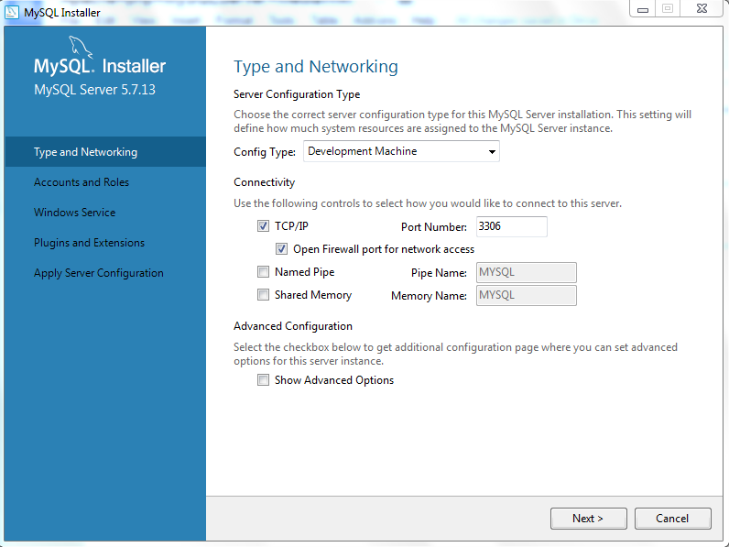

* **Windows server name: MySQL57**
* **Key: 369wiki@GDIT**
* **Start -> type “services” to check if mysql57 started**
* Check if works:**MySQL5.7 Command Line Client**
* =======================================================================

Enter password:

mysql>

=======================================================================

**Method2: Or add path C:\MySQL\MySQL Server 5.7\bin**

**CMD AS admin**

**Mysql –u root –p**

**Then go to php.ini to check the uncommand lines**

**1.1** **Start over MediaWiki**

**Only type in key and set account**

**Download LocalSettings.php and then copy and paste to c:\localhost\wiki**

**Restart the wiki and edit it!!!**

**1.2** **set media wiki logo image**

**localhost.php-> $wgLogo = "$wgResourceBasePath/resources/assets/wiki.png";**

**C:\localhost\wiki\resources\assets**

**1.1** **Create a GA account:**

|  |  |
| --- | --- |
| **Account Id** | **78961935** |
| **Account Name** | **WIKI** |
| **Website Name** | **GDIT Collaboration Wiki** |
| **URL** | **10.24.198.67** |
| **Tracking ID** | **UA-78961935-1** |

**1.2** **Add Tracking code to WIKI: (/Admin/Property/Tracking Info)**

**Instructions: https://www.mediawiki.org/wiki/Extension:Google_Analytics_Integration**

**https://github.com/wikimedia**

[**https://www.waltercedric.com**](https://www.waltercedric.com/index.php?option=com_content&view=article&id=1482&catid=157&Itemid=332)

**Completed Steps:**

**ü Downloaded GA extension**

**ü Extracted the files to a temporary directory on your local computer**

**Todo list:**

**§ To upload all of the extracted files to the extensions directory on the remote server, so we need the extension directory of MediaWiki installation**

***Extensions Directory:* ______________________________________**

**§ To register the extension in LocalSettings.php, following the instructions**

**1.3** **Set up business goals in GA: (/Admin/View/Goals)**

**Like, browsing 5 pages. It enables us to understand how many users complete these important activities so as to evaluate the success of the website. Go to /Admin/View/Goals and set up goals**

**1.4** **\* Link Analytics and AdWords account: (/Admin/Property/AdWords Linking)**

**AdWords is a marketing platform to advertise business, so we can use it to attract new visitors and to retain existing visitors.**

**1.5** **Ready for reports**