“Entendiendo el ingles en el Centro de desarrollo de ciudadanía Octaviano Santiago Dionicio”

Objetivo sesión 1

*Establecer una conexión coherente y cotidiana del uso del ingles en nuestro entorno personal, familiar y social.

Objetivo sesión 2

*Desarrollar la confianza para escuchar y conversar en ingles con firmeza y seguridad como en español.

Objetivo sesión 3

*Escribir una carta a nuestros padres en ingles, transcribir una canción o actuar un sketch y aprendiendo a usar adecuadamente un diccionario de ingles.

Elementos y acciones.

*Leer en voz alta frases en cada sesión y darle sentido sin traducir (mímica), 20-30 min.

- Facilitador dos veces, después con los participantes dos mas, y por ultimo una vuelta mas.

*Breves comentarios e importantes referencias mínimo 4 por sesión, 10min.

- Repartir a lo largo de la sesión como highlights.

*Repartir charts de elementos cotidianos y explicarlas mínimo 2 por sesión, 10min.

- Uno a la vez y resolverlo.

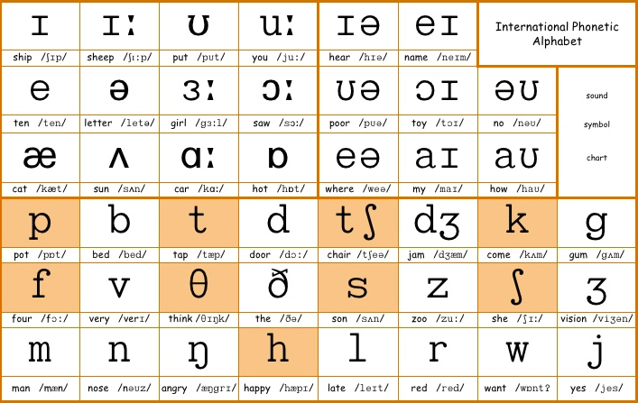

Contenido general

*Explicar que es el ingles

-Breve historia

-900M chino, 470M ingles, 420M Hindu, 360M español, 300M ruso[ref. 1].

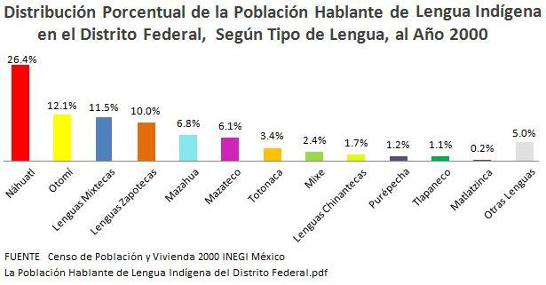

-Usar relación de ejemplo de lenguas Mexicanas que migran a un nuevo lugar y se mezclan[figura arriba]. (hacerles preguntas)

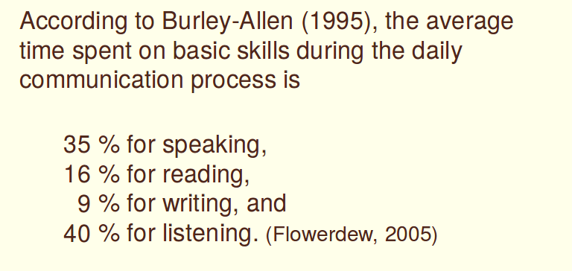

-Tiempo mínimo para aprender las bases mínimas del ingles es 35% hablando, 16% leyendo, 9% escribiendo y 40% escuchando [figura de arriba][ref 2].

*Chart 1 Frutas y sonidos

-Alfabeto y números [audio].

-Fonema: sonido de letra ( /p/, /ʊ/, / ʃ / ) , grafema: símbolo de la letra ( /p ʊ ʃ / – push ), fono: sonido con la boca ( [pʰ], [ʊ], [ ʃ ] ).

-Cada fonema tiene uno o mas fonos.

-Presente – Pasado - Futuro

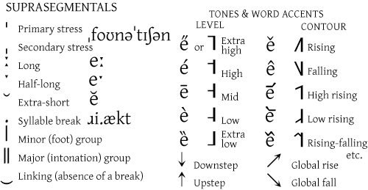 -Símbolos generales del diccionario.

-Espectro fonal del ingles de los sonidos y limitantes de las vocales[fig abajo].

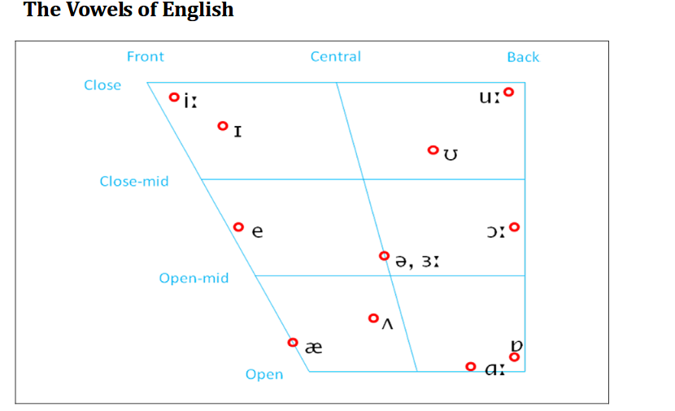

- Las fonemas en ingles son 13 y 5 grafemas para las vocales, cada fonema tiene uno o mas formas de pronunciarse o fonos [figura de abajo].

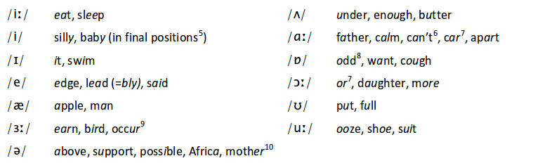

-Espectro fonal del ingles de los sonidos y limitantes de los diptongos [fig abajo].

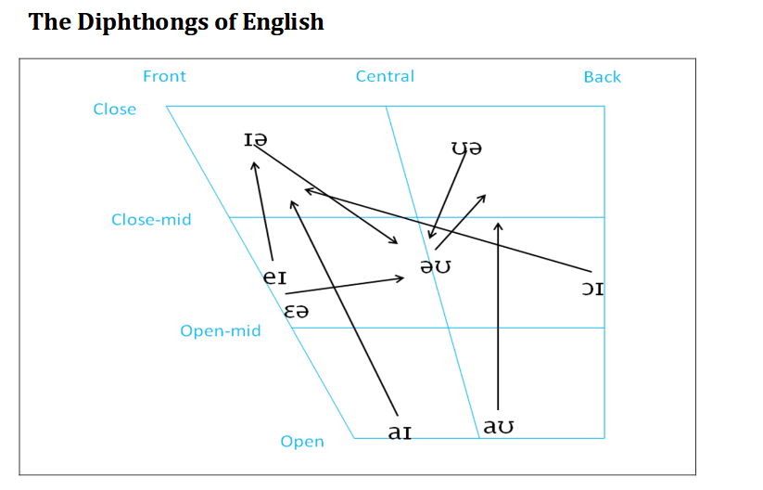-Los fonemas de los dipongos [figura abajo]

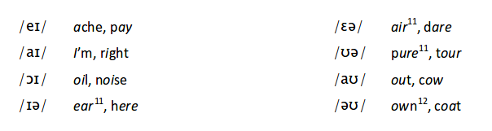

- Alfabeto en inlges y su pronunciación

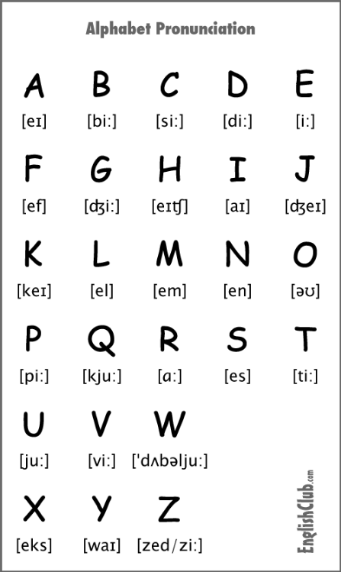

-Sonidos en ingles

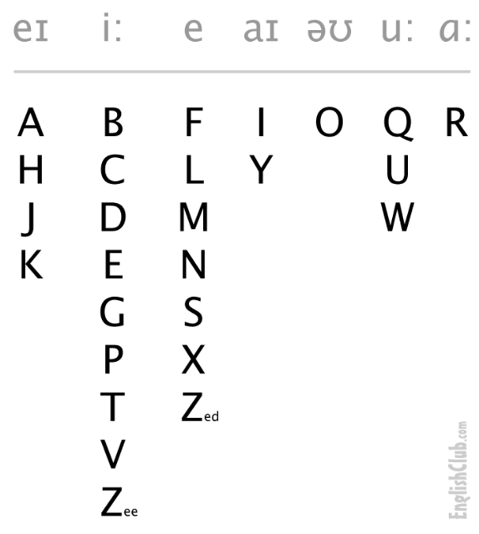

-Short quotes

1.-It’s not about ideas. It’s about making ideas happen.

2.- Always deliver more than expected.

3.-The most courageous act is still to think for yourself. Aloud.

4.-What would you do if you were not afraid?

5.-Nothing will work unless you do.

6.-Don’t be intimidated by what you don’t know. That can be your greatest strength and ensure that you do things differently from everyone else.

7.-Fearlessness is like a muscle. I know from my own life that the more I exercise it, the more natural it becomes to not let my fears run me out.

8.-One does not discover new lands without consenting to lose sight of the shore for a very long time.

9.-Surround yourself with only people who are going to lift you higher.

10.-Sweating the details is more important than anything else.

11.-You shouldn’t blindly accept a leader’s advice. You’ve got to question leaders on occasion.

12.-Your time is limited, so don’t waste it living someone else’s life.

13.-Never give up. Today is hard, tomorrow will be worse, but the day after tomorrow will be sunshine.

14.-Define success on your own terms, achieve it by your own rules, and build a life you’re proud to live.

15.-Someone’s sitting in the shade today because someone planted a tree a long time ago.

16.-The best and most beautiful things in the world cannot be seen or even touched - they must be felt with the heart.

17.-Good, better, best. Never let it rest. 'Til your good is better and your better is best.

18.-If you don’t make mistakes, you’re not working on hard enough problems. And that’s a big mistake.

19.-don’t know the key to success, but the key to failure is trying to please everybody.

20.-I hear: I forget / I see: I remember / I do: I understand

21.-I like long walks, especially when they are taken by people who annoy me.

22.-Education is what remains after one has forgotten what one has learned in school.

23.-Computers are useless. They can only give you answers.

24.-Logic will get you from A to B. Imagination will take you everywhere.

25.-Oliver, my dear, I don't give a damn.

26.-I'm going to make him an offer he can't refuse.

27.-United we stand, divided we fall.

28.-May the Force be with you.

29.-Nothing is certain except for death and taxes.

30.-That’s one small step for a man, a giant leap for mankind

31.-The love of money is the root of all evil.

32.-The truth will set you free.

33.-Three can keep a secret, if two of them are dead.

34.-To be or not to be, that is the question.

35.-You must be the change you wish to see in the world.

36.-Life is like riding a bicycle. To keep your balance, you must keep moving.

37.-Knowledge is power.

38.-If you want something done right, do it yourself.

39.-Keep your friends close, but your enemies closer.

40.-There's no place like home

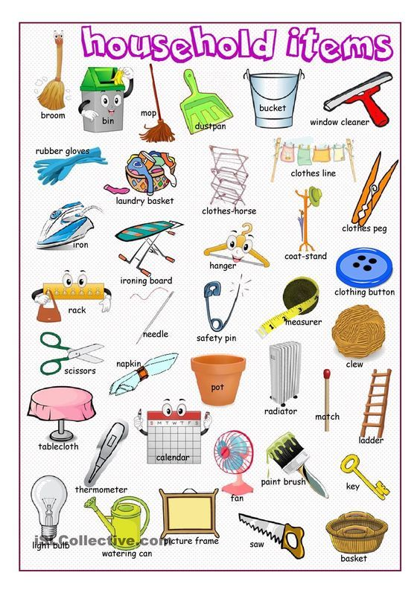 -Chart de muebles de la casa [figura de arriba]

-Frutas

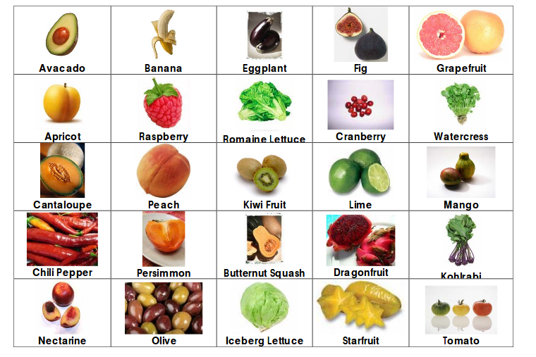

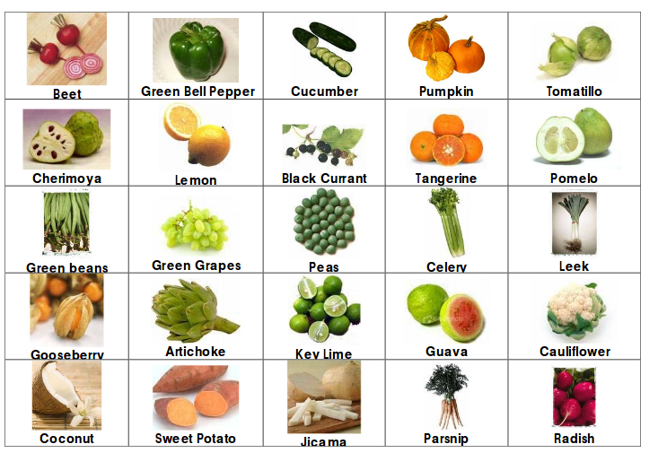

- Chart de la vocal “A corta” (short A) [ʌ] y la vocal “A larga” (long A) [ɑː]

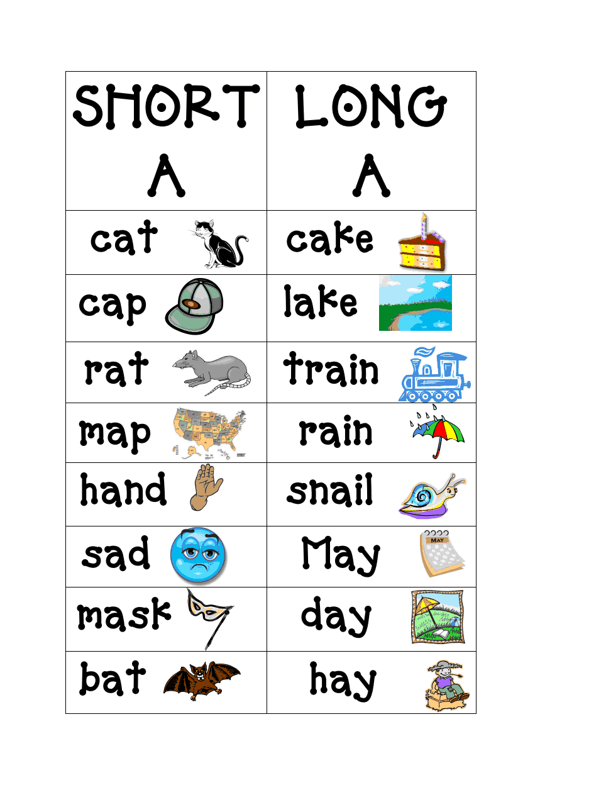

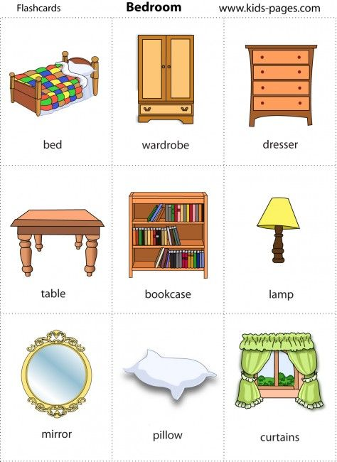



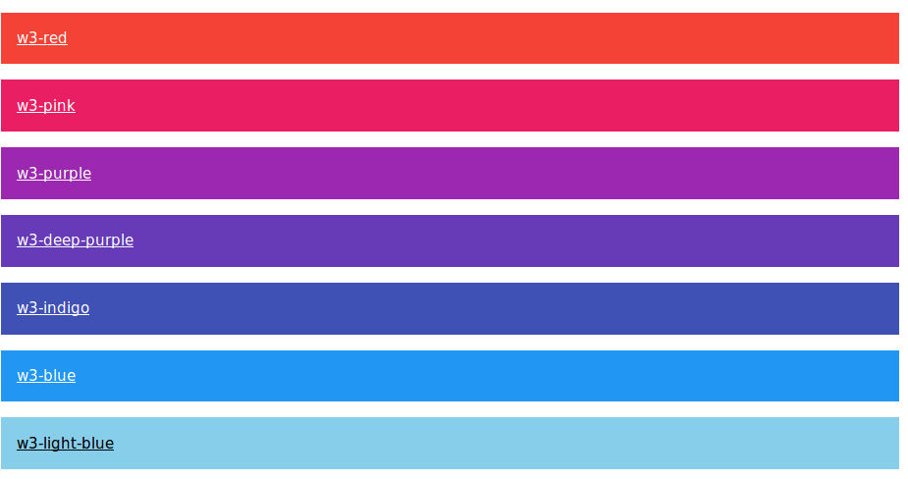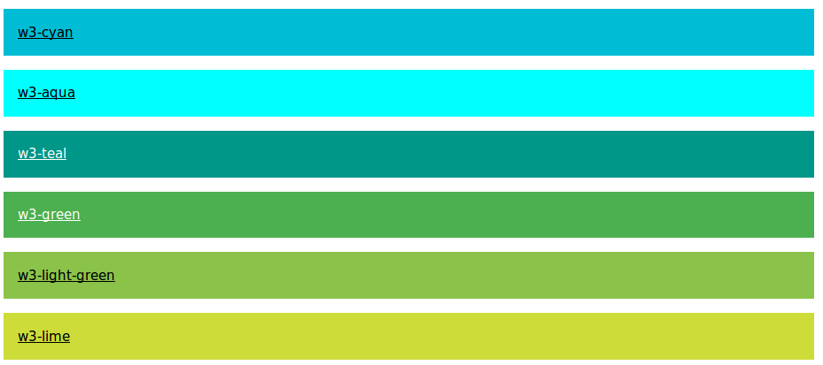

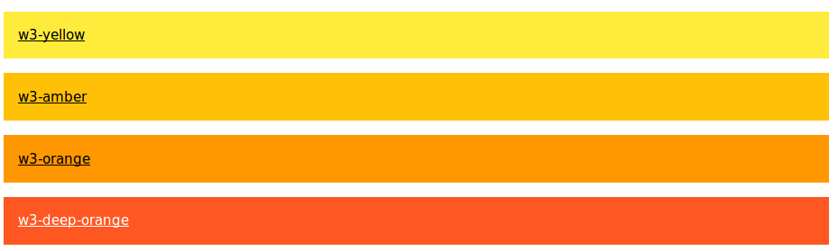- Chart de colores en ingles [figura de arriba]

- Latin script chart

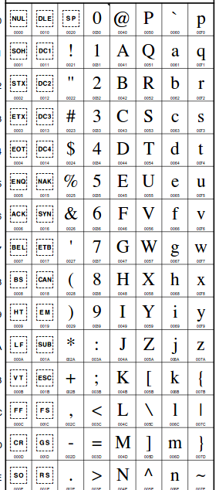

- Greek script chart

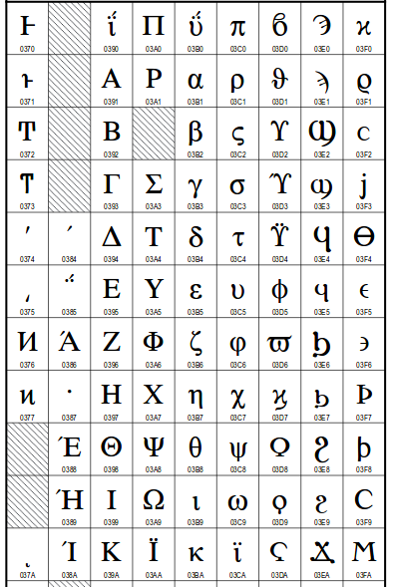

- Cyrilic script chart

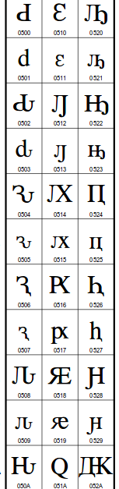

- Arabic script chart

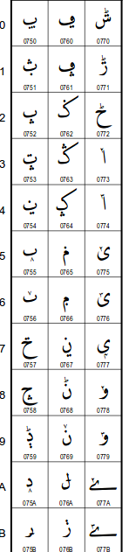

- Devaganari script chart

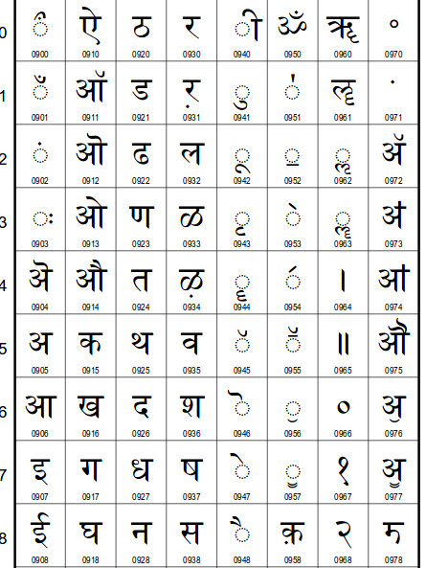

- Tibetan script chart

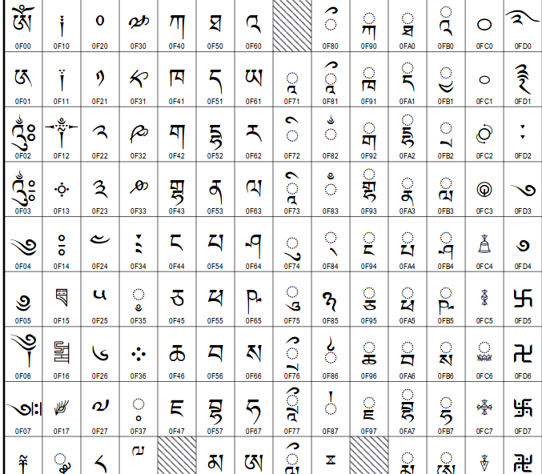

audio: <https://www.englishclub.com/pronunciation/alphabet.htm>

ayuda <http://www.phonicsinternational.com/Book.pdf>

ayuda <https://www.dvusd.org/cms/lib/AZ01901092/Centricity/Domain/3795/Sound_Spelling_Chart.pdf>

ayuda [https://old.liu.se/ikk/english/files/Course%20Webpages/english-3/1.206147/CompendiumVowelsConsonantsofEnglish.pdf](https://old.liu.se/ikk/english/files/Course Webpages/english-3/1.206147/CompendiumVowelsConsonantsofEnglish.pdf)

ayuda <http://www.aston.ac.uk/lss/research/lss-research/ccisc/discourse-and-culture/west-midlands-english-speech-and-society/sounds-of-english/>

recurso: [http://www.squaremeals.org/Portals/8/files/FFVP/100%20fruits%20and%20veggies.pdf](http://www.squaremeals.org/Portals/8/files/FFVP/100 fruits and veggies.pdf)

recurso: <http://www.myenglishonline.ca/wp-content/uploads/2014/03/Judy-Pronunciation-at-a-Glance.pdf>

recurso: <http://web.ntpu.edu.tw/~language/workshop/2010-1.pdf>

recurso: [https://koreatesol.org/sites/default/files/EClinic-%20Phonetic%20Symbols.pdf](https://koreatesol.org/sites/default/files/EClinic- Phonetic Symbols.pdf)

recurso: <http://unicode.org/charts/>

ref 1: <http://guerrero.gob.mx/articulos/los-pueblos-indigenas-de-guerrero-y-su-lengua-materna/>

ref 2: <http://web.ntpu.edu.tw/~language/workshop/2010-1.pdf>