Pretrain:

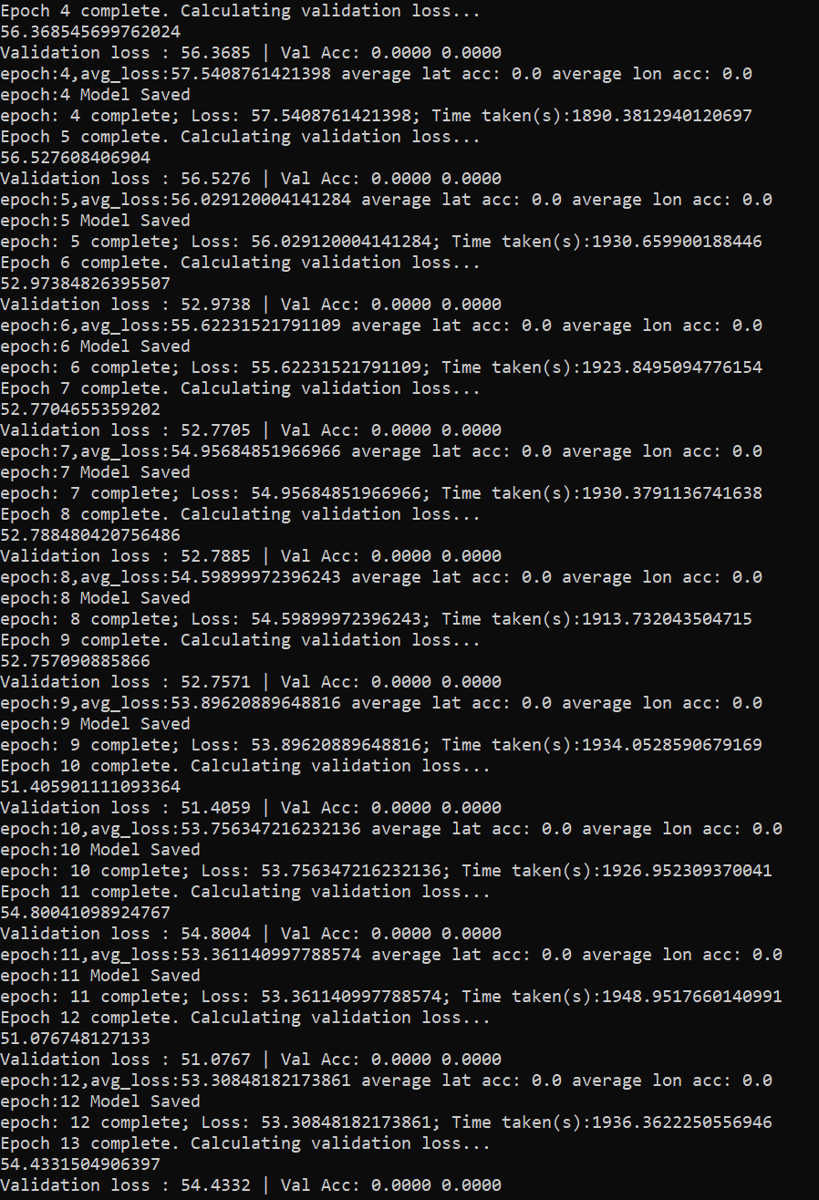

Train with NLL:

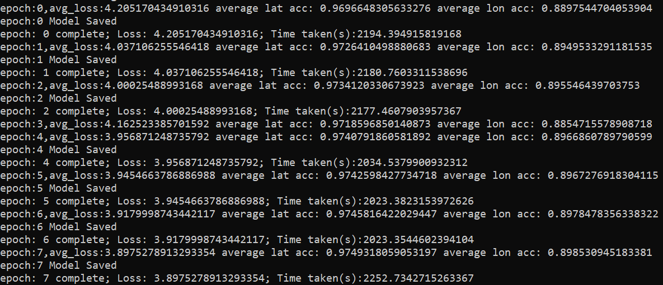

Orgnial model:

Encoder&decoder:

Pretrain（epoch1-5); train with NLL:(epoch6)

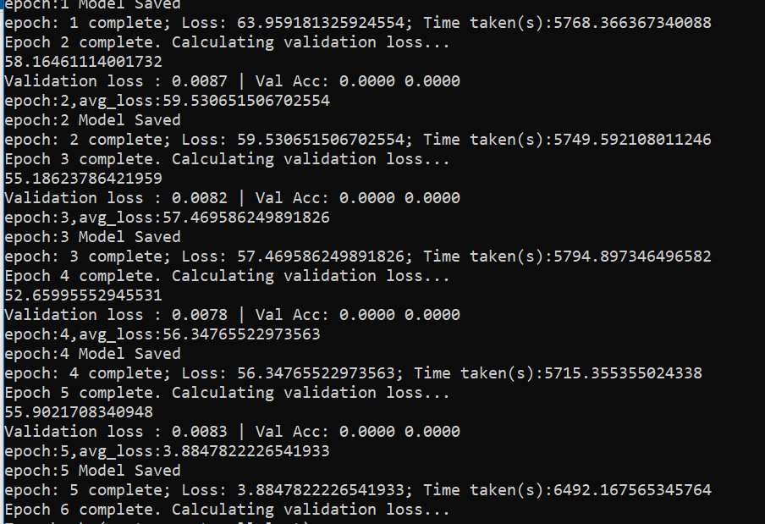

Classification:

