THE IMPACT OF THE INTERNET IN TODAY AND TOMORROWS TECHNOLOGY

STUDENT NAME: TAKWI BARYL LUCIA FUEN
DEPARTMENT: COMPUTER SCIENCE
SUBMITION DATE:



Table of Contents
Tables ii
Figures iii
INTRODUCTION 1
BACKGROUND STUDY 1
OBJECTIVES 1
REVIEW 2
Definition of the internet and Communication 2
The Internet: 2
Communication: 2
Some communication devices 2
HOW THE INTERNET HAS IMPROVED IN SOME BASIC ASPECTS AND THE WORLD 3
ADVANTAGES AND DISADVANTAGES OF USING THE INTERNET 4
SOME DIFFICULTIES FACED WHEN USING THE INTERNET AND SOME SOLUTIONS TO THEM 5
CONCLUSION: 6

Tables
Table 1: ADVANTAGES AND DISADVANTAGES 4
Table 2: DIFFERENCES AND SOLUTIONS 5

Figures
Figure 1: means of communication 2
Figure 2: how computers are connected to the internet 6

INTRODUCTION

BACKGROUND STUDY
Communication between two or more people has always been a part of the human society. From smoke signals and telegraphs to telephones and radios. But as time goes by the internet is brought about and communication digitalized that is from one-to-one analogue communication (phone call) to many-to-many digital networks (social media).

OBJECTIVES
- To know the definition of the internet and communication and some communication devices
- How the internet has improved in the aspects of education, business and the world in general.
- To know the advantages and disadvantages of using the internet
- Some difficulties faced when using the internet and its some solutions to them.
- To know How all these aspects affects today’s technology and that of the future

REVIEW

Definition of the internet and Communication

The Internet:
The internet is simply the interconnection of networks with the aim of sharing resources.

Communication:
Communication is the process of exchanging information, ideas, thoughts, and messages between 2 or more people through speaking writing or any other mediums such as telephones.

Some communication devices
Figure 1 below shows some common communication devices
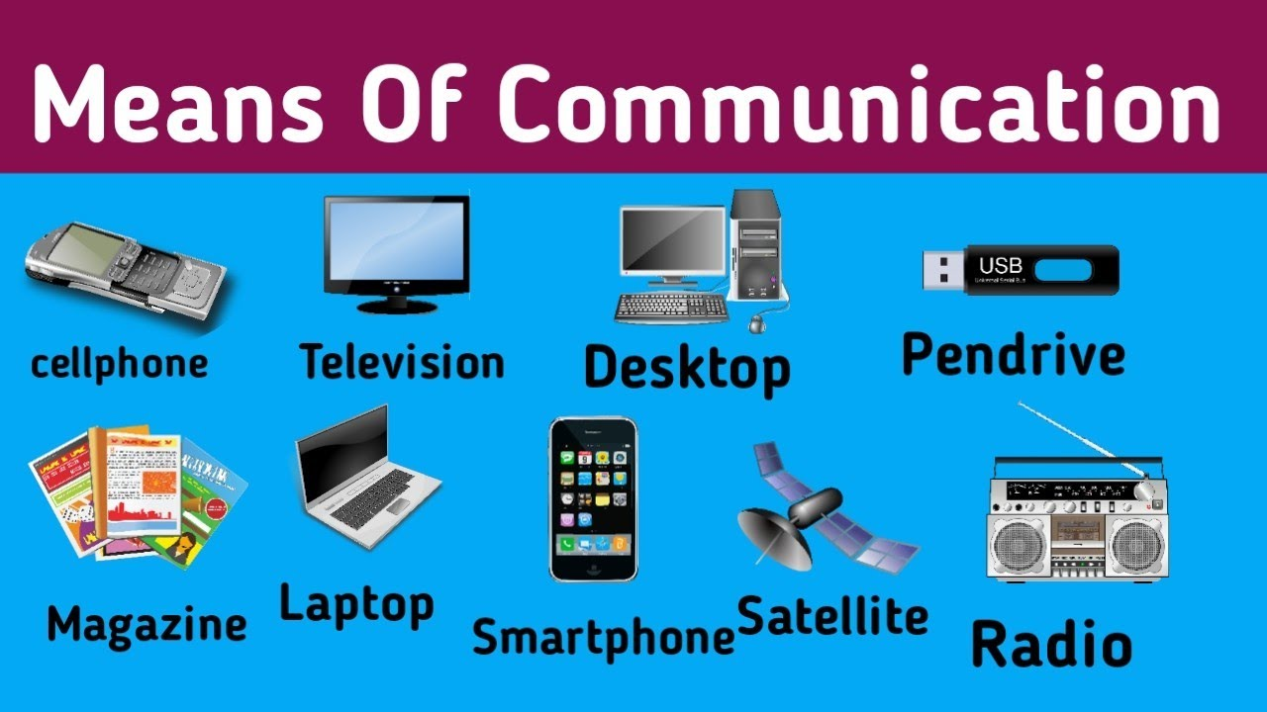
Figure 1: means of communication

HOW THE INTERNET HAS IMPROVED IN SOME BASIC ASPECTS AND THE WORLD
The internet and communication has improved the world in basic aspects such as ; business , education, health, etc.
- Business; Internet has facilitated the buying and selling of goods online by the help of platforms such as ecommerce which enables users to buy and sell goods without actual
Physical interactions
- Education; Internet has facilitated education in ways such as research, online courses, language learning and time management.
- Health; Improving efficiency with electronic records and data sharing
- Entertainment; we can watch millions of user uploaded videos on aps like YouTube, Tiktok, instagram. Playing of games.
- Communication; Internet has made communication easier by connecting people across the globe through Email whatsapp Facebook, etc.

ADVANTAGES AND DISADVANTAGES OF USING THE INTERNET
The internet has many advantages and disadvantages. This will be shown in the table below
Table 1: ADVANTAGES AND DISADVANTAGES
ADVANTAGES | DISADVANTAGES
Providing a vast source of communication | Internet addiction
Enabling banking and shopping | Exposure to bad habits
Offering entertainment | Spread of fake news
Makes research easier | Cyber bullying

SOME DIFFICULTIES FACED WHEN USING THE INTERNET AND SOME SOLUTIONS TO THEM
Table 2 below shows some difficulties faced while using the internet and some solutions
Table 2: DIFFERENCES AND SOLUTIONS
Difficulties | Solutions
Slow internet connection | - Check network settings  - Upgrade to a higher speed internet plan
Cyber security threats (viruses and hacking) | - Install anti-virus software’s  - Use strong passwords
Privacy issues | - Avoid sharing personal data online
Misinformation and fake news | - Verify information from reliable sources before sharing or believing it

CONCLUSION:
From the introduction going down through the entire research it is noticed that the internet cuts through every aspect in the human economy every individual is connected to the internet thus indicating that The internet is not just shaping how we use technology but it’s becoming the foundation of technology itself. Every new innovation from AI to robotics depends on connectivity and data exchange thus proving that in tomorrow’s world, the internet will be an invisible threat stitching together all intelligent systems into one global organization.
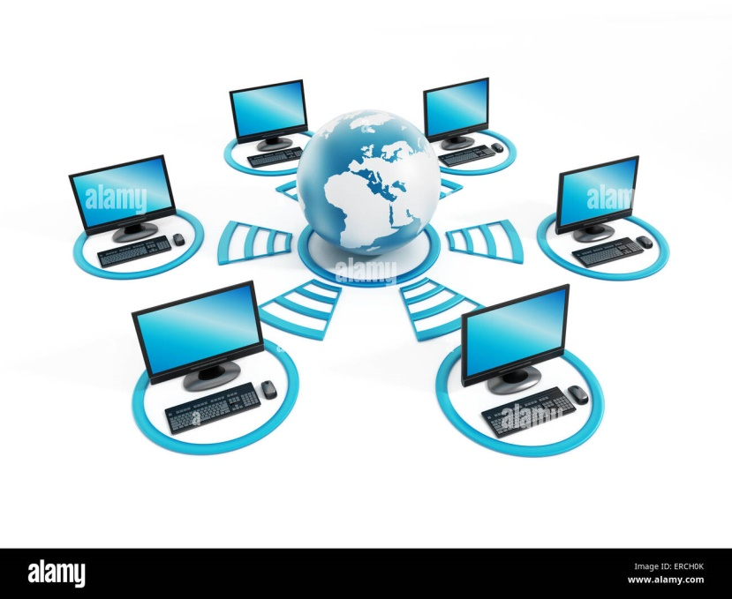
Figure 2: how computers are connected to the internet

(ANDERSON, 2021)
(A., 2019)
A., B. (2019). the internet impacts on mordern education systems. Retrieved from EdTech Global: https:www.edtechlbal.org/internet-education-impact
ANDERSON. (2021). The role of the internet shaping mordern tech. Retrieved from tech innovations daily: https://ww.techinovationsdaily.-com/internet-mordern-technology

