Introduction

Fiber-to-Chip coupling by microlenses is a very common problem in integrated optics \cite{ integrated_optics}, in wich single-mode fibers with a lensed end couple to waveguide made from semiconductor. By means of this technology the simple and reliable optical system with a small size become possible because a lensed fiber has a minized focal length. In this article the application of the lensed fiber-to-chip will be introduced and it coupling efficiency will be discussed.

Problem Deskription

The left side is a lensed tapered fiber as laser source and at the right side at the working distance there is a chip formed waveguide as signal receiver. The purpose is to find a way to gain optimized coupling efficiency through the simulations in CST MWS Environment (CST Studio suite 2010), which is a electromagnetic simulator basically with the implementation of the Finite Integration Technique (FIT)\cite{ cst_help_siulation_method}.

Following is a typical demonstration of fiber-to-chip coupling.

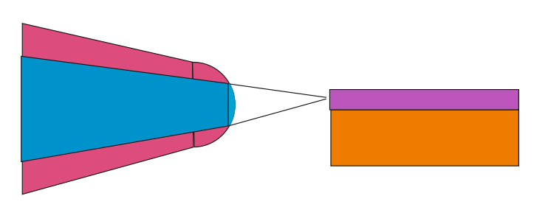

In this article the the tapered lensed fiber from \textbf{NANONICS} will be used. Fig.\ref{a} is the real image of the fiber and Fig.\ref{b} indicate its schema. In Table\ref{} are listed part of technical parameters, which refer later to the modeling. Additionally the real woking frequence is $\lambda=1064nm$ and working distance but $4\mu m$.

The real waveguide Fig.\ref{} is a trapezoid guide on a semiconductor. But the angles $\theta$ of this guide approximate to $90^{o}$ and is not easy to measure because of its micro-size. Thus a simplified guide model will be used in this article. And the detailed technical properties of the photonic waveguide are given:

\begin{itemize}

\item working frequence $\lambda=1064 \mu m$

\item guide :LiNbO_{3} n1=2.516, w\approxim 1\mu m, h\approxim 0.5 \mu m

\item substratum: SiO_{2} n2=1.544

\end{itemize}

\section{Modeling the Lensed Fiber}

Firstly, it is demanded to determine the Tapered and Lensed Fiber(TLF) model. Because of the heave computing cost creating a full size fiber is not economical. Therefore only the end of the fiber, which provides approximately the equal technical properties, will be modeled in this article. In \ cite{ TLF_analysis} \cite{ TLF_mode_transforming } two type of the TLF configuration are mentioned.

The Tapered Cladding TLF Fig.\ref{} shows that its cladding diameter decreases along the axis and its core diameter is a constant. For the Tapered Core TLF Fig.\ref{} its cladding diameter and core diameter both decrease along the axis. \cite{TLF_mode_transforming} develops method to estimate the performance of both type of TLF. And results show that the performance of the first type of TLF agrees well with the estimation and that of the second type is unpredictable.

Create two TLF models from each type and test the performances in CST MWS. The following xxx indicates the corresponding configurations.

\tabular

%2.20

The fowllowing is the E-Field demonstration in the xz-plane.

\Subfigure[E-Field demonstration of Tapered cladding TLF]

\Subfigure[E-Field demonstration of Tapered core TLF]

As is in section lense theory introduced, the minimum spot located not exactly at the focal length. By using the location of PP and that of MP the MS can be estimated. The theoretical distance from lens end to PP is $xx \mu m$ and the distance from lens end to MP is $xx \mu m$. Backword $3/4$ LAM form PP, the MS is founded at about $xx \mu m$far from lens end. Through The following figure is the theoretical beam propagation of the lense model.

Load the its beam propagation detail into \textbf{Matlab} workspace and check the beam power distribution in different distance. Fig.(\ref{}-\ref{}).%2D and 3D

\begin{figure}

\end{figure}

Draw Fig.\ref{}-\ref{} to illustrate the beam Spot size diameter along the longitude axis.

\begin{figure}

\caption{Curve of Spot size diameter}

\end{figure}

From Fig.\ref{tapered cladding} that the minimum spot size locate at $xxx \mu m$ from lense end and spot size equal about $1.7 \mu m$. While in Fig.\ref{tapered core} that the minimum spot size is found at $xxx \mu m$ from lense end and spot size equal about $1.5 \mu m$. Thus it is concluded that tapered core TLF has a bit higher focal performance. By rechecking the properties in Tab.\ref{} both TLF model are acceptable for the following development. In this article the Tapered core TLF will be used for further simulations.

\subsection{Modeling the Fiber to Chip}

As Fig\ref{fig:experiment_object} put the waveguide model at the MS point of TLF. In this case the beam field at the propragation direction has changed.(mode conversion at the boundary??) (Fig.\ref{fig:coupling_e_field}) The simulation result in Fig.\ref{fig:orignial_coupling_efficiency} shows at the working frequence $282hz(\lambda=1064 nm)$ the coupling efficiency ($S_{21}$) is about $47\%$.This result will act as the reference sample for the other simulations. From Fig.\ref{fig:power_distribution} the power distribution along the waveguide can be observed.

%%%%% talking about how to calculate the power in each section base on FIT knowledge.?? In Appix

\begin{figure}

\subfigure[]{}

\caption{coupling efficiency in Frequency area.}

\end{figure}

%%%%%

\begin{figure}

\caption{coupling efficiency in Frequency area.}

\end{figure}

\begin{figure}

\caption{power distribution along the waveguide.}

\end{figure}

\chapter{Optimize}

For further analysis of the coupling efficiency first thought is to change the relative position between TLF and the waveguide. Another consideration is to change the background conditions. At last, we can reform the structure of the waveguide to find the optimal

\section{coupling through at shifting location}

In vertical direction shift the waveguide in area $-0.5\mu m $ to $+0.5\mu m $

Considering in propagation and transversal direction.

Shifting

The rib waveguide is not $360^{o}$ symmetrical.

