Scope of Works
SDK Liveness Document - {{ enterprise_name }}

Document Number | : {{ nomor_surat }}
Release Date | : {{ release_date }}
Revision Number | : {{ revision_number }}

Document History
Date | Revision | Description | Requestor
{{ created_date }} | {{ revision_number }} | Request SDK Liveness for {{ merchant_name }} Environment | {{ pic_ve_name }}

*Please update everytime request update config

Introduction
This document outlines the scope of work for the SDK Liveness, detailing the product requirements, deliverables, timelines, and responsibilities. The purpose of this document is to provide a clear understanding of the requirements and expectations for the development and implementation of the SDK Liveness.

- Client Information
Company | {{ enterprise_name }}
Business Development | {{ pic_bd_name }}
Value Engineering | {{ pic_ve_name }} | PrivyID | {{ PIC_VE_PrivyID }}

- Application Setup
Enterprise Name | {{ enterprise_name }}
Merchant Name | {{ merchant_name }}
Application | {{ application_clean }}
Merchant Main App | {{ merchant_app }}
RASP Config | {{ rasp }}
RGB Config | {{ rgb }}
NFC Feature | {{ nfc }}

- Core Credentials
If the Client requests to use more than 1 application (e.g SDK Web, Android, iOS). Please provide Credentials according to the number of applications requested.

{% for c in credentials %}
{{ environment }} - {{ c.sdk_type }}
Merchant Key | {{ c.merchant_key }}
Username | {{ c.username }}
Password | {{ c.password }}
{% endfor %}

- Product Features Configuration
Basic Setup
Features | Value | Description
Liveness Provider | {{ liveness_providers }}
Liveness Threshold | {{ liveness_threshold }}
Masking Threshold | {{ masking_threshold }}
Liveness Face Flow | {{ liveness_face_flow }}

UI Setup
Features | Value | Description
Onboarding Screen | {{ ui_onboarding_screen }} | {{ ui_onboarding_screen_desc }}
Loading Screen | {{ ui_loading_screen }} | {{ ui_loading_screen_desc }}
Result Screen | {{ ui_result_screen }} | {{ ui_result_screen_desc }}
Navigation Bar | {{ ui_navigation_bar }} | {{ ui_navigation_bar_desc }}
Footnote | {{ ui_footnote }} | {{ ui_footnote_desc }}
Footer | {{ ui_footer }} | {{ ui_footer_desc }}
Button Color | {{ ui_button_color }}
Button Wording | {{ ui_button_wording }}
Face Scanner Shape | {{ ui_face_scanner_shape }}
Frame Camera Overlay | {{ ui_frame_overlay }}
Instruction Wording Color | {{ ui_instruction_color }}
Instruction Background Color | {{ ui_instruction_bg }}
Liveness Animation | {{ ui_liveness_animation }}
Liveness Countdown | {{ ui_liveness_countdown }}
Random Instruction | {{ liveness_random_instruction }}
Face Validation | {{ liveness_face_validation }}
Time Out By Step | {{ liveness_timeout }}s
Max Attempt Liveness | {{ liveness_max_attempt }}x
Logo Merchant | {{ asset_logo_merchant }} | {{ asset_logo_merchant_desc }}
Main Illustration | {{ asset_main_illustration }} | {{ asset_main_illustration_desc }}
Illustration Image 1 | {{ asset_illustration_1 }} | {{ asset_illustration_1_desc }}
Illustration Image 2 | {{ asset_illustration_2 }} | {{ asset_illustration_2_desc }}
Illustration Image 3 | {{ asset_illustration_3 }} | {{ asset_illustration_3_desc }}
Term of Use | {{ asset_term_of_use }} | {{ asset_term_of_use_id }}  {{ asset_term_of_use_en }}
Privacy Policy | {{ asset_privacy_policy }} | {{ asset_privacy_policy_id }}  {{ asset_privacy_policy_en }}
Default Language | {{ ui_default_language }} | {{ ui_default_language_desc }}
Support Android 16kb Pagesize | {{ ui_support_android }}

- Out of Scopes
The following is the product out of scope:
- Customization in addition to available configurations
- Support for UAT events that are notified under 1 week before D-day. Support for UAT required a notification at least 1 week before D-day.
- Usage of SDK outside the specified requirements

- Deliverables
The following deliverables are expected as part of this product:
- SDK Liveness General with requested version
- SDK Documentation for Liveness General
- Appendix document that include credentials for Merchant

- Timeline
Merchant Timeline
Trial Plan on STG | {{ plan_stg }}
UAT | {{ UAT }}
Trial Plan on PROD | {{ plan_prod }}
Live on Market | {{ live_on_market }}
Value Engineering Timeline
STG Request | {{ stg_request }}
Expected Approved | {{ expected_approved }}
Expected Deliver STG | {{ expected_deliver_stg }} | Max D+2 Request
PROD Request | {{ prod_request }}
Expected Deliver PROD | {{ expected_deliver_prod }} | Max D+2 Request

- Appendix
- User Journey
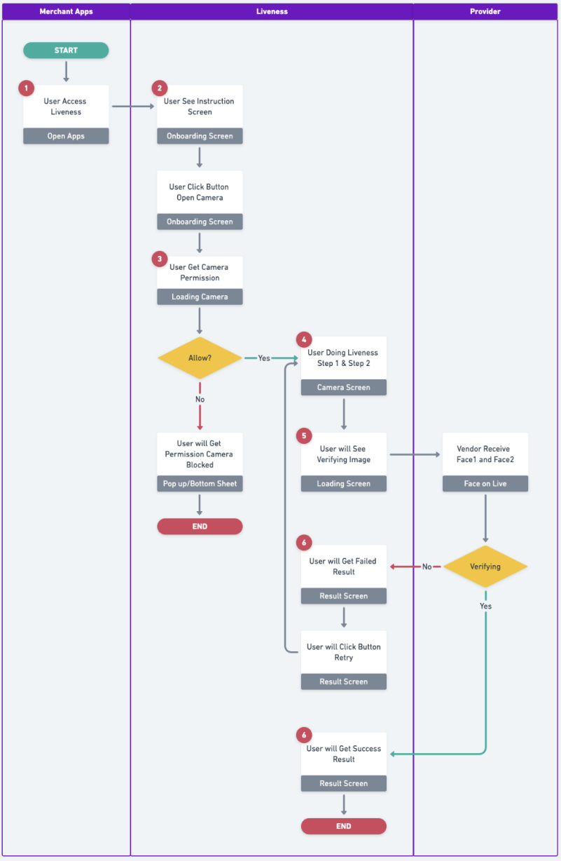 | - User access liveness via web or mobile app  - User will get onboarding screen and user can see some instruction before doing liveness. On this page, user can start liveness by clicking the button  - User will get pop up access camera permission. Click allow to continue liveness  - User will get instruction:  - Step 1: Face forward  - Step 2: Random instruction (blink, smile, or open mouth)  - Liveness will verify face1 and face2 user  - User will get result screen:  - Liveness success  - Liveness failed and user can retake liveness

- Technical Flow
Link here
- Security Feature
No | Feature | Web | Android | iOS
1 | Randomize instruction
2 | Max attempt liveness
3 | Time out by step
4 | Implement HMAC signature
5 | Secure payload with zero trust
6 | Full encrypt payload request and response
7 | Obfuscate code
8. | Virtual camera detection
9 | Emulator detection
10 | Root/jailbreak device detection
11 | Blacklist camera name
12 | Detect interrupt liveness

- FAR and FRR value
Value | FoL v1 | FoL v2 | FoL v3
Total TRUE | 197 | 136 | 199
Total FALSE | 3 | 64 | 1
FRR | 1,50% | 32,00% | 0,50%

Value | FoL v1 | FoL v2 | FoL v3
Total TRUE | 0 | 0 | 0
Total FALSE | 200 | 200 | 200
FAR | 0,00% | 0,00% | 0,00%

