HW2 – Machine Learning

Leonard Christopher Limanjaya

1a. Perform Shapiro-Wilk test on the differences of two datasets using R.

File: 1a.R

Result:

algo_a: w -> 0.88731, p-value -> 0.009812

algo_b: w -> 0.83833, p-value -> 0.001066

1b. Perform paired t test by hand

\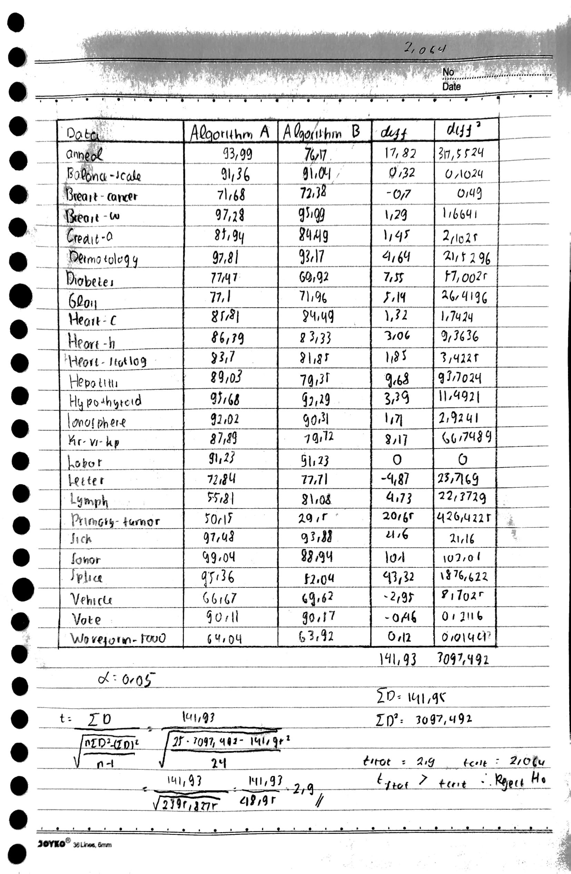

The Ho is Both of the algorith is equal, but from the calcualtion we can know that tstat­ is bigger than tcrit­­ so we reject the Ho

1c. Perform paired t test using R

File: 1c.R

Result:

t = 2.9049, df = 24, p-value = 0.007777

alternative hypothesis: true mean difference is not equal to 0

95 percent confidence interval: 1.643587, 9.710813

Mean of the differences: 5.6772

1d. Perform Wilcoxon Signed-Rank Test by hand

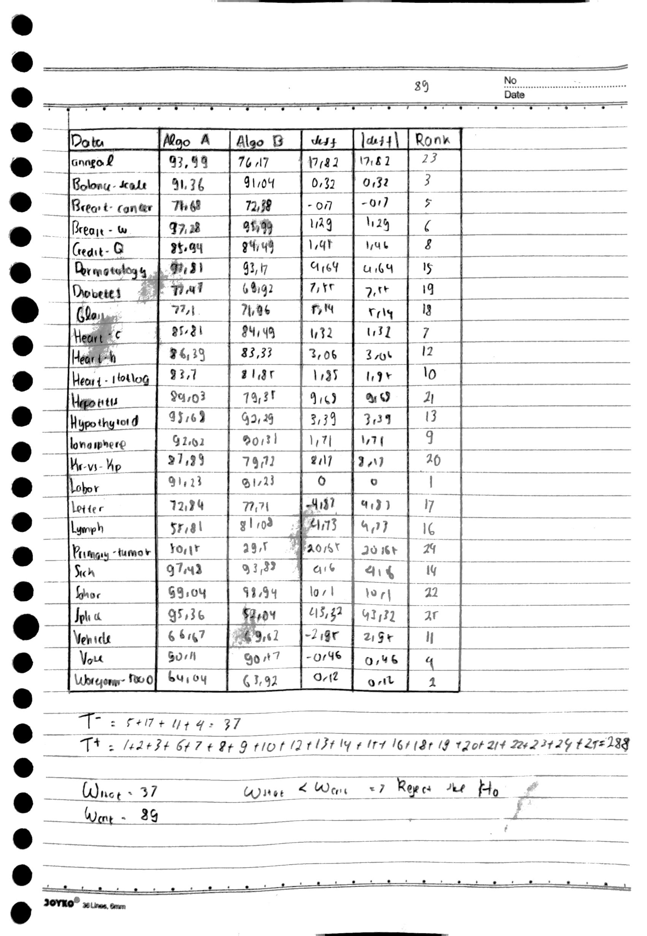

The Ho is both of the algorithm is equal, but from the calcualtion we can know that wstat­ is smaller than wcrit­­ so we reject the Ho

1e. Perform Wilcoxon Signed-Rank Test using R

File: 1e.R

Result:

V = 267, p-value = 0.0008729

Alterhative hypothesis: ture location shift is not equal to 0

Because of the p-value is below the crit value, we can saya that Ho is rejected

1f. Perform Sign Test (Binomial test) using R

File: 1f.R

Result:

S=20, p-value = 0.001544

95 percent confidence interval: 1.29, 5.1

Median of x: 3.06

Achieved and Interpolated Confidence Intervals:

Conf.Level L.E.pt U.E.pt

Lower Achieved CI 0.8922 1.3200 4.7300

Interpolated CI 0.9500 1.2931 5.0973

Upper Achieved CI 0.9567 1.2900 5.1400

2a. Perform Friedman Test by hand

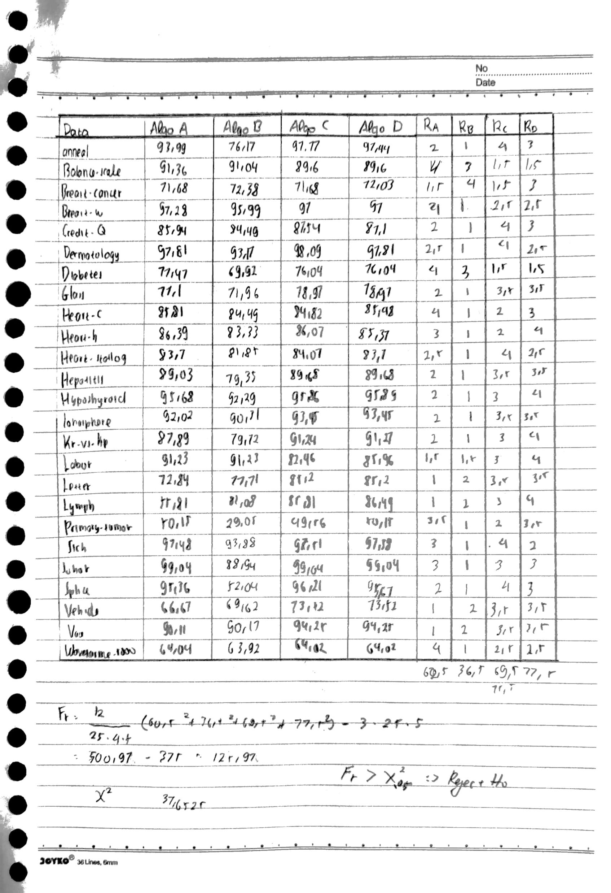

We have H­0 that say that all of them are equal, but from the calculation we can know that Fr is higher than X2­, so the H0 is rejected

2b. Perform Friedman Test using R

File: 2b.R

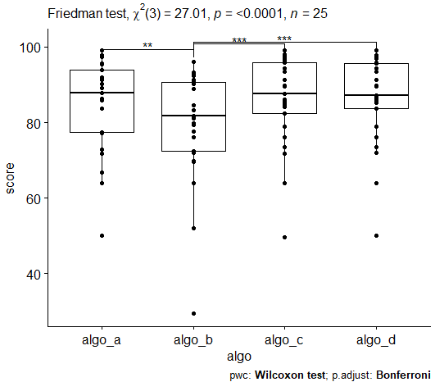

From the result we can know that the H0 is rejected, because of p value and X2value

2c. If needed, perform Nemenyi post-hoc test by hand.

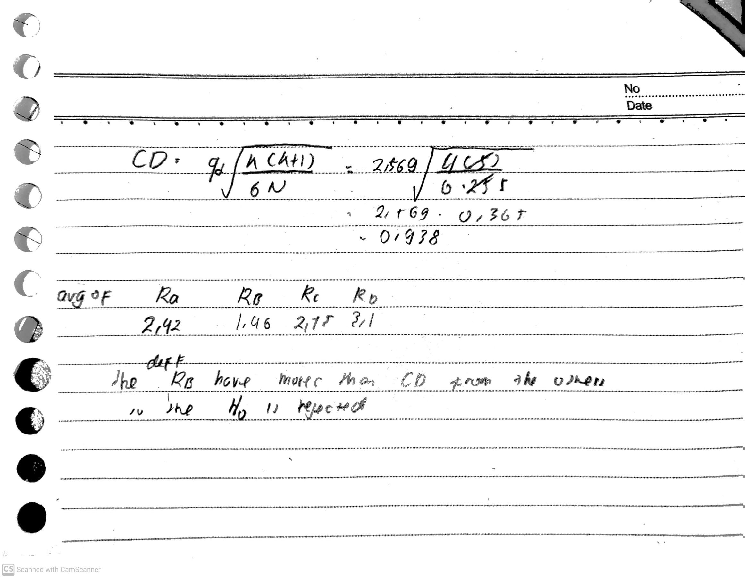

2d. If needed, perform Nemenyi post-hoc test using R. Draw Friedman test graph using R

File: 2d.R

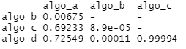

3. Run the Friedman test for the following result.

File: 3.R

