RNase H sweeps:

High tol

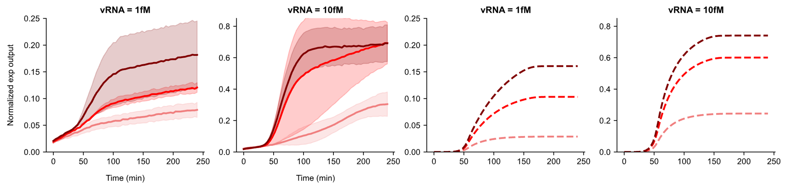

Low tol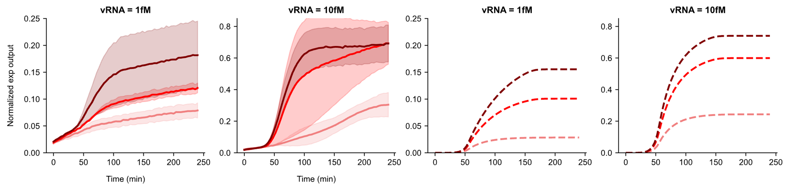____________________________________________________________________________

RT sweeps:

High tol

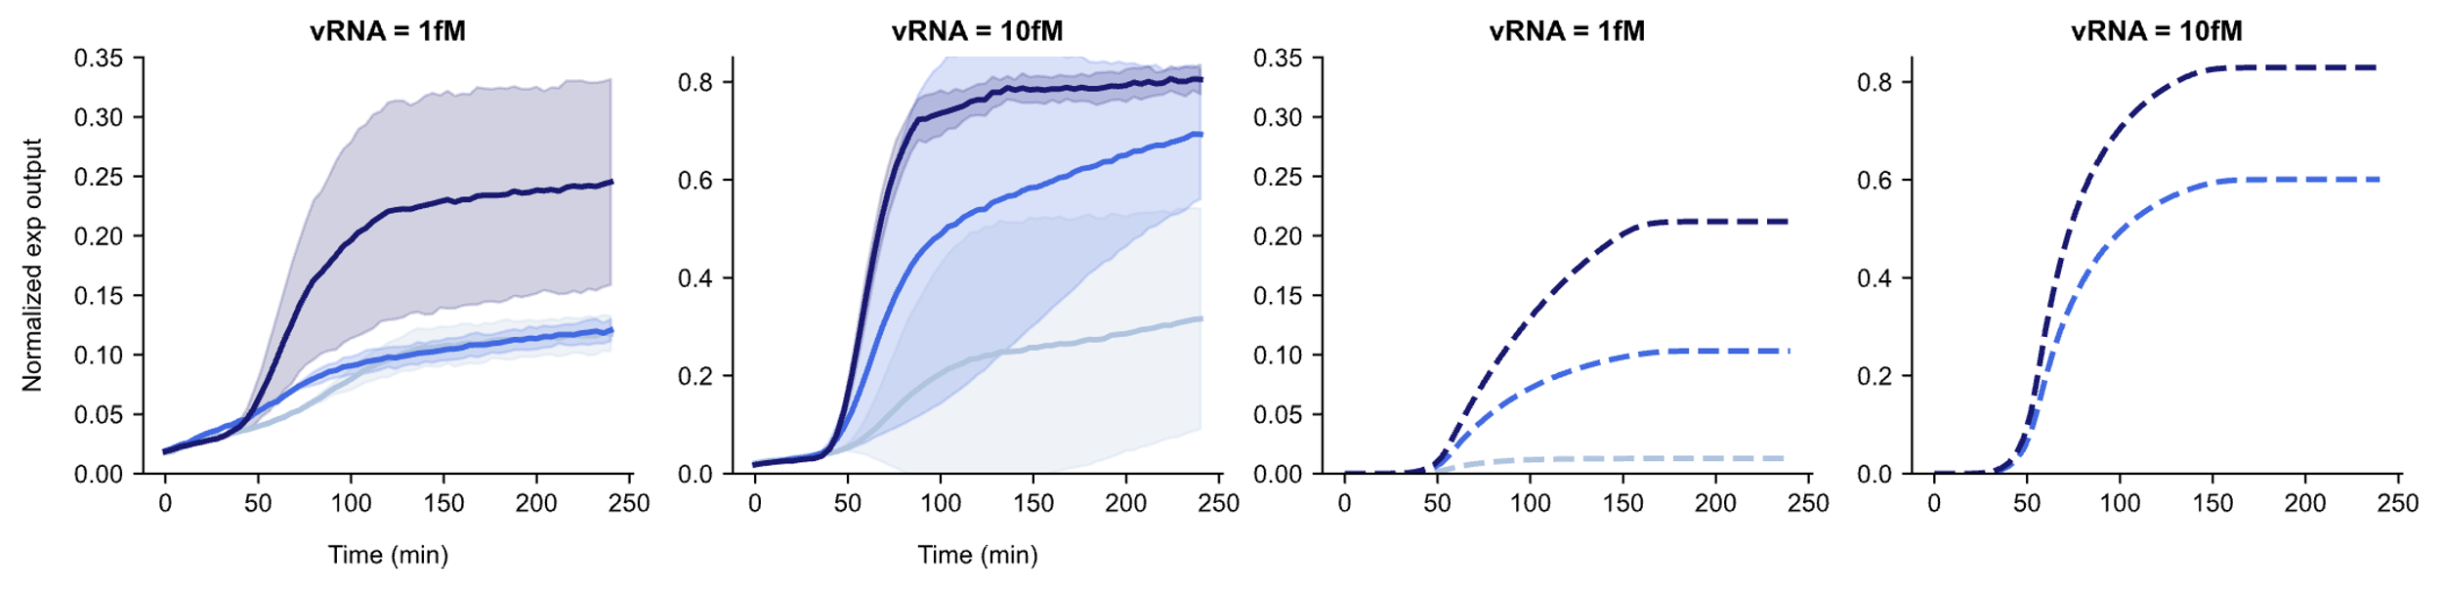

Low tol

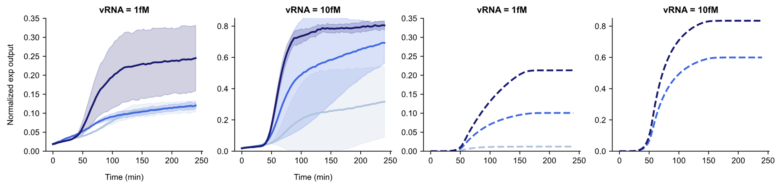

____________________________________________________________________________

T7 sweeps:

High tol

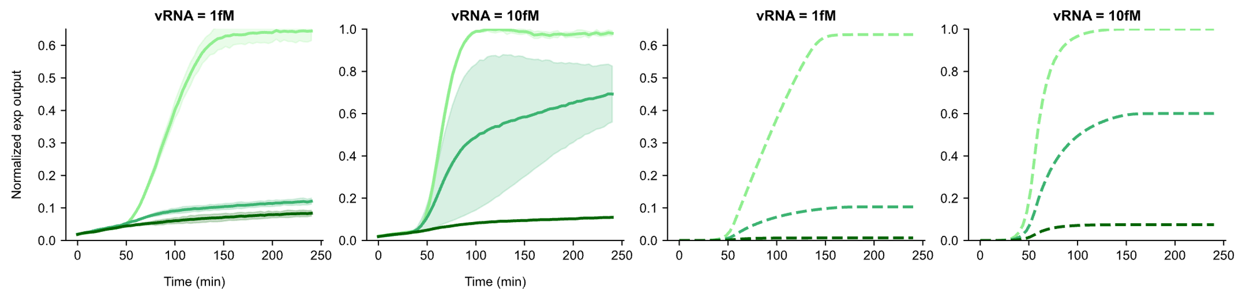

Low tol

