Emotional AI Mirror
Draft Project Report
Template 4.1: Orchestrating AI models to achieve a goal

1. Introduction
This project is a privacy-focused tool designed to help individuals develop deeper self-awareness of their emotions and mental states. Users engage with an emotional stimulus, a short video of carefully chosen images, while their facial expressions are analysed in real time. Their verbal responses are then transcribed and analysed for emotional tone. The system synthesises this data to generate a personalised psychological profile, identify emotional patterns, and provide targeted recommendations for stress management, self-improvement, and mental wellness. All processing occurs locally on the user's device with zero data transmission. This is an introductory tool for people who lack access to therapy or prefer an impersonal first step. It is not a replacement for professional mental health care.
The project is based on Template 4.1: Orchestrating AI models to achieve a goal.
Most people struggle to understand their own emotions. Professional support is expensive and not always accessible. Mental health disorders constitute five of the top ten causes of disability across Europe, with an estimated total cost exceeding €600 billion annually (Laidi et al., 2023). This tool targets two groups: those who cannot afford professional therapy, and those who experience anxiety or stigma when discussing mental health with strangers.
Similar technology already exists but serves different purposes. Affectiva, a commercial product born out of MIT Media Lab, uses computer vision to detect emotions from facial expressions in real time. However it is built for corporate use, its primary application is measuring consumer reactions to advertisements. The insights go to the advertiser, not the person being analysed. It is expensive, closed source, and inaccessible to individuals.
A more recent example is Ghatoray and Li (2025), from Brunel University London, who combined facial emotion recognition, speech-to-text, and sentiment analysis, feeding everything into a language model, a pipeline technically very similar to this project. However their system only processes pre-recorded video, is not interactive, and uses GPT-4o, a paid cloud service. The authors themselves flagged this as a privacy concern.
This project addresses both gaps: it uses a live webcam feed instead of pre-recorded video, and runs the language model entirely locally using Ollama. Rather than producing a static report for a researcher or feeding data to an advertiser, the system opens an interactive conversation with the user, putting the insight back in the hands of the person it came from.

2. Literature Review

Examples of similar projects

Abby AI, Medical Decision Support System
Abby AI is an Australian medical tool that uses AI to prepare patient profiles before clinical appointments. It collects medical history, past test results, and medication records, synthesises them, and presents a structured summary to the doctor before they see the patient (Abby Health, 2026). The doctor remains in control at all times, Abby does not diagnose or prescribe.
Both systems collect information about a person and generate a profile from it. The difference is who that profile is for. Abby serves the clinician, the insight goes to the professional, not the patient. This project does the opposite: there is no doctor, no intermediary. The profile goes directly to the user.

Affectiva, Emotion AI Software
Miller (2017) describes Affectiva as a company that makes AI software to detect human emotions, it started from MIT Media Lab. The company analyzes facial expressions, voice tone, and body movements to understand what people feel. And according to an article from Affectiva themselves (Affectiva, 2016) they used the Facial Action Coding System (FACS), developed by Paul Ekman, to label facial expressions.
Affectiva uses cameras and microphones to detect emotions in real-time. It analyzes facial expressions, voice tone, and body language. The company has studied over 10 million face videos from 90 countries. It can detect emotions like happiness, anger, confusion, and frustration.
My project aims at using similar technology, also based on Ekman's work, to detect emotions in real time from a live feed, and give immediate feedback to the user, for free.
Affectiva is used by large companies for different purposes. Advertising companies use it to measure how people react to ads. Car companies use it to monitor drivers and detect if they are tired or distracted. Companies use it to understand customer emotions in call centers. Gaming and education companies use it to detect if users are bored.
Both Affectiva and my project use AI to detect emotions. But it is a paid software for big corporations to make more money and understand customers. My project is a free software for people to understand their own emotions better.

Techniques and methods
Citation gaps in this chapter are now closed: the Brunel University London study is cited as Ghatoray and Li (2025) throughout (Introduction, this chapter, and Design), DeepFace, faster-whisper and j-hartmann are cited below at first mention, and the OASIS citation and IAPS note appear alongside the vision entry. Every source cited here has a matching entry in the References section.
For my project I combine several pre-trained models to achieve a common goal. The domains covered are four: vision, audio, text, and language generation. The library and model choices below were explored starting from more demanding options and downgraded to lighter frameworks where hardware constraints required it.

OpenCV, Computer Vision Library
OpenCV is an open-source library for detecting faces and tracking movement in videos. It runs locally on the user's machine, so the data stays private. The library is cross-platform and licensed as free and open-source software (OpenCV, 2026), making it well suited to this project.

Whisper / faster-whisper, Speech-to-Text Model
For speech recognition the project uses Whisper, an open-source speech recognition model created by OpenAI (Radford et al., 2022), trained on 680,000 hours of multilingual audio and supporting 99 languages. It runs locally without needing an internet connection. In practice the project uses faster-whisper (SYSTRAN, n.d.), a reimplementation that runs roughly four times faster on CPU at equivalent accuracy, which matters given the target hardware has no dedicated GPU.
Whisper transcribes what the user says during the emotional assessment; the transcribed text is then analysed for sentiment and emotional tone (Radford et al., 2022).
faster-whisper was benchmarked directly against the original openai-whisper on the same audio file (both at the tiny model size, see Evaluation, Stage 2 results). faster-whisper was confirmed faster on transcription and, on this test file, more accurate: openai-whisper mis-transcribed one word ('microphone' as 'Micah Cup') where faster-whisper transcribed the file correctly. Vosk was also considered as a lighter-weight fallback option (see Design chapter) but was not directly benchmarked, since the openai-whisper comparison already demonstrates the accuracy/performance case for faster-whisper against the model it is built on.

Sentiment / Text Emotion Detection
To detect emotion in text, the transcribed speech from Whisper is fed to a pre-trained model to identify emotional tone and sentiment. These models can be downloaded and run locally, using deep learning to classify text as positive, negative, or neutral, or to detect more nuanced emotions like frustration, joy, or sadness (Hugging Face, 2024).
Three candidates were benchmarked on a fixed set of test transcripts: VADER, a rule-based analyser (Hutto & Gilbert, 2014); tabularisai/multilingual-sentiment-analysis; and j-hartmann/emotion-english-distilroberta-base. j-hartmann (Hartmann, 2022) was selected, both for its higher accuracy on the test set and because it shares the same seven-emotion label space as the DeepFace facial-emotion model, allowing facial and verbal emotion to be compared directly. Full results are given in the Evaluation chapter.

Ollama, Local Language Model Framework
For the interactive component the project uses Ollama, a framework that allows large language models to run locally without an internet connection or cloud services (Ollama, 2024). Ollama generates the final psychological profile and personalised recommendations from the combined facial emotion, transcribed speech, and sentiment data. Because Ollama runs entirely on the user's machine, all emotional data stays private and is never sent to external servers (Ollama, 2024).
llama3.2 (approximately 2GB) was used for initial integration, chosen as the smallest widely-used Ollama model and confirmed to run on CPU-only consumer hardware without a dedicated GPU.
llama3.2 and qwen2.5:3b were benchmarked on an identical sample prompt (see Evaluation, Table 7). qwen2.5:3b was notably faster on both time-to-first-token and total generation time, but its reply did not include a recommendation to seek professional help despite the sample containing a fear signal comparable to earlier tests where llama3.2 reliably included one. Given the project's severity-assessment design requirement, llama3.2 was retained as the primary model, with qwen2.5:3b noted as a faster alternative worth further, more systematic safety testing.

Study cases and research evidence
To assess the effectiveness of AI in psychological diagnosis this project draws on a study by Alyssa Ezell, conducted at Widener University, testing whether six AI chatbots - three general-use (ChatGPT, Gemini, Claude) and three therapist-specific (Pi, Panda, Abby) - could accurately diagnose mental health conditions and create treatment plans (Ezell, 2026).
General-use chatbots provided diagnoses in 100% of cases, but only 36.7% were completely correct; in 40% of cases, chatbots gave both correct and incorrect diagnoses simultaneously (Ezell, 2026). Therapist-specific chatbots were more cautious, providing diagnoses only 53.3% of the time (Ezell, 2026). For treatment planning, general-use chatbots recommended plans in 93.3% of cases, most commonly Cognitive Behavioral Therapy, psychiatric medication, and social support, but these recommendations were very generic (Ezell, 2026).
Ezell's research demonstrates that AI can provide mental health information, but current systems struggle with accuracy, personalisation, and transparency. This project aims to narrow those gaps through real-time emotion detection, individual focus, and privacy-preserving local processing.

3. Design

Domain
Laidi et al. (2023) report that mental disorders constitute five of the top ten causes of disability across Europe, with an estimated total cost exceeding 4% of GDP, more than €600 billion annually. They also note that these conditions often begin early in life, with significant impacts on work productivity and quality of life.
The primary users of this product are individuals aged 18-45 seeking mental health support in Europe. The scale of the problem is considerable: in France alone, Laidi et al. (2023) estimate the annual cost of mental health at €163 billion in 2018, broken down into direct healthcare costs (14%), productivity loss (27%), and loss of quality of life (51%). These costs reflect both the prevalence of mental health conditions and barriers to access, with anxiety and depressive disorders being the most common conditions, affecting millions of people across the continent.
Affordability is not the only issue: discomfort with human interaction is also a critical barrier. While people generally prefer human doctors to AI systems, recent evidence shows that interaction with a fully automated AI chatbot can be an effective approach in the diagnosis and treatment of psychiatric disorders (Lee et al., 2022); some individuals may engage with AI-based tools when human interaction feels inaccessible or uncomfortable (Riedl et al., 2024).
This tool targets two user groups: those who cannot afford professional therapy, and those who experience anxiety or stigma when discussing mental health with strangers. The system is designed to assess the severity of a case; if a user's profile indicates serious mental health concerns, the system actively encourages them to seek professional help. It is not a replacement for therapy, but a meaningful first step toward self-awareness and care-seeking.

Design justification
The design choices in this project are based on the specific needs identified in the domain and user analysis: privacy, affordability, accessibility, and responsible care-seeking.

Fully local processing
To address privacy concerns that are especially important in mental health contexts, the entire system runs locally, with no internet connection or cloud services. Riedl et al. (2024) found that perceived privacy invasion was higher in AI-based interactions, and higher still in psychiatry than in other medical fields, where patients fear data breaches when discussing personal conditions. By keeping all emotional data on the user's machine, the system removes this barrier entirely. This is also what separates the project from commercial products like Affectiva, which send insights to third parties rather than the user.

Multiple models across different domains
The system combines facial emotion recognition, speech transcription, sentiment analysis, and a local language model. This is because people often find it hard to put their feelings into words, and what they say does not always match what their face shows. Using more than one source of information gives a fuller picture than any single model could. Recent work in the field follows the same logic: Ghatoray and Li (2025), for example, combined facial emotion recognition with text sentiment because no single model captured the full emotional picture on its own.

Interactive conversation
After analysing the user's emotions, the system opens a dialogue through the local language model instead of producing a static diagnosis. This matters because the target users are often approaching mental health for the first time and need guidance, not just a label. An interactive format lets them ask questions, explore recommendations, and feel heard. Lee et al. (2022) found that AI chatbots can foster rapport and self-disclosure, which is valuable for users who feel anxious or embarrassed talking to a stranger.

Severity assessment
The system is not designed to replace therapy. When a user's profile suggests serious concerns, it encourages them to seek professional help. The evidence is clear that people prefer and benefit from human care (Riedl et al., 2024), and an AI tool that masks the need for real treatment would be harmful. This project recognises the importance of human connection in effective mental healthcare, and treats itself as a first step rather than a substitute.

Inclusive design
The project's inclusion argument and its inclusion limitations sit on different axes, and both are stated here rather than only the former. The system requires no subscription, clinician referral, or paid appointment, and runs entirely on a personal laptop with nothing transmitted off-device; for someone who cannot afford therapy or who feels stigma discussing mental health with another person, being able to reflect privately at zero recurring cost is itself an inclusion argument, directly serving the two user groups identified in the Domain section above.
Set against this, every pre-trained model in the pipeline carries demographic bias that this project inherits rather than corrects. Facial-analysis models are well documented to perform unevenly across skin tone and gender: the landmark Gender Shades audit found commercial gender-classification error rates below 1% for lighter-skinned men against over 30% for darker-skinned women (Buolamwini & Gebru, 2018), and this project's own DeepFace resting-face misclassification (see Evaluation, Stage 1 results) was observed on a single tester, so it cannot be assumed to behave evenly, or unevenly in the same direction, across users of different skin tone or gender. Whisper and faster-whisper show a comparable pattern for speech: word error rates rise measurably for non-native and non-American-English accents relative to American and Canadian speech (Graham & Roll, 2024), meaning a user's accent could silently degrade transcript quality feeding every downstream stage without the user ever being told this is happening. Finally, the terminal-plus-OpenCV interface (see Session flow and user interaction), chosen for development speed rather than accessibility, has no screen-reader support and no accommodation for colour-blindness or low vision in the picture-in-picture display; a user who cannot read the terminal clearly cannot use this tool at all. None of these three limitations was addressed within this build's scope; they are named here as constraints a future iteration should treat as a starting requirement, not an afterthought.

Structure of the project
The user sits in front of their laptop and watches a short sequence of emotionally provocative images. While this happens, the webcam captures live video with the user's consent and feeds it to a facial emotion recognition model (DeepFace), which detects how the user's face reacts in real time and classifies expressions into emotional states.
The system then asks the user a few questions, which they answer aloud. Their voice is transcribed by Whisper (faster-whisper), running locally. The resulting text is passed to a sentiment analysis model, which identifies the emotional tone behind what the user said.
All the data collected so far - facial reactions, transcribed answers, sentiment scores - is then fed to a local language model running through Ollama. The model synthesises everything it has observed and opens an interactive conversation with the user, letting them ask questions and explore their results.
Finally the system delivers a personalised psychological profile consisting of a summary of detected emotional patterns, reported concerns, and personalised wellbeing recommendations, alongside practical suggestions: books to read, meditation practices, focus areas to work on, and lifestyle suggestions. If the profile indicates serious concerns, the system actively encourages the user to seek professional help from a qualified therapist.

4. Implementation

Orchestration overview
A pipeline.py module acts as the orchestrator. Each model lives in its own module with a clean interface (a class or a run function returning a small structured result), and pipeline.py is solely responsible for sequencing the stages and passing data between them. This keeps each model self-contained and independently testable, and allows stages to be added without changing the modules already written.
All four stages now run end to end within a single run_pipeline() function, wrapped in the guided session flow described later in this chapter: facial emotion detection (vision) produces a per-scene emotion summary; speech-to-text (audio) transcribes a recorded response; text-emotion analysis (text) classifies that transcript; and a local language model (Ollama) synthesises all three outputs into a written psychological reflection. Each module uses a try/except import pattern (importing as part of the src package when run through pipeline.py, or as a standalone module when run directly for isolated testing), which is what allowed every stage to be built and unit-tested independently before being wired in.
Every run is also logged: once the follow-up chat ends, save_session_log() writes a single timestamped JSON file containing every stage's output (the emotion summary, the three question-and-answer pairs, text-emotion result, and full profile) alongside the complete chat transcript, together with whether consent was given and whether the run was a demo. Recording consent and demo status in the log matters for the user study specifically: it distinguishes a real participant session from a demonstration run, and evidences that consent was obtained per session rather than assumed. This turns each session into structured, reusable data rather than terminal output that has to be copied by hand, which matters both for the results reported in this Evaluation chapter and for the planned six-to-ten person user study, where session data will need to be reviewed and compared systematically rather than one run at a time.

Stage 1: Facial emotion recognition (DeepFace)
DeepFace (Serengil & Ozpinar, 2020) classifies emotion from an image using a convolutional neural network (CNN). A webcam frame is first passed to a face detector that crops the face. The cropped face goes through convolutional layers, which slide filters over the image to pick out patterns (edges, then shapes, then features like a smile or a raised brow), and pooling layers, which shrink the data to keep only the strongest signals. A final softmax step turns the network's scores into probabilities across seven emotions and returns the highest one. Each frame is analysed on its own with no memory of previous frames, which is why neutral or ambiguous faces are often misread.
The vision prototype was refactored from a flat script into an importable run_session() function returning a timeline of (time, scene, emotion) readings, plus a pure summarise_timeline() helper, kept separate so it can be unit-tested without hardware.
DeepFace was benchmarked against FER, an alternative facial-emotion library with a separate Keras CNN and, by default, a different face detector (Haar Cascade), on live webcam frames sampled once per second (see Evaluation, Stage 1 results, for the full comparison and both result tables). With the face properly centred and facing the camera, the two models agreed on every reading and FER classified roughly six times faster; an earlier, less controlled run (face not consistently facing the camera) showed FER missing the face far more often than DeepFace, but that result is not treated as reliable, since it may reflect framing rather than model behaviour. DeepFace was retained as the primary model: the controlled comparison shows no classification disagreement to justify switching, and the framing-sensitivity difference between the two detectors is flagged as worth further, more controlled investigation rather than acted on now.
The four placeholder scene labels have been replaced with real stimulus images from OASIS (Kurdi, Lozano & Banaji, 2017), a 900-image open-access set with normative valence and arousal ratings (1-7 scale) collected from 822 raters. IAPS, the older and more established alternative, was considered first but ruled out: distribution was suspended by its host institution (the University of Florida's CSEA) around 2024, and as of the time of writing the database is not available through any official channel to new users, regardless of research justification. OASIS was therefore not simply the cheaper option but the only currently obtainable one, which strengthens rather than weakens the case for using it.
Three images were selected per scene (twelve in total) by sorting the full OASIS ratings file by valence and arousal and shortlisting candidates from each target quadrant: threatening (low valence, high arousal), joyful (high valence, high arousal), sad (low valence, low arousal), and relaxing (high valence, low arousal). Candidates were then reviewed by hand rather than taken automatically from the ranked list, because the images with the single most extreme ratings in the threatening quadrant included graphic injury and death imagery unsuitable for a wellbeing-facing tool with no clinical oversight. These were replaced with images expected to produce a comparable emotional reaction (e.g. a shark, a knife, fire) without the same intensity, deliberately trading a small amount of norming-score extremity for content that is safe to show an unscreened participant. The final twelve images and their OASIS ratings are recorded in the evidence log; this selection process - and the deliberate step of moderating image intensity - is itself evidence of the model/stimulus evaluation and rejection process the brief asks for.

Earlier prototype: fixed placeholder scenes
Before the OASIS stimulus was integrated, the vision stage was tested and evaluated using a hardcoded video_sequence of four fixed time windows, each carrying only a text label (Figure X) rather than any displayed image. This was a deliberate scaffolding decision, not an oversight: it let the webcam capture, DeepFace analysis, scene-tagging and timeline-summarisation logic (get_current_scene() and summarise_timeline()) be built, exercised and unit-tested against a controlled, reproducible schedule before the added complexity of real stimulus content and consent-gated capture was introduced. The consent screen (Figure X) and the running detection window (Figures X-X) both date from this stage, and show the system correctly reading a live emotion label and the active scene label from the placeholder schedule, with no image content behind either - confirming the underlying pipeline logic worked correctly ahead of the OASIS integration described above. The get_current_scene() lookup and the overall timing structure are unchanged by the later OASIS integration; only the content source of each scene was replaced.
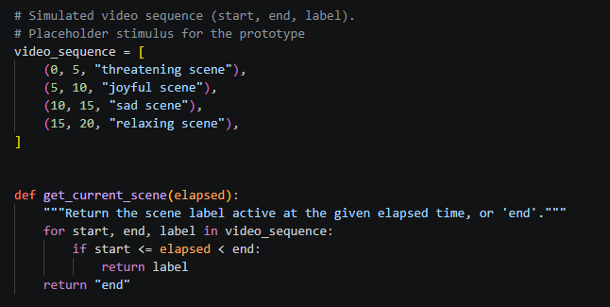
Figure 1. The original hardcoded video_sequence: four fixed time windows, each carrying only a text label, with no displayed image content.
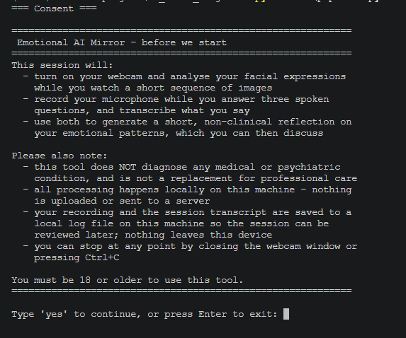
Figure 2. The consent/disclaimer screen, working correctly against the placeholder schedule prior to the OASIS integration.
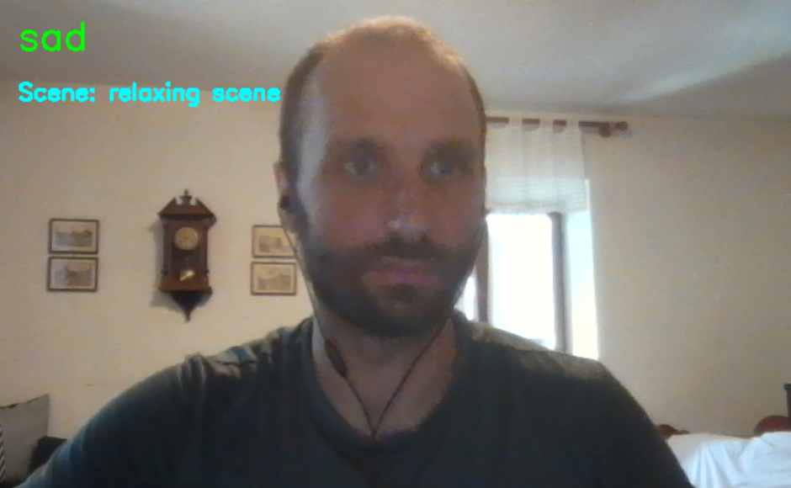
Figure 3. Live DeepFace emotion label (top left) and active scene label ("Scene: relaxing scene") displayed against the plain webcam feed, with no stimulus image shown - illustrating the placeholder-label approach this prototype stage used.
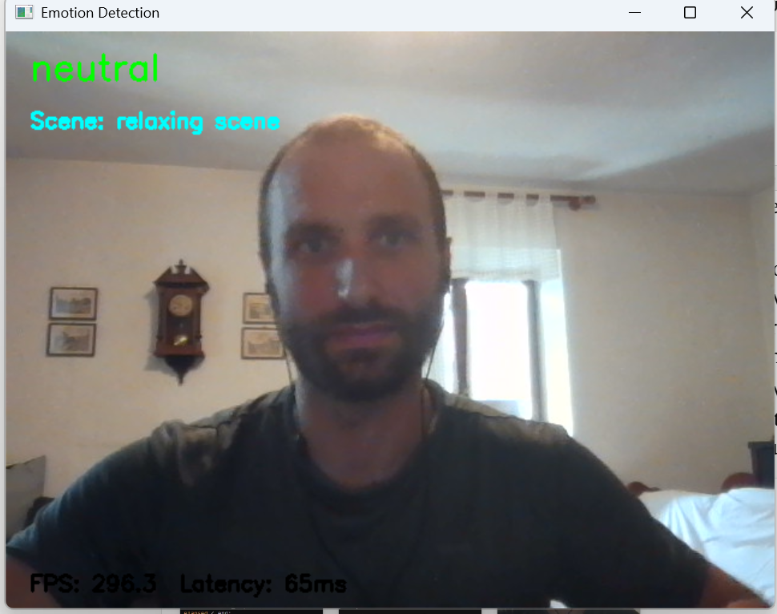
Figure 4. The same detection window with the FPS/latency overlay visible, confirming real-time performance was already being measured at this early stage.

OASIS integration and picture-in-picture display
video_sequence was replaced with build_video_sequence(), which constructs the stimulus schedule dynamically from whatever images are present in samples/stimuli/<scene>/, rather than from a hardcoded list. Each image is shown for a fixed 3 seconds, so a scene's total duration is simply image count × 3s; get_current_scene() is unchanged in behaviour, and a new get_current_stimulus() returns both the active scene label and the image path so the display loop knows what to render. Both functions accept an explicit sequence argument (defaulting to the real, filesystem-derived video_sequence), which decouples them from disk state for unit testing: tests can pass a small fixed schedule instead of depending on however many images happen to be in each folder locally.
The display itself changed from a bare webcam feed to a picture-in-picture composite, modelled on a video call: the current stimulus image fills the window (960×720) and the live webcam feed is resized and pasted into a bordered box in the bottom-right corner (160×120), via a new compose_frame() function. A brief standalone prototype (not part of the final codebase) was used first to tune the box size and position against a real image before this was folded into run_session().
A DEBUG_OVERLAY flag (default False) controls whether the scene label and the live detected-emotion label are drawn on screen. Both were shown by default in the earlier placeholder-scene prototype (Figures 3-4 above), but for a real stimulus this is a methodological problem, not just visual clutter: a participant who can see the scene is labelled "sad scene", or who watches their own face get tagged "fear" in real time, is no longer reacting to the image naturally - they are reacting to being told what they are supposed to feel, or to seeing themselves labelled. Hiding both by default keeps the stimulus unprompted, consistent with how validated affective-image studies are normally administered; DEBUG_OVERLAY = True remains available for development use, to visually confirm detection is working while coding, but must not be enabled for a real session or the user study.
With DEBUG_OVERLAY left at its default of False, a full run through all four scenes using the real OASIS images completed without errors, producing a per-scene dominant-emotion summary and a saved emotion_timeline.csv, with no scene or emotion text visible on screen during the session. The result reproduced the same negative-emotion over-detection bias already reported for the placeholder-scene runs (see Evaluation, Stage 1 results): the joyful and relaxing scenes were both dominantly read as "sad" rather than matching their intended valence, while only the threatening scene matched expectation (neutral was the closest available label, given DeepFace's resting-face tendency documented earlier). This is a further, independent data point for the same limitation rather than a new finding, and motivated the benchmark of DeepFace against an alternative facial-emotion model subsequently carried out (see Evaluation, Stage 1 results, Table 1 and Table 2). Figure 5 shows the composed session window with the debug overlays enabled.
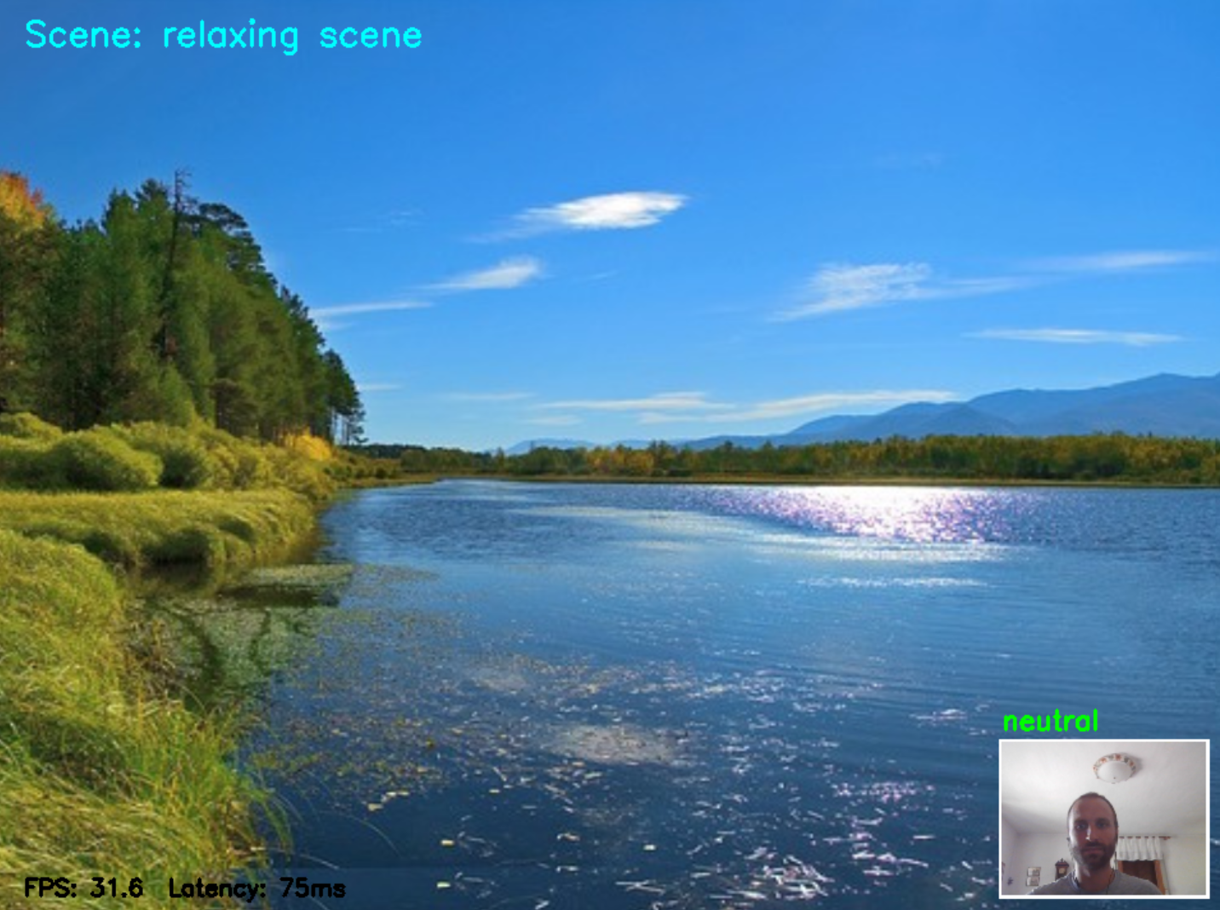
Figure 5. The running session with a real OASIS stimulus filling the window and the live webcam feed inset bottom-right, shown here with DEBUG_OVERLAY enabled so the active scene label, the live detected emotion, and the FPS/latency counters are visible. All three overlays are hidden by default during a real session.

Stage 2: Speech-to-text (Whisper / faster-whisper)
Whisper is a transformer model that converts audio to text. The audio is first turned into a mel spectrogram, a picture of how its frequencies change over time. An encoder compresses this into internal features, and a decoder then produces the transcript one token at a time, predicting each next word from the audio and the words so far. Because it models language and not just sounds, it handles continuous speech and punctuation well.
The project uses faster-whisper rather than the original openai-whisper, since it runs roughly four times faster on CPU at equivalent accuracy and supports int8 quantisation to reduce memory use - both matter given the project runs locally with no GPU. The component is built as a Transcriber class: the model is loaded once in __init__ and reused for every subsequent call, avoiding the cost of reloading it each time.
Live microphone input was added via a new recorder.py module, wrapping sounddevice. Rather than recording for a fixed duration, record_audio() streams audio into memory on a background callback until the user presses Enter, then writes it to a 16kHz mono WAV file - the sample rate Whisper expects internally, avoiding an extra resampling step. pipeline.py now records live by default, taking a separate recording for each of the three spoken questions rather than one continuous capture, so each answer can be attributed to the question that prompted it. A --demo flag switches back to the bundled sample.wav, which is kept as a fallback for offline demonstrations (e.g. the Topic 9 peer review) or if a working microphone is unavailable.

Stage 3: Sentiment / text-emotion analysis
The text stage is implemented in sentiment.py, following the same structural pattern as the Transcriber class: a SentimentAnalyzer class loads the chosen model once at construction and exposes a single analyze(text) method that returns a small structured result (an EmotionResult namedtuple of label and confidence score), so the rest of the pipeline always receives a predictable shape regardless of which model sits underneath.
j-hartmann/emotion-english-distilroberta-base was selected after benchmarking it against VADER and tabularisai/multilingual-sentiment-analysis on a fixed set of test transcripts (see Evaluation, Stage 3 results, for the full comparison). Its key advantage is sharing DeepFace's seven-emotion label space, so facial and verbal emotion can later be compared directly by the language model rather than reconciled across two different vocabularies.
As with the audio module, the transformers import sits inside __init__ rather than at the top of the file, so sentiment.py can be imported by the pipeline without the (fairly heavy) transformers/torch dependency being installed, unless a SentimentAnalyzer is actually constructed. The analyze() method also short-circuits on empty or whitespace-only input, returning a neutral, zero-confidence result rather than calling the model - an empty transcript is a valid pipeline state (e.g. a dropped audio segment or a silent response), not an error condition.
The stage was first verified in isolation, then integrated into pipeline.py directly after the transcription stage. It now receives the combined question-and-answer transcript assembled by session.format_qa_transcript() rather than a single recording's text, so the emotional tone it scores is that of the user's three spoken answers taken together. A full pipeline run on a sample recording ("This is a recorded message to test my program and to make sure that it will also work on a live feed from the microphone. Thank you.") correctly returned neutral (0.862) for this factual, unemotional sentence, confirming the stage integrates cleanly and the transcript passes to it in a usable form.

Stage 4: Local language model (Ollama)
The language stage is implemented in profile_generator.py as a ProfileGenerator class, following the same lazy-import pattern as the other three modules (the ollama package is only imported inside __init__, so the module can be imported elsewhere in the pipeline without it installed). The class holds a running conversation history on the instance, exposing both a generate_profile() method for the initial reflection and a chat(user_message) method for follow-up turns that share the same context, so the caller does not need to manage message state separately.
A run_chat_loop() function was then added to pipeline.py to close this gap: after the initial profile prints, the pipeline takes user input via input(), passes each message to generator.chat(), and prints the reply, repeating until the user types a quit word (quit/exit/q/bye/stop) or sends an interrupt. Because it reuses the same ProfileGenerator instance, the model retains full session context - the facial emotion summary, transcript, and profile it just wrote - for every follow-up turn, rather than starting a fresh, context-free conversation.
A single structured prompt is assembled from all three upstream stages: the per-scene dominant facial emotions from Stage 1, the transcript from Stage 2, and the transcript's classified emotional tone from Stage 3. The model is instructed to produce (1) a summary of the emotional patterns observed, explicitly including any mismatch between facial expression and spoken tone, (2) one or two focus areas, and (3) two or three general wellbeing recommendations.
A fixed system prompt is set once at construction and sent with every request. It explicitly forbids diagnostic or clinical language, instructs the model to stay warm and non-clinical, and requires it to recommend professional help when the observed patterns suggest significant or persistent distress. This is a direct implementation of the severity-assessment design decision (see Design chapter) and of the ethical requirement, established through the literature review (Ezell, 2026; Riedl et al., 2024), that the system must never attempt to replace a qualified professional.
A secondary, non-authoritative safety net was also added: generate_profile() checks the model's reply for keywords such as "professional" and "therapist" and sets a seek_help boolean flag on the returned Profile. This is not relied upon to make the system safe - the system prompt is the primary control - but gives the calling code (e.g. a future UI layer) a simple, cheap way to know whether to surface a resources link.
llama3.2 (the smallest available Ollama model, approximately 2GB) was used for this integration test, on the basis that it requires no dedicated GPU and was already confirmed to run acceptably on the target hardware during setup.
llama3.2 was compared against qwen2.5:3b on an identical sample prompt (see Evaluation, Table 7 for full numbers). qwen2.5:3b was faster on both time-to-first-token and total generation time, and produced a more concise reply, but it did not recommend professional help for a prompt containing a fear signal similar to earlier llama3.2 tests that did trigger that recommendation. llama3.2 was kept as the primary model on this basis: for a system whose core design requirement is severity assessment, a model that reliably surfaces the seek-help recommendation is prioritised over one that is faster but less consistent on this specific behaviour.

Integration test
With all four modules wired into pipeline.py, a full run was carried out: Stage 1 captured a (simulated) per-scene emotion summary, Stage 2 transcribed a short test recording, Stage 3 classified its tone as neutral, and Stage 4 received all three outputs and generated a full profile. The model correctly identified a mismatch between the fear reading recorded during the "sad scene" and the otherwise neutral tone of the transcript, and, per its system prompt, closed with an explicit recommendation to seek professional support, correctly setting the seek_help flag to True:
"...I do want to acknowledge the fear that showed up during your sad scene. If you're struggling to manage overwhelming emotions or if this feeling persists, it's essential to reach out to a mental health professional for support."
This confirms the full four-stage pipeline runs without errors and that the severity-assessment behaviour required by the system's design works as intended, at least in this initial test. This run used the real OASIS stimulus images now wired into Stage 1 rather than a placeholder sequence; however, it remains a single test session rather than a real user's data, so the result demonstrates correct integration rather than a validated real-world profile.
A second, fully live end-to-end run was then carried out with the mic-recording and interactive-chat additions in place: a real spoken response was recorded via recorder.py, transcribed, classified, and used to generate a profile, after which several follow-up questions were exchanged through run_chat_loop(). This confirmed that live microphone input, the full four-stage pipeline, and the interactive chat all work together correctly. See Evaluation, Stage 4 results, for a limitation identified during this test.
Following the OASIS and picture-in-picture integration described earlier in this chapter, a first fully real end-to-end run was carried out: real consent, the real OASIS stimulus sequence, a live microphone recording for each spoken question, and an interactive chat exchange, run via pipeline.py with no --demo flag and no placeholder content anywhere in the chain. The session completed and logged correctly, confirming the full guided flow works as designed outside of demo mode. This run was a pipeline smoke test rather than a genuine reflective session (the spoken answers were not considered), so its content is not treated as evaluation data in this chapter.

Session flow and user interaction
The four model stages are wrapped in a guided session implemented in session.py, so that what a user encounters is a structured, consent-first experience rather than the developer pipeline the stages alone provide. The flow runs in seven steps: consent and disclaimer, the stimulus sequence with live facial analysis, three spoken questions, processing, the generated profile, the follow-up conversation, and a closing message pointing to professional support.
Consent is handled by get_consent(), which prints a disclaimer stating what will be captured (webcam and microphone), what the system will not do (diagnose, or transmit anything off the machine), that the session is written to a local log file, and how to stop at any point. The check fails closed: only an explicit "yes" proceeds, while a blank line, a refusal, an end-of-file or a keyboard interrupt are all treated as consent withheld. The end-of-file case is the one worth naming, since a non-interactive run with no available stdin would otherwise raise an exception rather than declining cleanly, and an unclear answer must never be read as agreement. Where consent is not given, run_pipeline() returns before any stage executes, so nothing is captured, recorded or logged for a declined session.
The three spoken questions ("How are you feeling right now?", "What did those images bring to mind?", "Is anything weighing on you?") are held in a module-level constant and asked one at a time by run_spoken_questions(), with each answer recorded and transcribed separately rather than as a single continuous recording. format_qa_transcript() then combines them into the one string the text-emotion and language stages consume, keeping each question visible alongside its answer so the language model can see what each response was addressing rather than receiving three unlabelled sentences run together.
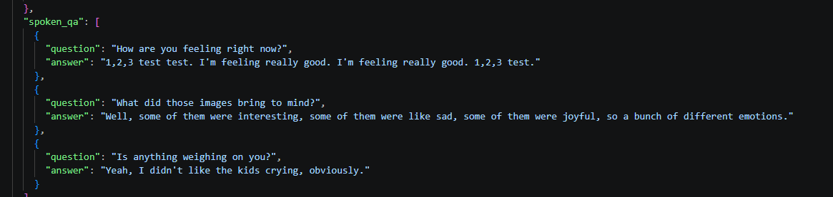
Figure 6. The spoken_qa field of a session log, showing each of the three questions stored alongside the answer it prompted rather than as one undifferentiated transcript.
The session closes with print_closing(), which always displays signposting to professional support and adds a more direct prompt when the seek_help flag is set. Showing the resources on every session rather than only flagged ones is deliberate: it implements the Design chapter's argument that this tool is a first step toward care-seeking, which would be undermined if the signpost appeared only on the sessions a small local model happened to classify as concerning.
A terminal interface plus the existing OpenCV window was judged sufficient for this prototype. The interaction-design questions that actually matter for a first-step self-reflection tool - whether consent is informed and freely given, whether the questions invite genuine reflection, and whether the closing message routes the user somewhere real - are all answerable in a terminal, and a graphical interface would have consumed build time without addressing any of them. This is a scope decision rather than an oversight, and is revisited in the Conclusion as candidate further work.
--demo mode auto-confirms consent and reuses the bundled sample.wav for all three questions, so that a peer reviewer can run a complete session without a webcam, microphone or Ollama installation. The reuse is a documented limitation of demo mode rather than a defect: only one sample recording ships with the project, and the mode prints this to the terminal at each question so that three identical answers are not mistaken for three real ones.
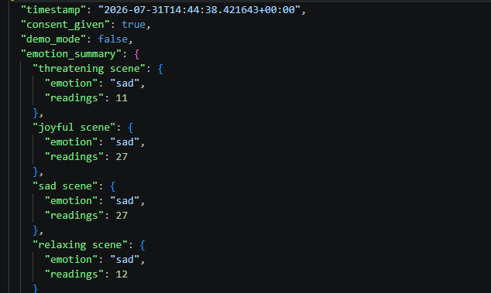
Figure 7. The head of a session log, showing the consent_given and demo_mode flags recorded per session alongside the per-scene emotion summary - evidence that consent is captured per run rather than assumed.

Visual representation of the product / results
Rather than collecting the system's visual evidence into a single gallery, each figure is placed in the section whose claim it supports and is referred to there by number. The running system is shown in Figure 5 (a real OASIS stimulus with the live webcam inset and the detection overlays enabled), with the earlier placeholder-stage prototype in Figures 1-4 for comparison. The guided session flow and its logging are evidenced in Figures 6 and 7 (the per-question spoken answers, and the consent and demo-mode flags recorded per run). Benchmark and result evidence sits with the corresponding results section: Figure 8 for the per-reading emotion timeline of a complete stimulus sequence, Figure 9 for speech-to-text, Figures 10-12 for the three text-emotion candidates, Figure 13 for a generated profile with the seek-help flag set, Figure 14 for a stage-timing log, Figure 15 for a follow-up chat exchange referring back to its own profile, and Figure 16 for the full passing test suite.

5. Evaluation

Testing methodology
Since this project uses pre-trained models rather than training one from scratch, evaluation focuses less on large user studies and more on whether the models run well on the target hardware and work together as one pipeline. Testing is split into three stages: checking each model in isolation, testing how the stages connect, and getting feedback from real users.
The first stage checks each model on its own. For every model, minimum hardware requirements were checked against the documentation, the model was installed locally and run on sample inputs to confirm usable output, and processing time and memory use were recorded. If a model proved too slow or too heavy, it was swapped for a lighter alternative (e.g. Vosk instead of Whisper, or VADER instead of a transformer-based sentiment model) - this swap is the main fallback built into the design.
The second stage tests how the models connect: whether output from one stage reaches the next in a usable form (e.g. Whisper's transcription passing cleanly to the sentiment model), watching for mismatched data formats, empty or dropped inputs, and total pipeline processing time.
The third stage tests the experience with real users. Between six and ten testers rate the result with a short Likert-scale survey (1-5) on accuracy, clarity, and usefulness, alongside a pre-session self-report used to check how well the generated profile matches the user's own account.
End-to-end pipeline timing was instrumented directly in pipeline.py (time.perf_counter() around each stage, written to a timestamped timing log alongside the session log) and measured across three full live runs; see End-to-end pipeline timing results below.

Stage 1 results: Facial emotion recognition
The model loaded and ran successfully on the test machine (Intel Core i7-1185G7, 16GB RAM, no dedicated GPU), confirming local execution is viable without specialist hardware. With FPS and analysis-latency instrumentation added, the system achieved approximately 127 FPS for video capture and 73ms per emotion analysis. Since analysis runs only every 10th frame, the display remained fluid while CPU load stayed manageable, confirming the pipeline is fast enough for real-time use on consumer hardware.
Across a 20-second test cycling through four labelled scenes, the model correctly identified the dominant emotion matching the deliberately expressed emotion in all four cases (surprise, happy, sad, neutral), confirming the emotion-to-scene tagging works as intended.
A clear limitation emerged in the emotion timeline: between deliberate expressions, when the face was relatively neutral, the model often returned fear or disgust instead of neutral. This suggests the model struggles with resting or ambiguous faces and tends to over-detect negative emotions with no strong signal present - a known limitation of frame-by-frame analysis with no temporal context.
A subsequent full-session run through the completed guided flow produced a sharper version of the same problem. Across all four scenes, every reading returned the same dominant emotion (sad: 10, 15, 15 and 12 readings for the threatening, joyful, sad and relaxing scenes respectively), with no variation between scenes that were designed to provoke markedly different responses. Unlike the earlier test, this run involved no deliberately expressed emotions, so it represents the resting-face condition specifically, and at the time indicated the model's behaviour on an unperforming face could be uniformly wrong in a single direction - a reading later complicated by a further run (below). This has a direct consequence for the system as a whole: the language stage receives a per-scene summary it treats as meaningful, and cannot distinguish a genuine emotional pattern from a constant misclassification, so a uniformly incorrect vision stage propagates silently into a confident-sounding profile.
A later run with the real OASIS stimulus in place complicates this picture rather than confirming it: the sad scene was dominantly misread as happy, the opposite direction from the sad/fear over-detection seen in the two runs above, while the other three scenes read as neutral. Taken together, the misclassification does not consistently favour negative emotion as first thought; it is direction-inconsistent, which if anything is a more serious problem for the profile-generation stage than a predictable bias would be, since a consistent error could in principle be corrected for, whereas an inconsistent one cannot. Figure 8 plots every reading from this run, showing the misclassification is not scattered noise but a sustained block: the happy readings run continuously for roughly the first half of the sad scene before reverting to neutral.
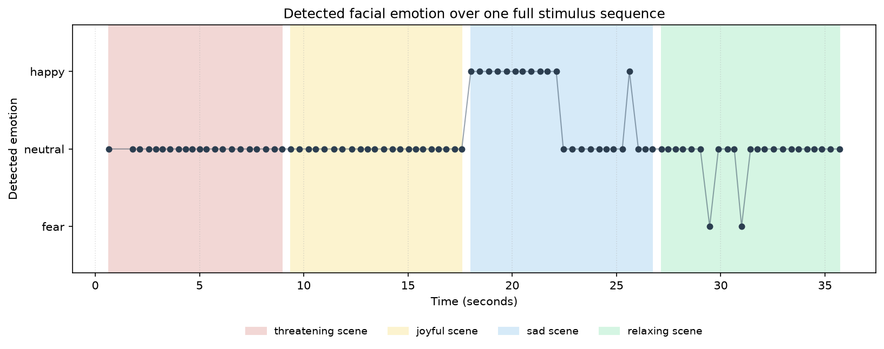
Figure 8. Detected emotion for every reading across one full OASIS sequence, with the four scenes shaded behind. The run is dominated by neutral readings, with a sustained block of happy misclassification through the first half of the sad scene - the direction-inconsistent error described above - and two isolated fear readings during the relaxing scene.

DeepFace vs. FER comparison
DeepFace was benchmarked against FER (a separate Keras CNN emotion model with, by default, a Haar Cascade face detector rather than DeepFace's) using emotion_benchmark.py, sampling one frame per second through both models simultaneously from a live webcam feed. Two runs were carried out.
The first run was not tightly controlled for camera framing (the participant was not consistently facing the camera throughout). Table 1 shows the result: FER failed to detect a face on 7 of 12 sampled frames, against zero missed detections for DeepFace, while both models agreed on every frame where FER did detect a face. This is not treated as a reliable finding about the two models' relative robustness, since it may reflect FER's detector being more sensitive to off-centre framing rather than a genuine reliability gap; it is reported for completeness rather than acted on.
Elapsed (s) | DeepFace label (latency) | FER label (latency) | Agreement
1.0 | happy (425.3ms) | no face detected (14.1ms) | -
4.0 | happy (70.5ms) | no face detected (13.3ms) | -
5.0 | happy (69.7ms) | no face detected (13.2ms) | -
6.1 | happy (65.1ms) | no face detected (13.2ms) | -
7.1 | happy (63.6ms) | no face detected (13.2ms) | -
8.1 | happy (72.3ms) | no face detected (11.1ms) | -
9.1 | neutral (68.7ms) | neutral (17.1ms) | yes
10.1 | neutral (73.9ms) | neutral (13.7ms) | yes
11.2 | neutral (78.1ms) | neutral (15.5ms) | yes
12.2 | neutral (75.0ms) | neutral (12.5ms) | yes
13.2 | happy (63.4ms) | happy (15.3ms) | yes
14.2 | happy (71.8ms) | no face detected (12.9ms) | -
Table 1. DeepFace vs. FER, run 1 (inconsistent camera framing). Average latency: DeepFace 99.8ms, FER 13.8ms. FER detected no face on 7/12 frames.
The run was repeated with the participant facing the camera directly and consistently for the full duration, maintaining a resting/neutral expression throughout - directly testing the same resting-face condition already flagged as a limitation in the placeholder-scene and OASIS runs above. Table 2 shows the result: both models detected a face on all 13 sampled frames and agreed on every single reading (all neutral), with FER roughly six times faster on average (15.1ms vs. 91.4ms).
Elapsed (s) | DeepFace label (latency) | FER label (latency) | Agreement
1.0 | neutral (346.5ms) | neutral (16.5ms) | yes
3.6 | neutral (73.3ms) | neutral (16.4ms) | yes
4.6 | neutral (74.8ms) | neutral (14.9ms) | yes
5.7 | neutral (70.3ms) | neutral (16.0ms) | yes
6.7 | neutral (71.5ms) | neutral (13.8ms) | yes
7.7 | neutral (67.3ms) | neutral (15.1ms) | yes
8.7 | neutral (66.3ms) | neutral (15.6ms) | yes
9.7 | neutral (67.8ms) | neutral (14.0ms) | yes
10.7 | neutral (69.2ms) | neutral (15.4ms) | yes
11.7 | neutral (70.6ms) | neutral (15.0ms) | yes
12.8 | neutral (71.2ms) | neutral (13.7ms) | yes
13.8 | neutral (66.0ms) | neutral (15.4ms) | yes
14.8 | neutral (72.8ms) | neutral (14.5ms) | yes
Table 2. DeepFace vs. FER, run 2 (controlled framing, resting face throughout). Average latency: DeepFace 91.4ms, FER 15.1ms. 13/13 frames agreed.
The controlled run (Table 2) is the more informative of the two: with framing held constant, DeepFace correctly read neutral on every frame of a genuine resting face, which does not reproduce the neutral-to-sad/fear misclassification seen in the earlier full-session runs (see above). This suggests camera framing or angle may be a contributing factor in that bias, rather than it being a fixed property of DeepFace on any resting face - an open question this benchmark was not designed to resolve on its own. DeepFace was retained as the primary model: with framing controlled, the two models showed no classification disagreement to justify switching, and FER's apparent detection gap in the first, uncontrolled run has an equally plausible framing-based explanation rather than a proven reliability advantage for DeepFace. FER's consistent speed advantage (roughly 6-7x faster across both runs) is noted as a reason a future iteration might reconsider this choice, particularly if frame-rate becomes a constraint, but is not sufficient on its own to switch away from a model with a working, evaluated pipeline built around it. Camera framing sensitivity in both models is flagged as worth further, more systematic investigation rather than resolved here.

Stage 2 results: Speech-to-text
The audio stage was verified as part of the full pipeline integration run: a sample recording was transcribed correctly and fluently ("This is a recorded message to test my program and to make sure that it will also work on a live feed from the microphone. Thank you."), confirming faster-whisper produces clean, directly usable text for the downstream sentiment stage.
faster-whisper was then benchmarked in isolation against the original openai-whisper on the same audio file, both at the tiny model size (see Table 3). faster-whisper was faster on transcription (0.54s vs 1.05s), used substantially less peak memory (13.4MB vs 72.1MB), and was more accurate on this file: openai-whisper again mis-transcribed "microphone" as "Micah Cup", while faster-whisper transcribed the sentence correctly in full. openai-whisper additionally required a system-level ffmpeg installation to run at all, which faster-whisper does not - a further practical point in favour of the chosen library for a tool intended to be simple to set up locally.
Model | Model load time | Transcription time | Peak memory | Notes
faster-whisper (tiny) | 0.74s | 0.54s | 13.4 MB | Transcribed the test sentence correctly in full
openai-whisper (tiny) | 0.44s | 1.05s | 72.1 MB | Mis-transcribed one word ("microphone" -> "Micah Cup"); required a separate system-level ffmpeg install to run
Table 3. faster-whisper vs openai-whisper on an identical audio file, tiny model size, on an Intel Core i7-1185G7, 16GB RAM, no dedicated GPU. Peak memory measured with tracemalloc, isolated per model; this captures Python-level allocations only and likely understates true peak memory, since it does not see inside PyTorch's C/C++ tensor backend.
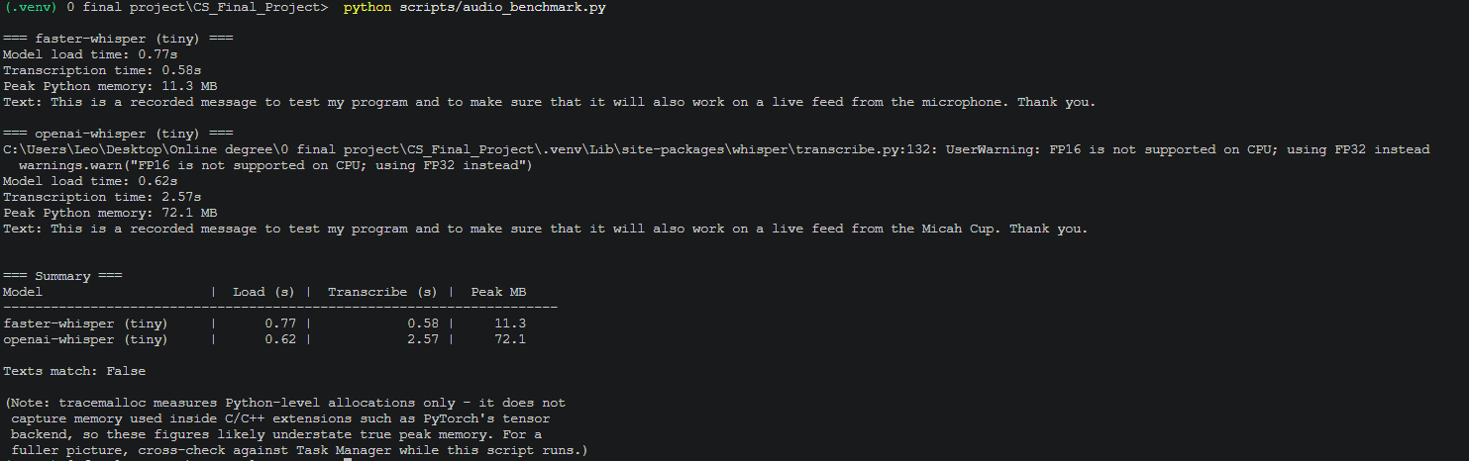
Figure 9. audio_benchmark.py output. The final line of each transcript shows the accuracy difference reported above: faster-whisper returns "microphone" where openai-whisper returns "Micah Cup".

Stage 3 results: Sentiment / text-emotion analysis
Three candidate models were benchmarked on the same 10 test transcripts (see test_transcripts.py): VADER, a rule-based sentiment analyser (Hutto & Gilbert, 2014); j-hartmann/emotion-english-distilroberta-base, a transformer trained on the same seven-emotion label space as DeepFace; and tabularisai/multilingual-sentiment-analysis, a 5-class sentiment model.
j-hartmann was selected. It correctly labelled 6 of 10 transcripts, including the surprise and disgust cases that both other models missed entirely, and its shared label space with DeepFace (anger, disgust, fear, joy, neutral, sadness, surprise) means facial and verbal emotion can be compared directly downstream (e.g. "your face showed sadness while your words expressed joy"). At 44ms per input it remains far faster than needed for a system driven by user speech, where the bottleneck is transcription and conversation, not sentiment scoring.
Table 4 summarises average performance per candidate model across all 10 test transcripts.
Model | Avg latency (ms/input) | Memory | Notes
VADER | 0.18 | Negligible (rule-based, no model weights) | Fastest by far, but only 3-class (positive/negative/neutral); cannot detect surprise or disgust and missed the mixed-emotion case entirely
j-hartmann/emotion-english-distilroberta-base | 44.31 | See note below table | 6/10 correct; shares DeepFace's 7-emotion label space; only model to correctly catch surprise and disgust
tabularisai/multilingual-sentiment-analysis | 30.87 | See note below table | Heavily biased toward "Negative" - 8/10 predictions were Negative, including clearly positive/neutral cases
Table 4. Average latency per candidate model on an Intel Core i7-1185G7, 16GB RAM, no dedicated GPU. Memory: tracemalloc reported 193.2MB peak Python memory across the full benchmark run (all three models); per-model isolation was not measured in this run and is noted as a limitation.
Table 5 shows the label each model predicted for every test transcript, against the expected label. Bold indicates a mismatch with the expected label.
Text | Expected | VADER | j-hartmann | tabularisai
Honestly I feel really good today... | happy | positive | joy | Positive
I don't know, I've just been feeling really down... | sad | negative | joy (wrong) | Negative
It was a normal day, nothing much happened. | neutral | neutral | neutral | Neutral
I keep worrying about this presentation... | fear | negative | fear | Negative
It's just so frustrating, nobody ever listens... | anger | negative | sadness (wrong) | Negative
I'm excited about the new job but also kind of scared... | mixed | negative | fear | Negative
I had this weird dream last night... | fear | negative | fear | Negative
Wait, I did not expect that at all, that's wild. | surprise | neutral | surprise | Negative
That really put me off, I couldn't stand it. | disgust | neutral | disgust | Negative
I'm fine. | neutral | positive | neutral | Positive
Table 5. Predicted label per model against the expected label for each test transcript, run on an Intel Core i7-1185G7, 16GB RAM, no dedicated GPU.
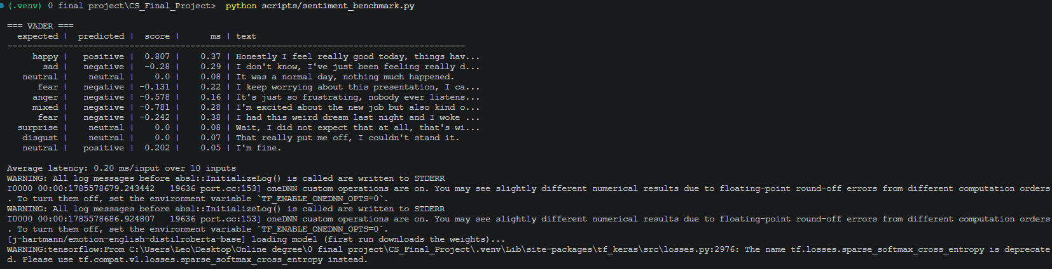
Figure 10. sentiment_benchmark.py output for VADER, showing the 3-class limitation: the surprise and disgust transcripts both fall back to neutral.
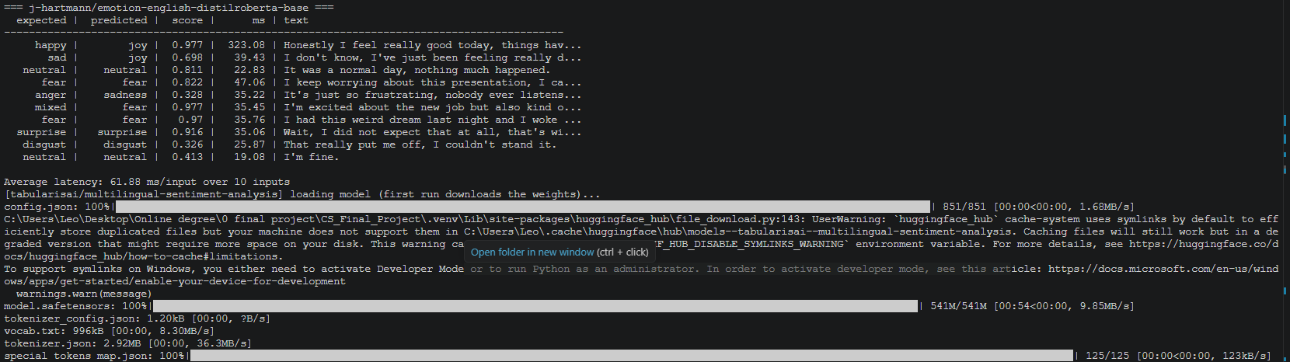
Figure 11. sentiment_benchmark.py output for j-hartmann/emotion-english-distilroberta-base, the selected model - the only candidate to label surprise and disgust correctly.
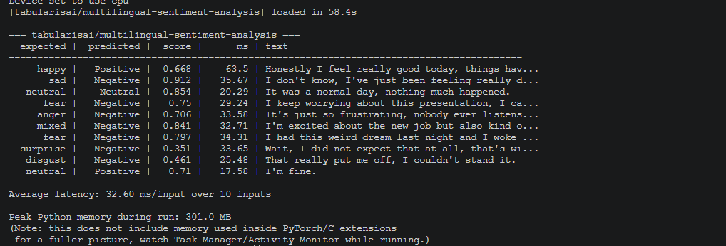
Figure 12. sentiment_benchmark.py output for tabularisai/multilingual-sentiment-analysis, showing the negative-label bias described above, with the run's peak memory figure.

Stage 4 results: Local language model (Ollama)
llama3.2 was integrated and tested as part of the full four-stage pipeline run described in the Implementation chapter. The model produced a coherent, non-diagnostic reflection that correctly identified an emotional mismatch across the facial and text-emotion signals (fear detected in the "sad scene" against an otherwise neutral spoken tone), offered three concrete, general wellbeing recommendations (journaling, mindful breathing, time outdoors), and correctly triggered the seek_help flag by recommending professional support given the distress signal - confirming the severity-assessment design requirement is functioning as intended for at least this test case.
Figure 13. The profile section of a session log, with seek_help correctly set to true for a session whose generated reflection recommended professional support.
This result is evidence of correct integration, not of overall output quality or safety across a range of inputs: it is a single run on simulated per-scene emotion data (see Stage 1), not real user sessions, and only one model has been tried so far.
The interactive follow-up conversation described in the Design chapter is now also functional: run_chat_loop() takes user input after the profile is printed and passes it to ProfileGenerator.chat(), which retains the full session context (facial emotion summary, transcript, and the profile itself) across turns. This was verified manually across several follow-up turns, with the model's replies generally remaining consistent with, and referencing, the profile it had just generated.
One notable limitation surfaced during this testing: on at least one follow-up turn, llama3.2 produced a reply that misjudged the intent of an ambiguous user message and responded with an inappropriate, unrelated safety refusal rather than asking for clarification or responding sensibly. The reply was incorrect and out of context rather than unsafe in itself, but it illustrates a real risk for this project: a small local model can misread short or ambiguous input in unpredictable ways, and for a tool operating in a mental-health-adjacent context, an erratic or nonsensical response at the wrong moment could undermine user trust or feel dismissive. This single incident is followed up systematically below.
A structured robustness test (chat_robustness_test.py) was then run to replace this single anecdote with a systematic count: 10 varied and ambiguous follow-up messages - spanning short/terse input, an off-topic question, ambiguous emotional statements, a direct diagnosis request, sarcasm, a meta-question about data handling, nonsense input, a topic shift, mild distress language, and a reference back to earlier context - were sent through the same conversation history on both llama3.2 and qwen2.5:3b, starting from an identical profile context on each model. Table 6 summarises the outcome per model.
Model | On-topic / appropriate | Inappropriate refusal | Factually wrong (system-inconsistent)
llama3.2 | 7/10 | 2/10 | 1/10
qwen2.5:3b | 9/10 | 0/10 | 1/10
Table 6. Chat robustness test, 10 messages per model, classified from the full reply transcripts (see logs/chat_robustness_results.csv).
The result confirms the original finding rather than overturning it: llama3.2 produced an inappropriate refusal on 2 of 10 messages (sarcasm and a reference back to earlier context, neither of which requested a diagnosis), refusing with "I can't provide a diagnosis" when no diagnosis had been asked for. qwen2.5:3b produced zero inappropriate refusals across the same 10 messages, correctly distinguishing an actual diagnosis request (which it declined appropriately) from messages that only superficially resembled one. This strengthens the case, raised in the Design chapter, that qwen2.5:3b's weaker seek-help consistency (Table 7, below) needs to be weighed against a more reliable non-refusal behaviour elsewhere, rather than treating llama3.2 as the safer choice by default.
One result was unexpected and is more serious than a refusal-style error: both models, asked "Are you saving what I just told you?", told the user their conversation was not being saved or stored ("each time you interact with me, it's a new conversation" / "I don't actually 'save' your conversations"). This directly contradicts both the consent screen, which discloses that the session and transcript are saved to a local log file, and the actual behaviour of save_session_log(), which does write the full chat history to disk after every session. Neither model was given this information in its system prompt, so this is an unprompted, confident, and incorrect claim about the system's own data handling, made immediately after the user consented to that same data handling being different. This is treated as a more significant finding than the refusal-rate result above: an erratic reply undermines trust, but a factually wrong answer about logging directly undermines informed consent, and is flagged as a priority fix - either instructing the model correctly on this point in the system prompt, or intercepting and answering this class of question outside the language model entirely.
llama3.2 and qwen2.5:3b were compared on an identical sample prompt built from a simulated emotion summary, transcript, and text-emotion result (see ollama_benchmark.py). Results are given in Table 7.
Model | Time to first token | Total generation time | Approx. size | Output quality (notes)
llama3.2:3b | 10.46s | 28.04s | ~2GB | 1332-character reply; explicitly recommended professional support given the fear signal
qwen2.5:3b | 8.79s | 18.99s | ~2GB | 789-character reply, more concise; covered the same emotional patterns but did not recommend professional support for a comparable distress signal
Table 7. Local LLM comparison for profile generation, run on an identical sample emotion summary (facial emotions + transcript + sentiment scores) on an Intel Core i7-1185G7, 16GB RAM, no dedicated GPU.
qwen2.5:3b is roughly 30-40% faster on both metrics and produces noticeably shorter output. However, the missing seek-help recommendation on a prompt with a comparable distress signal to earlier llama3.2 tests is a meaningful finding given the project's severity-assessment design requirement (see Design chapter): a faster model is of limited value if it is less consistent at surfacing this specific, safety-relevant behaviour. llama3.2 was therefore retained as the primary model for the current build. This is based on a single comparison prompt rather than a systematic test and should be treated as an initial finding, not a conclusive result - see the structured chat-testing item above.

End-to-end pipeline timing
Total pipeline processing time was measured directly rather than estimated: each stage in run_pipeline() is wrapped in time.perf_counter(), and a timestamped JSON timing log is written alongside the existing session log on every completed run. Three full live runs were carried out (real consent, real webcam and microphone input, no --demo flag) on the same test machine used throughout this chapter (Intel Core i7-1185G7, 16GB RAM, no dedicated GPU). Table 8 reports the per-stage breakdown for all three.
Run | Vision (stimulus) | Spoken Q + transcription | Text-emotion | Profile generation | Total (excl. chat)
1 | 41.48s | 26.41s | 2.41s | 46.97s | 117.27s
2 | 49.45s | 20.92s | 13.81s | 34.57s | 118.74s
3 | 47.48s | 57.70s | 10.34s | 32.23s | 147.75s
Average | 46.1s | 35.0s | 8.9s | 37.9s | ~128s
Table 8. End-to-end pipeline timing across three full live runs (consent through profile generation, excluding the open-ended follow-up chat), on an Intel Core i7-1185G7, 16GB RAM, no dedicated GPU.
Chat is excluded from the reported total because it is user-paced and open-ended rather than a fixed system cost; including it (run 1: 138.13s, run 2: 144.52s, run 3: 194.50s) would conflate the pipeline's own processing time with however long the user chooses to keep talking. The consistent finding across all three runs is that the system takes just under two minutes, on average around 128 seconds, from the start of the stimulus to a delivered profile, with no cloud round-trip anywhere in that time. Profile generation (Ollama, average 37.9s) and the vision stage (average 46.1s, which includes the 36-second stimulus display time (twelve images at three seconds each) rather than being pure DeepFace inference cost) are the two largest and most variable contributors; text-emotion analysis is consistently negligible (2.4-13.8s, the higher end likely reflecting model warm-up on first call rather than a real per-session cost). This is the honest tradeoff the fully-local design decision (see Design chapter) carries: privacy and zero data transmission are bought at the cost of a real, roughly two-minute wait before the user receives their reflection, which a cloud-based equivalent could likely shorten but only by sending emotional data off-device.
These timing runs also surfaced two findings unrelated to timing itself, recorded here since they emerged from the same sessions. First, one run (run 2) returned an empty transcript for all three spoken questions, yet profile_generator.py still produced a confident, detailed reflection referencing content that was never said - the same over-interpretation-of-low-signal-input pattern already reported above (see Session logging), now confirmed to occur on a fully empty transcript rather than only a short one. Second, the per-scene dominant emotion returned by DeepFace varied substantially between the three runs on the same stimulus sequence (from predominantly negative to predominantly positive readings), reinforcing the direction-inconsistent misclassification already reported in Stage 1 results above rather than constituting a new finding.
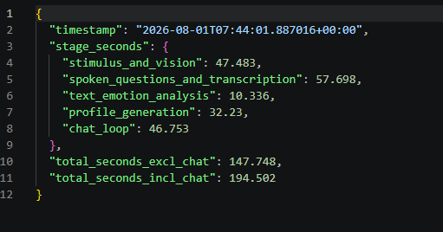
Figure 14. A timing log written at the end of a completed session, recording per-stage seconds and both totals. This is the raw form of the run 3 column in Table 8.

Session logging
Session logging (save_session_log()) was verified with a full live run: webcam capture, a spoken response, sentiment classification, profile generation, and a short follow-up chat, all written to a single timestamped JSON file. It was re-verified after the guided session flow was added, confirming that the consent status, demo-mode flag, and all three question-and-answer pairs are captured alongside the existing stage outputs. The chat history in the log confirmed the model correctly retained context across turns, referencing the earlier profile discussion when later asked what it remembered.
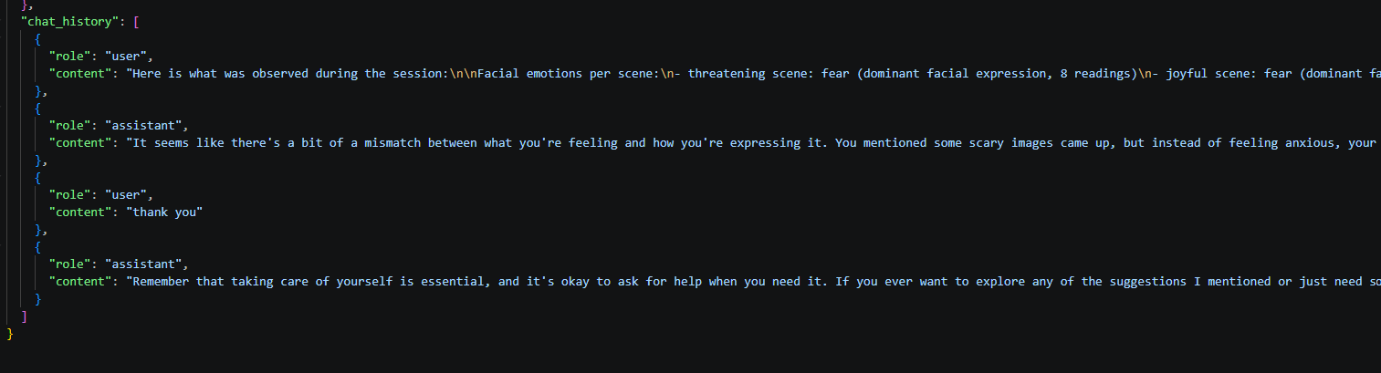
Figure 15. The chat_history field of a session log. The assistant's first reply refers directly back to the mismatch identified in the profile it had just generated, confirming session context is retained across turns.
This test run also surfaced another example of the model over-interpreting low-signal input, in addition to the finding noted above: given a microphone test phrase ("1, 2, 3, test") with neutral sentiment, the model constructed a confident, detailed narrative about the user's emotional state rather than recognising the input as a content-free test utterance. As with the earlier finding, this is not a crash or a safety failure, but it further supports the case for more systematic testing of how the language stage handles low-information or ambiguous input before this system could be relied upon with real users.

Unit testing
A pytest suite covers the deterministic, hardware-independent logic across all four testable modules, using mocks so tests run offline and instantly rather than loading real models, opening a microphone, or contacting a real Ollama server. For the vision module, test_emotion_detector.py was rewritten alongside the Stage 1 changes described in Implementation, and the two versions differ in both scope and design, not just line count.
The original suite (7 tests) covered only get_current_scene() and summarise_timeline(), asserting against the module-level video_sequence directly - a hardcoded, fixed four-scene schedule with round-number boundaries (0-5, 5-10, and so on), so exact elapsed-time values could be hardcoded straight into the test assertions.
The rewritten suite (17 tests) covers the same two functions plus three added by the OASIS integration: build_video_sequence(), get_current_stimulus(), and the picture-in-picture positioning helper _pip_position(). The more consequential change is structural rather than additive: video_sequence is no longer fixed, since its length now depends on however many images are present in each samples/stimuli/<scene> folder at runtime, which made the old approach of asserting against the real module-level sequence unreliable - the same test could pass or fail on a different machine depending on image counts with no code defect involved. get_current_scene() and get_current_stimulus() were therefore both given an optional sequence parameter, defaulting to the real filesystem-derived video_sequence for normal use but allowing tests to pass a small, fixed, hand-built four-scene schedule instead. This restores exactly the same determinism the original hardcoded video_sequence gave the old tests, without coupling the tests to disk contents. build_video_sequence() itself is tested separately, using pytest's tmp_path fixture to construct disposable scene folders per test case (correct entry count per image, duration scaling with image count, a missing stimuli root returning an empty sequence rather than raising, and non-image files being ignored) - this is the one genuinely new category of test, since there was no dynamic schedule-construction logic to test before. compose_frame() itself is not unit-tested, for the same reason live webcam capture wasn't: it needs real image arrays and a display, and is instead verified through the manual live run reported earlier in this chapter.
Live webcam capture is not unit-tested, since its input can't be reproduced deterministically, and is instead verified through feature testing.
For sentiment.py, the transformers pipeline is mocked so the tests check SentimentAnalyzer's own logic rather than the model's classification accuracy (that is instead covered by sentiment_benchmark.py against real model output): the empty/whitespace-input guard returns neutral without calling the model, the top label and score are extracted correctly regardless of the exact output nesting shape returned, and the model is confirmed to load only once across multiple analyze() calls rather than being reloaded each time.
For profile_generator.py, the ollama package is similarly mocked to isolate ProfileGenerator's own logic from the language model's output quality: the system prompt is confirmed to be set as the first history entry, _build_prompt() is confirmed to include all three upstream stages' outputs (and to handle an empty summary or transcript without raising), the seek_help keyword check is confirmed to trigger correctly (including case-insensitively) and to correctly stay False when no such keyword appears, and chat() is confirmed to both return the model's reply and share conversation history with an earlier generate_profile() call in the same session.
For session.py, both the microphone and the consent prompt are mocked, isolating the session logic from hardware and from a human typing at a terminal. The consent gate is tested across its full range of answers - an explicit "yes" (including with surrounding whitespace and mixed case), an explicit refusal, a blank line, an end-of-file and a keyboard interrupt - confirming that only the first proceeds and that the remainder fail closed rather than raising. The question stage is confirmed to ask all three questions in the defined order and to take a separate recording for each in live mode, while demo mode is confirmed to reuse the single bundled sample for all three. Transcript assembly is checked for content and ordering, including the empty case, and the closing message is confirmed to display professional-support signposting on every session while adding the stronger prompt only when the seek_help flag is set.
The full suite (46 tests across all four modules) passes: 17 vision tests, 6 sentiment tests, 8 profile-generator tests, and 15 session-flow tests, running in seconds with no external services, hardware or downloaded models required.
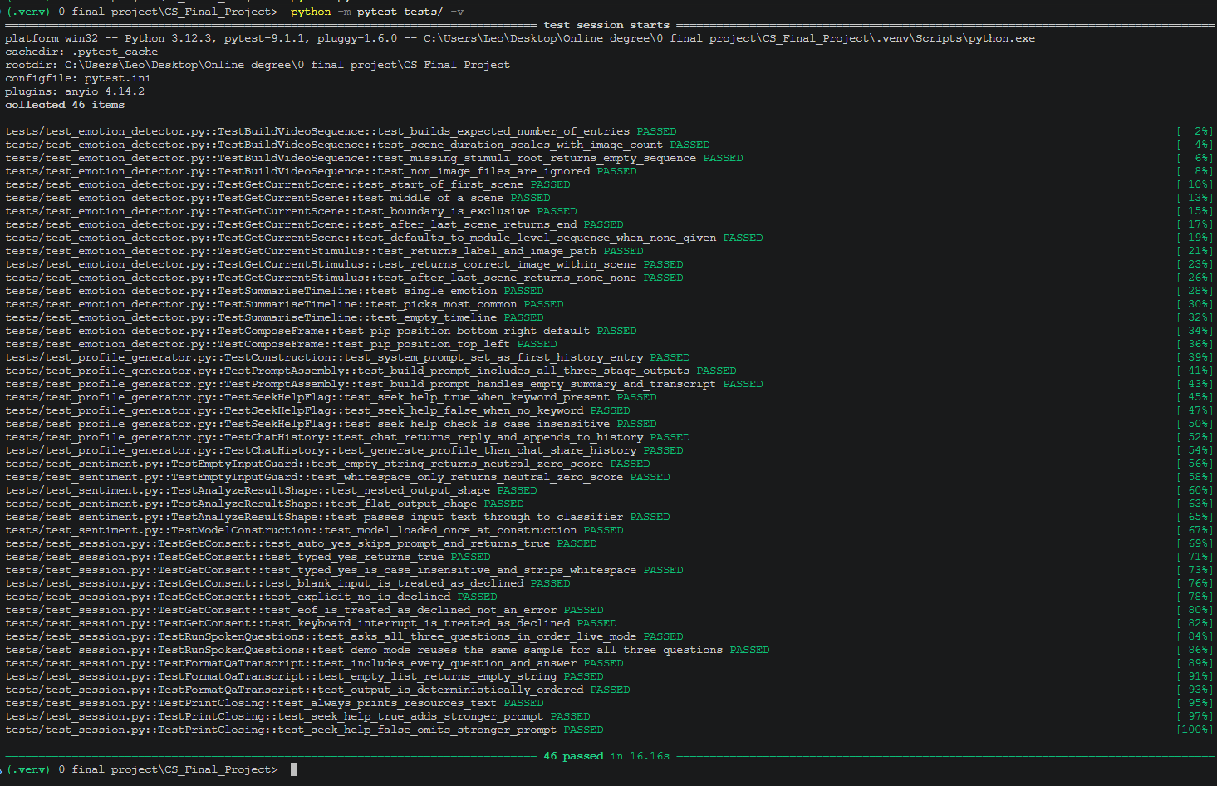
Figure 16. The full pytest suite: 46 tests across the four testable modules, passing in 16.16s with no external services, hardware or downloaded models required.
A pytest.ini file (pythonpath = src) was added at the project root so test files import directly from src (e.g. from sentiment import SentimentAnalyzer) without a manual sys.path workaround in every test file, and a matching .vscode/settings.json entry lets the editor's static analysis resolve the same imports, removing false-positive unresolved-import warnings during development.
Adding the fourth test module surfaced a latent inconsistency in this arrangement worth recording, since it is a genuine testing-infrastructure finding rather than a coding error. Two import styles had accumulated across the test suite: the vision tests import the package (from src import emotion_detector), which requires the project root on the path, while the remaining modules import flat module names, which requires src itself on the path. pytest.ini satisfied only the second, so the first worked only when pytest happened to be invoked in a way that placed the project root on sys.path incidentally. Running the full suite in one command exposed this. A root-level conftest.py that adds the project root to sys.path resolves it for every invocation, making the suite's behaviour independent of how it is launched.
Figure. The editor's static analyser (Pylance) flagging an unresolved import before pytest.ini and .vscode/settings.json were added. The import worked correctly at runtime throughout (the test suite passed regardless) - this was purely an editor-level false positive caused by the analyser not knowing about the src/ path used at test time, and was resolved by the configuration described above.

Peer review results

User testing

Inclusive design and demographic limitations

Overall assessment so far
The project is on track against its stated goal: a locally-run system combining multiple pre-trained models into a coherent psychological profile. All four stages are now implemented, integrated, and confirmed working together in a fully live end-to-end run, and are wrapped in the complete guided session flow: consent, stimulus with facial emotion detection, three separately recorded spoken questions, transcription, text-emotion classification, profile generation, an interactive follow-up conversation, and a closing message signposting professional support. All four stages now also have compare-and-reject evidence against a named alternative (Table 1-Table 7), with vision's DeepFace-vs-FER comparison the most recently closed of these. End-to-end pipeline timing is measured (Table 8) and the chat stage has been tested systematically rather than on a single incident (Table 6).
The main work remaining before the final report is no longer benchmarking or instrumentation but validation with real users and iteration on what that validation surfaces: running the planned pilot (2-3 people) and full (6-10 person) user studies, addressing the factually-wrong data-handling claim both language models produced under the chat robustness test (see Stage 4 results), and resolving DeepFace's direction-inconsistent resting-face misclassification, which the FER comparison narrowed to a likely camera-framing factor without fully resolving. The pipeline's architecture (small, independently-testable modules coordinated by pipeline.py) means each of these is an isolated change rather than a restructuring effort.

6. Conclusion
This project set out to build a fully local, privacy-preserving tool that helps a user reflect on their own emotional state by combining live facial-emotion detection, speech transcription, text-emotion analysis, and a local language model into a single guided session, rather than sending intimate emotional data to any cloud service or third party. The aim was to give a low-cost, stigma-reducing first step toward self-awareness and, where warranted, toward seeking real professional help, to people who cannot easily access or approach traditional mental health support.
At draft-submission time, all four model stages run correctly end to end: facial-emotion detection, transcription, text-emotion classification and profile generation are integrated, unit-tested (46 tests across all four modules), and confirmed working together across multiple live sessions, with the language model reliably surfacing a recommendation to seek professional support when the observed pattern warrants it. Real stimulus content (OASIS) has replaced the earlier placeholder scenes, and the guided session flow - consent, stimulus, three spoken questions, profile, interactive chat, and closing resources - is fully built and has been exercised repeatedly, including in the timing runs reported in Evaluation. What remains genuinely incomplete, rather than merely under-evidenced, is user-facing validation: a pilot study is planned but not yet run, the chat stage has not yet been tested systematically for erratic or off-topic replies beyond the incidents already documented, and DeepFace's resting-face misclassification, now confirmed to be direction-inconsistent across three OASIS runs rather than a single predictable bias, has not been resolved.
Before the final report, three pieces of work remain: a structured 5-10 message robustness test of the chat stage across both candidate language models; the planned pilot (2-3 people) and full (6-10 people) user studies, including analysis of self-report agreement and at least one documented change made in response to pilot feedback; and the Topic 9 peer review, which will specifically probe whether the conversational responses relate sensibly to the generated profile and whether the system makes clear it is not offering a diagnosis.
One tension threads through this project and is worth naming explicitly rather than leaving implicit: fully local processing is the system's central ethical commitment, and the end-to-end timing results (Evaluation) show what that commitment costs in practice - a genuine two-minute wait between finishing the stimulus and receiving a profile, dominated by local language-model inference. A cloud-hosted equivalent could likely deliver a faster result, but only by sending a user's facial-emotion readings, transcript, and inferred emotional state to a third-party server - precisely the trade-off this project was built to avoid. Whether that wait is an acceptable cost for privacy in a mental-health-adjacent tool, or a usability problem serious enough to warrant hybrid processing in a future iteration, is an open design question this project surfaces rather than resolves.

References
Abby Health. (2026). Abby AI: Medical decision support system. https://www.abbyhealth.com
Affectiva. (2016). The science behind Affectiva's emotion AI. https://www.affectiva.com
Buolamwini, J., & Gebru, T. (2018). Gender shades: Intersectional accuracy disparities in commercial gender classification. Proceedings of Machine Learning Research (Conference on Fairness, Accountability and Transparency), 81, 1-15.
Ezell, A. (2026). Evaluating AI chatbots for mental health diagnosis and treatment planning [Unpublished study]. Widener University.
Ghatoray, S. K., & Li, Y. (2025). Automated UX insights from user research videos by integrating facial emotion and text sentiment (arXiv:2503.22510). Department of Computer Science, Brunel University London. https://arxiv.org/abs/2503.22510
Graham, C., & Roll, N. (2024). Evaluating OpenAI's Whisper ASR: Performance analysis across diverse accents and speaker traits. JASA Express Letters, 4(2), Article 025206. https://doi.org/10.1121/10.0024876
Hartmann, J. (2022). Emotion English DistilRoBERTa-base [Model]. Hugging Face. https://huggingface.co/j-hartmann/emotion-english-distilroberta-base
Hugging Face. (2024). Text classification. https://huggingface.co/tasks/text-classification
Hutto, C. J., & Gilbert, E. (2014). VADER: A parsimonious rule-based model for sentiment analysis of social media text. Proceedings of the Eighth International AAAI Conference on Weblogs and Social Media, 216-225.
Kurdi, B., Lozano, S., & Banaji, M. R. (2017). Introducing the Open Affective Standardized Image Set (OASIS). Behavior Research Methods, 49(2), 457-470. https://doi.org/10.3758/s13428-016-0715-3
Laidi, R., et al. (2023).
Lee, D., et al. (2022).
Miller, R. (2017).
Ollama. (2024). Ollama documentation. https://ollama.com
OpenCV. (2026). OpenCV: Open source computer vision library. https://opencv.org
Radford, A., Kim, J. W., Xu, T., Brockman, G., McLeavey, C., & Sutskever, I. (2022). Robust speech recognition via large-scale weak supervision (arXiv:2212.04356). OpenAI. https://arxiv.org/abs/2212.04356
Riedl, R., et al. (2024).
Serengil, S. I., & Ozpinar, A. (2020). LightFace: A hybrid deep face recognition framework. 2020 Innovations in Intelligent Systems and Applications Conference (ASYU), 23-27. https://doi.org/10.1109/ASYU50717.2020.9259802
SYSTRAN. (n.d.). faster-whisper [Computer software]. GitHub. https://github.com/SYSTRAN/faster-whisper

