leonardo suarez Group 4 Assigment

Learning how to create diagrams in a database as a navigation tool. Creating diagram views as subject areas that isolates various sub-systems for querying information. Using the subject areas to solve problems for the business and document the necessary information needed to provide the appropriate query resolution. Writing 30 queries by each group member across the five databases identified.

Developing the soft skills needed in the business work environment such as teamwork, documentation and creating workflows.

Learning the structure of a newly acquired database systems by your company without any documentation.

Each Problem should follow the format in Problem 01.

Contents

Problem 01: 10

-- PROVIDE A LIST OF JOB CANDIDATES WHO GOT HIRED ALONG WITH THEIR RESPECTIVE JOB TITLE AND HIRE DATE 10

Explanation: 10

-- OUTPUT SHOULD SHOW ANYONE WHO GOT HIRED AND THE TITLE THEY RECEIVED ALONG WITH THE HIRE DATE 10

Database 10

Diagram(s) of tables 10

Columns from Standard view 11

Query 11

Sample Output with total number of rows returned (2) 12

Problem 02: 13

-- PROVIDE A LIST OF CITIES WITHT THE POSSIBLE DELIVERY METHODS 13

Explanation: 13

Database 13

Diagram(s) of tables 13

Columns from Standard view 14

Query 14

Sample Output with total number of rows returned (28) 15

Problem 03: 16

-- PROVIDE LIST OF LAST NAMES THAT INCLUDE AT LEAST ONE 1 "a" 16

Explanation: 16

Database 16

Diagram(s) of tables 16

Columns from Standard view 17

17

Query 17

Sample Output with total number of rows returned (2) 18

Problem 04: 19

-- PROVIDE A LIST OF PRODUCTS, THEIR PRICE AND THE CATEGORY THEY BELONG TO 19

Explanation: 19

Database 19

Diagram(s) of tables 19

Columns from Standard view 20

Query 21

Sample Output with total number of rows returned (77) 21

Problem 05: 22

-- PROVIDE A LIST OF AVAILABLE CURRENCY FORMS 22

Explanation: 22

Database 22

Diagram(s) of tables 22

Columns from Standard view 23

Query 23

Sample Output with total number of rows returned (105) 23

Problem 06: 24

-- provide me a list of all orders with a reason type that is not "other" 24

Explanation: 24

Database 24

Diagram(s) of tables 24

Columns from Standard view 25

Query 25

Sample Output with total number of rows returned (4237) 26

Problem 07: 27

-- make sure that every employee in the engineering department has a login ID 27

Explanation: 27

Database 27

Diagram(s) of tables 27

Columns from Standard view 28

Query 28

Sample Output with total number of rows returned (7) 29

Problem 08: 30

-- PROVIDE A LIST OF ALL TRANSACTIONS WITH UNKNOWN PAYMENT METHOD THAT OCCURED AT THE END OF THE MONTH IN 2016 30

Explanation: 30

Database 30

Diagram(s) of tables 30

Columns from Standard view 31

Query 31

Sample Output with total number of rows returned (319) 32

Problem 09: 33

-- PROVIDE A LIST OF STOCK ITEMS SOLD 33

Explanation: 33

Database 33

Diagram(s) of tables 33

Columns from Standard view 34

Query 34

Sample Output with total number of rows returned (227) 35

Problem 10: 36

-- PROVIDE A LIST THAT SHOWS IF ANY EMPLOYEE RATE CHANGED AT THE BEGINNING OF 2015 36

Explanation: 36

Database 36

Diagram(s) of tables 36

Columns from Standard view 37

Query 37

Sample Output with total number of rows returned (67) 38

Problem 11: 39

-- COUNT THE NUMBER OF PEOPLE WITH THE SAME SCORE 39

Explanation: 39

Database 39

Diagram(s) of tables 39

Columns from Standard view 40

Query 40

Sample Output with total number of rows returned (6) 41

Problem 12: 42

-- FIND HOW MANY CUSTOMERS WE HAVE IN EACH GEOGRAPHY KEY 42

Explanation: 42

Database 42

Diagram(s) of tables 42

Columns from Standard view 43

Query 43

Sample Output with total number of rows returned (336) 44

Problem 13: 45

-- #OF ORDERS PER SHIPPING COMPANY 45

Explanation: 45

Database 45

Diagram(s) of tables 45

Columns from Standard view 46

Query 46

Sample Output with total number of rows returned (3) 47

Problem 14: 48

Explanation: 48

Database 48

Diagram(s) of tables 48

Columns from Standard view 49

Query 49

Sample Output with total number of rows returned (2155) 50

Problem 15: 51

Explanation: 51

Database 51

Diagram(s) of tables 51

Columns from Standard view 52

Query 52

Sample Output with total number of rows returned (14) 53

Problem 16: 54

Explanation: 54

Database 54

Diagram(s) of tables 54

Columns from Standard view 55

Query 55

Sample Output with total number of rows returned (2155) 55

Problem 17: 56

Explanation: 56

Database 56

Diagram(s) of tables 56

Columns from Standard view 57

Query 57

Sample Output with total number of rows returned (2155) 57

Problem 18: 58

Explanation: 58

Database 58

Diagram(s) of tables 58

Columns from Standard view 59

Query 59

Sample Output with total number of rows returned (2155) 59

Problem 19: 60

Explanation: 60

Database 60

Diagram(s) of tables 60

Columns from Standard view 61

Query 61

Sample Output with total number of rows returned (2155) 61

Problem 20: 62

Explanation: 62

Database 62

Diagram(s) of tables 62

Columns from Standard view 63

Query 63

Sample Output with total number of rows returned (2155) 63

Problem 21: 64

Explanation: 64

Database 64

Diagram(s) of tables 64

64

Columns from Standard view 64

64

Query 65

Sample Output with total number of rows returned (3) 65

Problem 22: 66

Explanation: 66

Database 66

Diagram(s) of tables 66

Columns from Standard view 68

Query 68

Sample Output with total number of rows returned (2155) 68

Problem 23: 69

Explanation: 69

Database 69

Diagram(s) of tables 69

Columns from Standard view 70

Query 70

Sample Output with total number of rows returned (2155) 70

Problem 24: 71

Explanation: 71

Database 71

Diagram(s) of tables 71

Columns from Standard view 72

Query 72

Sample Output with total number of rows returned (2155) 72

Problem 25: 73

Explanation: 73

Database 73

Diagram(s) of tables 73

Columns from Standard view 74

Query 74

Sample Output with total number of rows returned (2155) 74

Problem 26: 75

Explanation: 75

Database 75

Diagram(s) of tables 75

Columns from Standard view 76

Query 76

Sample Output with total number of rows returned (2155) 76

Problem 27: 77

Explanation: 77

Database 77

Diagram(s) of tables 77

Columns from Standard view 78

Query 78

Sample Output with total number of rows returned (2155) 78

Problem 28: 79

Explanation: 79

Database 79

Diagram(s) of tables 79

Columns from Standard view 80

Query 80

Sample Output with total number of rows returned (2155) 80

Problem 29: 81

Explanation: 81

Database 81

Diagram(s) of tables 81

Columns from Standard view 82

Query 82

Sample Output with total number of rows returned (2155) 82

Problem 30: 83

Explanation: 83

Database 83

Diagram(s) of tables 83

Columns from Standard view 84

Query 84

Sample Output with total number of rows returned (2155) 84

# Problem 01:

## -- PROVIDE A LIST OF JOB CANDIDATES WHO GOT HIRED ALONG WITH THEIR RESPECTIVE JOB TITLE AND HIRE DATE

## Explanation:

## -- OUTPUT SHOULD SHOW ANYONE WHO GOT HIRED AND THE TITLE THEY RECEIVED ALONG WITH THE HIRE DATE

## Database

USE AdventureWorks2014;

## Diagram(s) of tables

Foreign Key(s) or column(s) used for the join

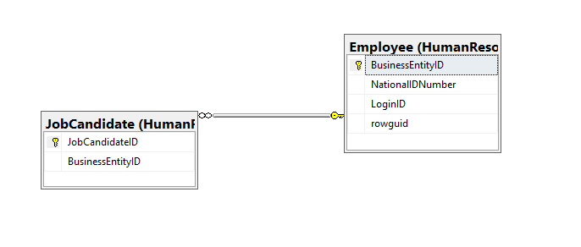

## Columns from Standard view

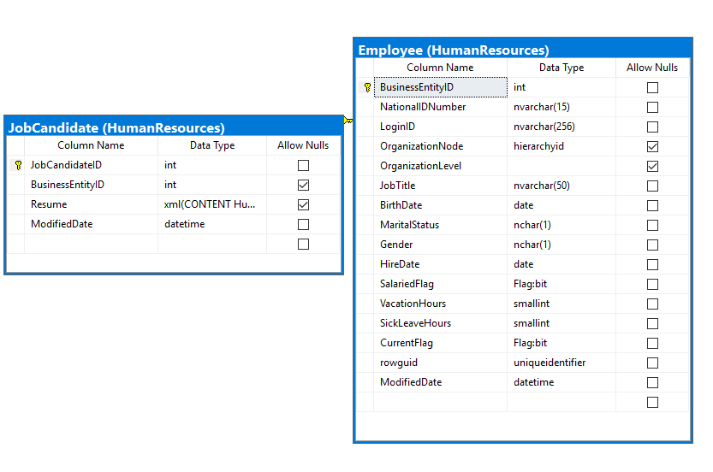

## Query

USE AdventureWorks2014;

SELECT JC.JobCandidateID

,E.JobTitle

,E.HireDate

FROM HumanResources.Employee AS E

INNER JOIN HumanResources.JobCandidate AS JC ON E.BusinessEntityID = JC.BusinessEntityID;

## Sample Output with total number of rows returned (2)

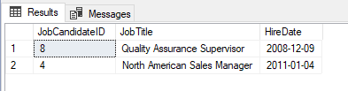

# Problem 02:

## -- PROVIDE A LIST OF CITIES WITHT THE POSSIBLE DELIVERY METHODS

## Explanation:

-- CROSS JOIN ALL THE POSSIBILITIES

## Database

USE WideWorldImporters;

## Diagram(s) of tables

Foreign Key(s) or column(s) used for the join

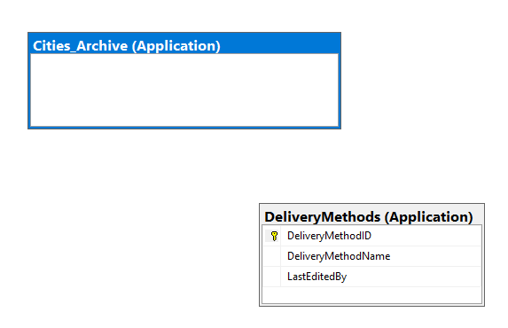

## Columns from Standard view

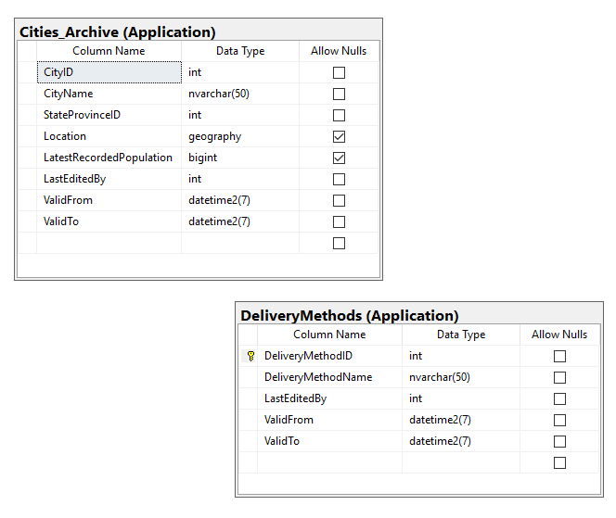

## Query

USE WideWorldImporters;

SELECT CA.CityName

,DM.DeliveryMethodName

FROM Application.Cities_Archive AS CA

CROSS JOIN Application.DeliveryMethods_Archive AS DM

## Sample Output with total number of rows returned (28)

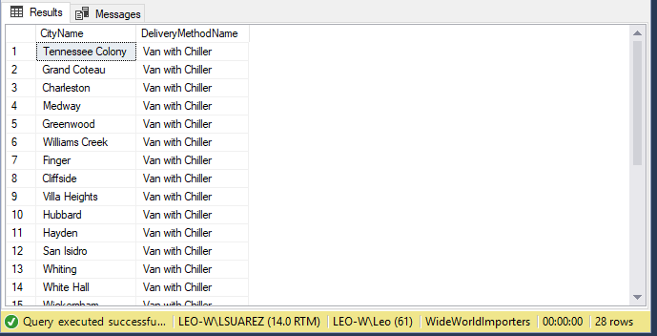

# Problem 03:

## -- PROVIDE LIST OF LAST NAMES THAT INCLUDE AT LEAST ONE "a"

## Explanation:

-- RUN THROUGH ALL THE NAMES AND ONLY RETURN THOSE WHICH HAVE 1 ONE MORE LETTERS “a”

## Database

USE TSQLV4;

## Diagram(s) of tables

Foreign Key(s) or column(s) used for the join

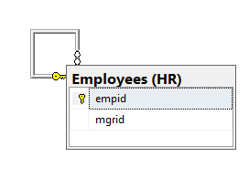

## Columns from Standard view

## 

## Query

USE TSQLV4;

SELECT lastname

,firstname

FROM HR.Employees

WHERE LastName LIKE '%a%';

## Sample Output with total number of rows returned (2)

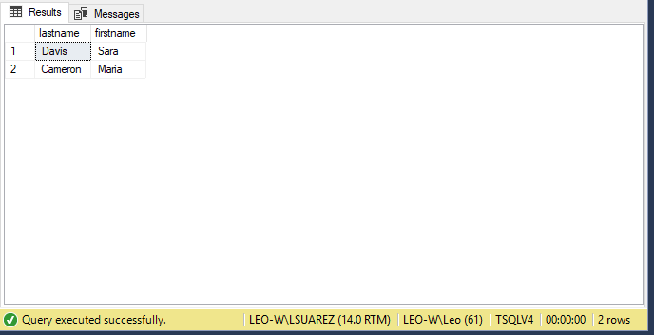

# Problem 04:

## -- PROVIDE A LIST OF PRODUCTS, THEIR PRICE AND THE CATEGORY THEY BELONG TO

## Explanation:

-- EACH PRODUCT SHOULD LIST THEIR PRICE AND THE CATEGORY THEY CORRESPOND TO

## Database

USE TSQLV4

## Diagram(s) of tables

Foreign Key(s) or column(s) used for the join

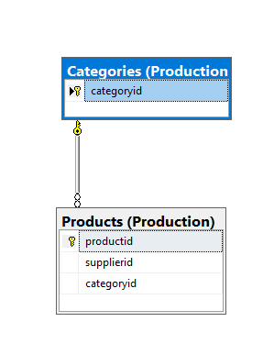

## Columns from Standard view

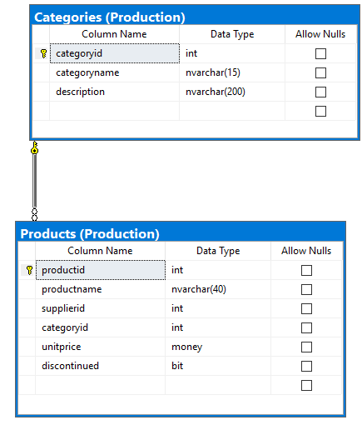

## Query

USE TSQLV4

SELECT P.productname AS Product

, P.unitprice AS Price

, C.categoryname AS Category

FROM Production.Products as P

INNER JOIN Production.Categories AS C ON P.categoryid = C.categoryid

## Sample Output with total number of rows returned (77)

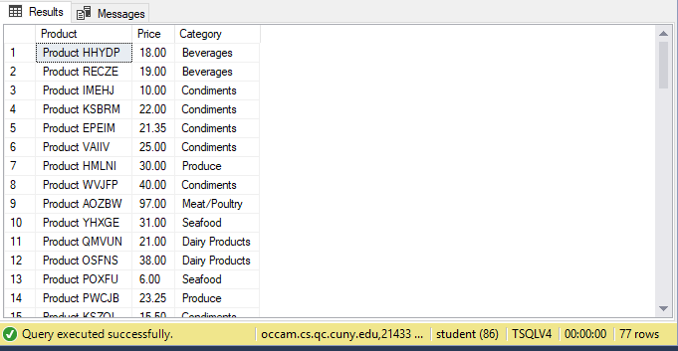

# Problem 05:

## -- PROVIDE A LIST OF AVAILABLE CURRENCY FORMS

## Explanation:

-- LIST ALL AVAILABLE CURRENCY FORMS

## Database

USE AdventureWorksDW2014;

## Diagram(s) of tables

Foreign Key(s) or column(s) used for the join

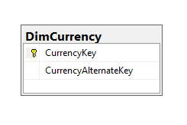

## Columns from Standard view

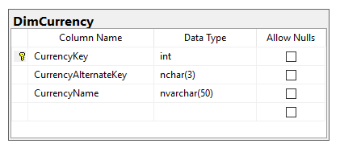

## Query

USE AdventureWorksDW2014;

SELECT CurrencyKey

,CurrencyName

FROM dbo.DimCurrency

## Sample Output with total number of rows returned (105)

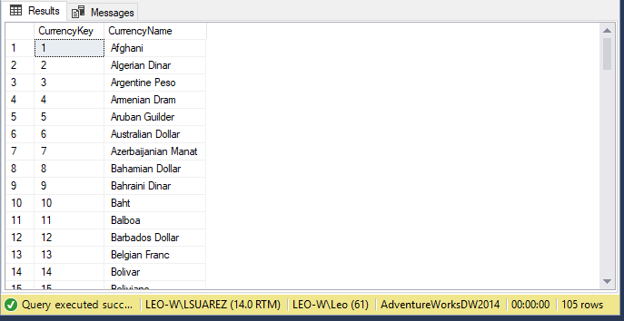

# Problem 06:

## -- PROVIDE A LIST OF ALL ORDERS WITH A REASON TYPE THAT IS NOT “OTHER”

## Explanation:

-- EVERY ORDER THAT IS RETURNED SHOULD NOT INDICATE “OTHER” AS A REASON TYPE

## Database

use AdventureWorks2014;

## Diagram(s) of tables

Foreign Key(s) or column(s) used for the join

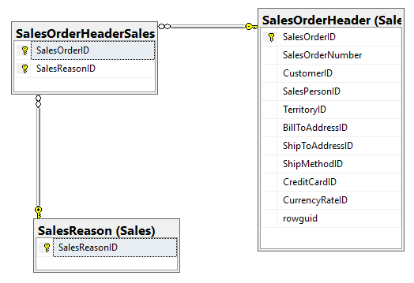

## Columns from Standard view

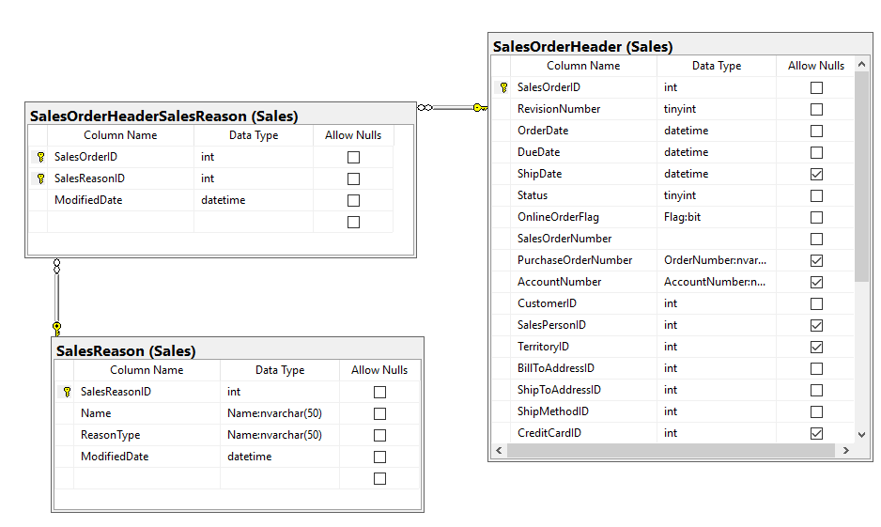

## Query

use AdventureWorks2014;

select OH.CustomerID, OH.SalesOrderNumber,SR.ReasonType

from sales.SalesOrderHeader as OH

join sales.SalesOrderHeaderSalesReason as OHR

on OH.SalesOrderID = OHR.SalesOrderID

join Sales.SalesReason as SR

on (SR.SalesReasonID = OHR.SalesReasonID and not SR.ReasonType = 'other')

## Sample Output with total number of rows returned (4237)

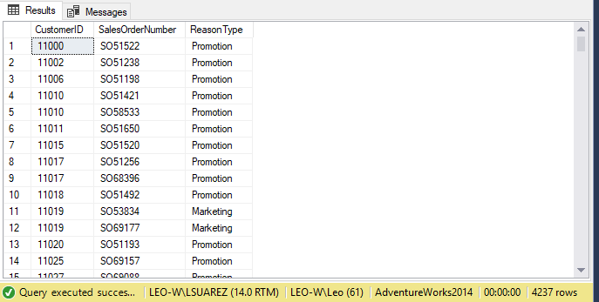

# Problem 07:

## -- make sure that every employee in the engineering department has a login ID

## Explanation:

-- make sure that every employee in the engineering department has a login ID

## Database

use AdventureWorks2014;

## Diagram(s) of tables

Foreign Key(s) or column(s) used for the join

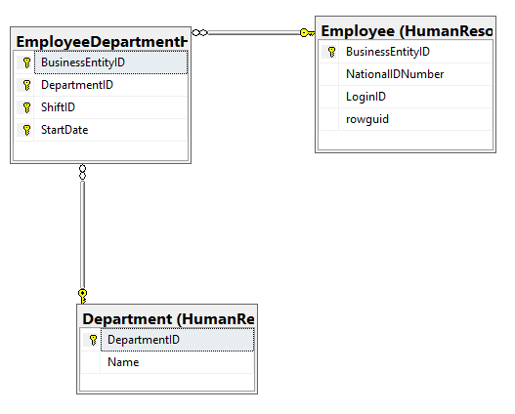

## Columns from Standard view

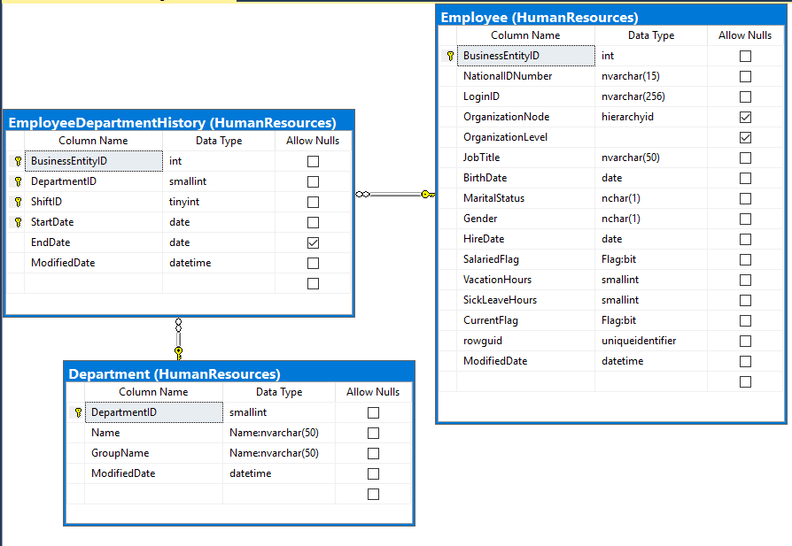

## Query

use AdventureWorks2014;

select E.LoginID, D.DepartmentID, D.[Name]

from HumanResources.Employee as E

join HumanResources.EmployeeDepartmentHistory as DH

on e.BusinessEntityID = DH.BusinessEntityID

join HumanResources.Department as D

on (d.DepartmentID = 1 and DH.DepartmentID = 1)

GROUP BY D.DepartmentID

,LoginID

,D.[Name]

## Sample Output with total number of rows returned (7)

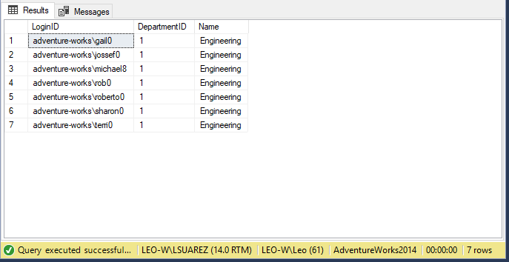

# Problem 08:

## -- PROVIDE A LIST OF ALL TRANSACTIONS WITH UNKNOWN PAYMENT METHOD THAT OCCURED AT THE END OF THE MONTH IN 2016

## Explanation:

-- PROVIDE A LIST OF ALL TRANSACTIONS WITH UNKNOWN PAYMENT METHOD THAT OCCURED AT THE END OF THE MONTH IN 2016

## Database

USE WideWorldImportersDW;

## Diagram(s) of tables

Foreign Key(s) or column(s) used for the join

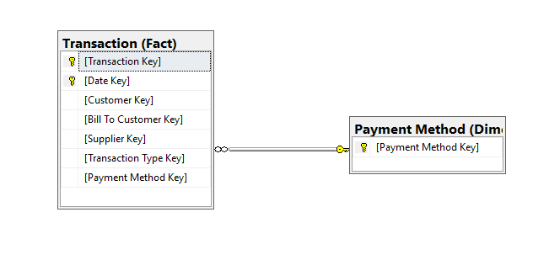

## Columns from Standard view

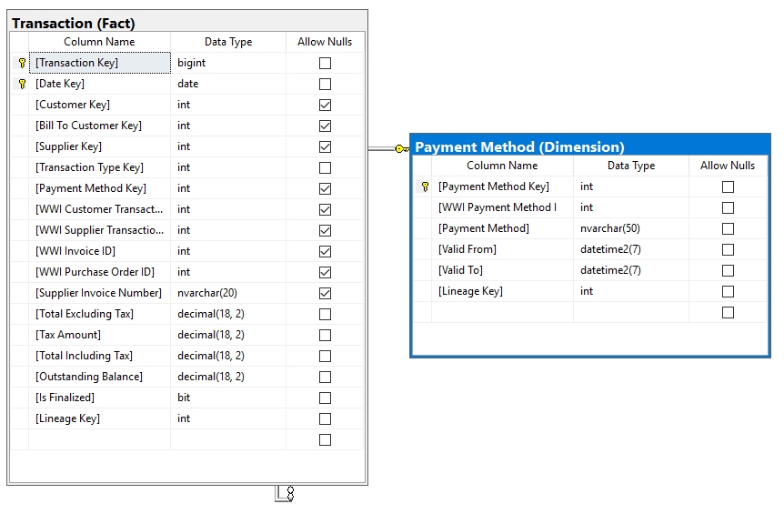

## Query

USE WideWorldImportersDW;

SELECT T.[Transaction Key]

,PM.[Payment Method]

,T.[Date Key] AS DATE

FROM Fact.[Transaction] AS T

INNER JOIN Dimension.[Payment Method] AS PM

ON T.[Payment Method Key] = PM.[Payment Method Key] AND PM.[Payment Method] = 'Unknown'

WHERE T.[Date Key] = EOMONTH(T.[Date Key])

AND YEAR(T.[Date Key]) = 2016

GROUP BY T.[Transaction Key]

,PM.[Payment Method]

,T.[Date Key]

ORDER BY T.[Date Key]

## Sample Output with total number of rows returned (319)

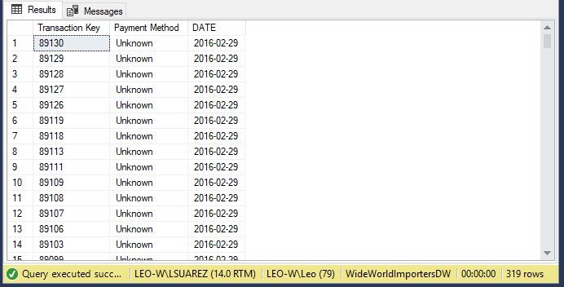

# Problem 09:

## -- PROVIDE A LIST OF STOCK ITEMS SOLD

## Explanation:

-- PROVIDE A LIST OF STOCK ITEMS SOLD

## Database

USE WideWorldImportersDW

## Diagram(s) of tables

Foreign Key(s) or column(s) used for the join

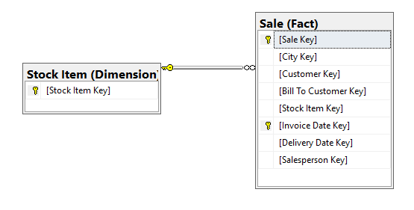

## Columns from Standard view

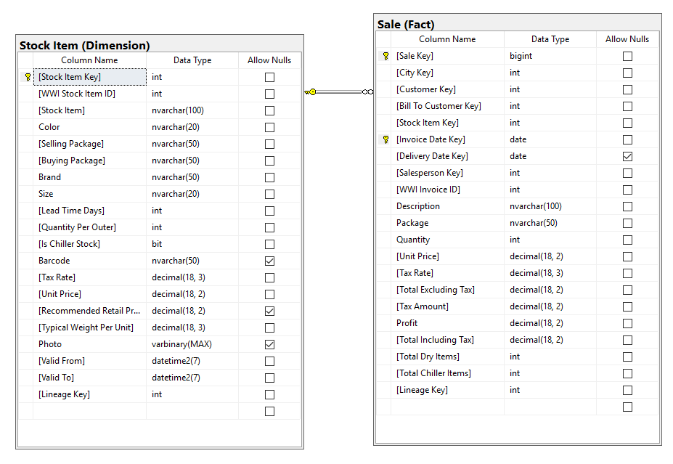

## Query

USE WideWorldImportersDW

SELECT DSI.[Stock Item Key]

,DSI.[Stock Item]

,SUM(FS.Quantity) AS QuantitySold

FROM Dimension.[Stock Item] AS DSI

INNER JOIN Fact.Sale AS FS ON FS.[Stock Item Key] = DSI.[Stock Item Key]

GROUP BY DSI.[Stock Item]

,DSI.[Stock Item Key]

## Sample Output with total number of rows returned (227)

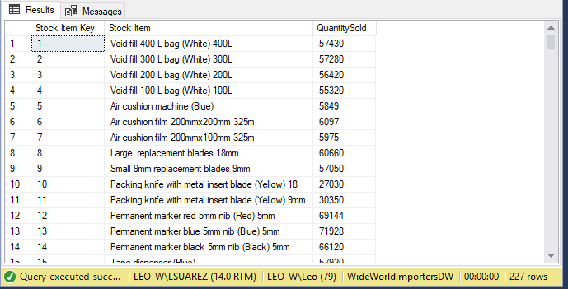

# Problem 10:

## -- PROVIDE A LIST THAT SHOWS IF ANY EMPLOYEE RATE CHANGED AT THE BEGINNING OF 2015

## Explanation:

-- PROVIDE A LIST THAT SHOWS IF ANY EMPLOYEE RATE CHANGED AT THE BEGINNING OF 2015

## Database

USE AdventureWorks2014

## Diagram(s) of tables

Foreign Key(s) or column(s) used for the join

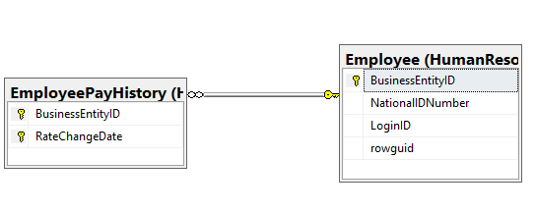

## Columns from Standard view

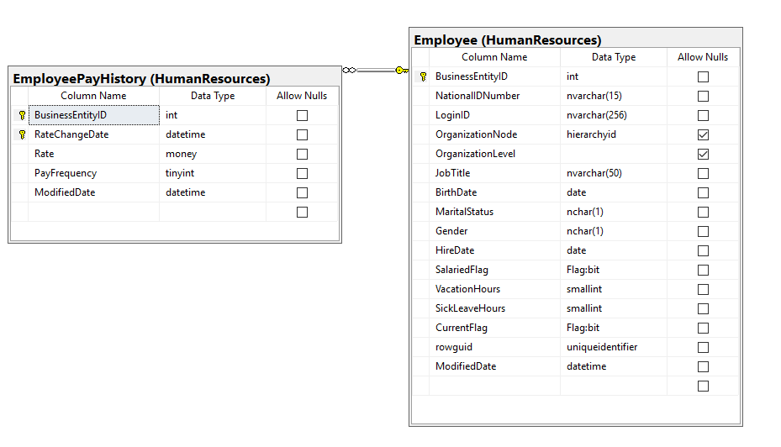

## Query

USE AdventureWorks2014

SELECT E.JobTitle

,PH.RateChangeDate

FROM HumanResources.Employee AS E

LEFT JOIN HumanResources.EmployeePayHistory AS PH

ON PH.RateChangeDate = CAST('20150101'AS DATE)

GROUP BY E.JobTitle

,PH.RateChangeDate

## Sample Output with total number of rows returned (67)

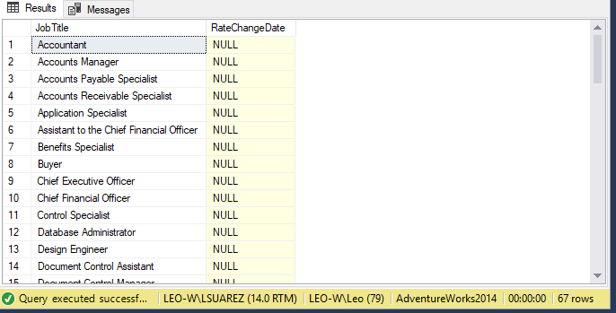

# Problem 11:

## -- COUNT THE NUMBER OF PEOPLE WITH THE SAME SCORE

## Explanation:

-- COUNT THE NUMBER OF PEOPLE WITH THE SAME SCORE

## Database

USE TSQLV4;

## Diagram(s) of tables

Foreign Key(s) or column(s) used for the join

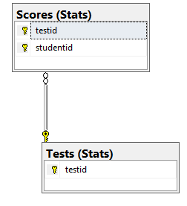

## Columns from Standard view

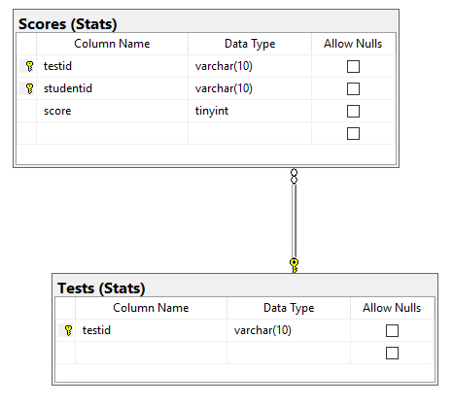

## Query

USE TSQLV4;

SELECT

COUNT(*) AS PeopleWithTheSameScore,

S.score AS Score

FROM

Stats.Tests AS T INNER JOIN Stats.Scores AS S

ON t.testid = s.testid

GROUP BY s.score

## Sample Output with total number of rows returned (6)

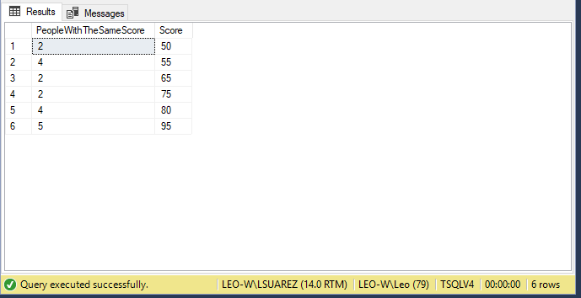

# Problem 12:

## -- FIND HOW MANY CUSTOMERS WE HAVE IN EACH GEOGRAPHY KEY

## Explanation:

-- FIND HOW MANY CUSTOMERS WE HAVE IN EACH GEOGRAPHY KEY

## Database

USE AdventureWorksDW2014;

## Diagram(s) of tables

Foreign Key(s) or column(s) used for the join

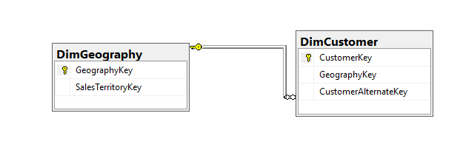

## Columns from Standard view

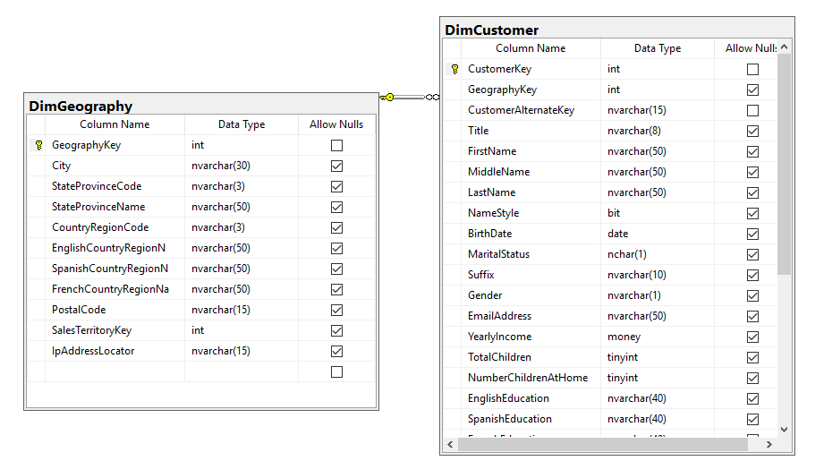

## Query

USE AdventureWorksDW2014;

SELECT

COUNT(DISTINCT C.CustomerKey) AS #CUSTOMERS,

g.GeographyKey

FROM

DimCustomer AS C INNER JOIN DimGeography AS G ON C.GeographyKey = G.GeographyKey

GROUP BY g.GeographyKey

## Sample Output with total number of rows returned (336)

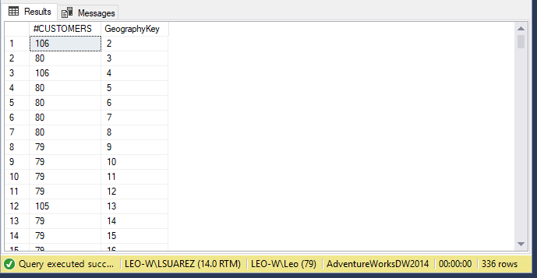

# Problem 13:

## -- #OF ORDERS PER SHIPPING COMPANY

## Explanation:

-- #OF ORDERS PER SHIPPING COMPANY

## Database

USE TSQLV4;

## Diagram(s) of tables

Foreign Key(s) or column(s) used for the join

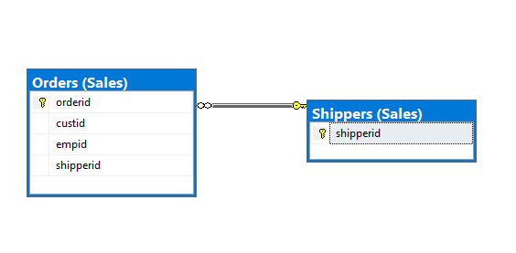

## Columns from Standard view

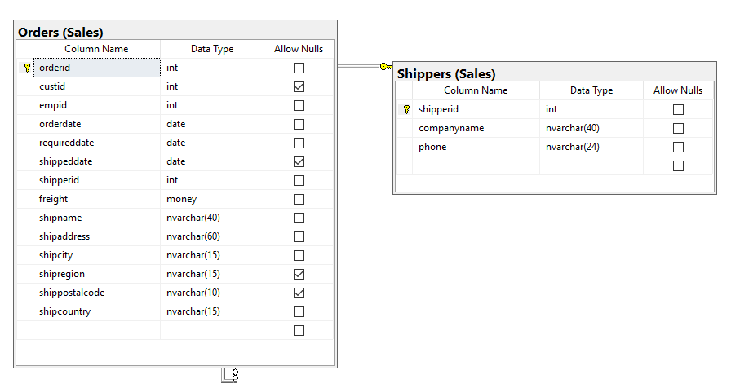

## Query

USE TSQLV4;

SELECT

COUNT( DISTINCT O.orderid) AS orders,

companyname

FROM Sales.Shippers AS SP

INNER JOIN Sales.Orders AS O

ON SP.shipperid = O.shipperid

GROUP BY companyname

## Sample Output with total number of rows returned (3)

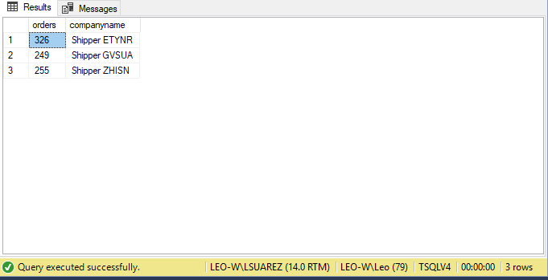

# Problem 14:

## --- PROVIDE A LIST OF THE TOP 200 STOCK ITEMS WITH THE HIGHEST LINE PROFIT

## Explanation:

--- THE LIST SHOULD BE ORDERED BY LINE PROFIT IN DESCENDING ORDER, PROVIDE DESCRIPTION AND ORDER LINE ID AS WELL AS WHEN THE PICKING WAS COMPLETED

## Database

use WideWorldImporters

## Diagram(s) of tables

Foreign Key(s) or column(s) used for the join

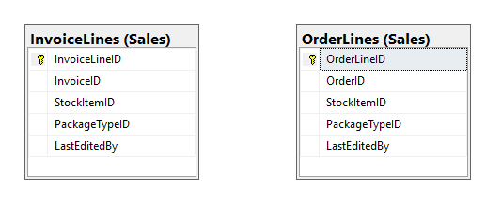

## Columns from Standard view

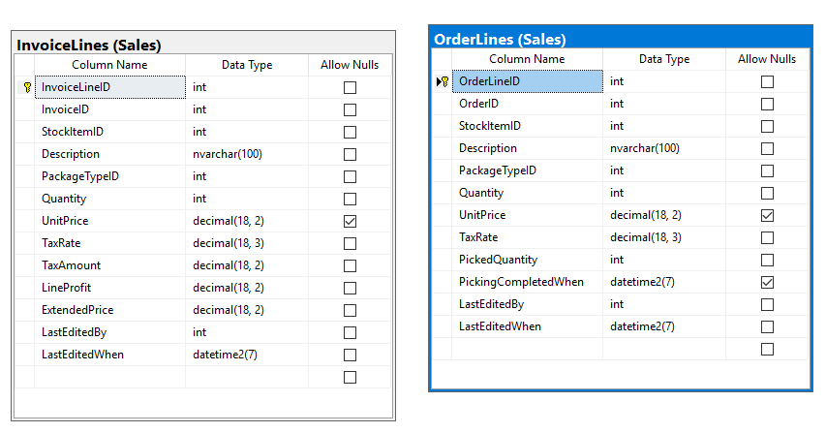

## Query

use WideWorldImporters

select top 200 OL.StockItemID,

OL.[Description],

OL.OrderLineID,

OL.PickingCompletedWhen,

IL.LineProfit

from Sales.InvoiceLines as IL

inner join (select StockItemID,

[Description],

OrderLineID,

PickingCompletedWhen

from Sales.OrderLines

WHERE PickingCompletedWhen Between CAST('20160201' as DATE) and CAST('20160301' as DATE)

group by StockItemID,

[Description],

OrderLineID,

PickingCompletedWhen

)as OL

on IL.StockItemID = OL.StockItemID

order by IL.LineProfit desc

## Sample Output with total number of rows returned (2155)

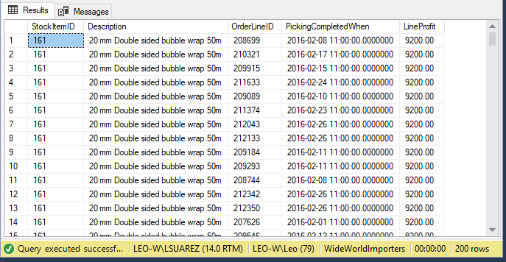

# Problem 15:

## --- PROVIDE A LIST OF CUSTUMERS AND SUPPLIERS WHERE THE CITY AND COUNTRY MATCH

## Explanation:

--- LIST SHOULD JOIN CUSTID AND SUPPLIERID BY CITY AND COUNTRY AS CUSTOMER REGION, SHOW COMPANY NAME AND CONTACT TITLE

## Database

use TSQLV4

## Diagram(s) of tables

Foreign Key(s) or column(s) used for the join

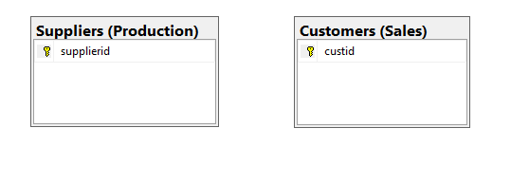

## Columns from Standard view

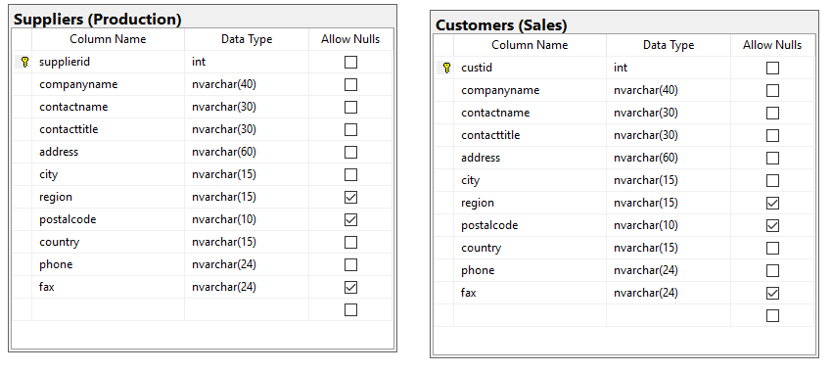

## Query

use TSQLV4

select cu.custid,

CU.companyname,

CU.contacttitle,

CONCAT(CU.city ,', ', CU.country) as CustomerRegion,

SU.supplierid,

SU.companyname,

SU.contacttitle,

CONCAT(SU.city ,', ', SU.country) as SupplierRegion

from sales.customers as CU

inner join Production.Suppliers as SU

on cu.country = SU.country and cu.city = su.city

## Sample Output with total number of rows returned (14)

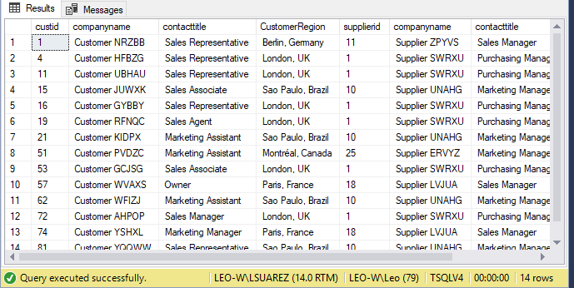

# Problem 16:

## --PROVIDE A LIST OF EMPLOYEE WHOSE PAY RATE CHANGED BETWEEEN 2009 AND 2010

## Explanation:

--JOIN TWO HUMAN RESOURCES AND EMPLOYEE PAY HISTORY MATCHED BY BUSINESS ENTITY ID AND SHOW ONLY VALUES BETWEEN 2009 AND 2010

## Database

USE AdventureWorks2014

## Diagram(s) of tables

Foreign Key(s) or column(s) used for the join



## Columns from Standard view



## Query

USE AdventureWorks2014

SELECT E.JobTitle

,PH.RateChangeDate

FROM HumanResources.Employee AS E

INNER JOIN HumanResources.EmployeePayHistory AS PH

ON e.BusinessEntityID = ph.BusinessEntityID

WHERE YEAR(PH.RateChangeDate) BETWEEN 2009 AND 2010

GROUP BY E.JobTitle

,PH.RateChangeDate

## Sample Output with total number of rows returned (183)

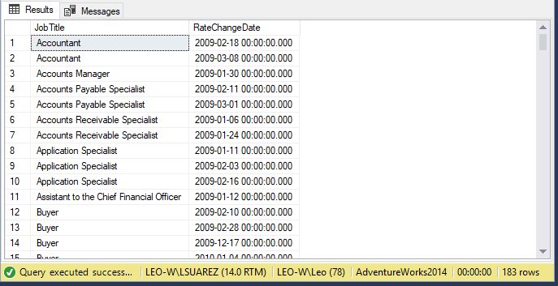

# Problem 17:

## --PROVIDE ALL ETF PURCHASES BETWEEN 2013 AND 2016

## Explanation:

--PROVIDE ALL ETF PURCHASES BETWEEN 2013 AND 2016

## Database

USE WideWorldImportersDW;

## Diagram(s) of tables

Foreign Key(s) or column(s) used for the join



## Columns from Standard view

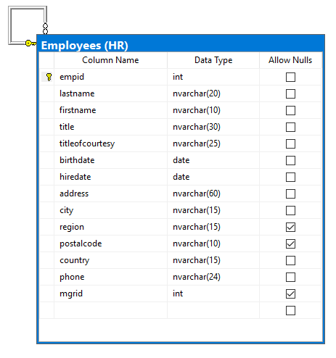

## Query

USE WideWorldImportersDW;

SELECT T.[Transaction Key]

,PM.[Payment Method]

,T.[Date Key] AS DATE

FROM Fact.[Transaction] AS T

INNER JOIN Dimension.[Payment Method] AS PM

ON T.[Payment Method Key] = PM.[Payment Method Key]

WHERE YEAR(T.[Date Key]) BETWEEN 2013 AND 2016

AND PM.[Payment Method] = 'EFT'

GROUP BY T.[Transaction Key]

,PM.[Payment Method]

,T.[Date Key]

ORDER BY T.[Date Key]

## Sample Output with total number of rows returned (29075)

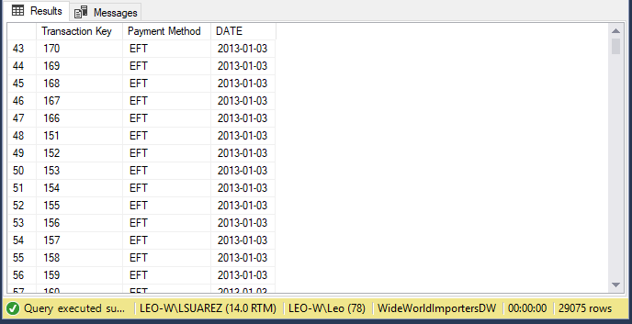

# Problem 18:

## Explanation:

## Database

## Diagram(s) of tables

Foreign Key(s) or column(s) used for the join

## Columns from Standard view

## Query

## Sample Output with total number of rows returned (2155)

# Problem 19:

## Explanation:

## Database

## Diagram(s) of tables

Foreign Key(s) or column(s) used for the join

## Columns from Standard view

## Query

## Sample Output with total number of rows returned (2155)

# Problem 20:

## Explanation:

## Database

## Diagram(s) of tables

Foreign Key(s) or column(s) used for the join

## Columns from Standard view

## Query

## Sample Output with total number of rows returned (2155)

# Problem 21:

## Explanation:

## Database

USE AdventureWorks2014

## Diagram(s) of tables

Foreign Key(s) or column(s) used for the join

## 

## Columns from Standard view

## 

## Query

USE AdventureWorks2014

DROP FUNCTION

IF EXISTS dbo.LastFourEquals;

GO

CREATE FUNCTION dbo.LastFourEquals

(

@LastFour int

)

RETURNS TABLE

AS

RETURN

SELECT

CAST(CardNumber AS bigint) AS number

FROM Sales.CreditCard

WHERE (CAST(CardNumber AS bigint) % 10000) = @LastFour

USE AdventureWorks2014

SELECT number as CreditCardNumber

-- ,LF.ExpMonth

--,LF.CardType

FROM dbo.LastFourEquals(1254) as number

INNER JOIN Sales.CreditCard AS CR ON CAST(CR.CardNumber as bigint) = number

GROUP BY number

## Sample Output with total number of rows returned (3)

