WDD130 - W03 Project: Rafting Site - Planning Document
Leonardo Wilches

- Logo

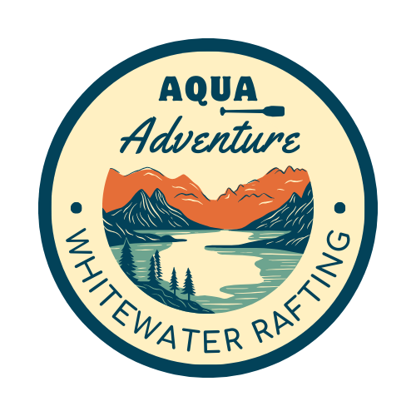
- Color Labels

- primary-color: #2364AA
- secondary-color: #73BFB8
- accent1-color: #FEC601
- accent2-color: #EA7317

- Font Labels

- heading-font: Comfortaa, SemiBold 600
- text-font: Roboto, Light 300

- Color palette

- Color palette URL link: https://coolors.co/2364aa-73bfb8-fec601-ea7317

