**Use Cases**

**1 - Admin**

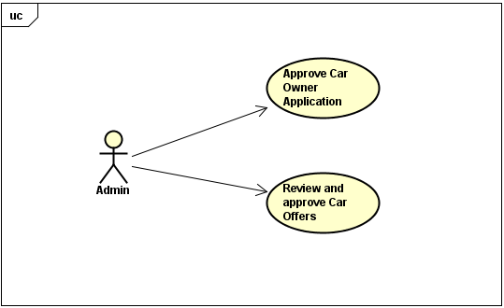

**2- Car Owner**

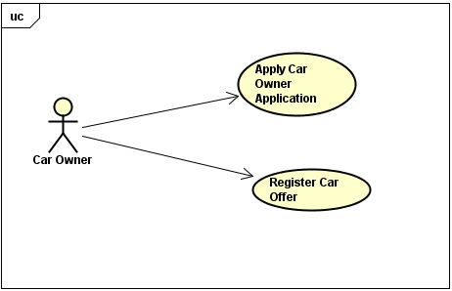

**3- Customer**

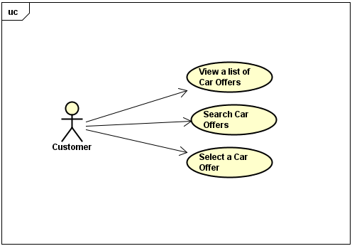

**Use Case Description**

|  |  |  |
| --- | --- | --- |
| **Use Case Number**: 1 | | |
| **Name** Approve CarOwner Application | | |
| **Brief description** This use case allows the Admin to manage Car Owner Applications | | |
| **Actors** Admin | | |
|  | | |
| **Preconditions** | | |
| The Admin must be logged in. | | |
| **Flows of Events:** | | |
| 1. Basic Flows | | |
| **1.1.0 Review and approve Car Owner Application** | | |
| **Step** | **User Actions** | **System Actions** |
| 1 | The admin selects to view pending Applications of Car Owner | The system returns a list of all pending Car Owner Applications |
| 2 | The admin selects the application that he wants to review | The system gets and displays details of selected Car Owner Application |
| 3 | The admin approves and saves the application | The system changes the state of application and saves it in the system.  The system returns a success or fail of this action |
| **Postconditions** | | |
| The Car Owner Application is updated and saved in DB | | |
| **Business Rules** | | |
|  | | |

|  |  |  |
| --- | --- | --- |
| **Use Case Number**: 2 | | |
| **Name** Review and approveCarOffers | | |
| **Brief description** This use case allows Admin to manage Car Offers | | |
| **Actors** Admin | | |
|  | | |
| **Preconditions** | | |
| The Admin must be logged in. | | |
| **Flows of Events:** | | |
| 1. Basic Flows | | |
| **1.1.0 Review and approve Car Offers** | | |
| **Step** | **User Actions** | **System Actions** |
| 1 | The admin selects to view pending Car Offers | The system returns a list of all pending Car Offers |
| 2 | The admin selects the Car Offer that he wants to review | The system gets and displays details of selected Car Offer |
| 3 | The admin approves and saves the Car Offer | The system changes the state of the Car Offer and saves it in the system.  The system returns a success or fail of this action |
| **Postconditions** | | |
| The Car Offer is updated and saved in DB and the car is ready for rental | | |
| **Business Rules** | | |
| The car up to 5 years old from the date is approved | | |
|  | | |

|  |  |  |
| --- | --- | --- |
| **Use Case Number**: 3 | | |
| **Name** ApplyCar Owner Application | | |
| **Brief description** This use case allows Car Owner to apply for it, and edit its application information | | |
| **Actors** CarOwner | | |
|  | | |
| **Preconditions** | | |
| The Car Owner must be logged in. | | |
| **Flows of Events:** | | |
| 1. Basic Flows | | |
| **1.1.0 Apply a Car Owner Application** | | |
| **Step** | **User Actions** | **System Actions** |
| 1 | The Car Owner clicks to Apply an Owner application | The system displays a Car Owner Profile form with fields: first name, last name, DOB, email, phone, address and bank account. |
| 2 | The Car Owner fills out and submit the form | The system validates required fields, verifies there is no other application the same requested one, saves the application with pending status in DB.  The system returns a success or fail. |
| **Postconditions** | | |
| The Car Owner Application is persistent in DB | | |
| **Business Rules** | | |
| There is no duplication of Car Owner application: no duplication of email, bank account. | | |
|  | | |
| **1.1.1 Edit an existing Car Owner application** | | |
| **Step** | **User Actions** | **System Actions** |
| 1 | The Car Owner gets their application profile | The system displays Car Owner Profile form a full info of first name, last name, DOB, email, phone, address and bank account. |
| 2 | The Car Owner selects to update fields they want to change, and submit the changes to the system | The system validates updated fields, saves the profile with pending status in DB.  The system returns a success or fail. |
|  |  |  |
| **Postconditions** | | |
| The system will save changes of Car Owner profile in DB | | |
| **Business Rules** | | |
| There is no duplication of Car Owner profile after changed: no duplication of email, bank account. | | |
| The Car Owner status will be changed to pending and waiting for Admin to approve. | | |

|  |  |  |
| --- | --- | --- |
| **Use Case Number**: 4 | | |
| **Name** RegisterCar Offers | | |
| **Brief description** This use case allows Car Owner to add, edit and delete their cars and offers | | |
| **Actors** CarOwner | | |
|  | | |
| **Preconditions** | | |
| The Car Owner must be logged in. | | |
| **Flows of Events:** | | |
| 1. Basic Flows | | |
| **1.1.0 Add a Car profile** | | |
| **Step** | **User Actions** | **System Actions** |
| 1 | The Car Owner selects to register a new Car and its Offer | The system displays a Car Offer form with fields: car name, model, manufacturer, year of manufacturing, rental price offer. |
| 2 | The Car Owner fills out and submit the form | The system validates required fields, saves the car profile with pending status in DB.  The system returns a success or fail. |
| **Postconditions** | | |
| The Car profile with its rental price offer is saved in DB | | |
| **Business Rules** | | |
| One Car Owner can add one or more Car Offers (same model, same manufacturer, etc) | | |
|  | | |
| **1.1.1 Edit an existing Car profile and offer** | | |
| **Step** | **User Actions** | **System Actions** |
| 1 | The Car Owner gets a list of their Car profiles and their Offers | The system displays Car profile and Offer list. |
| 2 | The Car Owner select a Car they want to update | The system displays Car form with a full info |
| 3 | The Car Owner selects to update fields they want to change, and submit the changes to the system | The system validates updated fields, saves the profile with pending status in DB.  The system returns a success or fail. |
|  |  |  |
| **Postconditions** | | |
| The system will save changes of Car Offer in DB | | |
| **Business Rules** | | |
| The Car Offer status will be changed to pending and waiting for Admin to approve. | | |
|  | | |
| **1.1.2 Delete an existing Car profile and Offer** | | |
| **Step** | **User Actions** | **System Actions** |
| 1 | The Car Owner gets a list of their Cars and Offers | The system displays the Car and Offer list |
| 2 | The Car Owner select a Car Offer that he wants to delete | The system asks for a confirmation to delete. |
| 3 | The Car Owner confirms to delete | The system deletes the profile from DB.  The system returns a success or fail. |
|  |  |  |
| **Postconditions** | | |
| Car offer is not existing in DB | | |
| **Business Rules** | | |
|  | | |
|  | | |

|  |  |  |
| --- | --- | --- |
| **Use Case Number**: 5 | | |
| **Name** View cars and their offers | | |
| **Brief description** Customer can view a list of available cars and their offers. | | |
| **Actors** Customer | | |
|  | | |
| **Preconditions** | | |
| The system must have cars in the DB. | | |
| **Flows of Events:** | | |
| 1. Basic Flows | | |
| **1.1.0 View cars and their offers** | | |
| **Step** | **User Actions** | **System Actions** |
| 1 | The customer opens the “home” page of Aha | The System shows the list of available cars and their offers. |
| **Postconditions** | | |
| The system will display the list of cars available. | | |
| **Business Rules** | | |
|  | | |

|  |  |  |
| --- | --- | --- |
| **Use Case Number**: 6 | | |
| **Name** Search/Filter car offers | | |
| **Brief description** Customer can search available cars that match with their needs. | | |
| **Actors** Customer | | |
|  | | |
| **Preconditions** | | |
| The system must have cars in the DB. | | |
| **Flows of Events:** | | |
| 1. Basic Flows | | |
| **1.1.0 Filter car offers** | | |
| **Step** | **User Actions** | **System Actions** |
| 1 | User inputs info on Search field at home page they want to search. | The System searches and returns Cars and Offers that match with search info. |
| 2 |  |  |
|  |  |  |
| **Postconditions** | | |
| The system apply the filter and return a subset of car offers. | | |
| **Business Rules** | | |
|  | | |

|  |  |  |
| --- | --- | --- |
| **Use Case Number**: 7 | | |
| **Name** Select and book a car offer. | | |
| **Brief description** Customer can select and book a car offer and book it. | | |
| **Actors** Customer | | |
|  | | |
| **Preconditions** | | |
| The system must have cars in the DB, the customer must to be logged in. | | |
| **Flows of Events:** | | |
| 1. Basic Flows | | |
| **1.1.0 Select a car offer** | | |
| **Step** | **User Actions** | **System Actions** |
| 1 | User click on one displayed car they want to book | The system opens a detail page: car name, rental price offer, etc, and other info for user to input |
| 2 | The customer input customer and rental info to book the car and clicks “Book” button. | The system receives customer info (name, address, driver license, rental date start, rental date end, credit card, …).  System returns a payment page. |
| 3 | The customer confirms the payment and clicks “Confirm”. | The system processes and returns a success or fail |
|  |  |  |
| **Postconditions** | | |
| The system processes the payment, books the car offer for the customer. This info is saved in DB. | | |
| **Business Rules** | | |
| Customer’s driver license must be valid | | |
| Credit card must be valid | | |