CS425 – Software Engineering

**Software Requirements Specification**

Aha

Version – 0.1

**3 August 2018**

TABLE OF CONTENTS

1 OVERVIEW 3

1.1 Purpose 3

1.2 Business Objectives 3

1.3 Scope 3

1.4 Out of Scope 3

1.5 Glossary 3

1.6 Assumptions 3

1.7 Constraints 3

1.8 Dependencies 3

2 USER REQUIREMENTS 4

2.1 Actors 4

2.2 Use Case Model 4

2.3 Use Case Catalogue 5

3 SYSTEM ARCHITECTURE 12

4 DATA DICTIONARY 12

5 COMMON BEHAVIOURS 12

6 NON-FUNCTIONAL REQUIREMENTS 13

# OVERVIEW

This document will specify Aha. In here include first the purpose of the system, its Scope and Objectives. Then detail of the system will be described through use case diagram and detail of each action.

## Purpose

The SRS should fully describe the external behaviour of the system. It also describes non-functional requirements, design constraints, and other factors necessary to provide a complete and comprehensive description of the requirements for the software.

## Business Objectives

The business objectives are to create Aha. The purposes of the system are:

1. Do not need to spend much money to invest in buying new cars at beginning.
2. Utilize unused or less-used cars to generate income for anyone those who are interested.
3. Create a new investment channel for anyone those who want to.
4. The car rental prices are much cheaper than the traditional car rental ones.

## Scope

* This project’s scope is to cover all use cases described on section 2.3 – Use Case Catalogue of this document.

## Out of Scope

* N/A

## Glossary

|  |  |
| --- | --- |
| **Term** | **Description** |
|  |  |
|  |  |

## Assumptions

|  |  |
| --- | --- |
| **Ref** | **Assumption** |
|  |  |
|  |  |
|  |  |

## Constraints

|  |  |
| --- | --- |
| **Ref** | **Constraint** |
|  |  |
|  |  |
|  |  |

## Dependencies

|  |  |
| --- | --- |
| **Ref** | **Dependency** |
|  |  |
|  |  |
|  |  |

# USER REQUIREMENTS

## Actors

|  |  |
| --- | --- |
| **Actor** | **Description** |
| Admin | Responsible for setting up, and managing the system. |
| Car Owner | Responsible to contribute cars to the service for rental. |
| Customer | Rent a car and pay car rental fee. |
|  |  |

## Use Case Model

### Use Case Model for System Admin

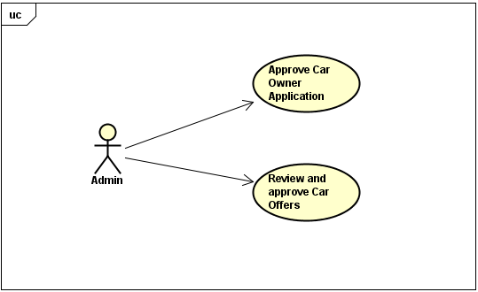

### Use Case Model Car Owner

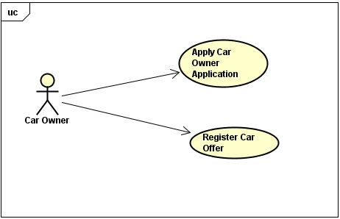

### Use Case Model Customer

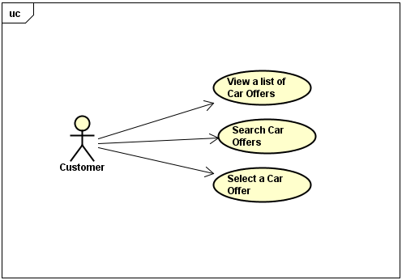

## Use Case Catalogue

### Approve Car Owner Application

|  |  |  |
| --- | --- | --- |
| **Use Case Number**: 1 | | |
| **Name** ApproveCarOwner Application | | |
| **Brief description** This use case allows the Admin to manage Car Owner Applications | | |
| **Actors** Admin | | |
|  | | |
| **Preconditions** | | |
| The Admin must be logged in. | | |
| **Flows of Events:** | | |
| 1. Basic Flows | | |
| **1.1.0 Review and approve Car Owner Application** | | |
| **Step** | **User Actions** | **System Actions** |
| 1 | The admin selects to view pending Applications of Car Owner | The system returns a list of all pending Car Owner Applications |
| 2 | The admin selects the application that he wants to review | The system gets and displays details of selected Car Owner Application |
| 3 | The admin approves and saves the application | The system changes the state of application and saves it in the system.  The system returns a success or fail of this action |
| **Postconditions** | | |
| The Car Owner Application is updated and saved in DB | | |
| **Business Rules** | | |
|  | | |

### Review and Approve Car Offer

|  |  |  |
| --- | --- | --- |
| **Use Case Number**: 2 | | |
| **Name** Review and ApproveCarOffer | | |
| **Brief description** This use case allows Admin to manage Car Offers | | |
| **Actors** Admin | | |
|  | | |
| **Preconditions** | | |
| The Admin must be logged in. | | |
| **Flows of Events:** | | |
| 1. Basic Flows | | |
| **1.1.0 Review and approve Profiles of Car** | | |
| **Step** | **User Actions** | **System Actions** |
| 1 | The admin selects to view pending Car Offers | The system returns a list of all pending Car Offers |
| 2 | The admin selects the Car Offer that he wants to review | The system gets and displays details of selected Car Offer |
| 3 | The admin approves and saves the Car Offer | The system changes the state of the Car Offer and saves it in the system.  The system returns a success or fail of this action |
| **Postconditions** | | |
| The Car Offer is updated and saved in DB and the car is ready for rental | | |
| **Business Rules** | | |
| The car is up to 5 years old from the date is approved | | |
|  | | |

### Apply Car Owner Application

|  |  |  |
| --- | --- | --- |
| **Use Case Number**: 3 | | |
| **Name** ApplyCar Owner Application | | |
| **Brief description** This use case allows Car Owner to apply for it, and edit its application information | | |
| **Actors** CarOwner | | |
|  | | |
| **Preconditions** | | |
| The Car Owner must be logged in. | | |
| **Flows of Events:** | | |
| 1. Basic Flows | | |
| **1.1.0 Add a Car Owner profile** | | |
| **Step** | **User Actions** | **System Actions** |
| 1 | The Car Owner clicks to Apply an Owner application | The system displays a Car Owner Profile form with fields: first name, last name, DOB, email, phone, address and bank account. |
| 2 | The Car Owner fills out and submit the form | The system validates required fields, verifies there is no other profile the same requested one, saves the profile with pending status in DB.  The system returns a success or fail. |
| **Postconditions** | | |
| The Car Owner Application is persistent in DB | | |
| **Business Rules** | | |
| There is no duplication of Car Owner profile: no duplication of email, bank account. | | |
|  | | |
| **1.1.1 Edit an existing Car Owner application** | | |
| **Step** | **User Actions** | **System Actions** |
| 1 | The Car Owner gets their application profile | The system displays Car Owner Profile form a full info of first name, last name, DOB, email, phone, address and bank account. |
| 2 | The Car Owner selects to update fields they want to change, and submit the changes to the system | The system validates updated fields, saves the profile with pending status in DB.  The system returns a success or fail. |
|  |  |  |
| **Postconditions** | | |
| The system will save changes of Car Owner profile in DB | | |
| **Business Rules** | | |
| There is no duplication of Car Owner profile after changed: no duplication of email, bank account. | | |
| The Car Owner status will be changed to pending and waiting for Admin to approve. | | |

### Register Car Offers

|  |  |  |
| --- | --- | --- |
| **Use Case Number**: 4 | | |
| **Name** RegisterCar Offers | | |
| **Brief description** This use case allows Car Owner to add, edit and delete their cars and offers | | |
| **Actors** CarOwner | | |
|  | | |
| **Preconditions** | | |
| The Car Owner must be logged in. | | |
| **Flows of Events:** | | |
| 1. Basic Flows | | |
| **1.1.0 Add a Car profile** | | |
| **Step** | **User Actions** | **System Actions** |
| 1 | The Car Owner selects to register a new Car Offer | The system displays a Car Offer form with fields: car name, model, manufacturer, year of manufacturing, rental price. |
| 2 | The Car Owner fills out and submit the form | The system validates required fields, saves the car profile with pending status in DB.  The system returns a success or fail. |
| **Postconditions** | | |
| The Car Offers with its rental price is saved in DB | | |
| **Business Rules** | | |
| One Car Owner can add one or more Car Offers (same model, same manufacturer, etc) | | |
|  | | |
| **1.1.1 Edit an existing Car profile and offer** | | |
| **Step** | **User Actions** | **System Actions** |
| 1 | The Car Owner gets a list of their Car profiles and their Offers | The system displays Car profile and Offer list. |
| 2 | The Car Owner selects a Car Offer they want to update | The system displays Car Offer form with a full info |
| 3 | The Car Owner selects to update fields they want to change, and submit the changes to the system | The system validates updated fields, saves the profile with pending status in DB.  The system returns a success or fail. |
|  |  |  |
| **Postconditions** | | |
| The system will save changes of Car Offer in DB | | |
| **Business Rules** | | |
| The Car Offer status will be changed to pending and waiting for Admin to approve. | | |
|  | | |
| **1.1.2 Delete an existing Car profile** | | |
| **Step** | **User Actions** | **System Actions** |
| 1 | The Car Owner gets a list of their Car and Offers | The system displays the Car and Offer list |
| 2 | The Car Owner select a Car Offer that he wants to delete | The system asks for a confirmation to delete. |
| 3 | The Car Owner confirms to delete | The system deletes the profile from DB.  The system returns a success or fail. |
|  |  |  |
| **Postconditions** | | |
| Car offer is not existing in DB | | |
| **Business Rules** | | |
|  | | |
|  | | |

### View cars and their offers

|  |  |  |
| --- | --- | --- |
| **Use Case Number**: 5 | | |
| **Name** Viewcars and offers | | |
| **Brief description** Customer can view a list of available cars and their offers. | | |
| **Actors** Customer | | |
|  | | |
| **Preconditions** | | |
| The system must have cars in the DB. | | |
| **Flows of Events:** | | |
| 1. Basic Flows | | |
| **1.1.0 Browse car offers** | | |
| **Step** | **User Actions** | **System Actions** |
| 1 | The customer opens the “home” page of Aha | The System shows the list of available cars and their offers. |
| **Postconditions** | | |
| The system will display the list of cars available. | | |
| **Business Rules** | | |
|  | | |

### Search/Filter the car offers

|  |  |  |
| --- | --- | --- |
| **Use Case Number**: 6 | | |
| **Name** Search/Filter the car offers | | |
| **Brief description** Customer can search available cars that match with their needs | | |
| **Actors** Customer | | |
|  | | |
| **Preconditions** | | |
| The system must have cars in the DB. | | |
| **Flows of Events:** | | |
| 1. Basic Flows | | |
| **1.1.0 Search/Filter car offers** | | |
| **Step** | **User Actions** | **System Actions** |
| 1 | User inputs info on Search field at home page they want to search. | The System searches and returns Cars and Offers that match with search info. |
|  |  |  |
| **Postconditions** | | |
| The system apply the search and return a subset of car offers. | | |
| **Business Rules** | | |
|  | | |
|  | | |

### Select and book a car

|  |  |  |
| --- | --- | --- |
| **Use Case Number**: 7 | | |
| **Name** Select and book a car | | |
| **Brief description** Customer can select a car offer and book it. | | |
| **Actors** Customer | | |
|  | | |
| **Preconditions** | | |
| The system must have cars in the DB, the customer must to be logged in. | | |
| **Flows of Events:** | | |
| 1. Basic Flows | | |
| **1.1.0 Select and book a car** | | |
| **Step** | **User Actions** | **System Actions** |
| 1 | User click on one displayed car they want to book | The system opens a detail page: car name, rental price offer, etc. and other info for user to input |
| 2 | The customer input customer and rental info to book the car and clicks “Book” button. | The system receives customer info (name, address, driver license, rental date start, rental date end, credit card, …). System returns a payment page. |
| 3 | The customer confirms the payment and clicks “Confirm”. | The system processes and returns a success or fail |
|  |  |  |
| **Postconditions** | | |
| The system processes the payment, books the car offer for the customer. This info is saved in DB | | |
| **Business Rules** | | |
| Customer’s driver license must be valid | | |
|  | | |

# SYSTEM ARCHITECTURE

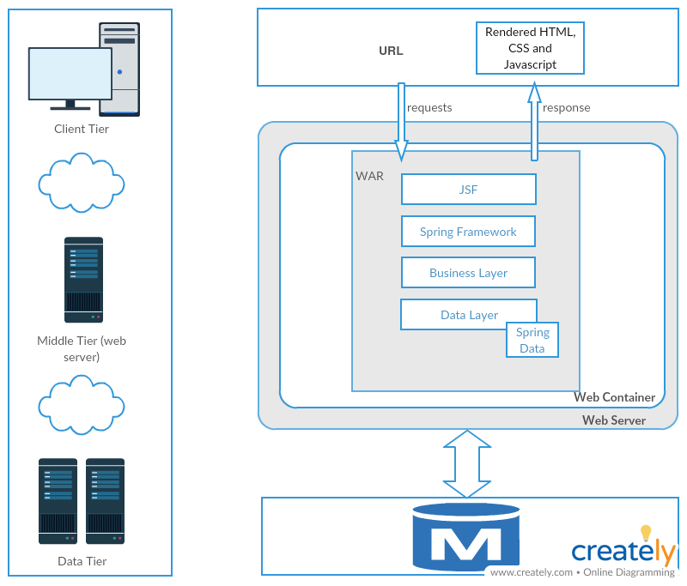

# DATA DICTIONARY

NA

# COMMON BEHAVIOURS

NA

# NON-FUNCTIONAL REQUIREMENTS

N/A