**Use Cases**

**1 - Admin**

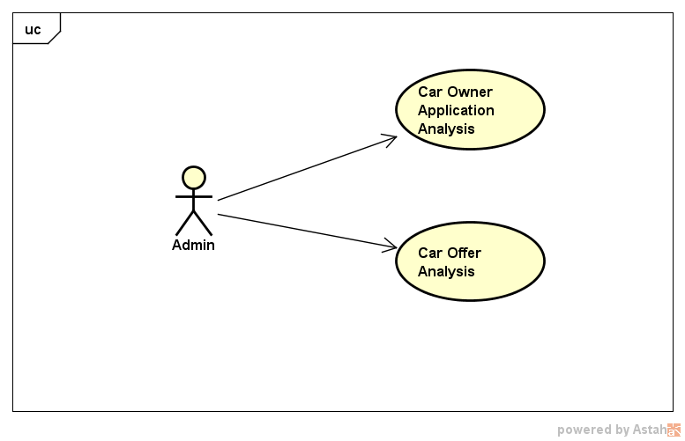

**2- Car Owner**

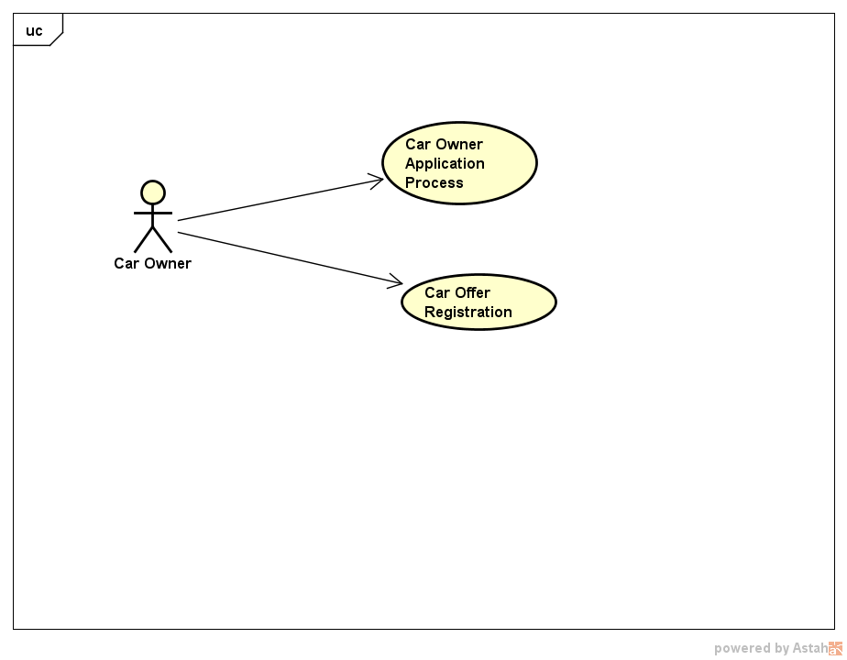

**3- Customer**

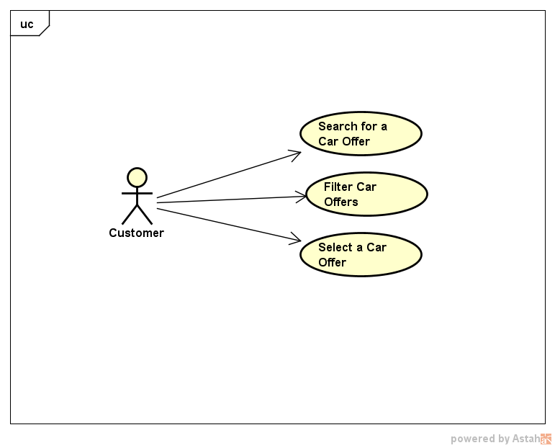

**Use Case Description**

|  |  |  |
| --- | --- | --- |
| **Use Case Number**: 1 | | |
| **Name** CarOwner Application Analysis | | |
| **Brief description** This use case allows the Admin to manage Car Owner Applications | | |
| **Actors** Admin | | |
|  | | |
| **Preconditions** | | |
| The Admin must be logged in. | | |
| **Flows of Events:** | | |
| 1. Basic Flows | | |
| **1.1.0 Review and approve Profiles of Car Owner** | | |
| **Step** | **User Actions** | **System Actions** |
| 1 | The admin selects to view pending Applications of Car Owner | The system returns a list of all pending Car Owner Applications |
| 2 | The admin selects the application that he wants to review | The system gets and displays details of selected Car Owner Application |
| 3 | The admin approves and saves the application | The system changes the state of application and saves it in the system.  The system returns a success or fail of this action |
| **Postconditions** | | |
| The Car Owner Application is updated and saved in DB | | |
| **Business Rules** | | |
|  | | |

|  |  |  |
| --- | --- | --- |
| **Use Case Number**: 2 | | |
| **Name** CarOffer Analysis | | |
| **Brief description** This use case allows Admin to manage Car Offers | | |
| **Actors** Admin | | |
|  | | |
| **Preconditions** | | |
| The Admin must be logged in. | | |
| **Flows of Events:** | | |
| 1. Basic Flows | | |
| **1.1.0 Review and approve Profiles of Car** | | |
| **Step** | **User Actions** | **System Actions** |
| 1 | The admin selects to view pending Car Offers | The system returns a list of all pending Car Offers |
| 2 | The admin selects the Car Offer that he wants to review | The system gets and displays details of selected Car Offer |
| 3 | The admin approves and saves the Car Offer | The system changes the state of the Car Offer and saves it in the system.  The system returns a success or fail of this action |
| **Postconditions** | | |
| The Car Offer is updated and saved in DB and the car is ready for rental | | |
| **Business Rules** | | |
| The car is up to 5 years old from the date is approved | | |
|  | | |

|  |  |  |
| --- | --- | --- |
| **Use Case Number**: 3 | | |
| **Name** Car Owner Application Process | | |
| **Brief description** This use case allows Car Owner to apply for it, and edit its profile information | | |
| **Actors** CarOwner | | |
|  | | |
| **Preconditions** | | |
| The Car Owner must be logged in. | | |
| **Flows of Events:** | | |
| 1. Basic Flows | | |
| **1.1.0 Add a Car Owner profile** | | |
| **Step** | **User Actions** | **System Actions** |
| 1 | The Car Owner calls Apply as Car Owner command | The system displays a Car Owner Profile form with fields: first name, last name, DOB, email, phone, address and bank account. |
| 2 | The Car Owner fills out and submit the form | The system validates required fields, verifies there is no other profile the same requested one, saves the profile with pending status in DB.  The system returns a success or fail. |
| **Postconditions** | | |
| The Car Owner Application is persistent in DB | | |
| **Business Rules** | | |
| There is no duplication of Car Owner profile: no duplication of email, bank account. | | |
|  | | |
| **1.1.1 Edit an existing Car Owner profile** | | |
| **Step** | **User Actions** | **System Actions** |
| 1 | The Car Owner gets their profile | The system displays Car Owner Profile form a full info of first name, last name, DOB, email, phone, address and bank account. |
| 2 | The Car Owner selects to update fields they want to change, and submit the changes to the system | The system validates updated fields, saves the profile with pending status in DB.  The system returns a success or fail. |
|  |  |  |
| **Postconditions** | | |
| The system will save changes of Car Owner profile in DB | | |
| **Business Rules** | | |
| There is no duplication of Car Owner profile after changed: no duplication of email, bank account. | | |
| The Car Owner status will be changed to pending and waiting for Admin to approve. | | |

|  |  |  |
| --- | --- | --- |
| **Use Case Number**: 4 | | |
| **Name** Car Offer Registration | | |
| **Brief description** This use case allows Car Owner to add, edit and delete their cars | | |
| **Actors** CarOwner | | |
|  | | |
| **Preconditions** | | |
| The Car Owner must be logged in. | | |
| **Flows of Events:** | | |
| 1. Basic Flows | | |
| **1.1.0 Add a Car profile** | | |
| **Step** | **User Actions** | **System Actions** |
| 1 | The Car Owner selects to register a new Car Offer | The system displays a Car Offer form with fields: car name, model, manufacturer, year of manufacturing, rental price. |
| 2 | The Car Owner fills out and submit the form | The system validates required fields, saves the car profile with pending status in DB.  The system returns a success or fail. |
| **Postconditions** | | |
| The Car Offers with its rental price is saved in DB | | |
| **Business Rules** | | |
| One Car Owner can add one or more Car Offers (same model, same manufacturer, etc) | | |
|  | | |
| **1.1.1 Edit an existing Car profile** | | |
| **Step** | **User Actions** | **System Actions** |
| 1 | The Car Owner gets a list of their Car Offers | The system displays Car Offer list. |
| 2 | The Car Owner select a Car Offer they want to update | The system displays Car Offer form with a full info |
| 3 | The Car Owner selects to update fields they want to change, and submit the changes to the system | The system validates updated fields, saves the profile with pending status in DB.  The system returns a success or fail. |
|  |  |  |
| **Postconditions** | | |
| The system will save changes of Car Offer in DB | | |
| **Business Rules** | | |
| The Car Offer status will be changed to pending and waiting for Admin to approve. | | |
|  | | |
| **1.1.2 Delete an existing Car profile** | | |
| **Step** | **User Actions** | **System Actions** |
| 1 | The Car Owner gets a list of their Car Offers | The system displays the Car Offer list |
| 2 | The Car Owner select a Car Offer that he wants to delete | The system asks for a confirmation to delete it. |
| 3 | The Car Owner confirms to delete | The system deletes the profile from DB.  The system returns a success or fail. |
|  |  |  |
| **Postconditions** | | |
| Car offer is not existing in DB | | |
| **Business Rules** | | |
|  | | |
|  | | |

|  |  |  |
| --- | --- | --- |
| **Use Case Number**: 5 | | |
| **Name** Search for a car offers | | |
| **Brief description** Customer can filter the set of available cars. | | |
| **Actors** Customer | | |
|  | | |
| **Preconditions** | | |
| The system must have cars in the DB. | | |
| **Flows of Events:** | | |
| 1. Basic Flows | | |
| **1.1.0 Search car offers** | | |
| **Step** | **User Actions** | **System Actions** |
| 1 | The customer opens the “home” page. | The System shows the list of cars available. |
| **Postconditions** | | |
| The system will display the list of cars available. | | |
| **Business Rules** | | |
|  | | |

|  |  |  |
| --- | --- | --- |
| **Use Case Number**: 6 | | |
| **Name** Filter car offers | | |
| **Brief description** Customer can browse available cars. | | |
| **Actors** Customer | | |
|  | | |
| **Preconditions** | | |
| The system must have cars in the DB. | | |
| **Flows of Events:** | | |
| **Flows of Events:** | | |
| 1. Basic Flows | | |
| **1.1.0 Filter car offers** | | |
| **Step** | **User Actions** | **System Actions** |
| 1 | The customer opens the “home” page. | The System shows the list of cars available. |
| 2 | Select one value for the filters (brand, model, year, …) and clicks “filter”. | The system shows a filtered set of car offers. |
|  |  |  |
| **Postconditions** | | |
| The system apply the filter and return a subset of car offers. | | |
| **Business Rules** | | |
|  | | |
|  | | |

|  |  |  |
| --- | --- | --- |
| **Use Case Number**: 7 | | |
| **Name** Select a car offer. | | |
| **Brief description** Customer can select a car offer and book it. | | |
| **Actors** Customer | | |
|  | | |
| **Preconditions** | | |
| The system must have cars in the DB, the customer must to be logged in. | | |
| **Flows of Events:** | | |
| 1. Basic Flows | | |
| **1.1.0 Select a car offer** | | |
| **Step** | **User Actions** | **System Actions** |
| 1 | User click on one displayed car. | The system opens a detail page. |
| 2 | The customer input the necessary data to book the car offer and clicks “confirm” button. | The system shows a payment page. |
| 3 | The customer inputs the payment data and clicks “Pay and Book”. | The system shows the confirmation page. |
|  |  |  |
| **Postconditions** | | |
| The system process the payment, book the car offer for the customer and shows the confirmation. | | |
| **Business Rules** | | |
|  | | |
|  | | |