**Farewell Rudolf Nieuwenhuys, You Neuroanatomical Legend**

Michel Thiebaut de Schotten

Another icon in neuroanatomy has left us. Nieuwenhuys was one of those rare connoisseurs of the brain. His mind crafted ideas with the same artistry and abandon as a master sommelier curating a vintage collection from a cellar few were allowed to enter.

I remember it was late Friday afternoon in London ten years back. Dusk was creeping in, and while many drowned their weekday sorrows in flat, room-temperature beer at the pub, an ‘illicit’ band of academics and bold students, drawn by the same obsession for brain anatomy, slipped into the hallowed and timeworn corridors of the Gordon museum. The air was heavy with the scent of musty old books and formaldehyde – a seductive perfume that promised untold stories and hidden truths. On the walls, ancient shelves displayed innumerable abnormal human body parts, preserved for centuries as silent witnesses to our shared, fragile history. In that dimly lit room, illuminated only by a screen that sliced through the darkness like a clandestine signal, stood a rather oddly tall old man, Nieuwenhuys, clutching an old-fashioned wooden stick like a wizard's staff. He had just scribbled a brain doodle, one of these rebellious sketches that defied conventional knowledge. For one unforgettable hour, he didn’t merely lecture; we weren’t just students; we were his crew, navigating the stormy seas of neuroanatomy as though we were aboard a pirate ship, following our captain who understood the treasures hidden in the convoluted and crevassed world of the brain. This wasn’t a lecture; it was an initiation into a secret world.  He guided us through the minds of the pioneers who first dared to map neuroanatomical uncharted territories, unveiling not only the *where* but also the bold *why* the brain is organised this way.

As the session ended, he offered me his drawing, signed and dated, a talisman I safeguarded across four laboratories over more than a decade (see Figure 1). His seminal work, “The Human Central Nervous System” (Nieuwenhuys et al. 2008), became my bible, a guide to every neuroanatomical enigma I dared to pursue. Its artistic audacity, exhaustive details and didactic narrative continue to inspire generations of neuroanatomists. Nieuwenhuys didn’t simply teach us about the brains; he ignited a fire of passion for neuroanatomy, a rebellion far beyond the dry confine of any textbook. Today, as we honour his passing, we also embrace his legacy – a call to challenge, explore, and make our field roar as boldly as he once did.  Farewell, Nieuwenhuys, captain of our neuroanatomical journey.

Nieuwenhuys, R., ten Donkelaar, H. J., & Nicholson, C. (2008). *The Human Central Nervous System* (Vol. 1). Springer.

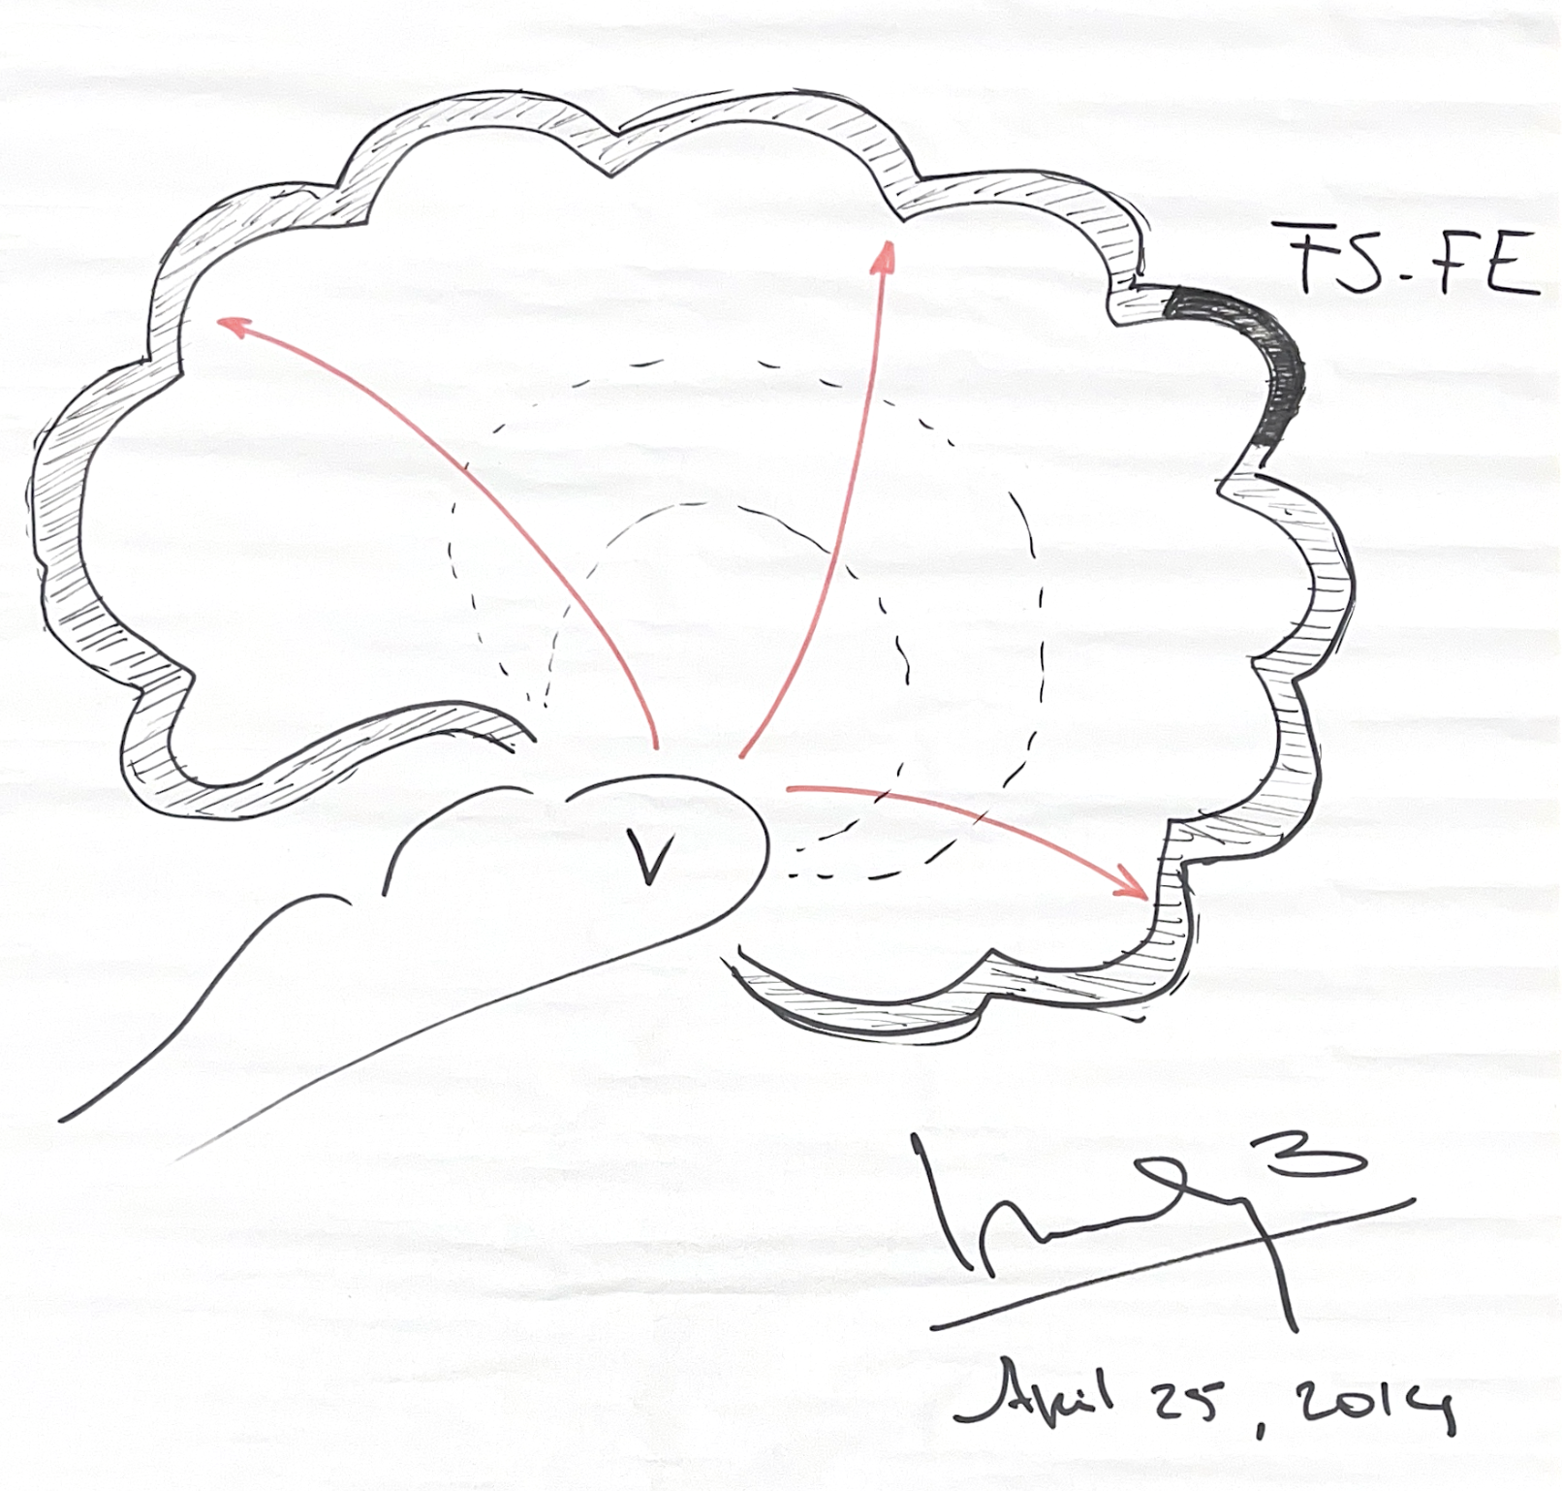

Figure 1: Schematic lateral view of the cerebral hemisphere (after Nieuwenhuys) illustrating the region in the frontal cortex labelled “FS–FE.” This label denotes two older designations—“Field S” and “Field E”—for the same cortical territory, highlighting overlapping nomenclature in historical cortical maps. The dashed lines suggest subdivisions within the frontal lobe, and the red arrows represent potential directional pathways projecting from the brain stem.