## Modeling Bakery Building Costs

Let us calculate the total cost of constructing the bakery. In modeling the bakery building costs (BBC) as a function of the annual capacity x of the bakery it is tempting to assume BBC=kx (where x = number of pastries that can be baked per year and $k is the per unit cost of pastry capacity). **Usually, however, the cost of building is made up of a fixed cost plus a per-unit cost**. We will follow this route and assume

That is, there is a fixed cost of $y incurred in building a bakery.

*Other Formulas*

*If you believe that there is a diminishing cost of adding each unit of capacity you might try a model of the form , where . This will ensure that each additional unit of capacity will incur a smaller cost.*

### Let us now start building the model to determine whether opening the new bakery is a good idea.

### 

In our example, we will assume that fixed cost, y = $400,000 incurred in building a bakery and k = $3 per unit of pastry capacity. Let us also assume that the annual capacity of the bakery is 300,000 pastries.

As described in our modeling rules, we have grouped all our inputs together. In Cells B1 through B14, we will enter values of our inputs and decision variables step by step. Also the range B1:B14 has been defined using Named ranges for better readability. Decision variables are color coded in blue and input assumptions in yellow. Calculations are in orange.

Step 1: Using the above data, fill in the following inputs in the spreadsheet model for Le Napoleon:

1. Plant fixed cost
2. Annual Discount rate for profit
3. Cost per unit of capacity

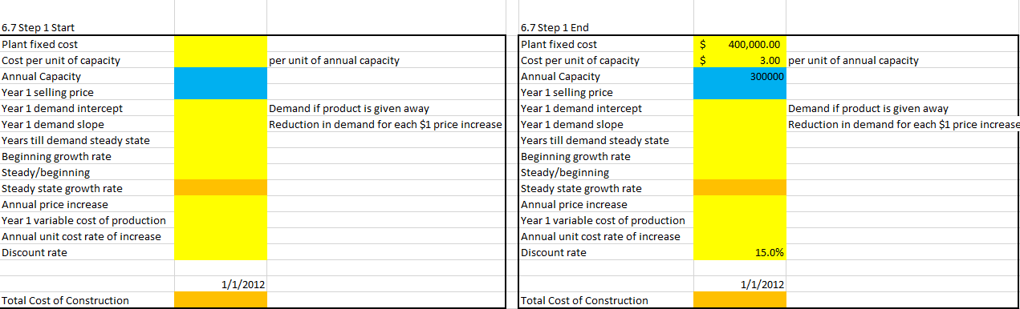

Step 2: Now calculate the total cost of construction using an equation

Help: The bakery building cost is calculated as the excel formula: = .

