## Introduction

Question 1:

Given the success of the bakery in Bloomington, Le Napoleon is now considering opening another bakery in a neighbouring town. Build out the model to calculate the NPV and determine whether opening up the bakery is a good idea for Le Napoleon.

Please use the following assumptions when building out your model:

1. Please colour-code the model according to our color-coding convention: yellow for Inputs, blue for Decision Variables, orange for Calculations, and gray for Outputs
2. For the cost of constructing the bakery, assume the formula we used earlier which is Bakery Building Cost = Fixed Cost + Unit Cost of Capacity x Total Annual Capacity, where the fixed cost of construction is $500,000, each unit of capacity costs $4.00 and 400,000 pastries can be baked per year.
3. The year 1 price of a pastry is $4.00. For each $1 increase in price, the number of pastries demanded will go down by 50,000. If the pastries are given away, then 500,000 pastries will be demanded.
4. The beginning growth rate of pastries demanded is 10%. After 5 years, demand will decrease to a steady-state level and the growth rate will go down by half.
5. Prices increase by 5.0% per year
6. The variable cost of producing a pastry in Year 1 is $2.00. This cost increases 6.0% per year.
7. The discount rate is 15%.

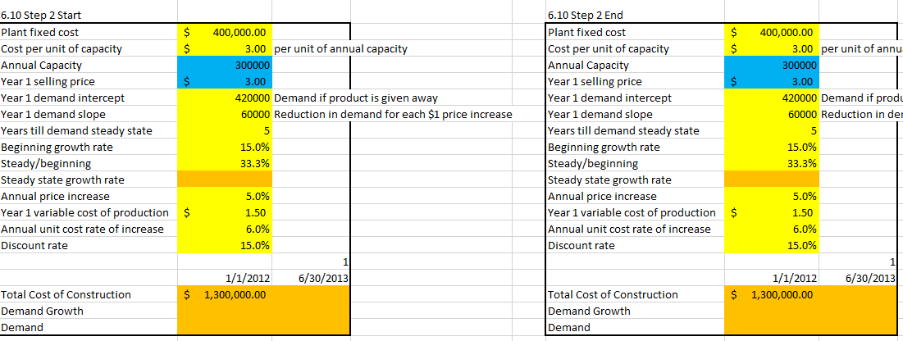

Question 2

Suppose Le Napoleon believes it can charge 10% more for its pastries at the proposed Bloomington bakery, that it had originally thought. Assuming all other inputs and decision variables remained constant, what would be the effect on the model:

1. Revenue, net profit and NPV would decrease
2. Revenue and net profit would increase but NPV would decrease
3. Revenue, net profit and NPV would increase
4. Revenue and NPV increase but net profit decreases

[The correct answer is c.]

Question 3

Le Napoleon has hired a new manager, Charlene Wu. Charlene is trying to build a model to help her determine how to save for retirement. Which of the following would be an output of Charlene’s saving model:

1. Amount of Charlene’s salary she should save each month
2. Charlene’s monthly salary
3. Amount Charlene receives as annual bonus
4. Expected annual growth rate of Charlene’s salary

[The correct answer is a.]