## Calculating Net Present Value & Sensitivity Analysis

Now that we have developed the annual cash flows of opening a new Core Fit location we can calculate the net present value.

We will also create a sensitivity table to show what happens to the net present value when we vary the discount rate and the monthly churn rate of members.

**Step 1**: Assume a discount rate of 15% and enter it into the spreadsheet in cell C4.

**Step 2:** Use the XNPV function to calculate the Net Present Value in cell C47.

[Hint: Use the following [link](https://exceljet.net/excel-functions/excel-xnpv-function) for a tutorial on the XNPV function]

**Step 3**: Using the Data Table function, fill in the values for the sensitivity table to calculate NPV at different values for the discount rate and monthly membership churn rate.

[Hint: Use the following [link](https://www.excel-easy.com/examples/data-tables.html) for a tutorial on setting up data tables]

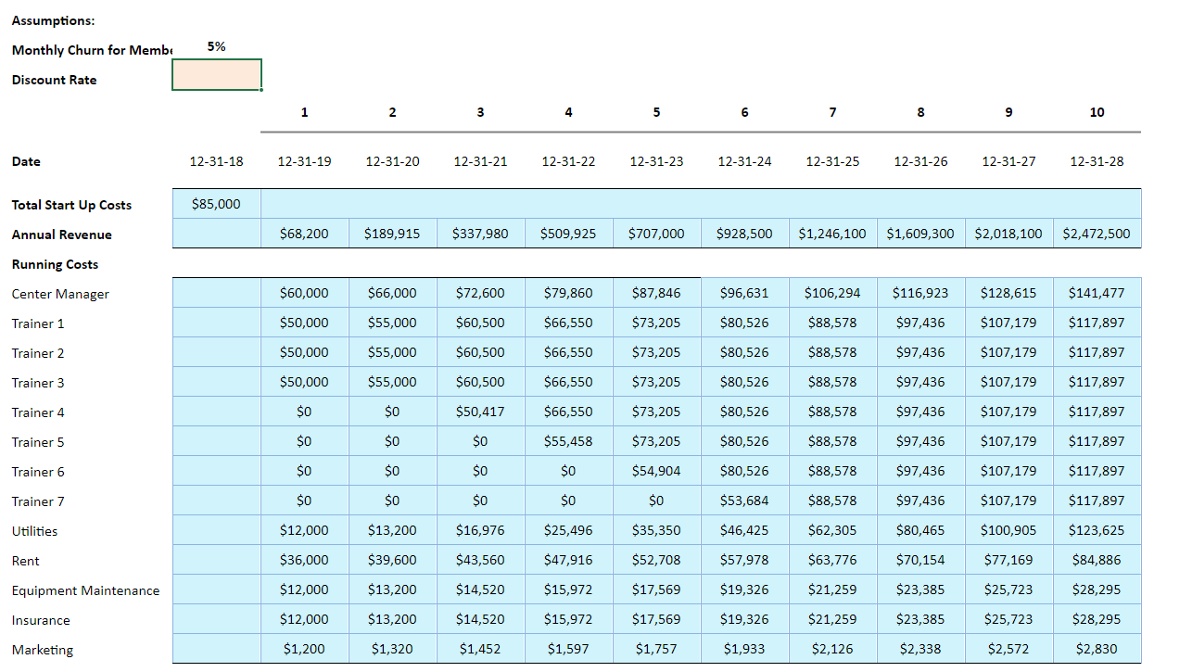

Now let us answer the following questions based on the model that we just built:

### Test Your Understanding

<ignore>

1. At a 15% discount rate and the current cash flow model: should Stella and Eddie open up the new studio and what is the NPV of the project:
2. Yes and $216,200
3. i) No; ii) $866,767
4. i) Yes; ii) $292, 907
5. i) No; ii) -$85,000

[Correct Answer: C]

1. Looking at the data table, what is the NPV when the discount rate is 13% and the monthly churn rate of members is 6%
2. $842,300
3. -$166,477
4. $13,876
5. $78,025

[Correct Answer: D]

1. If the monthly churn rate (the rate at which members suspend membership) is expected to be 8% should Stella and Eddie open up the new studio:
2. No
3. Yes, but in 2025 when the cash flow becomes positive
4. Yes, but only if the discount rate is 10%
5. Yes, immediately, under the current assumptions

[Correct Answer: A]