Le Napoleon is a bakery specializing in French pastries, now owned by a partnership that includes its two ex-pat French pastry chefs, Michel Toure, whose family moved to Strasbourg from Mali when he was a small child, and Anne-Sophie Le Nguyen, who grew up in the Cognac region.

The two met each other not long after moving to the U.S. and found that not only did they have a shared dream of business ownership but that each had strengths to offset the other's weaknesses. Both have exceedingly refined tastes, but their success lies more in Michel's way with obscure ingredients and techniques and Anne-Sophie's ambition and exceptional understanding of the customer.

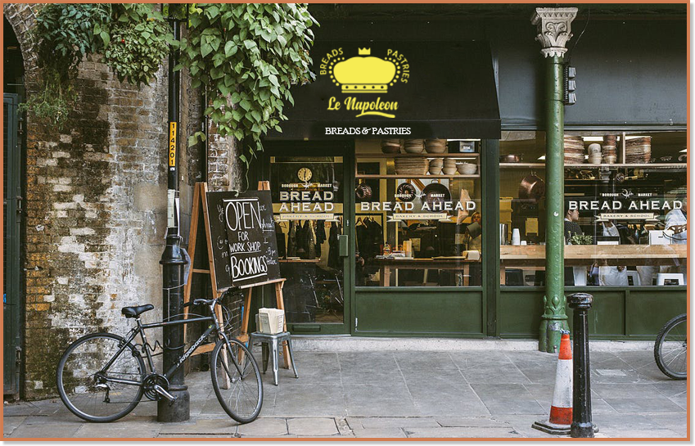

Le Napoleon got its start in a business incubator, and at first, the bakery had just a small stand at the weekly farmer's market. Soon, though, satisfied customers began to place special orders. When Michel and Anne-Sophia had to turn down their third wedding cake request, they decided to sit down and work out a plan to move out of the business incubator and into their own, dedicated location. The business is now thriving.  
  
In this course, we will use operations at Le Napoleon to illustrate some of the problems that businesses both large and small must face - and Excel to illustrate solutions to those problems.

