##### { "Format" : "SVG", "ResourceName" :"1.1_learningObj.svg" }

## Introduction

A **business** is an organization that exists to make a profit by selling goods and/or services to customers.

The goal of a business is to make a profit through its operations. It does this by generating sales to customers that are greater in dollar amount than the costs associated with producing those sales in the same time period. If the costs are greater than the sales, the result is an operating loss.

$$Revenue > Costs = Profit$$

$$Revenue < Costs = Loss$$

Take the example of a fitness studio, Core Fitness. If monthly membership fees for Core Fitness are $70 and the studio has 500 members, then Core Fitness’ revenue from membership fees is approximately $35,000 per month ($70 x 500 members). Core Fitness incurs a number of monthly expenses such as the rent of the premises, insurance, and the salaries of its employees. These expenses are **fixed costs** and don’t change even if more members join the gym. Some expenses, such as the utilities, laundry services and the maintenance of the equipment increase if the number of members increases. These expenses are **variable costs**. If fixed costs are $25,000 and variable costs per member are $15, then total expenses = $32,500 ($25,000 + $15 x 500 members). With these assumptions, Core Fitness’ revenue exceeds its costs by $2,500 per month and therefore, the business is profitable.

Below is an interactive chart with two lines: total revenue and total cost (where total cost is the fixed cost + variable cost). The chart shows the amount of profit and loss for a given number of members. The chart also shows the **breakeven point** – the number of members at which revenue = costs.

In order to see the affect on the profit, loss and break-even point, when our inputs change, you can use the three sliders below the graph to change:

* Membership fee per member
* Fixed costs
* Variable costs per member

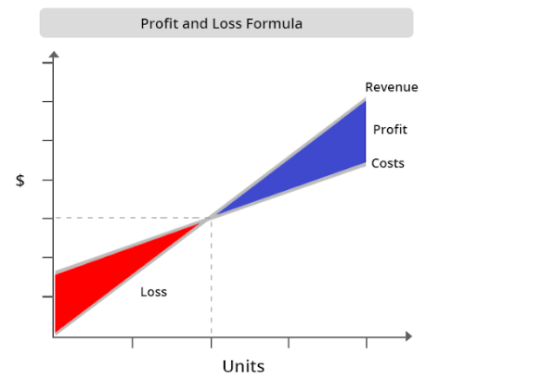

You will notice that as our fixed costs increase, our total cost curves move up and our break-even point increases.

As our variable costs per member increase, the slope of the total cost curve increases and, again, our break-even point increases.

As the membership fee (per member) increases, the slope of the total revenue line becomes steeper and the number of members we need to reach break-even decreases.

## Core Fitness Overview

Throughout this course, we will use the operations of Core Fitness to understand key accounting concepts.

Core Fitness was founded Stella and Eddie. The two founders met when they were personal trainers at a neighborhood gym. Eddie specializes in cardio and strength training while Stella specializes in yoga and pilates. A few years ago, the two friends decided to quit their jobs and start Core Fitness, an exercise studio that offers individual and group Core Fitness classes – a work out class they designed which combines cardio, strength and flexibility.



Core Fitness is a corporation. Stella and Eddie are the owners or stockholders. They invested $40,000 each in the business, which is the maximum amount they could lose if the business doesn’t do well and shuts down.

A service business sells expertise, advice, professional skills, or experiences rather than a physical product. Consultants, dry cleaners, airlines, attorneys, and repair shops are service-oriented businesses.

Core Fitness is a services business. It sells unique fitness classes, which is an experience.

A business must keep track of its financial activities and summarize this information in reports for managers, investors, creditors, and tax reporting entities.

## What is Accounting?

**Accounting** is the system of analyzing, classifying, recording, summarizing, and interpreting business transactions. Accounting is often referred to as “**the language of business”** because it communicates valuable financial information for planning, making decisions, and evaluating performance.

Did you Know?

The word “Accounting” comes from the Latin word computare meaning “to count” or “to score”.

As Core Fitness has started generating profits, Stella and Eddie are thinking about how to spend the cash they are generating. Some of the questions they are trying to answer include:

* Should they start selling healthy snacks, like smoothies or protein bars, in their studio?
* Does it make sense to sell Core Fitness branded clothing or water bottles?
* Could they start online video access of their classes for people that want to access the classes remotely?
* Is it a good idea to open up a second location?

While these decisions may seem like good business ideas, we need Accounting to help answer if they are financially viable.

### Test Your Understanding

<ignore>

The owners of a corporation are called

1. managers
2. customers
3. vendors
4. stockholders

</ignore>