The items that a business keeps track of are called **accounts**. Each of these accounts is one of the five main types.

## Assets

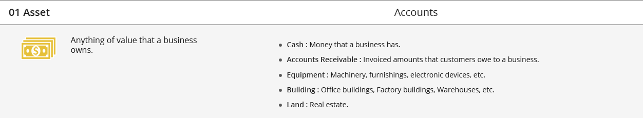

Core Fitness owns a number of valuable things including cash in its bank account and workout equipment, such as free weights. These are all assets. Core Fitness sells some of its memberships for cash and some on credit. The amount of cash Core Fitness is owed by customers that have bought on credit is categorized as Accounts Receivable and is also an asset.

## Liabilities



The money Core Fitness owes to others, such as the monthly rent for the studio, fall in the Accounts Payable account. In addition, if Core Fitness took out a loan to help buy some new machinery or open a new location, the dues of that loan would be a liability that would fall in the Notes Payable account.

## Stockholders’ Equity



The value of the shares that Stella and Eddie own in Core Fitness is known as Common Stock and is part of the stockholders’ equity account. Core Fitness’ quarterly profits accumulate as Retained Earnings and are also part of the stockholders’ equity account.

## Revenue



The fees that Core Fitness earns by selling memberships is the revenue. This includes the fees generated from cash sales as well as credit sales.

## Expense

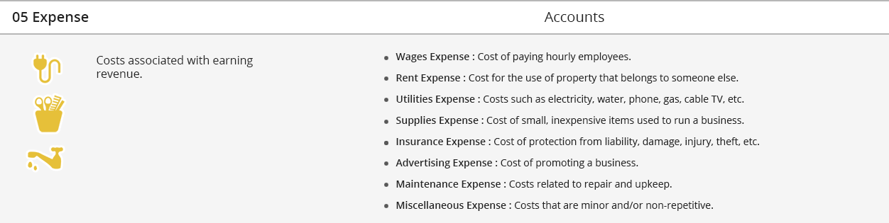

Core Fitness incurs a number of costs to earn its revenue. These include (but are not limited to) salaries for its other trainers and receptionist, the rent of the studio, electricity costs and insurance. All these costs fall in the expense category.

## Test Your Understanding

<ignore>

Question 1:

Which account does a company use to keep track of amounts owed to it by its customers?

1. Accounts Payable
2. Accounts Receivable
3. Fees Earned
4. Common Stock

[Breaking down the interactive Exercise into 5 different MCQs]

Question 2:

Select the account that falls in the Asset account category

1. Fees Earned
2. Accounts Receivable
3. Insurance Expense
4. Common Stock

Question 3:

Select the account that falls in the Liability account category

1. Retained Earnings
2. Equipment
3. Accounts Payable
4. Maintenance Expense

Question 4:

Select the account that falls in the Stockholders’ Equity account category

1. Land
2. Supplies Expense
3. Fees Earned
4. Retained Earnings

Question 5:

Select the account that falls in the Revenue account category

1. Cash
2. Fees Earned
3. Common Stock
4. Rent Expense

Question 6:

Select the account that falls in the Expense account category

1. Wages Expense
2. Note Payable
3. Fees Earned
4. Building

### Interactive Exercise 1: Account Classifications

**Instructions:** For each account type listed, select corresponding account that falls in that category.

|  |  |  |
| --- | --- | --- |
| ACCOUNT TYPE |  | ACCOUNT |
| Asset |  | (a) Fees Earned   (b) Accounts Receivable   (c) Insurance Expense (d) Common Stock |
| Liability |  | (a) Retained Earnings    (b) Equipment (c) Accounts Payable   (d) Maintenance Expense |
| Stockholders’ Equity |  | (a) Land   (b) Supplies Expense   (c) Fees Earned (d) Retained Earnings |
| Revenue |  | (a) Cash  (b) Fees Earned   (c) Common Stock (d) Rent Expense |
|  |  |  |
| Expense |  | (a) Wages Expense  (b) Note Payable (c) Fees Earned    (d) Building |

*[Hint:* Assets are items of value to a business. Liabilities are debts. Stockholders’ equity is the worth of the corporate owners of a business. Revenue represents income, and expenses are costs of generating revenue.*]*

</ignore>