Learning Objectives

* *Determine accounts affected and the nature of the impact for common business events*
* *Illustrate accounts affected and the nature of the impact for common business events in a tabular format*

An economic event that affects two or more accounts is called a **transaction**. Common business transactions include the business doing the following:

**1. Issuing Stock for Cash**

*Cash* increases AND *Common Stock* increases

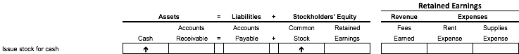

Stella and Eddie raise $5,000 from a friend of theirs, Marie, who becomes an investor in CoreFit.  When stock is issued to Marie, *Common Stock* increases by $5,000 and Core Fit receives cash of $5,000.

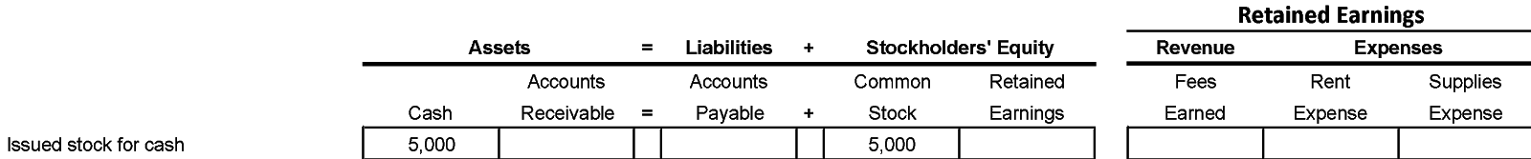

**2. Pay Cash for Rent**

*Retained Earnings* decreases (for expense incurred) AND *Cash* decreases

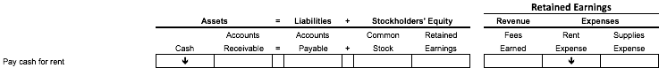

CoreFit pays $3,000 cash immediately to its landlord for January’s rent. Since this is a rent expense, net income decreases and therefore Retained Earnings decreases.  Expenses are shown as negative, as they are deductions that offset revenue and decrease net income.

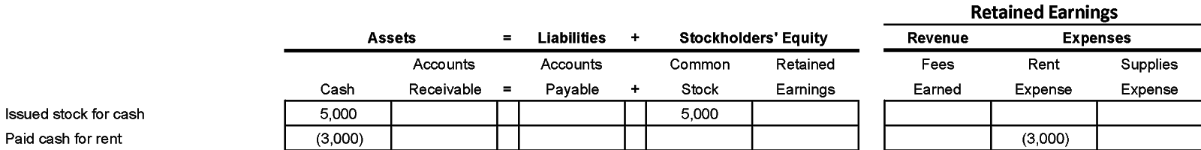

**3. Sell Services to Customers for Cash**

*Cash* increases AND *Retained Earnings* increases (for revenue generated)

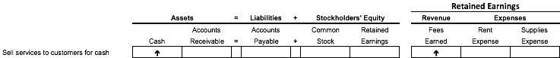

CoreFit sells an annual membership for $1,000 to a customer so Revenue increases.  Cash comes into the company immediately and the cash account increases.

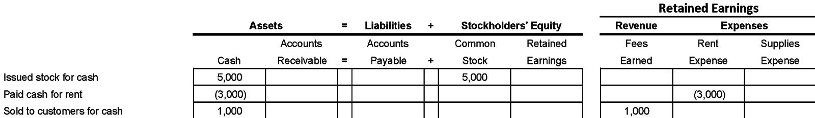

**4. Purchase Supplies on Account**

*Retained Earnings* decreases (for expense incurred) AND *Accounts Payable* increases

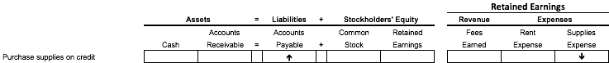

CoreFit buys $1,000 of gym supplies that the vendor invoices now, but CoreFit doesn’t pay until 30 days later. This increases the amount due or Account Payable by $1,000. This will decrease once CoreFit pays the cash owed for the supplies. Since buying supplies is an expense, the expense Account changes by -$1,000.

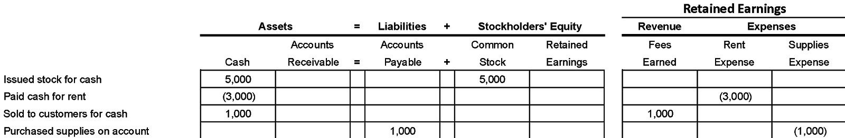

**5. Pay Cash on Account**

*Accounts Payable* decreases AND *Cash* decreases

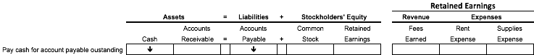

CoreFit pays cash for the $1,000 supplies it bought earlier but had not paid for.  Therefore, the cash account decreases by $1,000 and the Account Payable decreases by $1,000.

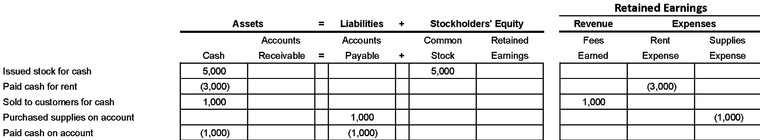

**6. Sell to Customers on Account**

*Accounts Receivable* increases AND *Retained Earnings* increases (for revenue generated)

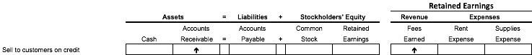

CoreFit sells a 6-monthly membership for $500 so Revenue increases by $500.  CoreFit invoices the customer now but receives cash later. Since the customer buys this on credit, Account Receivable increases by $500.

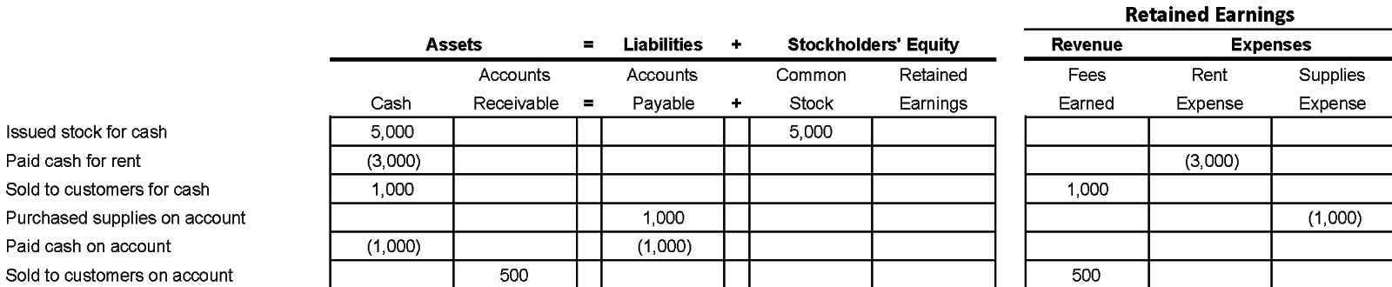

**7. Receive Cash on Account**

*Accounts Receivable* decreases AND *Cash* increases

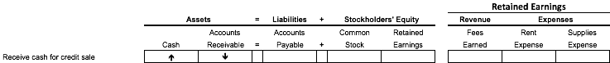

CoreFit ultimately receives $500 in cash for the membership sold on credit.  Therefore Cash increases and Account Receivable decreases.

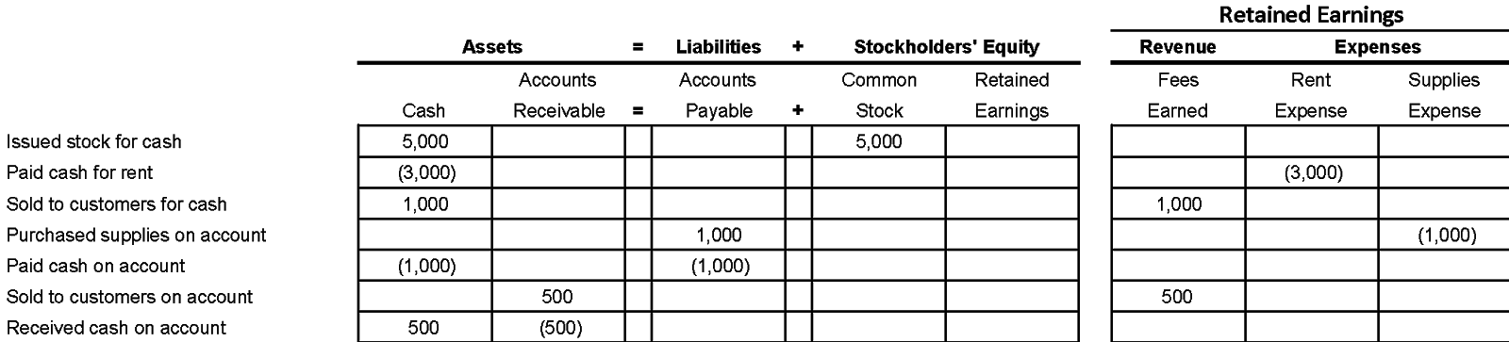

The following transaction grid illustrates how an aggregated picture of Core Fit’s common business transactions we just learn about fit into the accounting equation.

PLACEHOLDER – INSERT *0402_Image 1* from resources folder

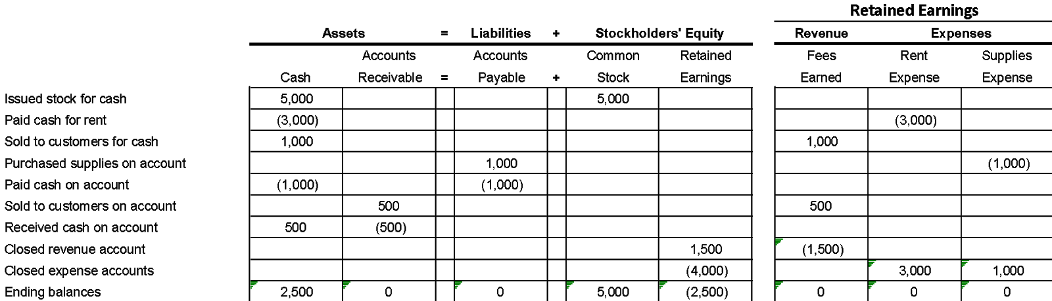

You will notice that each transaction in the first column impacts two accounts. For the asset, liability, and stockholders’ equity amounts, positive numbers represent increases and negative amounts indicate decreases. The ending balances prove that total assets of $2,500 ($2,500 + $0) equal total liabilities and stockholders’ equity of $2,500 ($0 + $5,000 - $2,500).

The revenue and expense accounts are used temporarily during the period to record operational transactions. At the end of the period, these accounts’ ending balances are set back to zero by transferring them to the Retained Earnings account under Closed revenue account and Closed expense accounts. As a result, the Retained Earnings balance decreased by the net loss of $2,500.

### Interactive Exercise 2: Accounting Transaction Grid

**Instruction:** For each account type listed, select corresponding account that falls in that category.

1. Complete the accounting transactions grid for an investment transaction.

PLACEHOLDER - Initial image. Insert 0402_IE_01_Initial



*[Hint: Stock is issued when an investor contributes cash to the business.]*

PLACEHOLDER - Final image. Insert 0402_IE_01_Final



1. Complete the accounting transactions grid for transactions related to sales to customers

PLACEHOLDER - Initial image. Insert 0402_IE_02_Initial

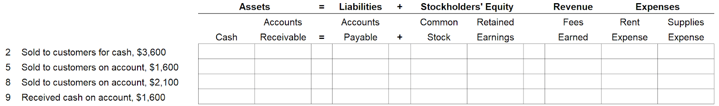

*[Hint: A sale to a customer is considered revenue. At the time of sale, the customer may pay cash or be sent an invoice.]*

PLACEHOLDER - Final image. Insert 0402_IE_02_Final

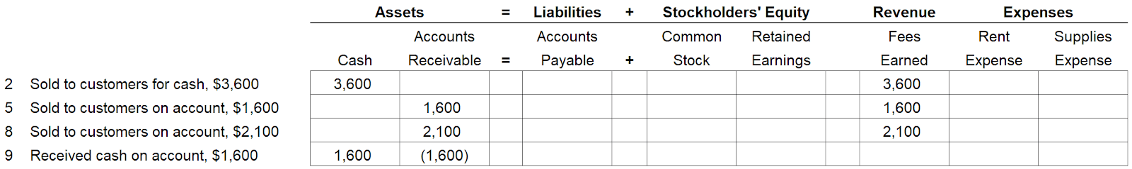

1. Complete the accounting transactions grid for transactions related to purchases from vendors.

PLACEHOLDER - Initial image. Insert 0402_IE_03_Initial

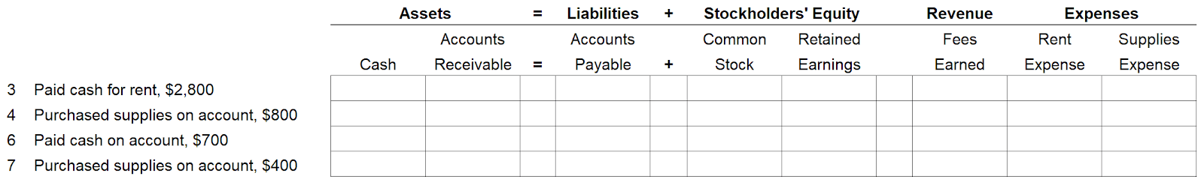

*[Hint: A purchase of either a service or product may be paid for with cash or be billed to the company on account.]*

PLACEHOLDER - Final image. Insert 0402_IE_03_Final

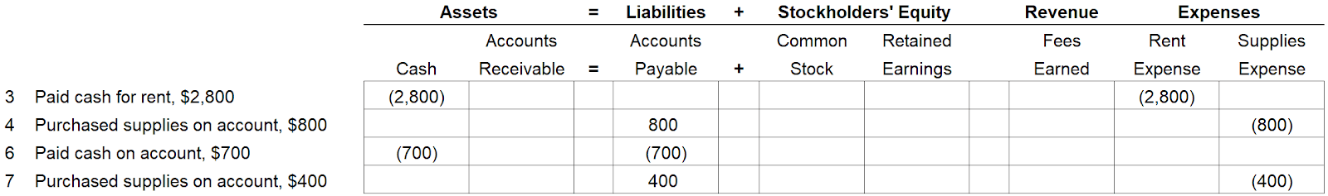

1. The following accounting transactions grid summarizes your entries from the previous three parts. Enter the totals for each account column in the last row.

PLACEHOLDER - Initial image. Insert 0402_IE_04_Initial

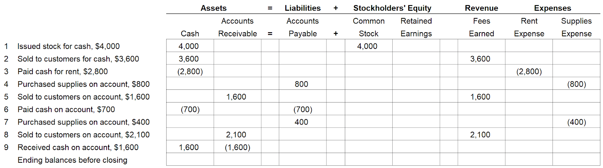

*[Hint: Revenue and expense balances are set back to zero at the end of the accounting period.]*

PLACEHOLDER - Final image. Insert 0402_IE_04_Final

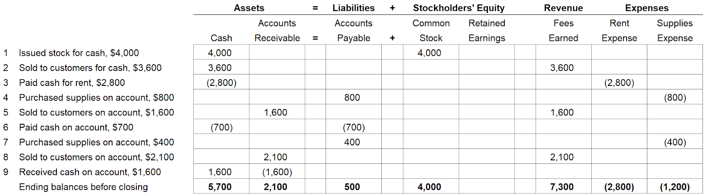

1. Based on the correct entries for part 4, complete the closing entries and ending balances after closing.

PLACEHOLDER - Initial image. Insert 0402_IE_05_Initial

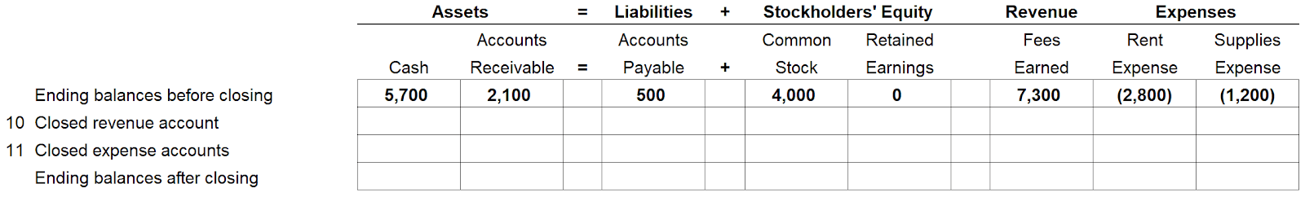

PLACEHOLDER - Final image. Insert 0402_IE_05_Final

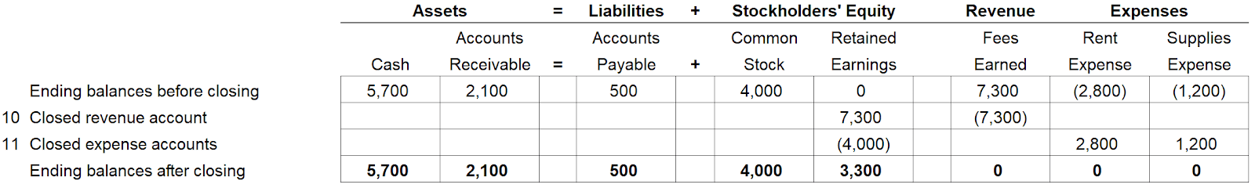

### Test Your Understanding

<ignore>

Which transaction in column A correctly matches with the corresponding account changes in column B?

   Column A                                        Column B

a. Purchase supplies on account     =>   *Retained Earnings* increases (for expense) AND *Accounts Payable* decreases

b. Sell to customers on account   =>      *Accounts Receivable* increases AND *Retained Earnings* decreases (for revenue)

c. Pay cash on account    =>          *Accounts Payable* decreases AND *Cash* decreases

d. Receive cash on account => *Cash* decreases AND *Accounts Receivable* increases

</ignore>