While Chapter 1 taught us how individual accounts are impacted, in order to get insight into Core Fitness’s financial health, we need to look at a consolidated view of the fitness studio’s transactions. We use Core Fitness’ **financial statements** to get an aggregated picture of the company and can analyze if it is doing well, financially.

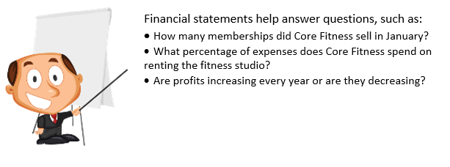

## Introducing the Accounting Cycle

The Accounting Cycle is a step-by-step process to identify, analyze and record the economic events of a company. The steps begin with identifying individual transactions by looking at source documents such as receipts, checks, invoices and bank statements. These transactions are similar to those outlined in Chapter 1 such as:

* Core Fitness receives cash from an external investor when Stella and Eddie start the company.
* Core Fitness pays rent for the month of March.
* Core Fitness signs up 10 new members on January 2nd.

These individual transactions are converted into the Company’s summary financial statements through 6 steps outlined below.

{ 
"Format" : "SVG",
"ResourceName" :"accounting_cycle.svg" 
}

s. The most common accounting period is annual, and therefore the accounting cycle would be for 1 year. However, statements can also be prepared or quarterly. period ends, the Company sand thereforeprocess of

We completed the first step of **Identifying Transactions** in Chapter 1.

In Chapter 2, we will learn how to complete steps 2 and 3 which involve taking these transactions and recording them in two ways – **Journals and Ledgers.**

Summary:

Financial Statements provides insight into the company’s financials and help answer key economic questions.

The Accounting Cycle is a set of 6 steps that repeats every period and is used to create Financial Statements.