##### { "Format" : "SVG", "ResourceName" :"quote_section2" }

The accounting equation grid discussed in [Section 1.4](file:///C:\Users\Neelu_singh\Dropbox\Accounting%20Courseware\Chapter_1_Introduction_to_business_and_accounting_concepts\documents\ITEM_CODE:Chapter_1_Introduction\Common_Accounting_Transactions) displays the transactions in an easy-to-read format in terms of the accounts impacted and the related amounts. However, this layout becomes a bit cumbersome when a large number of transactions are involved. The accounting process is streamlined by instead using two record keeping processes for analyzing, classifying and recording transactions. These are the **journal** and the **ledger**.

Financial transactions are written down throughout the accounting period as they happen in a record book called the **journal.**

This is a sample of a few rows in a journal. It has four columns:*Date, Account, Debit, Credit.*

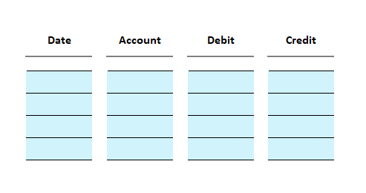

Note

In financial accounting, “Debit” indicates the left side of a ledger account and “Credit” indicates the right.

## Rules of Debit and Credit

##### { "Format" : "SVG", "ResourceName" :"Rules_Debit_Credit.svg" }

Whether an account’s amount should be entered in the debit column or the credit column is based on

* Type of account
* Whether the account is increasing or decreasing.

The following table summarizes the rules of debit and credit for commonly used accounts.

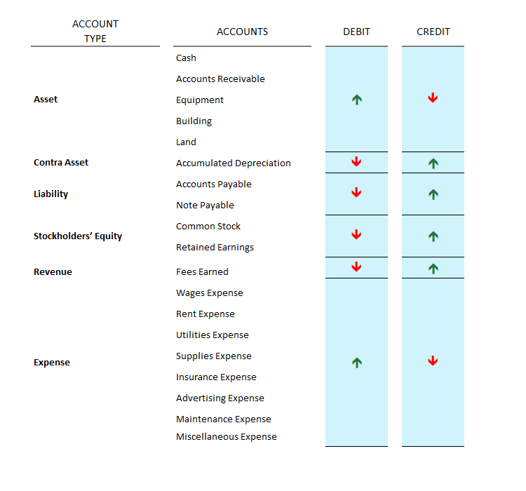

## Interactive Exercise 3 – Account classifications and behaviors

Instruction**:** For each account listed below under the column “ACCOUNTS”, enter its corresponding Account Type and whether it would increase with either a debit or a credit.

