The **ledger** is the second accounting record book that is a list of a company’s individual accounts list ordered by account category. While the journal lists all types of transactions chronologically, the ledgers separate this same information out by account and keep a running balance for each of these accounts.

[Insert example diagram of how ledger converts to journal:



Each account has its own ledger page. The account name appears across the top. The ledger form has six columns: *Date, Item, Debit, Credit, Debit, Credit.* The first set of Debit and Credit columns are where amounts from the journal transactions are **copied**. The second set of Debit and Credit columns are where the account’s running total is maintained. An account’s **running balance** typically appears in either the Debit or the Credit column, but not both.

The following are sample ledgers for the **Cash** and **Fees Earned** accounts.

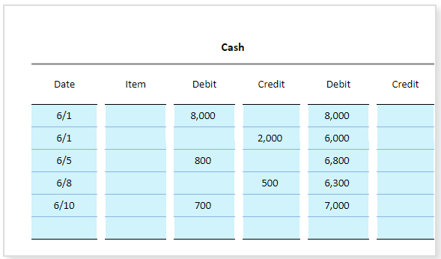

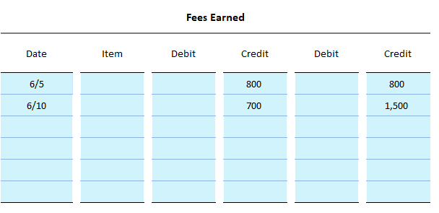  
  
Interactive Exercise 5 – Ledger accounts

***Instruction*:** Assume that the amounts provided in the ledger accounts below were posted from the journal. Complete each ledger by entering in the correct amounts in the account’s balance column.

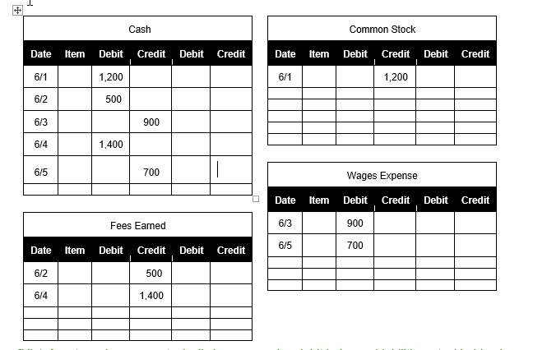

<ignore>

|  |  |  |  |  |  |  |  |  |  |  |  |  |  |  |  |  |  |  |  |  |  |  |  |  |  |  |  |  |  |  |  |  |  |  |  |  |  |  |  |  |  |  |  |  |  |  |  |  |  |  |  |  |  |  |  |  |  |  |  |  |  |  |  |  |  |  |  |  |  |  |  |  |  |  |  |  |  |  |  |  |  |  |  |  |  |  |  |  |  |  |  |  |  |  |  |  |  |  |  |  |  |  |  |  |  |  |  |  |  |  |  |  |  |  |  |  |  |  |  |  |  |  |  |  |  |  |  |  |  |  |  |  |  |  |  |  |  |  |  |  |  |  |  |  |  |  |  |  |  |  |  |  |  |  |  |  |  |  |  |  |  |  |  |  |  |  |  |  |  |  |  |  |  |  |  |  |  |  |  |  |  |
| --- | --- | --- | --- | --- | --- | --- | --- | --- | --- | --- | --- | --- | --- | --- | --- | --- | --- | --- | --- | --- | --- | --- | --- | --- | --- | --- | --- | --- | --- | --- | --- | --- | --- | --- | --- | --- | --- | --- | --- | --- | --- | --- | --- | --- | --- | --- | --- | --- | --- | --- | --- | --- | --- | --- | --- | --- | --- | --- | --- | --- | --- | --- | --- | --- | --- | --- | --- | --- | --- | --- | --- | --- | --- | --- | --- | --- | --- | --- | --- | --- | --- | --- | --- | --- | --- | --- | --- | --- | --- | --- | --- | --- | --- | --- | --- | --- | --- | --- | --- | --- | --- | --- | --- | --- | --- | --- | --- | --- | --- | --- | --- | --- | --- | --- | --- | --- | --- | --- | --- | --- | --- | --- | --- | --- | --- | --- | --- | --- | --- | --- | --- | --- | --- | --- | --- | --- | --- | --- | --- | --- | --- | --- | --- | --- | --- | --- | --- | --- | --- | --- | --- | --- | --- | --- | --- | --- | --- | --- | --- | --- | --- | --- | --- | --- | --- | --- | --- | --- | --- | --- | --- | --- | --- | --- | --- | --- | --- | --- | --- | --- | --- |
| |  |  |  |  |  |  | | --- | --- | --- | --- | --- | --- | | Cash | | | | | | | **Date** | **Item** | **Debit** | **Credit** | **Debit** | **Credit** | | 6/1 |  | 1,200 |  |  |  | | 6/2 |  | 500 |  |  |  | | 6/3 |  |  | 900 |  |  | | 6/4 |  | 1,400 |  |  |  | | 6/5 |  |  | 700 |  |  | |  |  |  |  |  |  |  |  |  |  |  |  |  | | --- | --- | --- | --- | --- | --- | | Fees Earned | | | | | | | **Date** | **Item** | **Debit** | **Credit** | **Debit** | **Credit** | | 6/2 |  |  | 500 |  |  | | 6/4 |  |  | 1,400 |  |  | |  |  |  |  |  |  | |  |  |  |  |  |  | |  |  |  |  |  |  | | |  |  |  |  |  |  | | --- | --- | --- | --- | --- | --- | | Common Stock | | | | | | | **Date** | **Item** | **Debit** | **Credit** | **Debit** | **Credit** | | 6/1 |  |  | 1,200 |  |  | |  |  |  |  |  |  | |  |  |  |  |  |  | |  |  |  |  |  |  | |  |  |  |  |  |  | |  |  |  |  |  |  |  |  |  |  |  |  |  | | --- | --- | --- | --- | --- | --- | | Wages Expense | | | | | | | **Date** | **Item** | **Debit** | **Credit** | **Debit** | **Credit** | | 6/3 |  | 900 |  |  |  | | 6/5 |  | 700 |  |  |  | |  |  |  |  |  |  | |  |  |  |  |  |  | |  |  |  |  |  |  | |

*[Hint:* Assets and expenses typically have a running debit balance. Liabilities, stockholders’ equity, and expense accounts normally have a running credit balance. In these ledgers, either the debit or the credit balance column is used; not both.]

*[ANSWER KEY]*

|  |  |  |  |  |  |  |  |  |  |  |  |  |  |  |  |  |  |  |  |  |  |  |  |  |  |  |  |  |  |  |  |  |  |  |  |  |  |  |  |  |  |  |  |  |  |  |  |  |  |  |  |  |  |  |  |  |  |  |  |  |  |  |  |  |  |  |  |  |  |  |  |  |  |  |  |  |  |  |  |  |  |  |  |  |  |  |  |  |  |  |  |  |  |  |  |  |  |  |  |  |  |  |  |  |  |  |  |  |  |  |  |  |  |  |  |  |  |  |  |  |  |  |  |  |  |  |  |  |  |  |  |  |  |  |  |  |  |  |  |  |  |  |  |  |  |  |  |  |  |  |  |  |  |  |  |  |  |  |  |  |  |  |  |  |  |  |  |  |  |  |  |  |  |  |  |  |  |  |  |  |  |
| --- | --- | --- | --- | --- | --- | --- | --- | --- | --- | --- | --- | --- | --- | --- | --- | --- | --- | --- | --- | --- | --- | --- | --- | --- | --- | --- | --- | --- | --- | --- | --- | --- | --- | --- | --- | --- | --- | --- | --- | --- | --- | --- | --- | --- | --- | --- | --- | --- | --- | --- | --- | --- | --- | --- | --- | --- | --- | --- | --- | --- | --- | --- | --- | --- | --- | --- | --- | --- | --- | --- | --- | --- | --- | --- | --- | --- | --- | --- | --- | --- | --- | --- | --- | --- | --- | --- | --- | --- | --- | --- | --- | --- | --- | --- | --- | --- | --- | --- | --- | --- | --- | --- | --- | --- | --- | --- | --- | --- | --- | --- | --- | --- | --- | --- | --- | --- | --- | --- | --- | --- | --- | --- | --- | --- | --- | --- | --- | --- | --- | --- | --- | --- | --- | --- | --- | --- | --- | --- | --- | --- | --- | --- | --- | --- | --- | --- | --- | --- | --- | --- | --- | --- | --- | --- | --- | --- | --- | --- | --- | --- | --- | --- | --- | --- | --- | --- | --- | --- | --- | --- | --- | --- | --- | --- | --- | --- | --- | --- | --- | --- | --- |
| |  |  |  |  |  |  | | --- | --- | --- | --- | --- | --- | | Cash | | | | | | | **Date** | **Item** | **Debit** | **Credit** | **Debit** | **Credit** | | 6/1 |  | 1,200 |  | 1,200 |  | | 6/2 |  | 500 |  | 1,700 |  | | 6/3 |  |  | 900 | 800 |  | | 6/4 |  | 1,400 |  | 2,200 |  | | 6/5 |  |  | 700 | 1,500 |  | |  |  |  |  |  |  |  |  |  |  |  |  |  | | --- | --- | --- | --- | --- | --- | | Fees Earned | | | | | | | **Date** | **Item** | **Debit** | **Credit** | **Debit** | **Credit** | | 6/2 |  |  | 500 |  | 500 | | 6/4 |  |  | 1,400 |  | 1,900 | |  |  |  |  |  |  | |  |  |  |  |  |  | |  |  |  |  |  |  | | |  |  |  |  |  |  | | --- | --- | --- | --- | --- | --- | | Common Stock | | | | | | | **Date** | **Item** | **Debit** | **Credit** | **Debit** | **Credit** | | 6/1 |  |  | 1,200 |  | 1,200 | |  |  |  |  |  |  | |  |  |  |  |  |  | |  |  |  |  |  |  | |  |  |  |  |  |  | |  |  |  |  |  |  |  |  |  |  |  |  |  | | --- | --- | --- | --- | --- | --- | | Wages Expense | | | | | | | **Date** | **Item** | **Debit** | **Credit** | **Debit** | **Credit** | | 6/3 |  | 900 |  | 900 |  | | 6/5 |  | 700 |  | 1,600 |  | |  |  |  |  |  |  | |  |  |  |  |  |  | |  |  |  |  |  |  | |