The process of copying from the journal to the ledger is called **posting**. It is done one line at a time from the journal. A running total is then maintained for each account and is updated every time an amount is posted. Here are step-by-step instructions for posting each transaction.

① Take note of the account name in the first line of the journal. Find that ledger account.

② Copy the date from the journal to the first blank row in that ledger.

③ Leave the Item column blank in the ledger at this point.

④ Take note of the amount on the first line of the journal and the column it is in. Copy that amount to the same column in the ledger on the same line where you entered the date.

⑤ Update the account’s running balance. Take note of any previous balance in the last two columns of the ledger.

⑥ If there is no previous balance and the entry is a Debit (Credit), enter the same amount in the Debit (Credit) balance column.

⑦ If the previous balance is in the Debit (Credit) column and the entry is a Debit (Credit), add the two amounts and enter the total in the Debit (Credit) balance column. If the previous balance is in the Debit (Credit) column and the entry is a Credit (Debit), subtract the credit (debit) amount from the balance and enter the difference in the Debit (Credit) balance column.

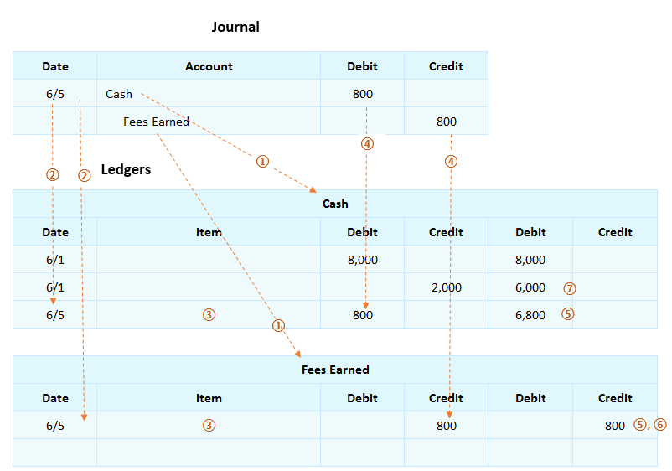

The example that follows shows a journal with six transactions that involve *Cash*. On each row where *Cash* appears in the journal, the amount on the same line is copied to the same column in the *Cash* ledger, in either the first Debit or the first Credit column. For example, the first debit to *Cash* in the journal for $1,000 is copied to the debit column in the ledger. The next time *Cash* appears in the journal is a debit for $6,000, so that is copied to the second debit column in the ledger.

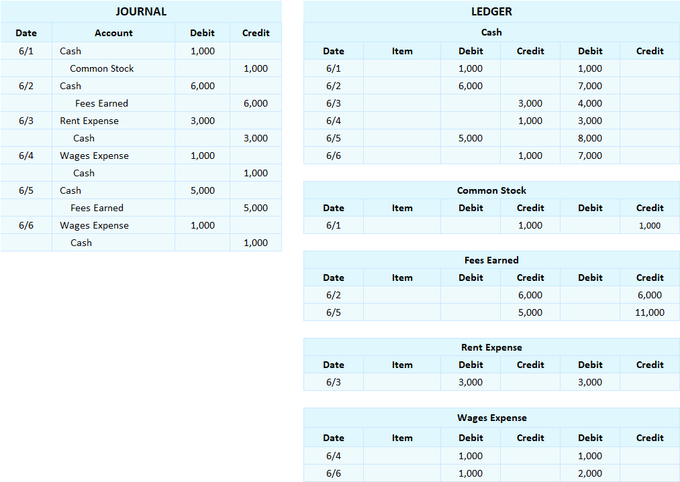

## Interactive Exercise 6 – Journalizing and posting transactions

Instructions: Record the following transactions in the journal.

1. On 6/1, an individual invested $5,000 in a corporation.
2. On 6/2, the company paid rent of $1,300 for the month for its office space.
3. On 6/3, a customer paid $2,400 cash for services the company provided.
4. On 6/4, the company paid $800 for employee wages.
5. On 6/5, a customer paid $1,500 cash for services the company provided.
6. On 6/6, the company paid $900 for employee wages.

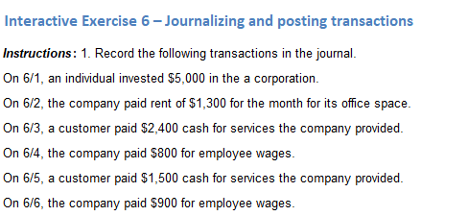

<ignore>

The Cash ledger has four entries that were posted from the journal in the following order: a $500 debit, a $100 credit, a $200 credit, and a $700 debit. What is the account’s current running balance in the ledger?  
  
                                        $ ___________________________

*[Answer: $900 debit]*

Interactive Exercise 6– Journalizing and posting transactions

***Instructions*:** 1. Record the following transactions in the journal.

On 6/1, an individual invested $5,000 in the a corporation.  
On 6/2, the company paid rent of $1,300 for the month for its office space.  
On 6/3, a customer paid $2,400 cash for services the company provided.  
On 6/4, the company paid $800 for employee wages.

On 6/5, a customer paid $1,500 cash for services the company provided.  
On 6/6, the company paid $900 for employee wages.

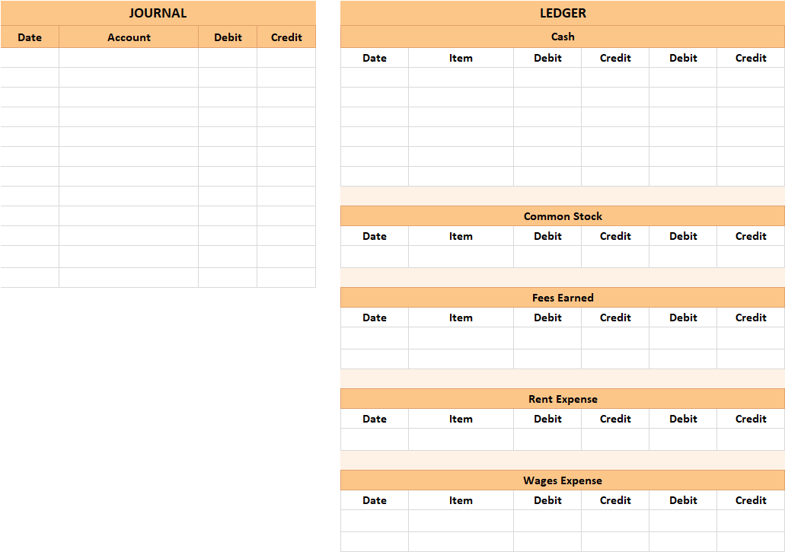

*[Hint:* In the journal, *a*ssets and expenses increase by debiting. Liabilities, stockholders’ equity, and expense accounts increase by crediting. Each line of the journal is then posted, or copied, to the corresponding account ledger. Assets and expenses typically have a running debit balance in the ledgers. Liabilities, stockholders’ equity, and expense accounts normally have a running credit balance in the ledgers.]