Now that the processes of journalizing, posting to the ledgers, and preparing a trial balance have been presented, additional transactions that are typical to many businesses will be illustrated and recorded in the journal.

## Investments by Owners

1.  Core Fitness receives $10,000 cash from an investor, Jay. Jay now owns $10,000 of common stock in Core Fitness.

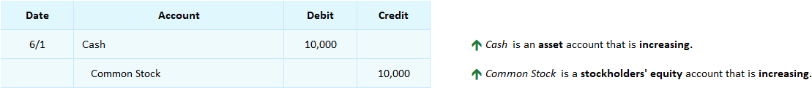

## Interactive Exercise 8 – Investment transaction

Instructions:  Journalize the following transaction.

A corporation receives $25,000 cash from an investor.



*[Hint:* An asset is increasing. A stockholders’ equity account is also increasing.]