1.  Core Fitness sells a membership to Frank for $100 and receives cash. When a business provides a service to a customer, the customer may immediately pay with cash.

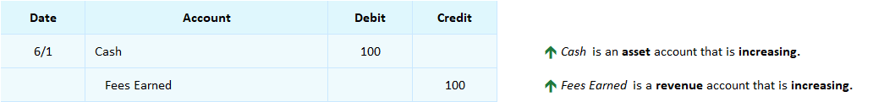

2.  Core Fitness sells a membership to Maya and sends her an invoice for $200. Maya purchased a membership but has not paid for it yet.  Therefore Core Fitness does not receive cash and the company’s Accounts Receivable increases.

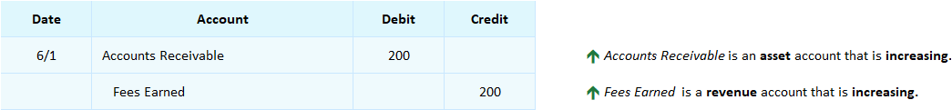

*[Notes Box]*

*“*Accounts Receivable *is an asset account that keeps track of how much customers owe because a business sent them invoices for goods or services rather than immediately receiving cash from them. This account is used as a substitute for a debit to Cash when a company provides services to customers and bills them* ***on account*** *rather than receiving cash right away. The expectation is that the customer will pay within a specified time period, usually 30 days.”*

3.  Core Fitness receives payment on account from Maya who had been invoiced for the membership sold to her on 6/1.

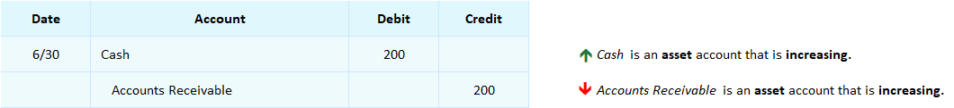

Maya pays the invoice and the Core Fitness receives the cash payment, *Cash* is debited and *Accounts Receivable* is credited. Fitness’s *Accounts Receivable* balance becomes zero now that he Maya has paid in full. This is shown in the following *Accounts Receivable* ledger where transactions #2 and #3 are posted.

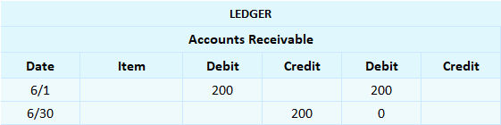

## Interactive Exercise 8 – Sales transactions on account

Instructions:  1. Journalize the following two transactions.  
                        2. Answer the question after the journal entries.

1.  6/1 A company provides a service and sends the customer an invoice for $1,400.  
2.  6/30 The company receives payment on account from the customer who had been invoiced on 6/1.

|  |  |  |  |  |  |
| --- | --- | --- | --- | --- | --- |
|  |  |  |  |  |  |
| **Date** | **Account** |  | **Debit** | **Credit** |
| 6/1 |  |  |  |  |
|  |  |  |  |  |
|  |  |  |  |  |
| 6/30 |  |  |  |  |  |
|  |  |  |  |  |  |
|  |  |  |  |  |  |

Question: What is the debit balance in the Accounts Receivable account after the 6/30 transaction is posted?  $ ________

*[Hint:* An asset other than Cash is used to record the original sale transaction. When the cash is received, that asset’s balance is set back to zero.]

*[ANSWER KEY]*

1.  6/1 A company provides a service and sends the customer an invoice for $1,430.  
2.  6/30 The company receives payment on account from the customer who had been invoiced on 6/1.

|  |  |  |  |  |  |  |  |  |  |  |  |  |
| --- | --- | --- | --- | --- | --- | --- | --- | --- | --- | --- | --- | --- |
|  |  |  |  |  |  |  | | | | | |  |
| **Date** | **Account** |  | **Debit** | **Credit** |  |  |  |  |  |  |  |
| 6/1 | Accounts Receivable |  | 1,430 |  |  | | | | | | |
|  | Fees Earned |  |  | 1,430 |  | | | | | | |
|  |  |  |  |  |  | | | | | | |
| 6/30 | Cash |  | 1,430 |  |  |  | | | | | | |
|  | Accounts Receivable |  |  | 1,430 |  |  | | | | | | |
|  |  |  |  |  |  |  | | | | | | |

*Answer:* What is the debit balance in the Accounts Receivable account after the 6/30 transaction is posted?  $____0____