1.  Core Fitness purchases studio cleaning supplies from Easy Clean, Inc. for $100 to be used this month and pays cash immediately.

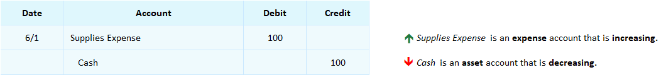

2. Core Fitness purchases floor cleaning supplies from Easy Clean to be used this month for $200 on account and receives an invoice from Easy Clean.

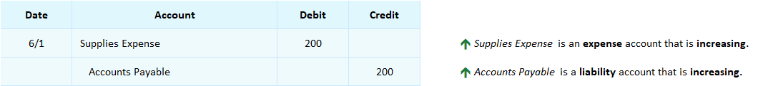

The amount Core Fitness owes to Easy Clean is in the Accounts Payable account.

**Accounts Payable** is a liability account that keeps track of how much a business owes because it was billed by vendors rather than immediately paying cash. A liability is a debt a business owes. The Accounts Payable account is **used as a substitute for Cash when a business purchases something or receives a service from a vendor and does not pay cash immediately**, but instead is billed on account (sent an invoice) and expected to pay in the future.

3. Core Fitness pays Easy Clean on account for the invoice it received on 6/1.

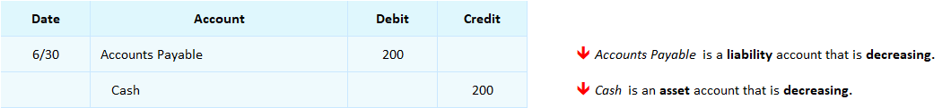

When Core Fitness pays the invoice to Easy Clean, *Accounts Payable* is debited to decrease it and *Cash* is credited to decrease it. Core Fitness’ *Accounts Payable* balance becomes zero now that it has paid in full. This is shown in the following *Accounts Payable* ledger where transactions #2 and #3 are posted.



## Interactive Exercise 9 – Purchase transactions on account

**Instructions**: Journalize the following two transactions and what is the credit balance in the Accounts Payable account after the 6/1 transaction is?

1. 6/1 A company purchases supplies to be used this month for $970 receives an invoice on account.
2. 6/30 The company pays the vendor on account for the invoice it received on 6/1.

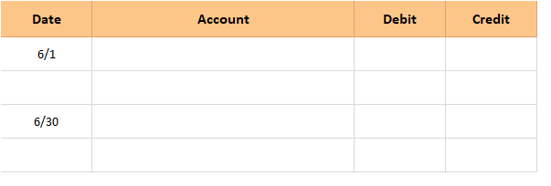

<ignore>

*Question:* What is the credit balance in the Accounts Payable account after the 6/1 transaction is posted?  $ __________

*[Hint:* A liability account is used to record the original purchase transaction. When the cash is paid, that liability’s balance is set back to zero.]

*[ANSWER KEY]*

1.  6/1 A company provides a service and sends the customer an invoice for $1,400.  
2.  6/30 The company receives payment on account from the customer who had been invoiced on 6/1.

|  |  |  |  |  |  |  |  |  |  |  |  |  |
| --- | --- | --- | --- | --- | --- | --- | --- | --- | --- | --- | --- | --- |
|  |  |  |  |  |  |  | | | | | |  |
| **Date** | **Account** |  | **Debit** | **Credit** |  |  |  |  |  |  |  |
| 6/1 | Supplies Expense |  | 970 |  |  | | | | | | |
|  | Accounts Payable |  |  | 970 |  | | | | | | |
|  |  |  |  |  |  | | | | | | |
| 6/30 | Accounts Payable |  | 970 |  |  |  | | | | | | |
|  | Cash |  |  | 970 |  |  | | | | | | |
|  |  |  |  |  |  |  | | | | | | |

*Question:* What is the credit balance in the Accounts Payable account after the 6/1 transaction is posted?  $ __970____