1. Core Fitness purchases land for a new studio, paying $80,000 cash.

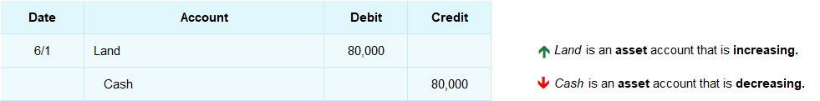

2. Core Fitness purchases new gym equipment for $5,000 on account.

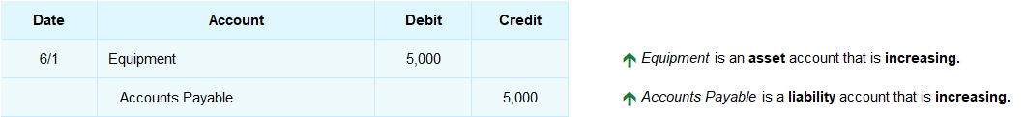

3. A company purchases a building that costs $90,000. The company pays a down payment of $40,000 and takes out a loan for the remaining $50,000.

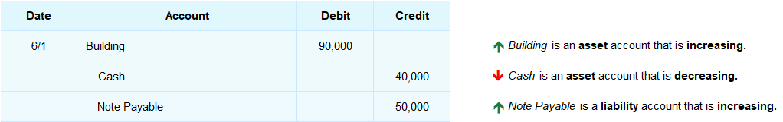

Transaction #3 is called a **compound transaction** because there is more than one credit. (A compound transaction could also have more than one debit, if required.) **The total of the debits must equal the total of the credits in each transaction.**

In transactions #1, 2, and 3, the accounts debited are Land, Equipment, and Building – often called **fixed assets.** These purchases are recorded as assets rather than expenses because they will last more than one accounting period and because their costs are significant amounts.

In practice, the **cost of a fixed asset becomes an expense over the time the asset is used** rather than all at once at the time of purchase.

## Interactive Exercise 11 – Asset purchase transaction

**Instructions**: Journalize the following transaction.

On June 1st, a company purchases equipment that costs $17,500. The company pays a down payment of $8,500 and takes out a loan for the remainder.

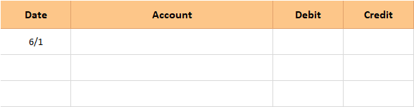

## Test Your Understanding

<ignore>

*[Hint:* An asset is increasing; another is decreasing. A liability account is also increasing.]

*[ANSWER KEY]*

|  |  |  |  |  |  |  |  |  |  |  |  |  |
| --- | --- | --- | --- | --- | --- | --- | --- | --- | --- | --- | --- | --- |
|  |  |  |  |  |  |  | | | | | |  |
| **Date** | **Account** |  | **Debit** | **Credit** |  |  |  |  |  |  |  |
| 6/1 | Equipment |  | 17,500 |  |  | | | | | | |
|  | Cash |  |  | 8,500 |  | | | | | | |
|  | Note Payable |  |  | 9,000 |  | | | | | | |
|  |  |  |  |  |  | | | | | | |

Which account could not be used as the credit account in a transaction for the purchase of equipment?

a. Fees Earned   
b. Note Payable   
c. Cash  
d. Accounts Payable