Depreciation

The process of "expensing off" the cost of a fixed asset as it is "used up" over the time it is used is depreciation.

For example, suppose the dumbbells that Core Fitness bought when they set up the gym need to be replaced after 5 years. We would say the useful life of the dumbbells is 5 years.

A transaction for depreciation occurs at the end of each accounting period during the asset’s useful life. It involves a debit to Depreciation Expense for the amount of the cost expired.

For example if the dumbbells cost $5,000 and depreciated at $1,000 per year for 5 years, then each year there would be a $1,000 *Depreciation Expense.*

Rather than crediting the asset account directly to reduce its value, a substitute account is used. That way the ledger balance of the fixed asset always remains at its full cost (such as $5,000 for the dumbbells).

Accumulated Depreciation

For fixed assets, the account credited to record depreciation is Accumulated Depreciation. This is called a **contra asset** account and is intentionally the opposite of the normal balance for an asset – it has a credit balance in the ledger. **The debit balance of the asset account minus the credit balance of its associated Accumulated Depreciation contra account equals the asset’s book value**, or its current value to the business.

Transactions #1 and #2 show the end-of-period entries that expense off some of the cost of a fixed asset.

1. Assume the dumbbells depreciate at a rate of $1,000 per year.

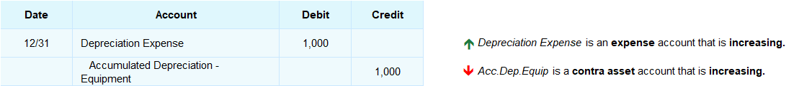

1. Assume Core Fitness’ new building depreciates at a rate of $4,000 per year

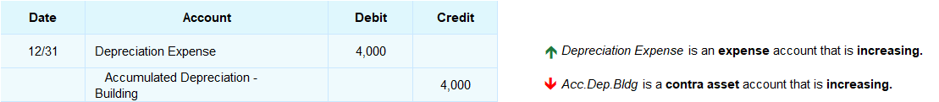

## Interactive Exercise 12 – Depreciation transaction on account

**Instructions**: Journalize the following transaction

A company records annual depreciation on its equipment of $800.

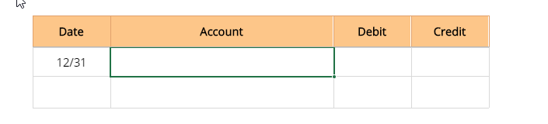

## Test Your Understanding

<ignore>

|  |  |  |  |  |  |  |
| --- | --- | --- | --- | --- | --- | --- |
|  |  |  |  |  |  |  |
| **Date** | **Account** |  | **Debit** | **Credit** |  |
| 12/31 |  |  |  |  |  |
|  |  |  |  |  |  |
|  |  |  |  |  |  |
|  |  |  |  |  |  |

*[Hint:* An expense account is increasing. A contra asset account is also increasing.]

*[ANSWER KEY]*

A company records annual depreciation on its equipment of $800.

|  |  |  |  |  |  |  |
| --- | --- | --- | --- | --- | --- | --- |
|  |  |  |  |  |  |  |
| **Date** | **Account** |  | **Debit** | **Credit** |  |
| 12/31 | Depreciation Expense |  | 800 |  |  |
|  | Accumulated Depreciation – Equipment |  |  | 800 |  |
|  |  |  |  |  |  |
|  |  |  |  |  |  |

## Test Your Understanding

A company purchased its building on January 1, 2016 for $200,000. It depreciates at a rate of $10,000 per year. What is the book value of the building on December 31, 2019?  
  
                                        $ ___________________________

*[Correct Answer: $160,000]*