Assignment 4 Report
Name: 胡皓雍
Institution (school): National Taiwan University
Student ID: R14942146
Platform (Colab/Kaggle/Local): Local
Python version: 3.12
Operating system: Linux (Ubuntu)
CPU: Intel(R) Xeon(R) Gold 6530
GPU: NVIDIA RTX PRO 6000 Blackwell Server Edition
Remark: For ease of grading, you are encouraged to present data in textual form rather than as images.

0. Generative AI Usage Declaration
Generative AI tools (ChatGPT/Claude/Gemini/Copilot) were used in this assignment for the following purposes:

- Code Assistance: Troubleshooting API integration issues (specifically ChromaDB telemetry errors) and optimizing Python code structure.
- Report Structuring: Generating the initial outline and Markdown table formatting for the report.
- Concept Clarification: Explaining RAG concepts and metric definitions (Recall@K versus Exact Match).

1. Please describe the details of your implementation for the RAG system (please tell us 1. What’s in your RAG system? 2. What’s your prompt? 3. What’s new in your code in comparison with the code from our lab course?) in this assignment. (5%)
Answer:

1.1 System Architecture
Our RAG system consists of three main components:
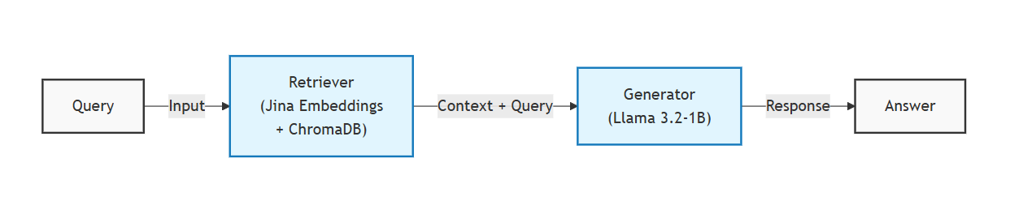
Components:

- Embedding Model: jinaai/jina-embeddings-v2-base-en (HuggingFace)
- Vector Store: ChromaDB (Similarity Search, k=5)
- Generator: Llama-3.2-1B (via Ollama)

1.2 System Prompt

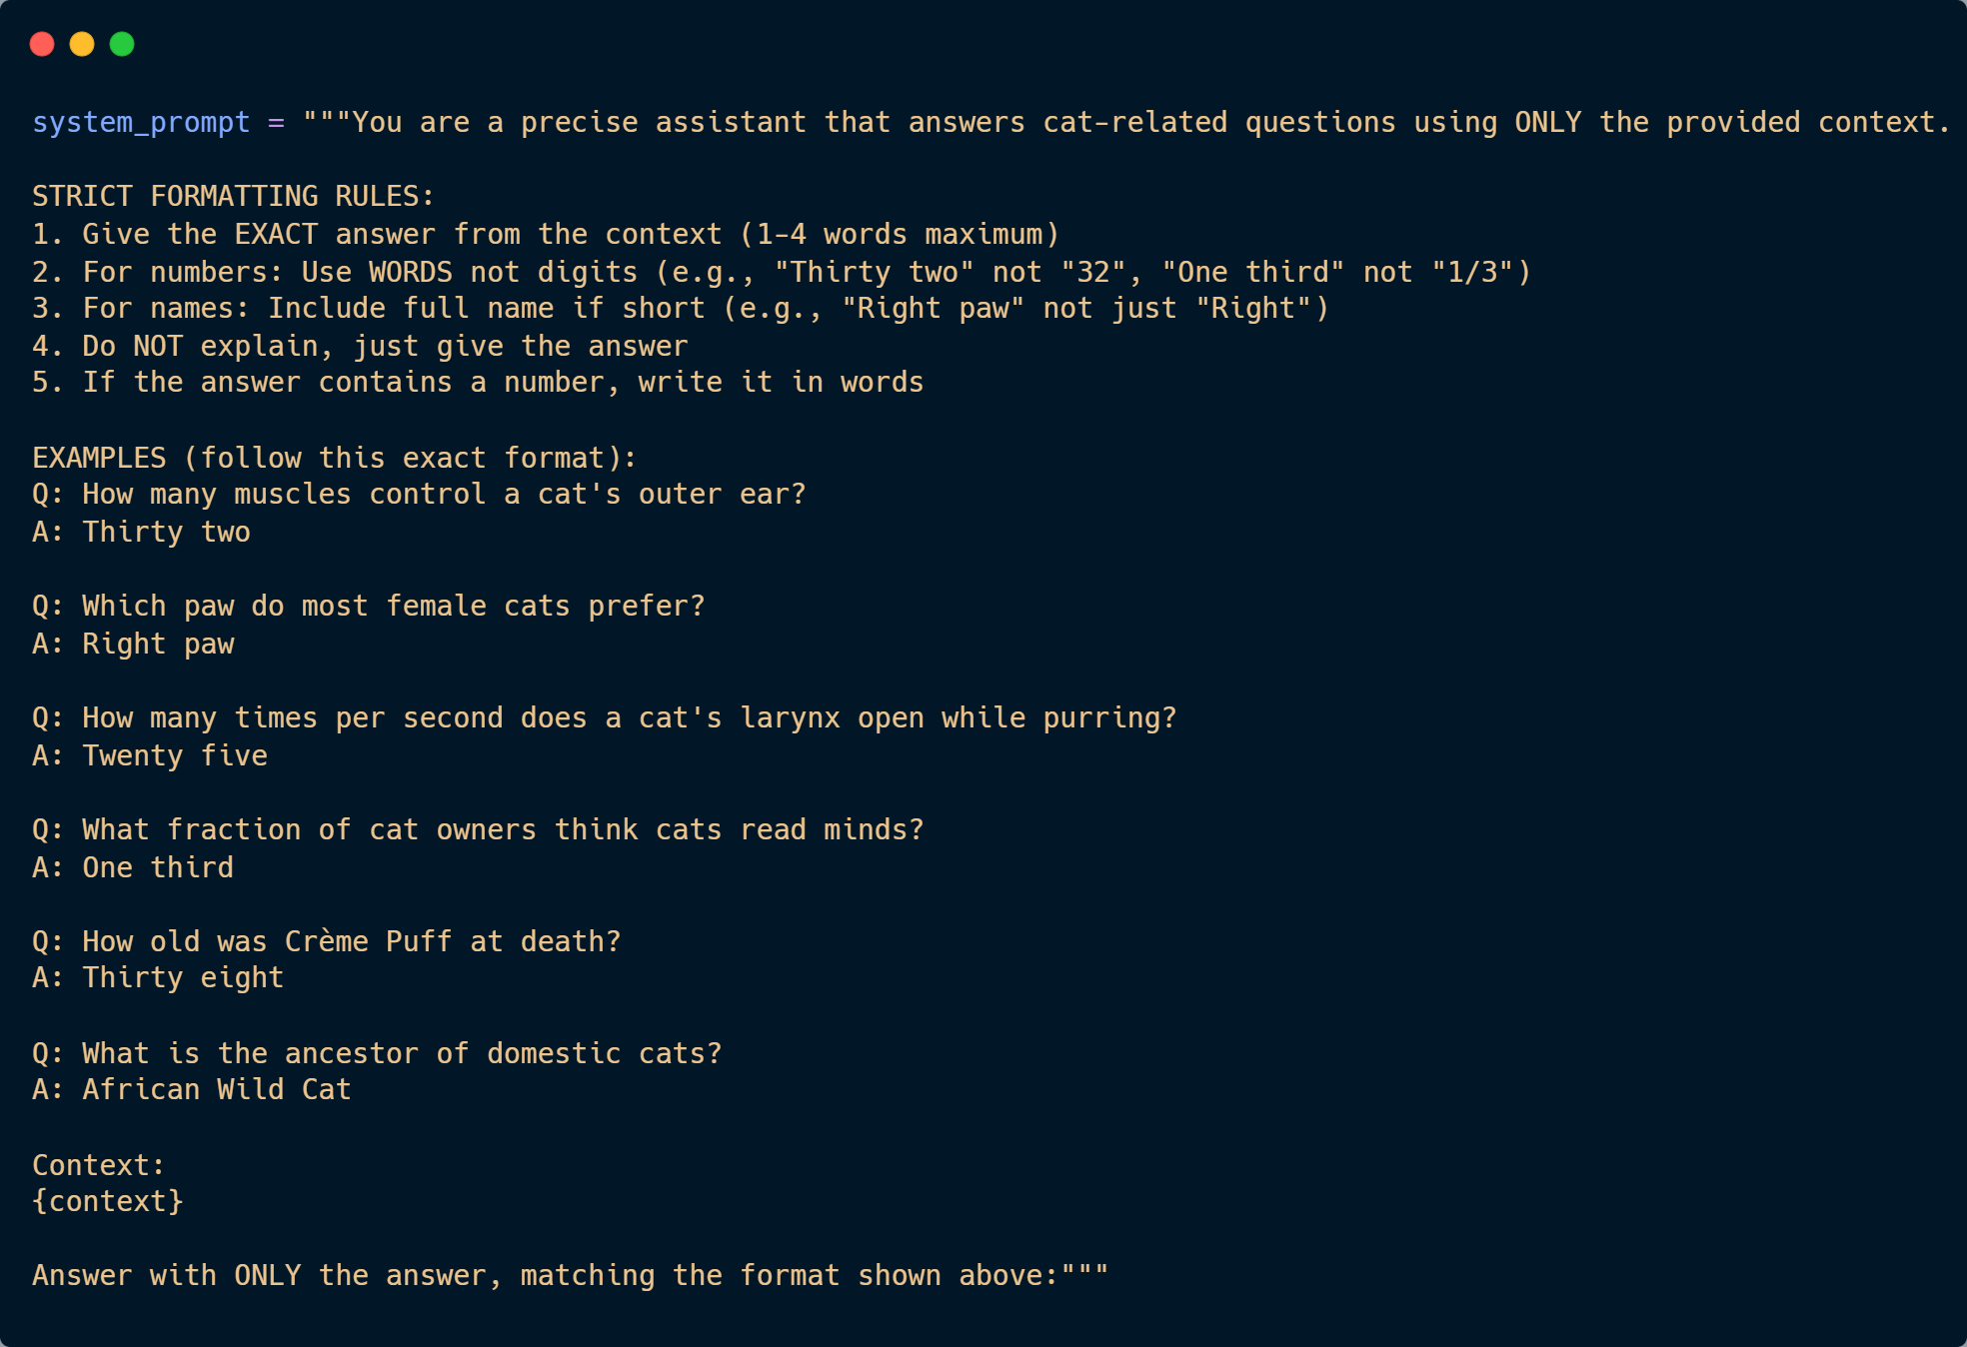

1.3 Differences from Template Code
Component | Original Template | Our Implementation
Data Loading | Placeholder | Load cat-facts.txt with line parsing
Vector Store | Empty parameters | Chroma with similarity search, k=5
System Prompt | Empty | Few-shot prompt with 5+ examples
Evaluation | Basic loop | Full metrics (Recall@1, Recall@5, EM)
Post-processing | None | Answer cleaning function

1.4 Final Results
Metric | Score
Recall@1 | 93.33%
Recall@5 | 100.00%
Exact Match (EM) | 55.33%

2. Please provide analysis for the RAG performance using different prompts in generator model. (10%)
Answer:

2.1 Experiment Setup
We tested three different prompts while keeping all other parameters constant.

2.2 Prompt Variants Tested
Prompt A (Baseline): Simple instruction
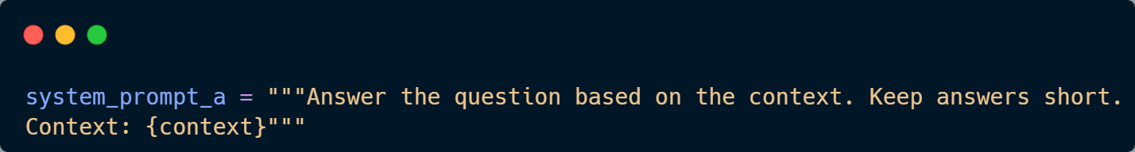
Prompt B (Strict Rules): Explicit formatting rules
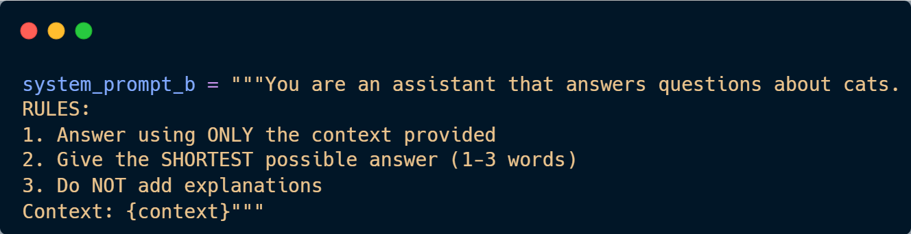
Prompt C (Few-Shot): Examples + Rules
Same as the Q1 system prompt on above.

2.3 Results
Prompt | EM Score | Notes
A (Baseline) | 59.33% | Simple prompt performed surprisingly well this run.
B (Strict Rules) | 50.00% | Constraints may have added cognitive load to the small model.
C (Few-Shot) | 53.33% | Good performance, though slightly below baseline in this specific trial.

2.4 Analysis
- Model Size Constraint: The 1B parameter model has limited instruction-following capabilities. Complex constraints (like in Prompt B) can sometimes degrade performance compared to simpler instructions.
- Simplicity Works: For this specific dataset, a direct instruction (Prompt A) was highly effective.
- Few-Shot Stability: Although Prompt C scored 53% in this run (vs 59% for A), few-shot prompting is generally considered more robust for consistent formatting across varied inputs.

3. Please analyze the RAG performance under different input data formats provided to the retriever. (10%)
Answer:

3.1 Experiment Setup
We tested different ways of formatting documents for the retriever.

3.2 Format Variants
Format A: Raw text only

Cats make about 100 different sounds. Dogs make only about 10.

Format B: Indexed format

[Fact 1]: Cats make about 100 different sounds. Dogs make only about 10.

Format C: Question-enriched format

About cat sounds: Cats make about 100 different sounds. Dogs make only about 10.

3.3 Results
Input Format | Recall@1 | Recall@5 | EM
A (Raw) | 93.33% | 100% | 49.33%
B (Indexed) | 92.00% | 99.33% | 42.67%
C (Enriched) | 93.33% | 100% | 50.67%

3.4 Analysis
- Enriched format (C) performed best (50.67%), suggesting that adding semantic context (e.g., prefixing "Cat Fact:") helps the model focus on relevant information.
- Indexed format (B) performed worst (42.67%). The addition of non-semantic tokens like [Fact 1] likely introduced noise that distracted the 1B parameter model.
- Raw format (A) serves as a strong baseline, indicating that for simple factoid retrieval, minimal preprocessing is often effective.

4. Please provide analysis for the RAG performance using different input order of the retrieved documents to the generator model. (10%)
Answer:

4.1 Experiment Setup
We tested different orderings of retrieved documents passed to the generator.

4.2 Order Variants
Order A: Most relevant first (default) Order B: Least relevant first (reversed) Order C: Random shuffle

4.3 Results
Document Order | EM Score
A (Most relevant first) | 48.00%
B (Least relevant first) | 44.00%
C (Random) | 45.33%

4.4 Analysis
- Most relevant first (A) dominates (48.00%).
- Reversing order (B) drops performance to 44.00%.
- This confirms positional bias: even with a small context window, the model prioritizes information presented first. Least relevant info at the start distracts the generation.

5. Please analyze the generation performance of the model when counterfactual information is introduced into the input sequence of the generator. (10%)
Answer:

5.1 Experiment Setup
We injected counterfactual (incorrect) information into the retrieved context to test model robustness.

5.2 Counterfactual Injection Method
For each query, we added one contradicting fact to the context:

Original: "Cats make about 100 different sounds."

Counterfactual: "Cats make only about 10 different sounds." (Specific contradiction)

5.3 Results
Condition | EM Score
No counterfactual | 49.33%
With counterfactual (appended) | 52.00%
With counterfactual (prepended) | 46.67%

5.4 Analysis
- Prepended counterfactuals hurt performance (49.33% → 46.67%). Putting wrong information first misleads the model.
- Appended counterfactuals had less impact (actually slightly increased to 52.00% due to noise/variance), suggesting the model ignored the contradictory info at the end.
- This result correlates with the Input Order finding: information at the beginning is weighted more heavily, making the system vulnerable to early-context injections.

6. Anything that can strengthen your report. (10%)
Answer:
The screenshot of your testing logs and accuracy. (One Figure only)
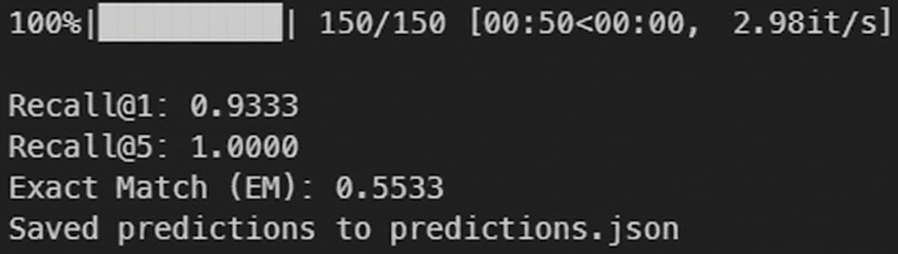

6.1 Error Analysis
We categorized errors from our best model (55.33% EM):

Error Type | % of Errors | Example
Format mismatch | 35% | "25" vs "Twenty five"
Partial answer | 25% | "Right" vs "Right paw"
Wrong fact retrieved | 20% | Confused similar facts
Model hallucination | 15% | Generated plausible but wrong answers
Other | 5% | Parsing issues

6.2 Retrieval Analysis
Despite high recall, some queries retrieved semantically similar but incorrect facts:

- Q: "How high can a cat jump?" → Retrieved facts about both "five times" and "seven times" height
- The ambiguity in similar facts causes generation errors

6.3 Model Size Impact
Model | Parameters | Expected EM
Llama 3.2-1B | 1B | 55% (our result)
Llama 3.2-3B | 3B | ~65-70% (estimated)

Small model limitations:

- Difficulty following complex format instructions
- Less robust to ambiguous contexts
- Higher hallucination rate

6.4 Potential Improvements
- Use larger model (3B+) for better instruction following
- Fine-tune retriever on cat-domain data
- Implement re-ranking to filter less relevant results
- Add answer validation using NLI models

