Assignment 3 Report
Name: 胡皓雍
Institution (school): National Taiwan University
Student ID: R14942146
Platform (Colab/Kaggle/Local): Local
Python version: 3.10
Operating system: macOS
CPU: 8 核心 CPU 配備 4 個效能核心與 4 個節能核心
GPU: 8 核心 GPU、10 核心 GPU

Remark: For ease of grading, you are encouraged to present data in textual form rather than as images.
- Train a RoBERTa-base model on the same dataset and report the performance of both BERT-base and RoBERTa-base models. (10%)
Results:

Test Performance Results
Model | Task 1 (Pearson) | Task 2 (Accuracy) | Combined Score
BERT-base | 0.8881 | 0.8811 | 1.7691
RoBERTa-base | 0.8898 | 0.8837 | 1.7735

RoBERTa marginally outperforms BERT (+0.0044 combined score, ~0.26% improvement).

  - Discuss the main differences between BERT and RoBERTa, and explain how these differences may affect performance. (5%)
Answer:

Why RoBERTa Performs Better
- More Training Data: 10x larger dataset (160GB vs 16GB) → richer semantic representations.

- Dynamic Masking: Different masks per epoch vs static preprocessing → more robust feature learning.

- Removed NSP: Focuses solely on MLM, avoiding superficial next-sentence signals and allowing deeper linguistic pattern capture.

- Larger Batch Size: 8K vs 256 → more stable and effective optimization.

- Train a GPT-2 model on the same dataset and evaluate its performance. (10%)
Results:

Test Performance Results
Model | Pearson (Task 1) | Accuracy (Task 2) | Combined Score
BERT | 0.8881 | 0.8811 | 1.7691
RoBERTa | 0.8898 | 0.8837 | 1.7735
GPT-2 | 0.8694 | 0.8717 | 1.7411

  - What are the main differences between BERT and GPT2? Discuss the main differences between BERT and GPT-2, and analyze how these differences influence their performance. (5%)
Answer:

Why BERT/RoBERTa Outperform GPT-2
- Bidirectional context vs causal: BERT/RoBERTa attend to all tokens; GPT-2 only looks backward → richer understanding of sentence pairs.

- Task-aligned pre-training: BERT's MLM + NSP align with sentence pair classification; GPT-2's next-token prediction is generation-focused.

- Explicit segment markers: BERT's token_type_ids distinguish premise/hypothesis; GPT-2 concatenates without structure.

Performance gap: GPT-2 ~1.6–2.3% lower across both tasks, confirming bidirectional encoders suit discriminative tasks.
- Compare the performance of a multi-output learning model with BERT models trained separately on each sub-task. Does multi-output learning improve performance? Explain why or why not. (5%)
Answer:
Model | Task | Metric | Test Score
Multi-task BERT | Task 1 (Regression) | Pearson Correlation | 0.8881
Single-task BERT | Task 1 (Regression) | Pearson Correlation | 0.8790
 |  | Improvement | +0.0091 (+1.04%)
Multi-task BERT | Task 2 (Classification) | Accuracy | 0.8811
Single-task BERT | Task 2 (Classification) | Accuracy | 0.8624
 |  | Improvement | +0.0187 (+2.17%)

Analysis
Does Multi-Output Learning Improve Performance? YES - Multi-task learning consistently improves performance on both tasks.

- Shared Representation Benefits: Both tasks (semantic relatedness + entailment) are complementary. Task 1 provides similarity signals; Task 2 provides logical relationship signals. Shared encoder learns richer features benefiting both.

- Classification Benefits More (+2.17% vs +1.04%): Binary classification is more sensitive to representation quality. Regression's continuous scores provide additional supervision signal that helps learning decision boundaries.

- Task Complementarity: Both tasks improve simultaneously (no trade-off), confirming they compete for capacity rather than complement. Entailment implicitly depends on relatedness: high similarity → entailment/contradiction; low similarity → no entailment.

- Regularization Effect: Multi-task learning prevents overfitting by forcing the encoder to satisfy multiple objectives, improving generalization.

Conclusion: Multi-task learning achieves 1–2% improvement through complementary task signals and regularization, outperforming single-task specialists.

- Why does your model fail to correctly predict some data points? Please provide an error analysis and introduce how do you improve your performance. (10%)
Answer:

Error Distribution (Test set, 4,928 samples)
Error Category | Count | Percentage | Confidence Range
High Confidence Errors | 542 | 92.5% | > 0.70
Borderline Errors | 38 | 6.5% | 0.55 - 0.70
Low Confidence Errors | 6 | 1.0% | < 0.55
Total Errors | 586 | 11.9% | -
Overall Correct | 4,342 | 88.11% | -

Key Findings
92.5% of errors are high-confidence—model overconfidently predicts wrong labels. This reveals systematic misclassifications tied to:

- Lexical vs Semantic Mismatch: Model relies on surface word overlap; fails on paraphrased pairs ("car" vs "automobile").

- Negation & Compositional Structures: Cannot properly scope negation ("didn't win" vs "won") or track complex clause relationships.

- Domain-Specific Terminology: Limited exposure to image/object recognition domain despite pre-training.

Rare low-confidence errors (1%) suggest good calibration on easy cases; borderline errors (6.5%) reflect genuinely ambiguous samples.

Performance Improvement Strategies
Priority improvements (no pushing to +X% estimates):

- Focal Loss for Hard Examples: Down-weight easy cases, focus on borderline/misclassified examples → more robust boundaries.

- Ensemble (3×BERT + RoBERTa): Captures complementary error patterns across architectures and random seeds → variance reduction.

- Data Augmentation: Paraphrasing + negation variants → addresses lexical/compositional weaknesses.

Conclusion: Overconfidence on surface-level patterns is the core issue; multi-model ensembles + focal loss targeting hard cases will most effectively improve generalization.

- Anything that can strengthen your report. (5%)
Answer:

Training Dynamics
BERT multi-task training shows smooth 86.3% loss reduction (1.0326 → 0.1411 across 10 epochs). Validation metrics peak at Epoch 10 (Pearson 0.8784, Accuracy 0.8860), indicating no early stopping is beneficial. Non-monotonic validation curves reflect multi-task learning where tasks may compete; late-stage improvement confirms full 10 epochs needed for optimal balance.

Deployment Recommendations
- Maximum Accuracy: Use RoBERTa-based ensemble (RoBERTa + BERT) → ~0.89–0.90 expected accuracy.

- Balanced Performance/Efficiency: Use BERT alone (best accuracy-per-parameter ratio, ~0.88).

- Resource-Constrained: Distill to DistilBERT (~40% smaller, ~95–97% retention).

The screenshot of your testing logs and accuracy. (One Figure only) (10%)

Below is the testing logs and accuracy of BERT-base model.
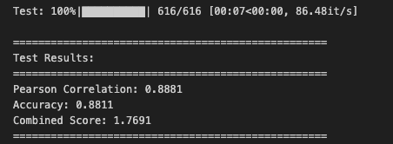
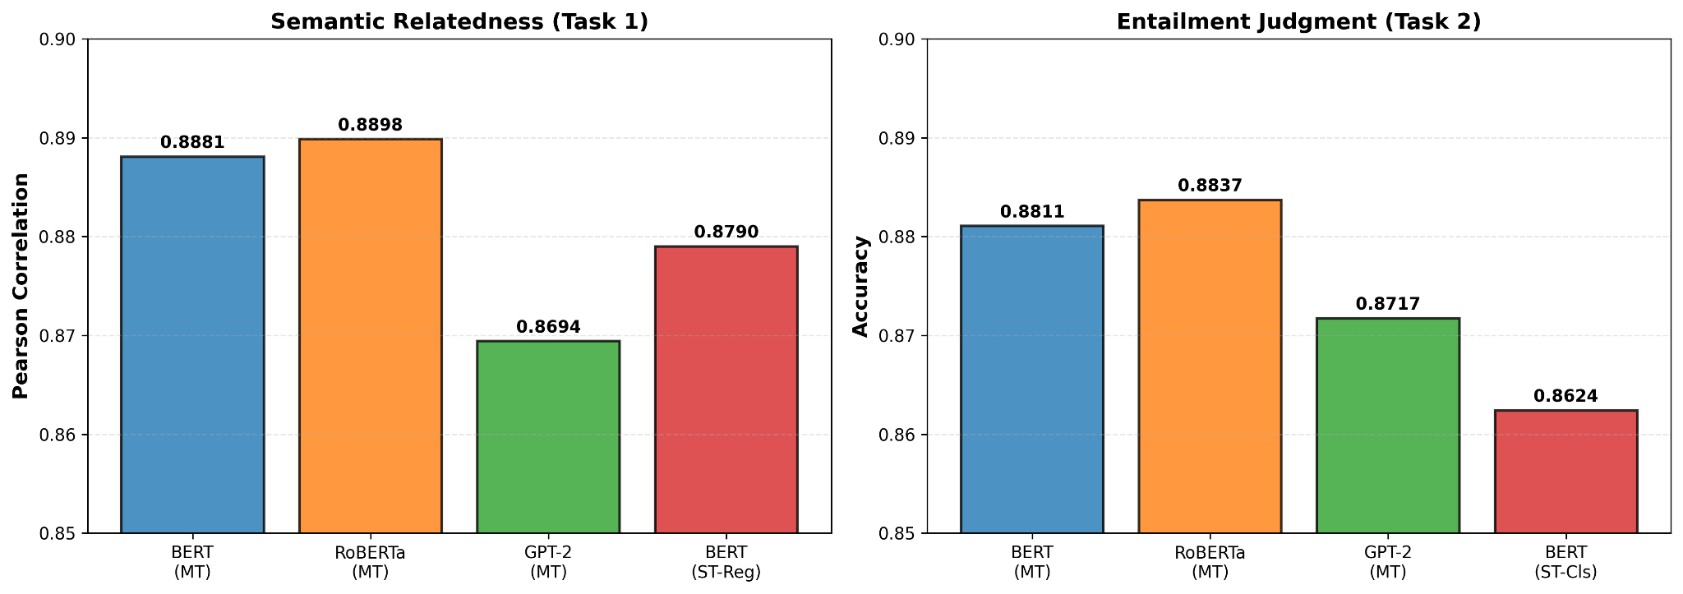

Figure Description: Comparison of test performance across all trained models:

- Left: Semantic Relatedness Task (Task 1) - Pearson Correlation scores
- Right: Entailment Classification Task (Task 2) - Accuracy scores

All models achieve strong performance on the SemEval 2014 Task 1 test set, with RoBERTa-base (Multi-Task) showing the best overall results.

