TCC

Leonardo Fernandes Wink

27/08/2022

Table of Contents

# Anotações de coisas por fazer:

* Descobrir como colocar as estações no sentido correto montante -> jusante nos sumários

87398500, 87398980, 87398900, 87398950, 87405500, 87406900, 87409900

* ~~Aprender a segmentar o meu dataset por períodos~~
* ~~aprender a criar uma nova coluna com a segmentação dos períodos~~
* aprender a colocar a legenda dentro do gráfico
  + reduzir o tamanho da legenda
* ~~corrigir os valores 0 de IQA pra NA~~
* descobrir como conseguir a equação do lm
* aprender a pivotar o sumário
* descobrir se há outros TCCs com disponibilização de códigos
* correlação forte entre condutividade e Namon/Ptot/DBO

| 1990-2000 | 2000-2010 | 2010-2020 |
| --- | --- | --- |
| 1990-2000 | 2000-2010 | 2010-2020 |

# Instalar os pacotes

# install.packages(tidyverse)

## acessar os pacotes

library(readr)  
library(rmarkdown)  
library(qboxplot)  
library(readxl)  
library(pillar)  
library(dplyr)  
library(tidyverse)  
library(gapminder)  
library(knitr)  
library(kableExtra)

## Warning in !is.null(rmarkdown::metadata$output) && rmarkdown::metadata$output  
## %in% : 'length(x) = 3 > 1' in coercion to 'logical(1)'

library(ggpubr)  
library(gridExtra)  
library(modelsummary)  
library(gtsummary)

## importando a planilha

plan_wide_19902020 <- read_delim("C:/Users/maria/OneDrive/Área de Trabalho/Amor/TCC_gh/plan_wide_19902020.tsv",   
 delim = "\t", escape_double = FALSE,   
 col_types = cols(Alcalinidade = col_double(),   
 CODIGO = col_character(), COORD_GEO_LAT_GRAU = col_double(),   
 COORD_GEO_LONG_GRAU = col_double(),   
 DATA_COLETA = col_date(format = "%d/%m/%Y"),   
 Nitrato = col_double(), Nitrito = col_double(),   
 SDT = col_double(), SST = col_double(),   
 `Vazao` = col_double(), `Vazao rio` = col_double()),   
 locale = locale(date_names = "pt", decimal_mark = ",",   
 grouping_mark = ""), trim_ws = TRUE)

## Parâmetros físico-químicos

### Oxigênio Dissolvido

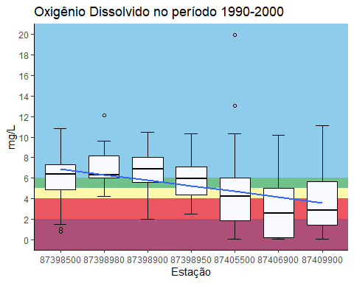

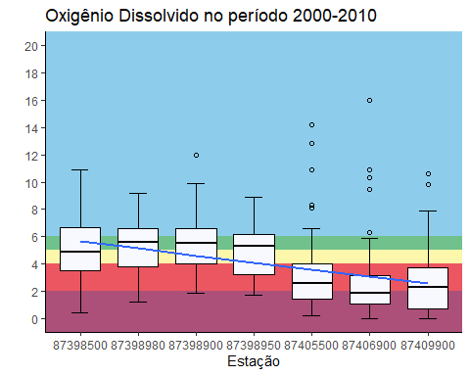

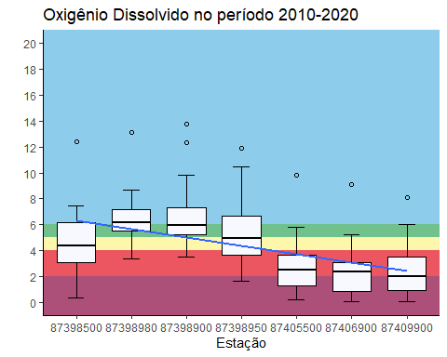

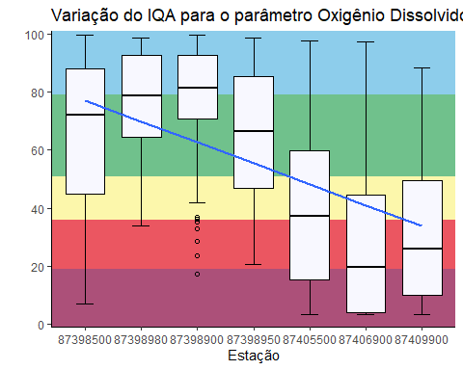

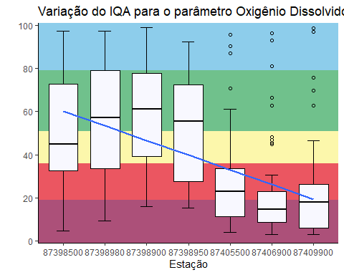

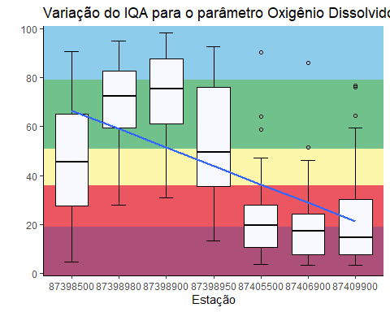

iqaod1 <- iqaod_1990_2000  
iqaod2 <- iqaod_2000_2010  
iqaod3 <- iqaod_2010_2020  
# grid.arrange(iqaod1, iqaod2, iqaod3, ncol = 3)  
grid.arrange(od_p1, od_p2, od_p3,  
 iqaod1, iqaod2, iqaod3,  
 ncol = 3, nrow=2)

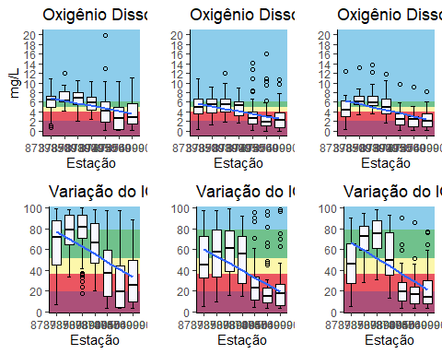

Resultado que quero chegar pro sumário

| variable | Estação 1 | Estação 2 | Estação 3 | Estação 4 |
| --- | --- | --- | --- | --- |
| max | 15 | 17 | 16 | 14 |
| med | 14 | 16 | 15 | 13 |
| min | 13 | 15 | 14 | 12 |
| n | 15 | 12 | 3 | 4 |

## # A tibble: 7 × 7  
## CODIGO min q1 median mean q3 max  
## <chr> <dbl> <dbl> <dbl> <dbl> <dbl> <dbl>  
## 1 87398500 0.8 4.9 6.4 5.99 7.3 10.8  
## 2 87398900 2 5.6 6.9 6.78 8 10.5  
## 3 87398950 2.5 4.4 5.95 5.98 7.1 10.3  
## 4 87398980 4.2 6 6.3 7.01 8.2 12.1  
## 5 87405500 0.1 1.9 4.2 4.22 6 19.9  
## 6 87406900 0.1 0.25 2.6 2.98 5 10.2  
## 7 87409900 0.1 1.4 2.9 3.60 5.65 11.1

## # A tibble: 7 × 7  
## CODIGO min q1 median mean q3 max  
## <chr> <dbl> <dbl> <dbl> <dbl> <dbl> <dbl>  
## 1 87398500 0.4 3.5 4.9 5.01 6.65 10.9  
## 2 87398900 1.9 4 5.5 5.33 6.6 12   
## 3 87398950 1.7 3.2 5.3 5.06 6.18 8.9  
## 4 87398980 1.2 3.8 5.6 5.38 6.6 9.2  
## 5 87405500 0.2 1.4 2.55 3.28 4 14.2  
## 6 87406900 0 1.1 1.9 2.59 3.15 16   
## 7 87409900 0 0.7 2.3 3.12 3.7 10.6

## # A tibble: 7 × 7  
## CODIGO min q1 median mean q3 max  
## <chr> <dbl> <dbl> <dbl> <dbl> <dbl> <dbl>  
## 1 87398500 0.38 3.11 4.41 4.57 6.2 12.4  
## 2 87398900 3.52 5.25 5.96 6.61 7.3 13.8  
## 3 87398950 1.62 3.68 4.92 5.28 6.64 11.9  
## 4 87398980 3.37 5.5 6.17 6.48 7.14 13.1  
## 5 87405500 0.2 1.3 2.53 2.83 3.66 9.8  
## 6 87406900 0.1 0.865 2.4 2.43 3.05 9.1  
## 7 87409900 0.1 0.92 2.03 2.43 3.5 8.1

### Demanda Bioquímica de Oxigênio

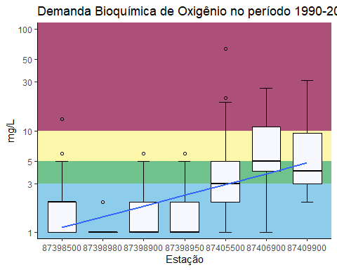

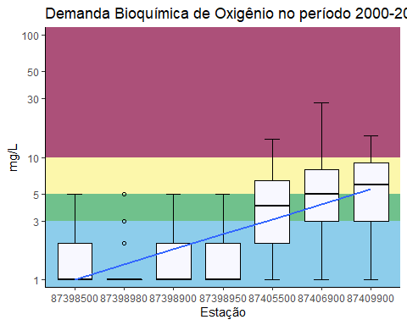

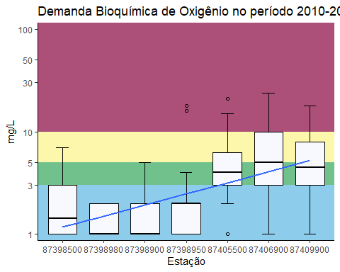

(iqa_dbo1<-ggplot(plan_wide_19902020 %>%   
 filter(ANO_COLETA>"1990" &  
 ANO_COLETA<="2000"),  
 aes(CODIGO,  
 IQA_DBO))+  
 annotate("rect",  
 xmin=-Inf,  
 xmax=Inf,  
 ymin=-Inf,  
 ymax=19,  
 alpha=1,  
 fill="#ac5079")+ #>pior classe  
 annotate("rect",  
 xmin=-Inf,  
 xmax=Inf,  
 ymin=19,  
 ymax=36,  
 alpha=1,  
 fill="#eb5661")+ #classe 4  
 annotate("rect",  
 xmin=-Inf,  
 xmax=Inf,  
 ymin=36,  
 ymax=51,  
 alpha=1,  
 fill="#fcf7ab")+ #classe 3  
 annotate("rect",  
 xmin=-Inf,  
 xmax=Inf,  
 ymin=51,  
 ymax=79,  
 alpha=1,  
 fill="#70c18c")+ #classe 2  
 annotate("rect",  
 xmin=-Inf,  
 xmax=Inf,  
 ymin=79,  
 ymax=Inf,  
 alpha=1,  
 fill="#8dcdeb")+ #classe 1))  
 stat_boxplot(geom = 'errorbar',  
 width=0.3,  
 position = position_dodge(width = 0.65),  
 na.rm = TRUE)+  
 geom_boxplot(fill='#F8F8FF',  
 color="black",  
 outlier.shape = 1, #se deixar NA fica só o jitter, se não, deixa 1  
 width= 0.7)+  
 labs(title = "Variação do IQA para o parâmetro DBO 1990-2020",  
 x="Estação",  
 y="mg/L")+  
 # geom_jitter(width = .05,  
 # alpha=.2,  
 # size=1.5,  
 # color="black")+  
 scale_y_continuous(expand = expansion(mult = c(0,0)),  
 n.breaks = 6,  
 limits = c(-1,101))+  
 scale_x_discrete(limits = c("87398500", "87398980", "87398900", "87398950", "87405500", "87406900", "87409900"))+  
 geom_smooth(method = "lm",  
 se=FALSE, #se deixar TRUE gera o intervalo de confiança de 95%  
 aes(group=1),  
 alpha=.5,  
 na.rm = TRUE,  
 size = 1)+  
 # geom_line(aes(color="red"),  
 # alpha=.0)+  
 # scale_color_manual("Legenda",  
 # guide="legend",  
 # values = c("Classe 1"="#8dcdeb",  
 # "Classe 2"="#70c18c",  
 # "Classe 3"="#fcf7ab",  
 # "Classe 4"="#eb5661",  
 # "Pior Classe"="#ac5079"))+  
 # guides(color=guide_legend(override.aes = list(linetype=c(1,1,1,1,1),  
 # lwd=c(2,2,2,2,2),  
 # shape=c(NA,NA,NA,NA,NA),  
 # alpha=1)))+  
 theme(legend.position = "bottom")+  
 theme_classic())

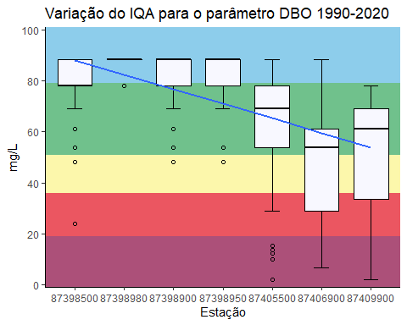

(iqa_dbo2<-ggplot(plan_wide_19902020%>%   
 filter(ANO_COLETA>"2000" &  
 ANO_COLETA<="2010"),  
 aes(CODIGO,  
 IQA_DBO))+  
 annotate("rect",  
 xmin=-Inf,  
 xmax=Inf,  
 ymin=-Inf,  
 ymax=19,  
 alpha=1,  
 fill="#ac5079")+ #>pior classe  
 annotate("rect",  
 xmin=-Inf,  
 xmax=Inf,  
 ymin=19,  
 ymax=36,  
 alpha=1,  
 fill="#eb5661")+ #classe 4  
 annotate("rect",  
 xmin=-Inf,  
 xmax=Inf,  
 ymin=36,  
 ymax=51,  
 alpha=1,  
 fill="#fcf7ab")+ #classe 3  
 annotate("rect",  
 xmin=-Inf,  
 xmax=Inf,  
 ymin=51,  
 ymax=79,  
 alpha=1,  
 fill="#70c18c")+ #classe 2  
 annotate("rect",  
 xmin=-Inf,  
 xmax=Inf,  
 ymin=79,  
 ymax=Inf,  
 alpha=1,  
 fill="#8dcdeb")+ #classe 1))  
 stat_boxplot(geom = 'errorbar',  
 width=0.3,  
 position = position_dodge(width = 0.65),  
 na.rm = TRUE)+  
 geom_boxplot(fill='#F8F8FF',  
 color="black",  
 outlier.shape = 1, #se deixar NA fica só o jitter, se não, deixa 1  
 width= 0.7)+  
 labs(title = "Variação do IQA para o parâmetro DBO 2000-2010",  
 x="Estação",  
 y="mg/L")+  
 # geom_jitter(width = .05,  
 # alpha=.2,  
 # size=1.5,  
 # color="black")+  
 scale_y_continuous(expand = expansion(mult = c(0,0)),  
 n.breaks = 6,  
 limits = c(-1,101))+  
 scale_x_discrete(limits = c("87398500", "87398980", "87398900", "87398950", "87405500", "87406900", "87409900"))+  
 geom_smooth(method = "lm",  
 se=FALSE, #se deixar TRUE gera o intervalo de confiança de 95%  
 aes(group=1),  
 alpha=.5,  
 na.rm = TRUE,  
 size = 1)+  
 # geom_line(aes(color="red"),  
 # alpha=.0)+  
 # scale_color_manual("Legenda",  
 # guide="legend",  
 # values = c("Classe 1"="#8dcdeb",  
 # "Classe 2"="#70c18c",  
 # "Classe 3"="#fcf7ab",  
 # "Classe 4"="#eb5661",  
 # "Pior Classe"="#ac5079"))+  
 # guides(color=guide_legend(override.aes = list(linetype=c(1,1,1,1,1),  
 # lwd=c(2,2,2,2,2),  
 # shape=c(NA,NA,NA,NA,NA),  
 # alpha=1)))+  
 theme(legend.position = "bottom")+  
 theme_classic())

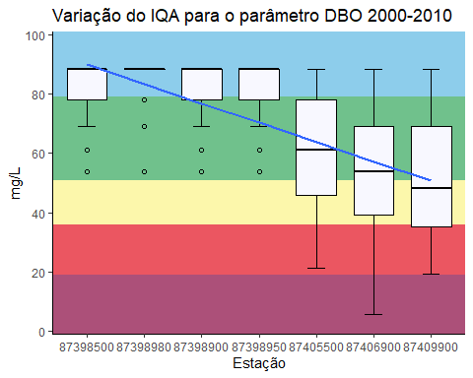

(iqa_dbo3<-ggplot(plan_wide_19902020%>%   
 filter(ANO_COLETA>"2010" &  
 ANO_COLETA<="2020"),  
 aes(CODIGO,  
 IQA_DBO))+  
 annotate("rect",  
 xmin=-Inf,  
 xmax=Inf,  
 ymin=-Inf,  
 ymax=19,  
 alpha=1,  
 fill="#ac5079")+ #>pior classe  
 annotate("rect",  
 xmin=-Inf,  
 xmax=Inf,  
 ymin=19,  
 ymax=36,  
 alpha=1,  
 fill="#eb5661")+ #classe 4  
 annotate("rect",  
 xmin=-Inf,  
 xmax=Inf,  
 ymin=36,  
 ymax=51,  
 alpha=1,  
 fill="#fcf7ab")+ #classe 3  
 annotate("rect",  
 xmin=-Inf,  
 xmax=Inf,  
 ymin=51,  
 ymax=79,  
 alpha=1,  
 fill="#70c18c")+ #classe 2  
 annotate("rect",  
 xmin=-Inf,  
 xmax=Inf,  
 ymin=79,  
 ymax=Inf,  
 alpha=1,  
 fill="#8dcdeb")+ #classe 1))  
 stat_boxplot(geom = 'errorbar',  
 width=0.3,  
 position = position_dodge(width = 0.65),  
 na.rm = TRUE)+  
 geom_boxplot(fill='#F8F8FF',  
 color="black",  
 outlier.shape = 1, #se deixar NA fica só o jitter, se não, deixa 1  
 width= 0.7)+  
 labs(title = "Variação do IQA para o parâmetro DBO 2010-2020",  
 x="Estação",  
 y="mg/L")+  
 # geom_jitter(width = .05,  
 # alpha=.2,  
 # size=1.5,  
 # color="black")+  
 scale_y_continuous(expand = expansion(mult = c(0,0)),  
 n.breaks = 6,  
 limits = c(-1,101))+  
 scale_x_discrete(limits = c("87398500", "87398980", "87398900", "87398950", "87405500", "87406900", "87409900"))+  
 geom_smooth(method = "lm",  
 se=FALSE, #se deixar TRUE gera o intervalo de confiança de 95%  
 aes(group=1),  
 alpha=.5,  
 na.rm = TRUE,  
 size = 1)+  
 # geom_line(aes(color="red"),  
 # alpha=.0)+  
 # scale_color_manual("Legenda",  
 # guide="legend",  
 # values = c("Classe 1"="#8dcdeb",  
 # "Classe 2"="#70c18c",  
 # "Classe 3"="#fcf7ab",  
 # "Classe 4"="#eb5661",  
 # "Pior Classe"="#ac5079"))+  
 # guides(color=guide_legend(override.aes = list(linetype=c(1,1,1,1,1),  
 # lwd=c(2,2,2,2,2),  
 # shape=c(NA,NA,NA,NA,NA),  
 # alpha=1)))+  
 theme(legend.position = "bottom")+  
 theme_classic())

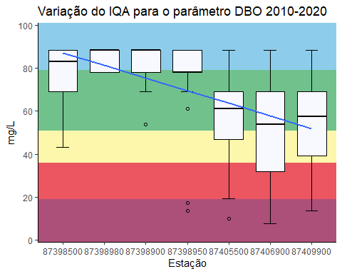

# iqa_dbo1  
# iqa_dbo2  
# iqa_dbo3  
# grid.arrange(iqaod1, iqaod2, iqaod3, ncol = 3)  
grid.arrange(dbo_p1, dbo_p2, dbo_p3,  
 iqa_dbo1, iqa_dbo2, iqa_dbo3,  
 ncol = 3, nrow=2)

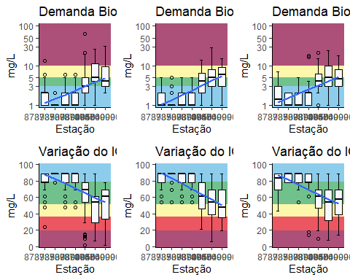

(sum_dbo_p1 <- plan_wide_19902020 %>%  
 select(CODIGO, DBO, ANO_COLETA) %>%   
 filter(ANO_COLETA>"1990" &  
 ANO_COLETA<="2000") %>%   
 group_by(CODIGO) %>%   
 summarize(  
 min =   
 min(DBO,   
 na.rm = TRUE),  
 q1 =   
 quantile(DBO, 0.25,   
 na.rm = TRUE),  
 median =   
 median(DBO,   
 na.rm = TRUE),  
 mean =   
 mean(DBO,   
 na.rm= TRUE),  
 q3 =   
 quantile(DBO, 0.75,   
 na.rm = TRUE),  
 max =   
 max(DBO,   
 na.rm = TRUE))  
)

## # A tibble: 7 × 7  
## CODIGO min q1 median mean q3 max  
## <chr> <dbl> <dbl> <dbl> <dbl> <dbl> <dbl>  
## 1 87398500 1 1 2 1.86 2 13  
## 2 87398900 1 1 1 1.52 2 6  
## 3 87398950 1 1 1 1.66 2 6  
## 4 87398980 1 1 1 1.13 1 2  
## 5 87405500 1 2 3 5.37 5 64  
## 6 87406900 1 4 5 9 11 26  
## 7 87409900 2 3 4 6.97 9.5 31

(sum_dbo_p2 <- plan_wide_19902020 %>%  
 select(CODIGO, DBO, ANO_COLETA) %>%   
 filter(ANO_COLETA>"2000" &  
 ANO_COLETA<="2010") %>%   
 group_by(CODIGO) %>%   
 summarize(  
 min =   
 min(DBO,   
 na.rm = TRUE),  
 q1 =   
 quantile(DBO, 0.25,   
 na.rm = TRUE),  
 median =   
 median(DBO,   
 na.rm = TRUE),  
 mean =   
 mean(DBO,   
 na.rm= TRUE),  
 q3 =   
 quantile(DBO, 0.75,   
 na.rm = TRUE),  
 max =   
 max(DBO,   
 na.rm = TRUE))  
)

## # A tibble: 7 × 7  
## CODIGO min q1 median mean q3 max  
## <chr> <dbl> <dbl> <dbl> <dbl> <dbl> <dbl>  
## 1 87398500 1 1 1 1.58 2 5  
## 2 87398900 1 1 1 1.40 2 5  
## 3 87398950 1 1 1 1.66 2 5  
## 4 87398980 1 1 1 1.30 1 5  
## 5 87405500 1 2 4 4.67 6.5 14  
## 6 87406900 1 3 5 6.53 8 28  
## 7 87409900 1 3 6 6.31 9 15

(sum_dbo_p3 <- plan_wide_19902020 %>%  
 select(CODIGO, DBO, ANO_COLETA) %>%   
 filter(ANO_COLETA>"2010" &  
 ANO_COLETA<="2020") %>%   
 group_by(CODIGO) %>%   
 summarize(  
 min =   
 min(DBO,   
 na.rm = TRUE),  
 q1 =   
 quantile(DBO, 0.25,   
 na.rm = TRUE),  
 median =   
 median(DBO,   
 na.rm = TRUE),  
 mean =   
 mean(DBO,   
 na.rm= TRUE),  
 q3 =   
 quantile(DBO, 0.75,   
 na.rm = TRUE),  
 max =   
 max(DBO,   
 na.rm = TRUE))  
)

## # A tibble: 7 × 7  
## CODIGO min q1 median mean q3 max  
## <chr> <dbl> <dbl> <dbl> <dbl> <dbl> <dbl>  
## 1 87398500 1 1 1.5 2.15 3 7  
## 2 87398900 1 1 1 1.51 2 5  
## 3 87398950 1 1 2 2.65 2 18  
## 4 87398980 1 1 1 1.32 2 2  
## 5 87405500 1 3 4 5.28 6.25 21  
## 6 87406900 1 3 5 6.58 10 24  
## 7 87409900 1 3 4.5 6.18 8 18

### Fósforo total

(ptot_p1<-ggplot(plan_wide_19902020%>%   
 filter(ANO_COLETA>"1990" &  
 ANO_COLETA<="2000"),  
 aes(CODIGO,  
 `Fósforo total`))+  
 annotate("rect",  
 xmin=-Inf,  
 xmax=Inf,  
 ymin=0.15,  
 ymax=Inf,  
 alpha=1,  
 fill="#ac5079")+ #>pior classe  
 #annotate("rect",  
 # xmin=-Inf,  
 # xmax=Inf,  
 # ymin=2,  
 # ymax=4,  
 # alpha=1,  
 # fill="#eb5661")+ #classe 4  
 annotate("rect",  
 xmin=-Inf,  
 xmax=Inf,  
 ymin=0.1,  
 ymax=0.15,  
 alpha=1,  
 fill="#fcf7ab")+ #classe 3  
 #annotate("rect",  
 # xmin=-Inf,  
 # xmax=Inf,  
 # ymin=3,  
 # ymax=5,  
 # alpha=1,  
 # fill="#70c18c")+ #classe 2  
 annotate("rect",  
 xmin=-Inf,  
 xmax=Inf,  
 ymin=0,  
 ymax=0.1,  
 alpha=1,  
 fill="#8dcdeb")+ #classe 1  
 stat_boxplot(geom = 'errorbar',  
 width=0.3,  
 position = position_dodge(width = 0.65))+  
 geom_boxplot(fill='#F8F8FF',  
 color="black",  
 outlier.shape = 1, #se deixar NA fica só o jitter, se não, deixa 1  
 width= 0.7)+  
 labs(title = "Fósforo total no período 1990-2000",  
 x="Estação",  
 y="mg/L")+  
 # geom_jitter(width = .05,  
 # alpha=.2,  
 # size=1.5,  
 # color="black")+  
 scale_y_continuous(expand = expansion(mult = c(0.03,0.03)),  
 n.breaks = 8,  
 limits = c(min(plan_wide_19902020$`Fósforo total`, na.rm = TRUE),  
 max(plan_wide_19902020$`Fósforo total`), na.rm = TRUE),  
 trans = "log10")+  
 scale_x_discrete(limits = c("87398500", "87398980", "87398900", "87398950", "87405500", "87406900", "87409900"))+  
 geom_smooth(method = "lm",  
 se=FALSE, #se deixar TRUE gera o intervalo de confiança de 95%  
 aes(group=1),  
 alpha=.5,  
 na.rm = TRUE,  
 size = 1)+  
 # geom_line(aes(color="red"),  
 # alpha=.0)+  
 # scale_color_manual("Legenda",  
 # guide="legend",  
 # values = c("Pior Classe"="#ac5079",  
 # "Classe 3"="#fcf7ab",  
 # "Classe 1"="#8dcdeb"))+  
 # guides(color=guide_legend(override.aes = list(linetype=c(1,1,1),  
 # lwd=c(2,2,2),  
 # shape=c(NA,NA,NA),  
 # alpha=1)))+  
 theme(legend.position = "bottom")+  
 theme_classic())

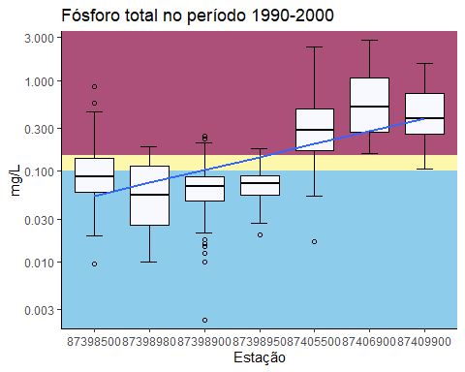

(ptot_p2 <- ggplot(plan_wide_19902020%>%   
 filter(ANO_COLETA>"2000" &  
 ANO_COLETA<="2010"),  
 aes(CODIGO,  
 `Fósforo total`))+  
 annotate("rect",  
 xmin=-Inf,  
 xmax=Inf,  
 ymin=0.15,  
 ymax=Inf,  
 alpha=1,  
 fill="#ac5079")+ #>pior classe  
 #annotate("rect",  
 # xmin=-Inf,  
 # xmax=Inf,  
 # ymin=2,  
 # ymax=4,  
 # alpha=1,  
 # fill="#eb5661")+ #classe 4  
 annotate("rect",  
 xmin=-Inf,  
 xmax=Inf,  
 ymin=0.1,  
 ymax=0.15,  
 alpha=1,  
 fill="#fcf7ab")+ #classe 3  
 #annotate("rect",  
 # xmin=-Inf,  
 # xmax=Inf,  
 # ymin=3,  
 # ymax=5,  
 # alpha=1,  
 # fill="#70c18c")+ #classe 2  
 annotate("rect",  
 xmin=-Inf,  
 xmax=Inf,  
 ymin=0,  
 ymax=0.1,  
 alpha=1,  
 fill="#8dcdeb")+ #classe 1  
 stat_boxplot(geom = 'errorbar',  
 width=0.3,  
 position = position_dodge(width = 0.65))+  
 geom_boxplot(fill='#F8F8FF',  
 color="black",  
 outlier.shape = 1, #se deixar NA fica só o jitter, se não, deixa 1  
 width= 0.7)+  
 labs(title = "Fósforo total no período 2000-2010",  
 x="Estação",  
 y="mg/L")+  
 # geom_jitter(width = .05,  
 # alpha=.2,  
 # size=1.5,  
 # color="black")+  
 scale_y_continuous(expand = expansion(mult = c(0.03,0.03)),  
 n.breaks = 8,  
 limits = c(min(plan_wide_19902020$`Fósforo total`, na.rm = TRUE),  
 max(plan_wide_19902020$`Fósforo total`), na.rm = TRUE),  
 trans = "log10")+  
 scale_x_discrete(limits = c("87398500", "87398980", "87398900", "87398950", "87405500", "87406900", "87409900"))+  
 geom_smooth(method = "lm",  
 se=FALSE, #se deixar TRUE gera o intervalo de confiança de 95%  
 aes(group=1),  
 alpha=.5,  
 na.rm = TRUE,  
 size = 1)+  
 # geom_line(aes(color="red"),  
 # alpha=.0)+  
 # scale_color_manual("Legenda",  
 # guide="legend",  
 # values = c("Pior Classe"="#ac5079",  
 # "Classe 3"="#fcf7ab",  
 # "Classe 1"="#8dcdeb"))+  
 # guides(color=guide_legend(override.aes = list(linetype=c(1,1,1),  
 # lwd=c(2,2,2),  
 # shape=c(NA,NA,NA),  
 # alpha=1)))+  
 theme(legend.position = "bottom")+  
 theme_classic())

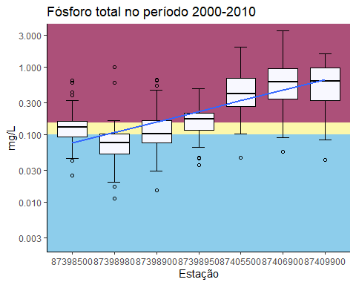

(ptot_p3 <- ggplot(plan_wide_19902020%>%   
 filter(ANO_COLETA>"2010" &  
 ANO_COLETA<="2020"),  
 aes(CODIGO,  
 `Fósforo total`))+  
 annotate("rect",  
 xmin=-Inf,  
 xmax=Inf,  
 ymin=0.15,  
 ymax=Inf,  
 alpha=1,  
 fill="#ac5079")+ #>pior classe  
 #annotate("rect",  
 # xmin=-Inf,  
 # xmax=Inf,  
 # ymin=2,  
 # ymax=4,  
 # alpha=1,  
 # fill="#eb5661")+ #classe 4  
 annotate("rect",  
 xmin=-Inf,  
 xmax=Inf,  
 ymin=0.1,  
 ymax=0.15,  
 alpha=1,  
 fill="#fcf7ab")+ #classe 3  
 #annotate("rect",  
 # xmin=-Inf,  
 # xmax=Inf,  
 # ymin=3,  
 # ymax=5,  
 # alpha=1,  
 # fill="#70c18c")+ #classe 2  
 annotate("rect",  
 xmin=-Inf,  
 xmax=Inf,  
 ymin=0,  
 ymax=0.1,  
 alpha=1,  
 fill="#8dcdeb")+ #classe 1  
 stat_boxplot(geom = 'errorbar',  
 width=0.3,  
 position = position_dodge(width = 0.65))+  
 geom_boxplot(fill='#F8F8FF',  
 color="black",  
 outlier.shape = 1, #se deixar NA fica só o jitter, se não, deixa 1  
 width= 0.7)+  
 labs(title = "Fósforo total no período 2010-2020",  
 x="Estação",  
 y="mg/L")+  
 # geom_jitter(width = .05,  
 # alpha=.2,  
 # size=1.5,  
 # color="black")+  
 scale_y_continuous(expand = expansion(mult = c(0.03,0.03)),  
 n.breaks = 8,  
 limits = c(min(plan_wide_19902020$`Fósforo total`, na.rm = TRUE),  
 max(plan_wide_19902020$`Fósforo total`), na.rm = TRUE),  
 trans = "log10")+  
 scale_x_discrete(limits = c("87398500", "87398980", "87398900", "87398950", "87405500", "87406900", "87409900"))+  
 geom_smooth(method = "lm",  
 se=FALSE, #se deixar TRUE gera o intervalo de confiança de 95%  
 aes(group=1),  
 alpha=.5,  
 na.rm = TRUE,  
 size = 1)+  
 # geom_line(aes(color="red"),  
 # alpha=.0)+  
 # scale_color_manual("Legenda",  
 # guide="legend",  
 # values = c("Pior Classe"="#ac5079",  
 # "Classe 3"="#fcf7ab",  
 # "Classe 1"="#8dcdeb"))+  
 # guides(color=guide_legend(override.aes = list(linetype=c(1,1,1),  
 # lwd=c(2,2,2),  
 # shape=c(NA,NA,NA),  
 # alpha=1)))+  
 theme(legend.position = "bottom")+  
 theme_classic())

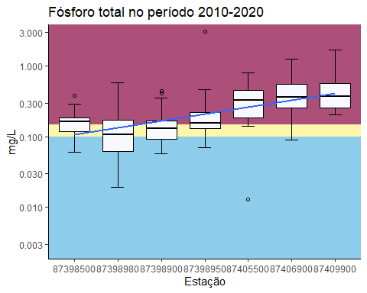

# ptot_p1  
# ptot_p2  
# ptot_p3  
grid.arrange(ptot_p1, ptot_p2, ptot_p3, ncol = 3)

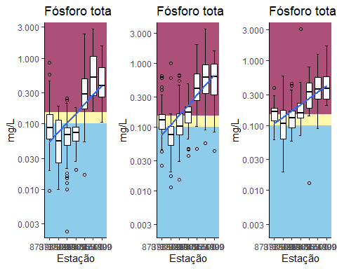

# grid.arrange(dbo_p1, dbo_p2, dbo_p3,  
# ptot_p1, ptot_p2, ptot_p3,  
# ncol = 3, nrow=2)

(sum_ptot_p1 <- plan_wide_19902020 %>%  
 select(CODIGO, `Fósforo total`, ANO_COLETA) %>%   
 filter(ANO_COLETA>"1990" &  
 ANO_COLETA<="2000") %>%   
 group_by(CODIGO) %>%   
 summarize(  
 min =   
 min(`Fósforo total`, na.rm = TRUE),  
 q1 =   
 quantile(`Fósforo total`, 0.25, na.rm = TRUE),  
 median =   
 median(`Fósforo total`, na.rm = TRUE),  
 mean =   
 mean(`Fósforo total`, na.rm= TRUE),  
 q3 =   
 quantile(`Fósforo total`, 0.75, na.rm = TRUE),  
 max =   
 max(`Fósforo total`, na.rm = TRUE)))

## # A tibble: 7 × 7  
## CODIGO min q1 median mean q3 max  
## <chr> <dbl> <dbl> <dbl> <dbl> <dbl> <dbl>  
## 1 87398500 0.0097 0.0593 0.0881 0.123 0.14 0.863  
## 2 87398900 0.0023 0.0468 0.0678 0.0747 0.0883 0.247  
## 3 87398950 0.0202 0.0544 0.0737 0.0751 0.0904 0.179  
## 4 87398980 0.01 0.0254 0.0547 0.0708 0.114 0.189  
## 5 87405500 0.017 0.171 0.281 0.417 0.492 2.32   
## 6 87406900 0.156 0.270 0.508 0.785 1.07 2.79   
## 7 87409900 0.107 0.258 0.384 0.489 0.712 1.53

(sum_ptot_p2 <- plan_wide_19902020 %>%  
 select(CODIGO, `Fósforo total`, ANO_COLETA) %>%   
 filter(ANO_COLETA>"2000" &  
 ANO_COLETA<="2010") %>%   
 group_by(CODIGO) %>%   
 summarize(  
 min =   
 min(`Fósforo total`, na.rm = TRUE),  
 q1 =   
 quantile(`Fósforo total`, 0.25, na.rm = TRUE),  
 median =   
 median(`Fósforo total`, na.rm = TRUE),  
 mean =   
 mean(`Fósforo total`, na.rm= TRUE),  
 q3 =   
 quantile(`Fósforo total`, 0.75, na.rm = TRUE),  
 max =   
 max(`Fósforo total`, na.rm = TRUE)))

## # A tibble: 7 × 7  
## CODIGO min q1 median mean q3 max  
## <chr> <dbl> <dbl> <dbl> <dbl> <dbl> <dbl>  
## 1 87398500 0.025 0.094 0.131 0.148 0.16 0.637  
## 2 87398900 0.015 0.0764 0.104 0.140 0.164 0.646  
## 3 87398950 0.036 0.116 0.171 0.180 0.207 0.485  
## 4 87398980 0.0115 0.052 0.076 0.101 0.103 1   
## 5 87405500 0.046 0.261 0.406 0.547 0.681 1.98   
## 6 87406900 0.056 0.338 0.599 0.752 0.967 3.49   
## 7 87409900 0.043 0.325 0.624 0.677 0.989 1.57

(sum_ptot_p3 <- plan_wide_19902020 %>%  
 select(CODIGO, `Fósforo total`, ANO_COLETA) %>%   
 filter(ANO_COLETA>"2010" &  
 ANO_COLETA<="2020") %>%   
 group_by(CODIGO) %>%   
 summarize(  
 min =   
 min(`Fósforo total`, na.rm = TRUE),  
 q1 =   
 quantile(`Fósforo total`, 0.25, na.rm = TRUE),  
 median =   
 median(`Fósforo total`, na.rm = TRUE),  
 mean =   
 mean(`Fósforo total`, na.rm= TRUE),  
 q3 =   
 quantile(`Fósforo total`, 0.75, na.rm = TRUE),  
 max =   
 max(`Fósforo total`, na.rm = TRUE)))

## # A tibble: 7 × 7  
## CODIGO min q1 median mean q3 max  
## <chr> <dbl> <dbl> <dbl> <dbl> <dbl> <dbl>  
## 1 87398500 0.061 0.118 0.163 0.166 0.186 0.381  
## 2 87398900 0.057 0.0935 0.130 0.163 0.168 0.444  
## 3 87398950 0.07 0.132 0.156 0.292 0.221 3.11   
## 4 87398980 0.019 0.0625 0.106 0.144 0.170 0.59   
## 5 87405500 0.013 0.187 0.332 0.361 0.45 0.803  
## 6 87406900 0.089 0.254 0.364 0.448 0.560 1.26   
## 7 87409900 0.203 0.259 0.369 0.488 0.564 1.7

### Escherichia coli

(ecoli_p1 <- ggplot(plan_wide_19902020 %>%   
 filter(ANO_COLETA>"1990" &  
 ANO_COLETA<="2000"),  
 aes(CODIGO,  
 `Escherichia coli`))+  
 annotate("rect",  
 xmin=-Inf,  
 xmax=Inf,  
 ymin=3200,  
 ymax=Inf,  
 alpha=1,  
 fill="#ac5079")+ #>pior classe  
 #annotate("rect",  
 # xmin=-Inf,  
 # xmax=Inf,  
 # ymin=2,  
 # ymax=4,  
 # alpha=1,  
 # fill="#eb5661")+ #classe 4  
 annotate("rect",  
 xmin=-Inf,  
 xmax=Inf,  
 ymin=800,  
 ymax=3200,  
 alpha=1,  
 fill="#fcf7ab")+ #classe 3  
 annotate("rect",  
 xmin=-Inf,  
 xmax=Inf,  
 ymin=160,  
 ymax=800,  
 alpha=1,  
 fill="#70c18c")+ #classe 2  
 annotate("rect",  
 xmin=-Inf,  
 xmax=Inf,  
 ymin=0,  
 ymax=160,  
 alpha=1,  
 fill="#8dcdeb")+ #classe 1  
 stat_boxplot(geom = 'errorbar',  
 width=0.3,  
 position = position_dodge(width = 0.65))+  
 geom_boxplot(fill='#F8F8FF',  
 color="black",  
 outlier.shape = 1, #se deixar NA fica só o jitter, se não, deixa 1  
 width= 0.7)+  
 labs(title = "Escherichia coli no período 1990-2000",  
 x="Estação",  
 y="NMP/100mL")+  
 # geom_jitter(width = .05,  
 # alpha=.2,  
 # size=1.5,  
 # color="black")+  
 scale_y_continuous(expand = expansion(mult = c(0.01, 0.01)),  
 n.breaks = 9,  
 limits = c(min(plan_wide_19902020$`Escherichia coli`, na.rm = TRUE),  
 max(plan_wide_19902020$`Escherichia coli`, na.rm = TRUE)),  
 trans = "log10",  
 labels = scales::number_format(accuracy = 1,  
 decimal.mark = ",",  
 big.mark = " "))+  
 scale_x_discrete(limits = c("87398500", "87398980", "87398900", "87398950", "87405500", "87406900", "87409900"))+  
 geom_smooth(method = "lm",  
 se=FALSE, #se deixar TRUE gera o intervalo de confiança de 95%  
 aes(group=1),  
 alpha=.5,  
 na.rm = TRUE,  
 size = 1)+  
 # geom_line(aes(color="red"),  
 # alpha=.0)+  
 # scale_color_manual("Legenda",  
 # guide="legend",  
 # values = c("Pior Classe"="#ac5079",  
 # "Classe 3"="#fcf7ab",  
 # "Classe 2"="#70c18c",  
 # "Classe 1"="#8dcdeb"))+  
 # guides(color=guide_legend(override.aes = list(linetype=c(1,1,1,1),  
 # lwd=c(2,2,2,2),  
 # shape=c(NA,NA,NA,NA),  
 # alpha=1)))+  
 theme_classic())

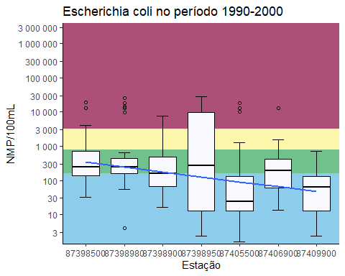

(ecoli_p2 <- ggplot(plan_wide_19902020 %>%   
 filter(ANO_COLETA>"2000" &  
 ANO_COLETA<="2010"),  
 aes(CODIGO,  
 `Escherichia coli`))+  
 annotate("rect",  
 xmin=-Inf,  
 xmax=Inf,  
 ymin=3200,  
 ymax=Inf,  
 alpha=1,  
 fill="#ac5079")+ #>pior classe  
 #annotate("rect",  
 # xmin=-Inf,  
 # xmax=Inf,  
 # ymin=2,  
 # ymax=4,  
 # alpha=1,  
 # fill="#eb5661")+ #classe 4  
 annotate("rect",  
 xmin=-Inf,  
 xmax=Inf,  
 ymin=800,  
 ymax=3200,  
 alpha=1,  
 fill="#fcf7ab")+ #classe 3  
 annotate("rect",  
 xmin=-Inf,  
 xmax=Inf,  
 ymin=160,  
 ymax=800,  
 alpha=1,  
 fill="#70c18c")+ #classe 2  
 annotate("rect",  
 xmin=-Inf,  
 xmax=Inf,  
 ymin=0,  
 ymax=160,  
 alpha=1,  
 fill="#8dcdeb")+ #classe 1  
 stat_boxplot(geom = 'errorbar',  
 width=0.3,  
 position = position_dodge(width = 0.65))+  
 geom_boxplot(fill='#F8F8FF',  
 color="black",  
 outlier.shape = 1, #se deixar NA fica só o jitter, se não, deixa 1  
 width= 0.7)+  
 labs(title = "Escherichia coli no período 2000-2010",  
 x="Estação",  
 y="NMP/100mL")+  
 # geom_jitter(width = .05,  
 # alpha=.2,  
 # size=1.5,  
 # color="black")+  
 scale_y_continuous(expand = expansion(mult = c(0.01, 0.01)),  
 n.breaks = 9,  
 limits = c(min(plan_wide_19902020$`Escherichia coli`, na.rm = TRUE),  
 max(plan_wide_19902020$`Escherichia coli`, na.rm = TRUE)),  
 trans = "log10",  
 labels = scales::number_format(accuracy = 1,  
 decimal.mark = ",",  
 big.mark = " "))+  
 scale_x_discrete(limits = c("87398500", "87398980", "87398900", "87398950", "87405500", "87406900", "87409900"))+  
 geom_smooth(method = "lm",  
 se=FALSE, #se deixar TRUE gera o intervalo de confiança de 95%  
 aes(group=1),  
 alpha=.5,  
 na.rm = TRUE,  
 size = 1)+  
 # geom_line(aes(color="red"),  
 # alpha=.0)+  
 # scale_color_manual("Legenda",  
 # guide="legend",  
 # values = c("Pior Classe"="#ac5079",  
 # "Classe 3"="#fcf7ab",  
 # "Classe 2"="#70c18c",  
 # "Classe 1"="#8dcdeb"))+  
 # guides(color=guide_legend(override.aes = list(linetype=c(1,1,1,1),  
 # lwd=c(2,2,2,2),  
 # shape=c(NA,NA,NA,NA),  
 # alpha=1)))+  
 theme_classic())

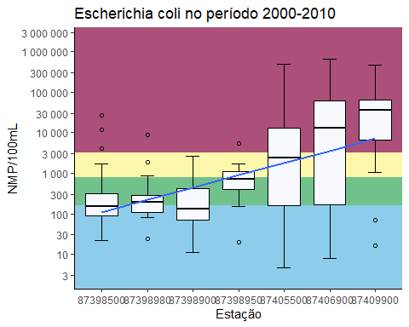

(ecoli_p3 <- ggplot(plan_wide_19902020 %>%   
 filter(ANO_COLETA>"2010" &  
 ANO_COLETA<="2020"),  
 aes(CODIGO,  
 `Escherichia coli`))+  
 annotate("rect",  
 xmin=-Inf,  
 xmax=Inf,  
 ymin=3200,  
 ymax=Inf,  
 alpha=1,  
 fill="#ac5079")+ #>pior classe  
 #annotate("rect",  
 # xmin=-Inf,  
 # xmax=Inf,  
 # ymin=2,  
 # ymax=4,  
 # alpha=1,  
 # fill="#eb5661")+ #classe 4  
 annotate("rect",  
 xmin=-Inf,  
 xmax=Inf,  
 ymin=800,  
 ymax=3200,  
 alpha=1,  
 fill="#fcf7ab")+ #classe 3  
 annotate("rect",  
 xmin=-Inf,  
 xmax=Inf,  
 ymin=160,  
 ymax=800,  
 alpha=1,  
 fill="#70c18c")+ #classe 2  
 annotate("rect",  
 xmin=-Inf,  
 xmax=Inf,  
 ymin=0,  
 ymax=160,  
 alpha=1,  
 fill="#8dcdeb")+ #classe 1  
 stat_boxplot(geom = 'errorbar',  
 width=0.3,  
 position = position_dodge(width = 0.65))+  
 geom_boxplot(fill='#F8F8FF',  
 color="black",  
 outlier.shape = 1, #se deixar NA fica só o jitter, se não, deixa 1  
 width= 0.7)+  
 labs(title = "Escherichia coli no período 2010-2020",  
 x="Estação",  
 y="NMP/100mL")+  
 # geom_jitter(width = .05,  
 # alpha=.2,  
 # size=1.5,  
 # color="black")+  
 scale_y_continuous(expand = expansion(mult = c(0.01, 0.01)),  
 n.breaks = 9,  
 limits = c(min(plan_wide_19902020$`Escherichia coli`, na.rm = TRUE),  
 max(plan_wide_19902020$`Escherichia coli`, na.rm = TRUE)),  
 trans = "log10",  
 labels = scales::number_format(accuracy = 1,  
 decimal.mark = ",",  
 big.mark = " "))+  
 scale_x_discrete(limits = c("87398500", "87398980", "87398900", "87398950", "87405500", "87406900", "87409900"))+  
 geom_smooth(method = "lm",  
 se=FALSE, #se deixar TRUE gera o intervalo de confiança de 95%  
 aes(group=1),  
 alpha=.5,  
 na.rm = TRUE,  
 size = 1)+  
 # geom_line(aes(color="red"),  
 # alpha=.0)+  
 # scale_color_manual("Legenda",  
 # guide="legend",  
 # values = c("Pior Classe"="#ac5079",  
 # "Classe 3"="#fcf7ab",  
 # "Classe 2"="#70c18c",  
 # "Classe 1"="#8dcdeb"))+  
 # guides(color=guide_legend(override.aes = list(linetype=c(1,1,1,1),  
 # lwd=c(2,2,2,2),  
 # shape=c(NA,NA,NA,NA),  
 # alpha=1)))+  
 theme_classic())

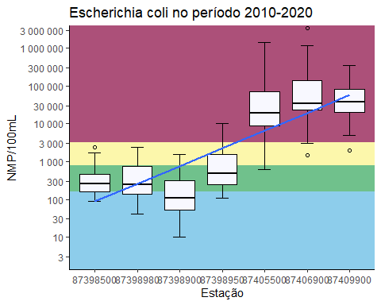

ecoli_p1



ecoli_p2



ecoli_p3



grid.arrange(ecoli_p1, ecoli_p2, ecoli_p3, ncol = 3)

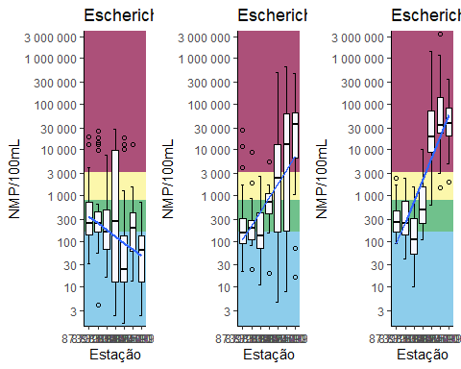

# grid.arrange(dbo_p1, dbo_p2, dbo_p3,  
# iqa_dbo1, iqa_dbo2, iqa_dbo3,  
# ncol = 3, nrow=2)

(sum_ecoli_p1 <- plan_wide_19902020 %>%  
 select(CODIGO, `Escherichia coli`, ANO_COLETA) %>%   
 filter(ANO_COLETA>"1990" &  
 ANO_COLETA<="2000") %>%   
 group_by(CODIGO) %>%   
 summarize(  
 min =   
 min(`Escherichia coli`,   
 na.rm = TRUE),  
 q1 =   
 quantile(`Escherichia coli`, 0.25,   
 na.rm = TRUE),  
 median =   
 median(`Escherichia coli`,   
 na.rm = TRUE),  
 mean =   
 mean(`Escherichia coli`,   
 na.rm= TRUE),  
 q3 =   
 quantile(`Escherichia coli`, 0.75,   
 na.rm = TRUE),  
 max =   
 max(`Escherichia coli`,   
 na.rm = TRUE))  
)

## # A tibble: 7 × 7  
## CODIGO min q1 median mean q3 max  
## <chr> <dbl> <dbl> <dbl> <dbl> <dbl> <dbl>  
## 1 87398500 32 136 240 854. 720 19200  
## 2 87398900 16 68 160 548. 480 7760  
## 3 87398950 2.4 12.8 268 4039. 10000 28000  
## 4 87398980 4 160 243. 2907. 446 25600  
## 5 87405500 1.6 12.8 24 545. 128 18400  
## 6 87406900 13.6 61.6 192 718. 414 12800  
## 7 87409900 2.4 12.8 64 97.7 128 720

(sum_ecoli_p2 <- plan_wide_19902020 %>%  
 select(CODIGO, `Escherichia coli`, ANO_COLETA) %>%   
 filter(ANO_COLETA>"2000" &  
 ANO_COLETA<="2010") %>%   
 group_by(CODIGO) %>%   
 summarize(  
 min =   
 min(`Escherichia coli`,   
 na.rm = TRUE),  
 q1 =   
 quantile(`Escherichia coli`, 0.25,   
 na.rm = TRUE),  
 median =   
 median(`Escherichia coli`,   
 na.rm = TRUE),  
 mean =   
 mean(`Escherichia coli`,   
 na.rm= TRUE),  
 q3 =   
 quantile(`Escherichia coli`, 0.75,   
 na.rm = TRUE),  
 max =   
 max(`Escherichia coli`,   
 na.rm = TRUE))  
)

## # A tibble: 7 × 7  
## CODIGO min q1 median mean q3 max  
## <chr> <dbl> <dbl> <dbl> <dbl> <dbl> <dbl>  
## 1 87398500 21.6 91 150 1335. 308 27200  
## 2 87398900 11 70 133. 444. 414. 2600  
## 3 87398950 20 400 720 935. 1120 5500  
## 4 87398980 24 110. 195 410. 289. 8800  
## 5 87405500 4.7 162 2400 25445. 12950 490000  
## 6 87406900 8 172 12800 66370. 62300 650000  
## 7 87409900 16 7355. 35500 72440. 68750 460000

(sum_ecoli_p3 <- plan_wide_19902020 %>%  
 select(CODIGO, `Escherichia coli`, ANO_COLETA) %>%   
 filter(ANO_COLETA>"2010" &  
 ANO_COLETA<="2020") %>%   
 group_by(CODIGO) %>%   
 summarize(  
 min =   
 min(`Escherichia coli`,   
 na.rm = TRUE),  
 q1 =   
 quantile(`Escherichia coli`, 0.25,   
 na.rm = TRUE),  
 median =   
 median(`Escherichia coli`,   
 na.rm = TRUE),  
 mean =   
 mean(`Escherichia coli`,   
 na.rm= TRUE),  
 q3 =   
 quantile(`Escherichia coli`, 0.75,   
 na.rm = TRUE),  
 max =   
 max(`Escherichia coli`,   
 na.rm = TRUE))  
)

## # A tibble: 7 × 7  
## CODIGO min q1 median mean q3 max  
## <chr> <dbl> <dbl> <dbl> <dbl> <dbl> <dbl>  
## 1 87398500 90 155. 260 409. 451 2420   
## 2 87398900 10 52.8 107 245. 313 1553.  
## 3 87398950 108. 250 487 1424. 1553. 10462   
## 4 87398980 40.8 140. 242. 529. 738. 2400   
## 5 87405500 632 8965 19232. 109992. 70750 1400000   
## 6 87406900 1440 23100 34500 230828. 140500 3400000   
## 7 87409900 2000 20100 38400 83128. 83680 345000

### Nitrogênio amoniacal

(namon_p1 <- ggplot(plan_wide_19902020 %>%   
 filter(ANO_COLETA>"1990" &  
 ANO_COLETA<="2000"),  
 aes(CODIGO,  
 `Nitrogênio total`))+  
 annotate("rect",  
 xmin=-Inf,  
 xmax=Inf,  
 ymin=0,  
 ymax=3.7,  
 alpha=1,  
 fill="#8dcdeb")+ #classe 1  
 annotate("rect",  
 xmin=-Inf,  
 xmax=Inf,  
 ymin=13.3,  
 ymax=Inf,  
 alpha=1,  
 fill="#ac5079")+ #>pior classe  
 annotate("rect",  
 xmin=-Inf,  
 xmax=Inf,  
 ymin=3.7,  
 ymax=13.3,  
 alpha=1,  
 fill="#fcf7ab")+ #classe 3  
 stat_boxplot(geom = 'errorbar',  
 width=0.3,  
 position = position_dodge(width = 0.65))+  
 geom_boxplot(fill='#F8F8FF',  
 color="black",  
 outlier.shape = 1, #se deixar NA fica só o jitter, se não, deixa 1  
 width= 0.7)+  
 labs(title = "Nitrogênio amoniacal no período 1990-2000",  
 x="Estação",  
 y="mg/L")+  
 # geom_jitter(width = .05,  
 # alpha=.2,  
 # size=1.5,  
 # color="black")+  
 scale_y_continuous(expand = expansion(mult = c(0.01, 0.05)),  
 n.breaks = 9,  
 limits = c(min(plan_wide_19902020$`Nitrogênio total`, na.rm = TRUE),  
 max(plan_wide_19902020$`Nitrogênio total`, na.rm = TRUE)),  
 trans = "log10",  
 labels = scales::number_format(accuracy = .001,  
 decimal.mark = ",",  
 big.mark = " "))+  
 scale_x_discrete(limits = c("87398500", "87398980", "87398900", "87398950", "87405500", "87406900", "87409900"))+  
 geom_smooth(method = "lm",  
 se=FALSE, #se deixar TRUE gera o intervalo de confiança de 95%  
 aes(group=1),  
 alpha=.5,  
 na.rm = TRUE,  
 size = 1)+  
 # geom_line(aes(color="red"),  
 # alpha=.0)+  
 # scale_color_manual("Legenda",  
 # guide="legend",  
 # values = c("Pior Classe"="#ac5079",  
 # "Classe 3"="#fcf7ab",  
 # "Classe 1"="#8dcdeb"))+  
 # guides(color=guide_legend(override.aes = list(linetype=c(1,1,1),  
 # lwd=c(2,2,2),  
 # shape=c(NA,NA,NA),  
 # alpha=1)))+  
 theme_classic())

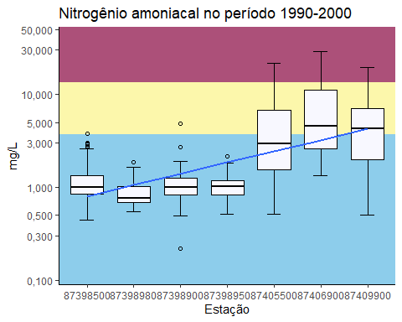

(namon_p2 <- ggplot(plan_wide_19902020 %>%   
 filter(ANO_COLETA>"2000" &  
 ANO_COLETA<="2010"),  
 aes(CODIGO,  
 `Nitrogênio total`))+  
 annotate("rect",  
 xmin=-Inf,  
 xmax=Inf,  
 ymin=0,  
 ymax=3.7,  
 alpha=1,  
 fill="#8dcdeb")+ #classe 1  
 annotate("rect",  
 xmin=-Inf,  
 xmax=Inf,  
 ymin=13.3,  
 ymax=Inf,  
 alpha=1,  
 fill="#ac5079")+ #>pior classe  
 annotate("rect",  
 xmin=-Inf,  
 xmax=Inf,  
 ymin=3.7,  
 ymax=13.3,  
 alpha=1,  
 fill="#fcf7ab")+ #classe 3  
 stat_boxplot(geom = 'errorbar',  
 width=0.3,  
 position = position_dodge(width = 0.65))+  
 geom_boxplot(fill='#F8F8FF',  
 color="black",  
 outlier.shape = 1, #se deixar NA fica só o jitter, se não, deixa 1  
 width= 0.7)+  
 labs(title = "Nitrogênio amoniacal no período 2000-2010",  
 x="Estação",  
 y="mg/L")+  
 # geom_jitter(width = .05,  
 # alpha=.2,  
 # size=1.5,  
 # color="black")+  
 scale_y_continuous(expand = expansion(mult = c(0.01, 0.05)),  
 n.breaks = 9,  
 limits = c(min(plan_wide_19902020$`Nitrogênio total`, na.rm = TRUE),  
 max(plan_wide_19902020$`Nitrogênio total`, na.rm = TRUE)),  
 trans = "log10",  
 labels = scales::number_format(accuracy = .001,  
 decimal.mark = ",",  
 big.mark = " "))+  
 scale_x_discrete(limits = c("87398500", "87398980", "87398900", "87398950", "87405500", "87406900", "87409900"))+  
 geom_smooth(method = "lm",  
 se=FALSE, #se deixar TRUE gera o intervalo de confiança de 95%  
 aes(group=1),  
 alpha=.5,  
 na.rm = TRUE,  
 size = 1)+  
 # geom_line(aes(color="red"),  
 # alpha=.0)+  
 # scale_color_manual("Legenda",  
 # guide="legend",  
 # values = c("Pior Classe"="#ac5079",  
 # "Classe 3"="#fcf7ab",  
 # "Classe 1"="#8dcdeb"))+  
 # guides(color=guide_legend(override.aes = list(linetype=c(1,1,1),  
 # lwd=c(2,2,2),  
 # shape=c(NA,NA,NA),  
 # alpha=1)))+  
 theme_classic())

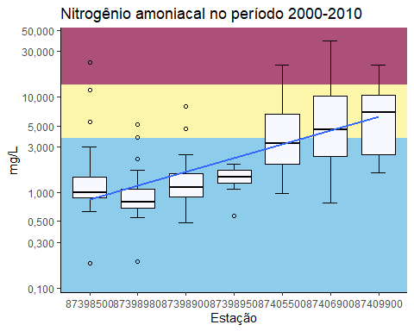

(namon_p3 <- ggplot(plan_wide_19902020 %>%   
 filter(ANO_COLETA>"2010" &  
 ANO_COLETA<="2020"),  
 aes(CODIGO,  
 `Nitrogênio total`))+  
 annotate("rect",  
 xmin=-Inf,  
 xmax=Inf,  
 ymin=0,  
 ymax=3.7,  
 alpha=1,  
 fill="#8dcdeb")+ #classe 1  
 annotate("rect",  
 xmin=-Inf,  
 xmax=Inf,  
 ymin=13.3,  
 ymax=Inf,  
 alpha=1,  
 fill="#ac5079")+ #>pior classe  
 annotate("rect",  
 xmin=-Inf,  
 xmax=Inf,  
 ymin=3.7,  
 ymax=13.3,  
 alpha=1,  
 fill="#fcf7ab")+ #classe 3  
 stat_boxplot(geom = 'errorbar',  
 width=0.3,  
 position = position_dodge(width = 0.65))+  
 geom_boxplot(fill='#F8F8FF',  
 color="black",  
 outlier.shape = 1, #se deixar NA fica só o jitter, se não, deixa 1  
 width= 0.7)+  
 labs(title = "Nitrogênio amoniacal no período 2010-2020",  
 x="Estação",  
 y="mg/L")+  
 # geom_jitter(width = .05,  
 # alpha=.2,  
 # size=1.5,  
 # color="black")+  
 scale_y_continuous(expand = expansion(mult = c(0.01, 0.05)),  
 n.breaks = 9,  
 limits = c(min(plan_wide_19902020$`Nitrogênio total`, na.rm = TRUE),  
 max(plan_wide_19902020$`Nitrogênio total`, na.rm = TRUE)),  
 trans = "log10",  
 labels = scales::number_format(accuracy = .001,  
 decimal.mark = ",",  
 big.mark = " "))+  
 scale_x_discrete(limits = c("87398500", "87398980", "87398900", "87398950", "87405500", "87406900", "87409900"))+  
 geom_smooth(method = "lm",  
 se=FALSE, #se deixar TRUE gera o intervalo de confiança de 95%  
 aes(group=1),  
 alpha=.5,  
 na.rm = TRUE,  
 size = 1)+  
 # geom_line(aes(color="red"),  
 # alpha=.0)+  
 # scale_color_manual("Legenda",  
 # guide="legend",  
 # values = c("Pior Classe"="#ac5079",  
 # "Classe 3"="#fcf7ab",  
 # "Classe 1"="#8dcdeb"))+  
 # guides(color=guide_legend(override.aes = list(linetype=c(1,1,1),  
 # lwd=c(2,2,2),  
 # shape=c(NA,NA,NA),  
 # alpha=1)))+  
 theme_classic())

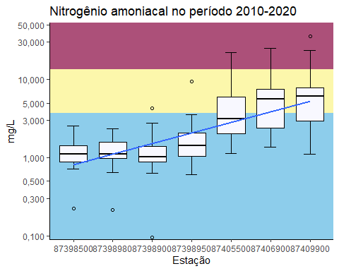

namon_p1



namon_p2



namon_p3



grid.arrange(namon_p1, namon_p2, namon_p3, ncol = 3)

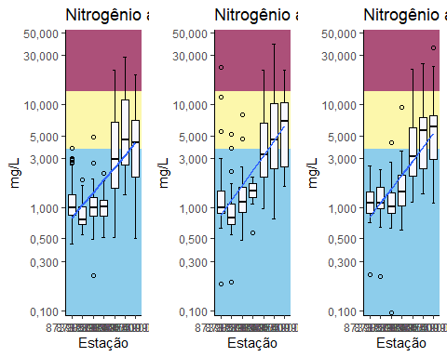

# grid.arrange(dbo_p1, dbo_p2, dbo_p3,  
# iqa_dbo1, iqa_dbo2, iqa_dbo3,  
# ncol = 3, nrow=2)

(sum_namon_p1 <- plan_wide_19902020 %>%  
 select(CODIGO, `Nitrogênio total`, ANO_COLETA) %>%   
 filter(ANO_COLETA>"1990" &  
 ANO_COLETA<="2000") %>%   
 group_by(CODIGO) %>%   
 summarize(  
 min =   
 min(`Nitrogênio total`,   
 na.rm = TRUE),  
 q1 =   
 quantile(`Nitrogênio total`, 0.25,   
 na.rm = TRUE),  
 median =   
 median(`Nitrogênio total`,   
 na.rm = TRUE),  
 mean =   
 mean(`Nitrogênio total`,   
 na.rm= TRUE),  
 q3 =   
 quantile(`Nitrogênio total`, 0.75,   
 na.rm = TRUE),  
 max =   
 max(`Nitrogênio total`,   
 na.rm = TRUE))  
)

## # A tibble: 7 × 7  
## CODIGO min q1 median mean q3 max  
## <chr> <dbl> <dbl> <dbl> <dbl> <dbl> <dbl>  
## 1 87398500 0.44 0.842 1.00 1.22 1.34 3.81  
## 2 87398900 0.22 0.82 1 1.09 1.25 4.86  
## 3 87398950 0.51 0.83 1.02 1.06 1.19 2.16  
## 4 87398980 0.549 0.68 0.755 0.872 1.01 1.85  
## 5 87405500 0.51 1.53 2.94 5.27 6.77 21.6   
## 6 87406900 1.34 2.60 4.56 7.58 11.2 29.1   
## 7 87409900 0.5 1.98 4.29 5.18 7.01 19.6

(sum_namon_p2 <- plan_wide_19902020 %>%  
 select(CODIGO, `Nitrogênio total`, ANO_COLETA) %>%   
 filter(ANO_COLETA>"2000" &  
 ANO_COLETA<="2010") %>%   
 group_by(CODIGO) %>%   
 summarize(  
 min =   
 min(`Nitrogênio total`,   
 na.rm = TRUE),  
 q1 =   
 quantile(`Nitrogênio total`, 0.25,   
 na.rm = TRUE),  
 median =   
 median(`Nitrogênio total`,   
 na.rm = TRUE),  
 mean =   
 mean(`Nitrogênio total`,   
 na.rm= TRUE),  
 q3 =   
 quantile(`Nitrogênio total`, 0.75,   
 na.rm = TRUE),  
 max =   
 max(`Nitrogênio total`,   
 na.rm = TRUE))  
)

## # A tibble: 7 × 7  
## CODIGO min q1 median mean q3 max  
## <chr> <dbl> <dbl> <dbl> <dbl> <dbl> <dbl>  
## 1 87398500 0.18 0.885 0.992 1.80 1.46 23.2   
## 2 87398900 0.48 0.894 1.13 1.38 1.57 7.92  
## 3 87398950 0.57 1.26 1.45 1.43 1.71 1.98  
## 4 87398980 0.19 0.685 0.79 1.05 1.10 5.2   
## 5 87405500 0.968 2 3.29 5.45 6.60 21.7   
## 6 87406900 0.77 2.4 4.54 7.30 10.2 39.1   
## 7 87409900 1.62 2.5 6.97 7.92 10.6 21.5

(sum_namon_p3 <- plan_wide_19902020 %>%  
 select(CODIGO, `Nitrogênio total`, ANO_COLETA) %>%   
 filter(ANO_COLETA>"2010" &  
 ANO_COLETA<="2020") %>%   
 group_by(CODIGO) %>%   
 summarize(  
 min =   
 min(`Nitrogênio total`,   
 na.rm = TRUE),  
 q1 =   
 quantile(`Nitrogênio total`, 0.25,   
 na.rm = TRUE),  
 median =   
 median(`Nitrogênio total`,   
 na.rm = TRUE),  
 mean =   
 mean(`Nitrogênio total`,   
 na.rm= TRUE),  
 q3 =   
 quantile(`Nitrogênio total`, 0.75,   
 na.rm = TRUE),  
 max =   
 max(`Nitrogênio total`,   
 na.rm = TRUE))  
)

## # A tibble: 7 × 7  
## CODIGO min q1 median mean q3 max  
## <chr> <dbl> <dbl> <dbl> <dbl> <dbl> <dbl>  
## 1 87398500 0.222 0.89 1.11 1.24 1.41 2.56  
## 2 87398900 0.095 0.883 1.02 1.29 1.40 4.25  
## 3 87398950 0.612 1.04 1.43 1.90 2.06 9.5   
## 4 87398980 0.216 0.973 1.12 1.22 1.58 2.32  
## 5 87405500 1.12 2.03 3.14 4.50 5.93 22.0   
## 6 87406900 1.37 2.40 5.58 6.47 7.58 25   
## 7 87409900 1.11 3 6.15 7.29 7.75 36

### Turbidez

(turb_p1 <- ggplot(plan_wide_19902020 %>%   
 filter(ANO_COLETA>"1990" &  
 ANO_COLETA<="2000"),  
 aes(CODIGO,  
 Turbidez))+  
 annotate("rect",  
 xmin=-Inf,  
 xmax=Inf,  
 ymin=100,  
 ymax=Inf,  
 alpha=1,  
 fill="#ac5079")+ #>pior classe  
 annotate("rect",  
 xmin=-Inf,  
 xmax=Inf,  
 ymin=40,  
 ymax=100,  
 alpha=1,  
 fill="#fcf7ab")+ #classe 3  
 annotate("rect",  
 xmin=-Inf,  
 xmax=Inf,  
 ymin=0,  
 ymax=40,  
 alpha=1,  
 fill="#8dcdeb")+ #classe 1  
 stat_boxplot(geom = 'errorbar',  
 width=0.3,  
 position = position_dodge(width = 0.65))+  
 geom_boxplot(fill='#F8F8FF',  
 color="black",  
 outlier.shape = 1, #se deixar NA fica só o jitter, se não, deixa 1  
 width= 0.7)+  
 labs(title = "Turbidez no período 1990-2000",  
 x="Estação",  
 y="UNT")+  
 # geom_jitter(width = .05,  
 # alpha=.2,  
 # size=1.5,  
 # color="black")+  
 scale_y_continuous(expand = expansion(mult = c(0.05, 0.03)),  
 n.breaks = 8,  
 limits = c(min(plan_wide_19902020$Turbidez, na.rm = TRUE),  
 max(plan_wide_19902020$Turbidez, na.rm = TRUE)),  
 trans = "log10",  
 labels = scales::number_format(accuracy = 1,  
 decimal.mark = ",",  
 big.mark = " "))+  
 scale_x_discrete(limits = c("87398500", "87398980", "87398900", "87398950", "87405500", "87406900", "87409900"))+  
 geom_smooth(method = "lm",  
 se=FALSE, #se deixar TRUE gera o intervalo de confiança de 95%  
 aes(group=1),  
 alpha=.5,  
 na.rm = TRUE,  
 size = 1)+  
 # geom_line(aes(color="red"),  
 # alpha=.0)+  
 # scale_color_manual("Legenda",  
 # guide="legend",  
 # values = c("Pior Classe"="#ac5079",  
 # "Classe 3"="#fcf7ab",  
 # "Classe 1"="#8dcdeb"))+  
 # guides(color=guide_legend(override.aes = list(linetype=c(1,1,1),  
 # lwd=c(2,2,2),  
 # shape=c(NA,NA,NA),  
 # alpha=1)))+  
 theme_classic())

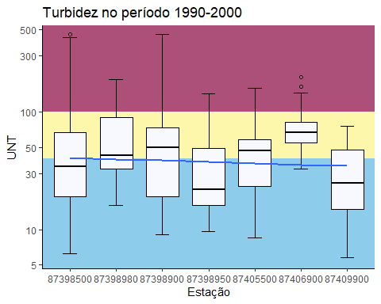

(turb_p2 <- ggplot(plan_wide_19902020 %>%   
 filter(ANO_COLETA>"2000" &  
 ANO_COLETA<="2010"),  
 aes(CODIGO,  
 Turbidez))+  
 annotate("rect",  
 xmin=-Inf,  
 xmax=Inf,  
 ymin=100,  
 ymax=Inf,  
 alpha=1,  
 fill="#ac5079")+ #>pior classe  
 annotate("rect",  
 xmin=-Inf,  
 xmax=Inf,  
 ymin=40,  
 ymax=100,  
 alpha=1,  
 fill="#fcf7ab")+ #classe 3  
 annotate("rect",  
 xmin=-Inf,  
 xmax=Inf,  
 ymin=0,  
 ymax=40,  
 alpha=1,  
 fill="#8dcdeb")+ #classe 1  
 stat_boxplot(geom = 'errorbar',  
 width=0.3,  
 position = position_dodge(width = 0.65))+  
 geom_boxplot(fill='#F8F8FF',  
 color="black",  
 outlier.shape = 1, #se deixar NA fica só o jitter, se não, deixa 1  
 width= 0.7)+  
 labs(title = "Turbidez no período 2000-2010",  
 x="Estação",  
 y="UNT")+  
 # geom_jitter(width = .05,  
 # alpha=.2,  
 # size=1.5,  
 # color="black")+  
 scale_y_continuous(expand = expansion(mult = c(0.05, 0.03)),  
 n.breaks = 8,  
 limits = c(min(plan_wide_19902020$Turbidez, na.rm = TRUE),  
 max(plan_wide_19902020$Turbidez, na.rm = TRUE)),  
 trans = "log10",  
 labels = scales::number_format(accuracy = 1,  
 decimal.mark = ",",  
 big.mark = " "))+  
 scale_x_discrete(limits = c("87398500", "87398980", "87398900", "87398950", "87405500", "87406900", "87409900"))+  
 geom_smooth(method = "lm",  
 se=FALSE, #se deixar TRUE gera o intervalo de confiança de 95%  
 aes(group=1),  
 alpha=.5,  
 na.rm = TRUE,  
 size = 1)+  
 # geom_line(aes(color="red"),  
 # alpha=.0)+  
 # scale_color_manual("Legenda",  
 # guide="legend",  
 # values = c("Pior Classe"="#ac5079",  
 # "Classe 3"="#fcf7ab",  
 # "Classe 1"="#8dcdeb"))+  
 # guides(color=guide_legend(override.aes = list(linetype=c(1,1,1),  
 # lwd=c(2,2,2),  
 # shape=c(NA,NA,NA),  
 # alpha=1)))+  
 theme_classic())

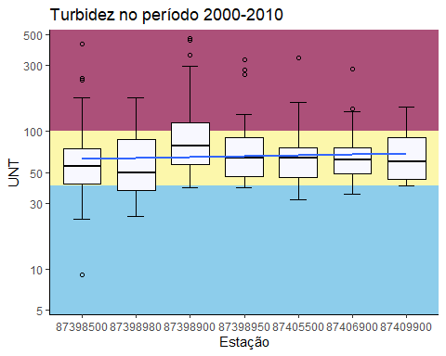

(turb_p3 <- ggplot(plan_wide_19902020 %>%   
 filter(ANO_COLETA>"2010" &  
 ANO_COLETA<="2020"),  
 aes(CODIGO,  
 Turbidez))+  
 annotate("rect",  
 xmin=-Inf,  
 xmax=Inf,  
 ymin=100,  
 ymax=Inf,  
 alpha=1,  
 fill="#ac5079")+ #>pior classe  
 annotate("rect",  
 xmin=-Inf,  
 xmax=Inf,  
 ymin=40,  
 ymax=100,  
 alpha=1,  
 fill="#fcf7ab")+ #classe 3  
 annotate("rect",  
 xmin=-Inf,  
 xmax=Inf,  
 ymin=0,  
 ymax=40,  
 alpha=1,  
 fill="#8dcdeb")+ #classe 1  
 stat_boxplot(geom = 'errorbar',  
 width=0.3,  
 position = position_dodge(width = 0.65))+  
 geom_boxplot(fill='#F8F8FF',  
 color="black",  
 outlier.shape = 1, #se deixar NA fica só o jitter, se não, deixa 1  
 width= 0.7)+  
 labs(title = "Turbidez no período 2010-2020",  
 x="Estação",  
 y="UNT")+  
 # geom_jitter(width = .05,  
 # alpha=.2,  
 # size=1.5,  
 # color="black")+  
 scale_y_continuous(expand = expansion(mult = c(0.05, 0.03)),  
 n.breaks = 8,  
 limits = c(min(plan_wide_19902020$Turbidez, na.rm = TRUE),  
 max(plan_wide_19902020$Turbidez, na.rm = TRUE)),  
 trans = "log10",  
 labels = scales::number_format(accuracy = 1,  
 decimal.mark = ",",  
 big.mark = " "))+  
 scale_x_discrete(limits = c("87398500", "87398980", "87398900", "87398950", "87405500", "87406900", "87409900"))+  
 geom_smooth(method = "lm",  
 se=FALSE, #se deixar TRUE gera o intervalo de confiança de 95%  
 aes(group=1),  
 alpha=.5,  
 na.rm = TRUE,  
 size = 1)+  
 # geom_line(aes(color="red"),  
 # alpha=.0)+  
 # scale_color_manual("Legenda",  
 # guide="legend",  
 # values = c("Pior Classe"="#ac5079",  
 # "Classe 3"="#fcf7ab",  
 # "Classe 1"="#8dcdeb"))+  
 # guides(color=guide_legend(override.aes = list(linetype=c(1,1,1),  
 # lwd=c(2,2,2),  
 # shape=c(NA,NA,NA),  
 # alpha=1)))+  
 theme_classic())

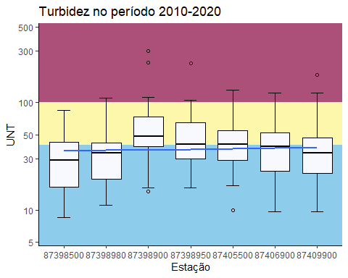

turb_p1



turb_p2



turb_p3



grid.arrange(turb_p1, turb_p2, turb_p3, ncol = 3)

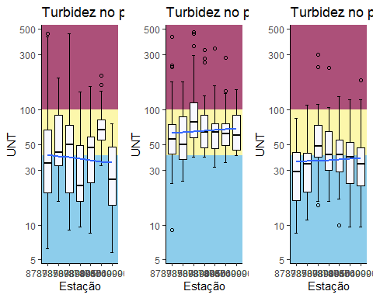

# grid.arrange(dbo_p1, dbo_p2, dbo_p3,  
# iqa_dbo1, iqa_dbo2, iqa_dbo3,  
# ncol = 3, nrow=2)

(sum_turb_p1 <- plan_wide_19902020 %>%  
 select(CODIGO, Turbidez, ANO_COLETA) %>%   
 filter(ANO_COLETA>"1990" &  
 ANO_COLETA<="2000") %>%   
 group_by(CODIGO) %>%   
 summarize(  
 min =   
 min(Turbidez,   
 na.rm = TRUE),  
 q1 =   
 quantile(Turbidez, 0.25,   
 na.rm = TRUE),  
 median =   
 median(Turbidez,   
 na.rm = TRUE),  
 mean =   
 mean(Turbidez,   
 na.rm= TRUE),  
 q3 =   
 quantile(Turbidez, 0.75,   
 na.rm = TRUE),  
 max =   
 max(Turbidez,   
 na.rm = TRUE))  
)

## # A tibble: 7 × 7  
## CODIGO min q1 median mean q3 max  
## <chr> <dbl> <dbl> <dbl> <dbl> <dbl> <dbl>  
## 1 87398500 6.2 19 34.5 63.5 67 461  
## 2 87398900 9 19 49.5 61.5 73.8 460  
## 3 87398950 9.6 16 22 33.3 48.8 144  
## 4 87398980 16 32.8 43 66.8 90.5 190  
## 5 87405500 8.5 23.5 47 47.5 58 159  
## 6 87406900 33 54.8 67 77.7 81.5 199  
## 7 87409900 5.8 15 25 32.2 48 76

(sum_turb_p2 <- plan_wide_19902020 %>%  
 select(CODIGO, Turbidez, ANO_COLETA) %>%   
 filter(ANO_COLETA>"2000" &  
 ANO_COLETA<="2010") %>%   
 group_by(CODIGO) %>%   
 summarize(  
 min =   
 min(Turbidez,   
 na.rm = TRUE),  
 q1 =   
 quantile(Turbidez, 0.25,   
 na.rm = TRUE),  
 median =   
 median(Turbidez,   
 na.rm = TRUE),  
 mean =   
 mean(Turbidez,   
 na.rm= TRUE),  
 q3 =   
 quantile(Turbidez, 0.75,   
 na.rm = TRUE),  
 max =   
 max(Turbidez,   
 na.rm = TRUE))  
)

## # A tibble: 7 × 7  
## CODIGO min q1 median mean q3 max  
## <chr> <dbl> <dbl> <dbl> <dbl> <dbl> <dbl>  
## 1 87398500 9 41.2 55.5 71.1 74.2 428  
## 2 87398900 39 57 78 107. 116. 475  
## 3 87398950 39 47 64 96.5 90 330  
## 4 87398980 24 37 50 64.5 87 176  
## 5 87405500 32 46 63.5 70.3 76 341  
## 6 87406900 35 49 62 69.9 75.5 284  
## 7 87409900 40 45 60 70.4 90 151

(sum_turb_p3 <- plan_wide_19902020 %>%  
 select(CODIGO, Turbidez, ANO_COLETA) %>%   
 filter(ANO_COLETA>"2010" &  
 ANO_COLETA<="2020") %>%   
 group_by(CODIGO) %>%   
 summarize(  
 min =   
 min(Turbidez,   
 na.rm = TRUE),  
 q1 =   
 quantile(Turbidez, 0.25,   
 na.rm = TRUE),  
 median =   
 median(Turbidez,   
 na.rm = TRUE),  
 mean =   
 mean(Turbidez,   
 na.rm= TRUE),  
 q3 =   
 quantile(Turbidez, 0.75,   
 na.rm = TRUE),  
 max =   
 max(Turbidez,   
 na.rm = TRUE))  
)

## # A tibble: 7 × 7  
## CODIGO min q1 median mean q3 max  
## <chr> <dbl> <dbl> <dbl> <dbl> <dbl> <dbl>  
## 1 87398500 8.52 16.4 29 33.3 43 85   
## 2 87398900 14.8 39.2 48.3 66.7 73.4 299   
## 3 87398950 16 29.9 41 51.6 65 230   
## 4 87398980 11 19.4 33.6 39.5 42.2 110.  
## 5 87405500 10.0 29.0 41 42.9 54.5 131   
## 6 87406900 9.62 23 39 41.2 52 122   
## 7 87409900 9.68 22.0 34.0 40.5 47 182.

### pH

(pH_p1 <- ggplot(plan_wide_19902020 %>%   
 filter(ANO_COLETA>"1990" &  
 ANO_COLETA<="2000"),  
 aes(CODIGO,  
 pH))+  
 annotate("rect",  
 xmin=-Inf,  
 xmax=Inf,  
 ymin=-Inf,  
 ymax=6,  
 alpha=1,  
 fill="#eb5661")+ #classe 4  
 annotate("rect",  
 xmin=-Inf,  
 xmax=Inf,  
 ymin=9,  
 ymax=Inf,  
 alpha=1,  
 fill="#eb5661")+ #classe 4  
 annotate("rect",  
 xmin=-Inf,  
 xmax=Inf,  
 ymin=6,  
 ymax=9,  
 alpha=1,  
 fill="#8dcdeb")+ #classe 1  
 stat_boxplot(geom = 'errorbar',  
 width=0.3,  
 position = position_dodge(width = 0.65))+  
 geom_boxplot(fill='#F8F8FF',  
 color="black",  
 outlier.shape = 1, #se deixar NA fica só o jitter, se não, deixa 1  
 width= 0.7)+  
 labs(title = "pH no período 1990-2000",  
 x="Estação",  
 y="")+  
 # geom_jitter(width = .05,  
 # alpha=.2,  
 # size=1.5,  
 # color="black")+  
 scale_y_continuous(expand = expansion(mult = c(0.01, 0.01)),  
 n.breaks = 8,  
 limits = c(4,11),  
 labels = scales::number_format(accuracy = 1,  
 decimal.mark = ",",  
 big.mark = " "))+  
 scale_x_discrete(limits = c("87398500", "87398980", "87398900", "87398950", "87405500", "87406900", "87409900"))+  
 geom_smooth(method = "lm",  
 se=FALSE, #se deixar TRUE gera o intervalo de confiança de 95%  
 aes(group=1),  
 alpha=.5,  
 na.rm = TRUE,  
 size = 1)+  
 # geom_line(aes(color="red"),  
 # alpha=.0)+  
 # scale_color_manual("Legenda",  
 # guide="legend",  
 # values = c("Pior Classe"="#ac5079",  
 # "Classe 3"="#fcf7ab",  
 # "Classe 1"="#8dcdeb"))+  
 # guides(color=guide_legend(override.aes = list(linetype=c(1,1,1),  
 # lwd=c(2,2,2),  
 # shape=c(NA,NA,NA),  
 # alpha=1)))+  
 theme_classic())

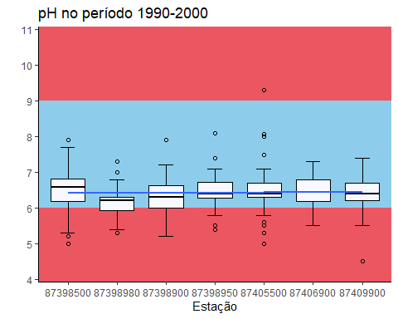

(pH_p2 <- ggplot(plan_wide_19902020 %>%   
 filter(ANO_COLETA>"2000" &  
 ANO_COLETA<="2010"),  
 aes(CODIGO,  
 pH))+  
 annotate("rect",  
 xmin=-Inf,  
 xmax=Inf,  
 ymin=-Inf,  
 ymax=6,  
 alpha=1,  
 fill="#eb5661")+ #classe 4  
 annotate("rect",  
 xmin=-Inf,  
 xmax=Inf,  
 ymin=9,  
 ymax=Inf,  
 alpha=1,  
 fill="#eb5661")+ #classe 4  
 annotate("rect",  
 xmin=-Inf,  
 xmax=Inf,  
 ymin=6,  
 ymax=9,  
 alpha=1,  
 fill="#8dcdeb")+ #classe 1  
 stat_boxplot(geom = 'errorbar',  
 width=0.3,  
 position = position_dodge(width = 0.65))+  
 geom_boxplot(fill='#F8F8FF',  
 color="black",  
 outlier.shape = 1, #se deixar NA fica só o jitter, se não, deixa 1  
 width= 0.7)+  
 labs(title = "pH no período 2000-2010",  
 x="Estação",  
 y="")+  
 # geom_jitter(width = .05,  
 # alpha=.2,  
 # size=1.5,  
 # color="black")+  
 scale_y_continuous(expand = expansion(mult = c(0.01, 0.01)),  
 n.breaks = 8,  
 limits = c(4,11),  
 labels = scales::number_format(accuracy = 1,  
 decimal.mark = ",",  
 big.mark = " "))+  
 scale_x_discrete(limits = c("87398500", "87398980", "87398900", "87398950", "87405500", "87406900", "87409900"))+  
 geom_smooth(method = "lm",  
 se=FALSE, #se deixar TRUE gera o intervalo de confiança de 95%  
 aes(group=1),  
 alpha=.5,  
 na.rm = TRUE,  
 size = 1)+  
 # geom_line(aes(color="red"),  
 # alpha=.0)+  
 # scale_color_manual("Legenda",  
 # guide="legend",  
 # values = c("Pior Classe"="#ac5079",  
 # "Classe 3"="#fcf7ab",  
 # "Classe 1"="#8dcdeb"))+  
 # guides(color=guide_legend(override.aes = list(linetype=c(1,1,1),  
 # lwd=c(2,2,2),  
 # shape=c(NA,NA,NA),  
 # alpha=1)))+  
 theme_classic())

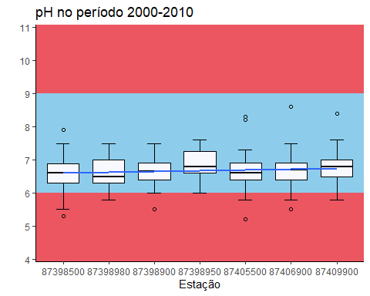

(pH_p3 <- ggplot(plan_wide_19902020 %>%   
 filter(ANO_COLETA>"2010" &  
 ANO_COLETA<="2020"),  
 aes(CODIGO,  
 pH))+  
 annotate("rect",  
 xmin=-Inf,  
 xmax=Inf,  
 ymin=-Inf,  
 ymax=6,  
 alpha=1,  
 fill="#eb5661")+ #classe 4  
 annotate("rect",  
 xmin=-Inf,  
 xmax=Inf,  
 ymin=9,  
 ymax=Inf,  
 alpha=1,  
 fill="#eb5661")+ #classe 4  
 annotate("rect",  
 xmin=-Inf,  
 xmax=Inf,  
 ymin=6,  
 ymax=9,  
 alpha=1,  
 fill="#8dcdeb")+ #classe 1  
 stat_boxplot(geom = 'errorbar',  
 width=0.3,  
 position = position_dodge(width = 0.65))+  
 geom_boxplot(fill='#F8F8FF',  
 color="black",  
 outlier.shape = 1, #se deixar NA fica só o jitter, se não, deixa 1  
 width= 0.7)+  
 labs(title = "pH no período 2010-2020",  
 x="Estação",  
 y="")+  
 # geom_jitter(width = .05,  
 # alpha=.2,  
 # size=1.5,  
 # color="black")+  
 scale_y_continuous(expand = expansion(mult = c(0.01, 0.01)),  
 n.breaks = 8,  
 limits = c(4,11),  
 labels = scales::number_format(accuracy = 1,  
 decimal.mark = ",",  
 big.mark = " "))+  
 scale_x_discrete(limits = c("87398500", "87398980", "87398900", "87398950", "87405500", "87406900", "87409900"))+  
 geom_smooth(method = "lm",  
 se=FALSE, #se deixar TRUE gera o intervalo de confiança de 95%  
 aes(group=1),  
 alpha=.5,  
 na.rm = TRUE,  
 size = 1)+  
 # geom_line(aes(color="red"),  
 # alpha=.0)+  
 # scale_color_manual("Legenda",  
 # guide="legend",  
 # values = c("Pior Classe"="#ac5079",  
 # "Classe 3"="#fcf7ab",  
 # "Classe 1"="#8dcdeb"))+  
 # guides(color=guide_legend(override.aes = list(linetype=c(1,1,1),  
 # lwd=c(2,2,2),  
 # shape=c(NA,NA,NA),  
 # alpha=1)))+  
 theme_classic())

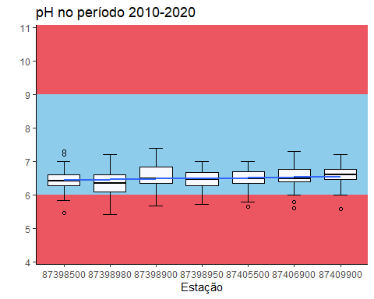

pH_p1



pH_p2



pH_p3



grid.arrange(pH_p1, pH_p2, pH_p3, ncol = 3)

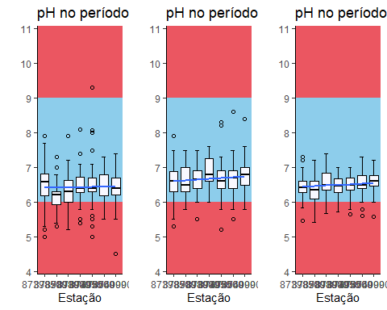

# grid.arrange(dbo_p1, dbo_p2, dbo_p3,  
# iqa_dbo1, iqa_dbo2, iqa_dbo3,  
# ncol = 3, nrow=2)

(sum_pH_p1 <- plan_wide_19902020 %>%  
 select(CODIGO, pH, ANO_COLETA) %>%   
 filter(ANO_COLETA>"1990" &  
 ANO_COLETA<="2000") %>%   
 group_by(CODIGO) %>%   
 summarize(  
 min =   
 min(pH,   
 na.rm = TRUE),  
 q1 =   
 quantile(pH, 0.25,   
 na.rm = TRUE),  
 median =   
 median(pH,   
 na.rm = TRUE),  
 mean =   
 mean(pH,   
 na.rm= TRUE),  
 q3 =   
 quantile(pH, 0.75,   
 na.rm = TRUE),  
 max =   
 max(pH,   
 na.rm = TRUE))  
)

## # A tibble: 7 × 7  
## CODIGO min q1 median mean q3 max  
## <chr> <dbl> <dbl> <dbl> <dbl> <dbl> <dbl>  
## 1 87398500 5 6.18 6.59 6.51 6.82 7.9  
## 2 87398900 5.2 6 6.3 6.33 6.63 7.9  
## 3 87398950 5.4 6.29 6.4 6.49 6.72 8.1  
## 4 87398980 5.3 5.93 6.2 6.16 6.3 7.3  
## 5 87405500 5 6.3 6.4 6.47 6.7 9.3  
## 6 87406900 5.5 6.18 6.45 6.43 6.8 7.3  
## 7 87409900 4.5 6.2 6.4 6.44 6.7 7.4

(sum_pH_p2 <- plan_wide_19902020 %>%  
 select(CODIGO, pH, ANO_COLETA) %>%   
 filter(ANO_COLETA>"2000" &  
 ANO_COLETA<="2010") %>%   
 group_by(CODIGO) %>%   
 summarize(  
 min =   
 min(pH,   
 na.rm = TRUE),  
 q1 =   
 quantile(pH, 0.25,   
 na.rm = TRUE),  
 median =   
 median(pH,   
 na.rm = TRUE),  
 mean =   
 mean(pH,   
 na.rm= TRUE),  
 q3 =   
 quantile(pH, 0.75,   
 na.rm = TRUE),  
 max =   
 max(pH,   
 na.rm = TRUE))  
)

## # A tibble: 7 × 7  
## CODIGO min q1 median mean q3 max  
## <chr> <dbl> <dbl> <dbl> <dbl> <dbl> <dbl>  
## 1 87398500 5.3 6.3 6.6 6.59 6.88 7.9  
## 2 87398900 5.5 6.4 6.65 6.63 6.9 7.5  
## 3 87398950 6 6.6 6.8 6.89 7.25 7.6  
## 4 87398980 5.8 6.3 6.5 6.63 7 7.5  
## 5 87405500 5.2 6.4 6.6 6.68 6.9 8.3  
## 6 87406900 5.5 6.4 6.7 6.66 6.9 8.6  
## 7 87409900 5.8 6.5 6.8 6.77 7 8.4

(sum_pH_p3 <- plan_wide_19902020 %>%  
 select(CODIGO, pH, ANO_COLETA) %>%   
 filter(ANO_COLETA>"2010" &  
 ANO_COLETA<="2020") %>%   
 group_by(CODIGO) %>%   
 summarize(  
 min =   
 min(pH,   
 na.rm = TRUE),  
 q1 =   
 quantile(pH, 0.25,   
 na.rm = TRUE),  
 median =   
 median(pH,   
 na.rm = TRUE),  
 mean =   
 mean(pH,   
 na.rm= TRUE),  
 q3 =   
 quantile(pH, 0.75,   
 na.rm = TRUE),  
 max =   
 max(pH,   
 na.rm = TRUE))  
)

## # A tibble: 7 × 7  
## CODIGO min q1 median mean q3 max  
## <chr> <dbl> <dbl> <dbl> <dbl> <dbl> <dbl>  
## 1 87398500 5.47 6.28 6.42 6.47 6.60 7.3   
## 2 87398900 5.68 6.36 6.5 6.57 6.84 7.4   
## 3 87398950 5.71 6.28 6.46 6.46 6.68 7   
## 4 87398980 5.42 6.10 6.36 6.39 6.6 7.2   
## 5 87405500 5.64 6.34 6.5 6.49 6.7 7.01  
## 6 87406900 5.6 6.4 6.48 6.51 6.77 7.3   
## 7 87409900 5.59 6.46 6.6 6.57 6.76 7.2

### Sólidos totais

(SolTot_p1 <- ggplot(plan_wide_19902020 %>%   
 filter(ANO_COLETA>"1990" &  
 ANO_COLETA<="2000"),  
 aes(CODIGO,  
 `Sólidos totais`))+  
 annotate("rect",  
 xmin=-Inf,  
 xmax=Inf,  
 ymin=500,  
 ymax=Inf,  
 alpha=1,  
 fill="#eb5661")+ #classe 4  
 annotate("rect",  
 xmin=-Inf,  
 xmax=Inf,  
 ymin=-Inf,  
 ymax=500,  
 alpha=1,  
 fill="#8dcdeb")+ #classe 1  
 stat_boxplot(geom = 'errorbar',  
 width=0.3,  
 position = position_dodge(width = 0.65))+  
 geom_boxplot(fill='#F8F8FF',  
 color="black",  
 outlier.shape = 1, #se deixar NA fica só o jitter, se não, deixa 1  
 width= 0.7)+  
 labs(title = "Sólidos totais no período 1990-2000",  
 x="Estação",  
 y="")+  
 # geom_jitter(width = .05,  
 # alpha=.2,  
 # size=1.5,  
 # color="black")+  
 scale_y_continuous(expand = expansion(mult = c(0.01, 0.05)),  
 n.breaks = 8,  
 limits = c(0,  
 max(plan_wide_19902020$`Sólidos totais`, na.rm = TRUE)),  
 labels = scales::number_format(accuracy = 1,  
 decimal.mark = ",",  
 big.mark = " "))+  
 scale_x_discrete(limits = c("87398500", "87398980", "87398900", "87398950", "87405500", "87406900", "87409900"))+  
 geom_smooth(method = "lm",  
 se=FALSE, #se deixar TRUE gera o intervalo de confiança de 95%  
 aes(group=1),  
 alpha=.5,  
 na.rm = TRUE,  
 size = 1)+  
 # geom_line(aes(color="red"),  
 # alpha=.0)+  
 # scale_color_manual("Legenda",  
 # guide="legend",  
 # values = c("Pior Classe"="#ac5079",  
 # "Classe 3"="#fcf7ab",  
 # "Classe 1"="#8dcdeb"))+  
 # guides(color=guide_legend(override.aes = list(linetype=c(1,1,1),  
 # lwd=c(2,2,2),  
 # shape=c(NA,NA,NA),  
 # alpha=1)))+  
 theme_classic())

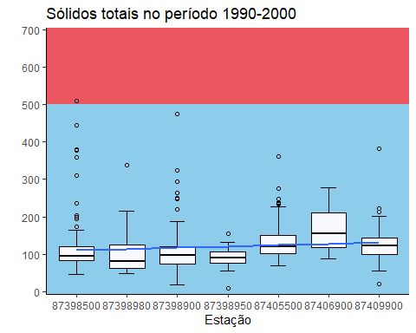

(SolTot_p2 <- ggplot(plan_wide_19902020 %>%   
 filter(ANO_COLETA>"2000" &  
 ANO_COLETA<="2010"),  
 aes(CODIGO,  
 `Sólidos totais`))+  
 annotate("rect",  
 xmin=-Inf,  
 xmax=Inf,  
 ymin=500,  
 ymax=Inf,  
 alpha=1,  
 fill="#eb5661")+ #classe 4  
 annotate("rect",  
 xmin=-Inf,  
 xmax=Inf,  
 ymin=-Inf,  
 ymax=500,  
 alpha=1,  
 fill="#8dcdeb")+ #classe 1  
 stat_boxplot(geom = 'errorbar',  
 width=0.3,  
 position = position_dodge(width = 0.65))+  
 geom_boxplot(fill='#F8F8FF',  
 color="black",  
 outlier.shape = 1, #se deixar NA fica só o jitter, se não, deixa 1  
 width= 0.7)+  
 labs(title = "Sólidos totais no período 2000-2010",  
 x="Estação",  
 y="")+  
 # geom_jitter(width = .05,  
 # alpha=.2,  
 # size=1.5,  
 # color="black")+  
 scale_y_continuous(expand = expansion(mult = c(0.01, 0.05)),  
 n.breaks = 8,  
 limits = c(0,  
 max(plan_wide_19902020$`Sólidos totais`, na.rm = TRUE)),  
 labels = scales::number_format(accuracy = 1,  
 decimal.mark = ",",  
 big.mark = " "))+  
 scale_x_discrete(limits = c("87398500", "87398980", "87398900", "87398950", "87405500", "87406900", "87409900"))+  
 geom_smooth(method = "lm",  
 se=FALSE, #se deixar TRUE gera o intervalo de confiança de 95%  
 aes(group=1),  
 alpha=.5,  
 na.rm = TRUE,  
 size = 1)+  
 # geom_line(aes(color="red"),  
 # alpha=.0)+  
 # scale_color_manual("Legenda",  
 # guide="legend",  
 # values = c("Pior Classe"="#ac5079",  
 # "Classe 3"="#fcf7ab",  
 # "Classe 1"="#8dcdeb"))+  
 # guides(color=guide_legend(override.aes = list(linetype=c(1,1,1),  
 # lwd=c(2,2,2),  
 # shape=c(NA,NA,NA),  
 # alpha=1)))+  
 theme_classic())

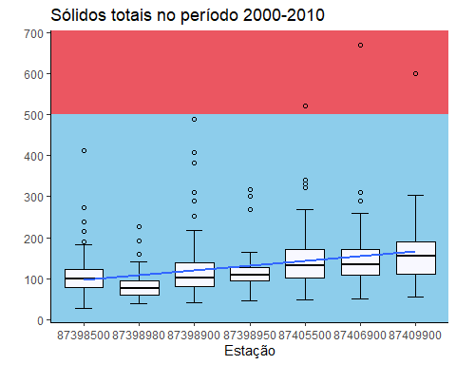

(SolTot_p3 <- ggplot(plan_wide_19902020 %>%   
 filter(ANO_COLETA>"2010" &  
 ANO_COLETA<="2020"),  
 aes(CODIGO,  
 `Sólidos totais`))+  
 annotate("rect",  
 xmin=-Inf,  
 xmax=Inf,  
 ymin=500,  
 ymax=Inf,  
 alpha=1,  
 fill="#eb5661")+ #classe 4  
 annotate("rect",  
 xmin=-Inf,  
 xmax=Inf,  
 ymin=-Inf,  
 ymax=500,  
 alpha=1,  
 fill="#8dcdeb")+ #classe 1  
 stat_boxplot(geom = 'errorbar',  
 width=0.3,  
 position = position_dodge(width = 0.65))+  
 geom_boxplot(fill='#F8F8FF',  
 color="black",  
 outlier.shape = 1, #se deixar NA fica só o jitter, se não, deixa 1  
 width= 0.7)+  
 labs(title = "Sólidos totais no período 2010-2020",  
 x="Estação",  
 y="")+  
 # geom_jitter(width = .05,  
 # alpha=.2,  
 # size=1.5,  
 # color="black")+  
 scale_y_continuous(expand = expansion(mult = c(0.01, 0.05)),  
 n.breaks = 8,  
 limits = c(0,  
 max(plan_wide_19902020$`Sólidos totais`, na.rm = TRUE)),  
 labels = scales::number_format(accuracy = 1,  
 decimal.mark = ",",  
 big.mark = " "))+  
 scale_x_discrete(limits = c("87398500", "87398980", "87398900", "87398950", "87405500", "87406900", "87409900"))+  
 geom_smooth(method = "lm",  
 se=FALSE, #se deixar TRUE gera o intervalo de confiança de 95%  
 aes(group=1),  
 alpha=.5,  
 na.rm = TRUE,  
 size = 1)+  
 # geom_line(aes(color="red"),  
 # alpha=.0)+  
 # scale_color_manual("Legenda",  
 # guide="legend",  
 # values = c("Pior Classe"="#ac5079",  
 # "Classe 3"="#fcf7ab",  
 # "Classe 1"="#8dcdeb"))+  
 # guides(color=guide_legend(override.aes = list(linetype=c(1,1,1),  
 # lwd=c(2,2,2),  
 # shape=c(NA,NA,NA),  
 # alpha=1)))+  
 theme_classic())

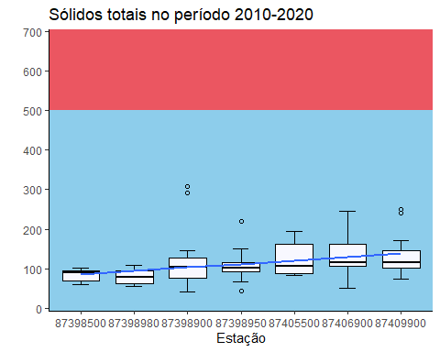

SolTot_p1



SolTot_p2



SolTot_p3



grid.arrange(SolTot_p1, SolTot_p2, SolTot_p3, ncol = 3)

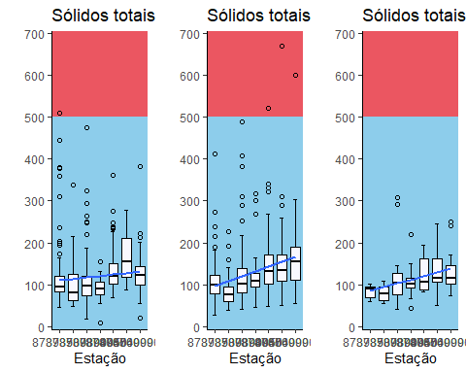

# grid.arrange(dbo_p1, dbo_p2, dbo_p3,  
# iqa_dbo1, iqa_dbo2, iqa_dbo3,  
# ncol = 3, nrow=2)

(sum_SolTot_p1 <- plan_wide_19902020 %>%  
 select(CODIGO, `Sólidos totais`, ANO_COLETA) %>%   
 filter(ANO_COLETA>"1990" &  
 ANO_COLETA<="2000") %>%   
 group_by(CODIGO) %>%   
 summarize(  
 min =   
 min(`Sólidos totais`,   
 na.rm = TRUE),  
 q1 =   
 quantile(`Sólidos totais`, 0.25,   
 na.rm = TRUE),  
 median =   
 median(`Sólidos totais`,   
 na.rm = TRUE),  
 mean =   
 mean(`Sólidos totais`,   
 na.rm= TRUE),  
 q3 =   
 quantile(`Sólidos totais`, 0.75,   
 na.rm = TRUE),  
 max =   
 max(`Sólidos totais`,   
 na.rm = TRUE))  
)

## # A tibble: 7 × 7  
## CODIGO min q1 median mean q3 max  
## <chr> <dbl> <dbl> <dbl> <dbl> <dbl> <dbl>  
## 1 87398500 46 84.5 95 122. 120 510  
## 2 87398900 18 74.5 97 111. 122. 474  
## 3 87398950 10 76.5 91 90.9 106. 155  
## 4 87398980 48 63.5 81.5 104. 126. 337  
## 5 87405500 70 101 121 133. 151 361  
## 6 87406900 89 118 155 165. 210 279  
## 7 87409900 20 99.5 122 128. 143 381

(sum_SolTot_p2 <- plan_wide_19902020 %>%  
 select(CODIGO, `Sólidos totais`, ANO_COLETA) %>%   
 filter(ANO_COLETA>"2000" &  
 ANO_COLETA<="2010") %>%   
 group_by(CODIGO) %>%   
 summarize(  
 min =   
 min(`Sólidos totais`,   
 na.rm = TRUE),  
 q1 =   
 quantile(`Sólidos totais`, 0.25,   
 na.rm = TRUE),  
 median =   
 median(`Sólidos totais`,   
 na.rm = TRUE),  
 mean =   
 mean(`Sólidos totais`,   
 na.rm= TRUE),  
 q3 =   
 quantile(`Sólidos totais`, 0.75,   
 na.rm = TRUE),  
 max =   
 max(`Sólidos totais`,   
 na.rm = TRUE))  
)

## # A tibble: 7 × 7  
## CODIGO min q1 median mean q3 max  
## <chr> <dbl> <dbl> <dbl> <dbl> <dbl> <dbl>  
## 1 87398500 28 80 100 111. 123. 412  
## 2 87398900 42 82 102. 128. 140. 489  
## 3 87398950 46 94.2 108. 126. 127. 318  
## 4 87398980 40 61 77 85.3 96 228  
## 5 87405500 48 102 133 148. 170. 522  
## 6 87406900 50 109 134. 154. 170. 670  
## 7 87409900 56 112. 156 167. 190. 599

(sum_SolTot_p3 <- plan_wide_19902020 %>%  
 select(CODIGO, `Sólidos totais`, ANO_COLETA) %>%   
 filter(ANO_COLETA>"2010" &  
 ANO_COLETA<="2020") %>%   
 group_by(CODIGO) %>%   
 summarize(  
 min =   
 min(`Sólidos totais`,   
 na.rm = TRUE),  
 q1 =   
 quantile(`Sólidos totais`, 0.25,   
 na.rm = TRUE),  
 median =   
 median(`Sólidos totais`,   
 na.rm = TRUE),  
 mean =   
 mean(`Sólidos totais`,   
 na.rm= TRUE),  
 q3 =   
 quantile(`Sólidos totais`, 0.75,   
 na.rm = TRUE),  
 max =   
 max(`Sólidos totais`,   
 na.rm = TRUE))  
)

## # A tibble: 7 × 7  
## CODIGO min q1 median mean q3 max  
## <chr> <dbl> <dbl> <dbl> <dbl> <dbl> <dbl>  
## 1 87398500 61 69 90 82.8 96 101  
## 2 87398900 41 77 104 120. 127 308  
## 3 87398950 45 93 101 109. 117 221  
## 4 87398980 55 62.8 80 79.9 95 109  
## 5 87405500 83 89.2 108. 124. 162. 195  
## 6 87406900 50 106 117 135. 163 246  
## 7 87409900 75 103 115 131. 145 251

### IQA

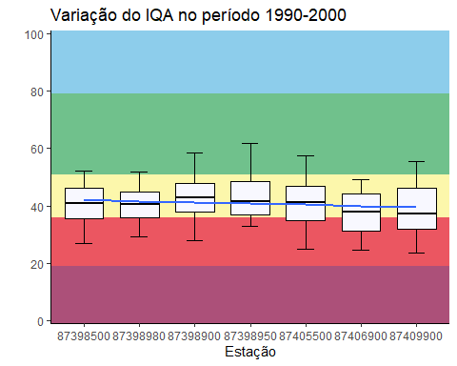

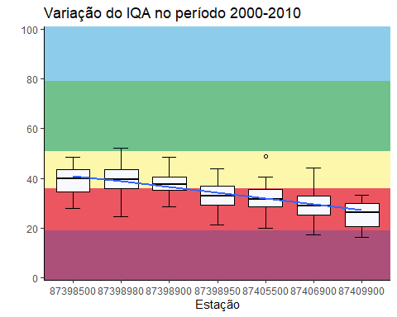

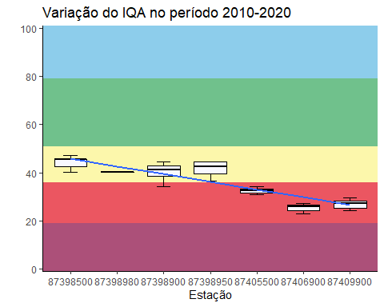

grid.arrange(iqa_p1, iqa_p2, iqa_p3, ncol = 3)

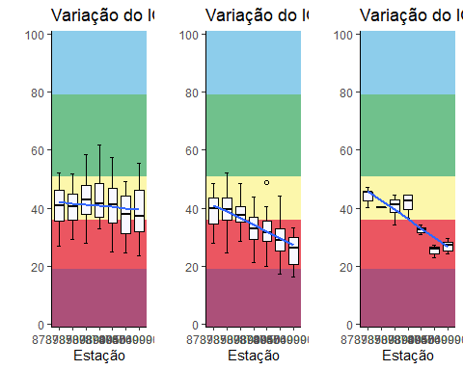

# grid.arrange(dbo_p1, dbo_p2, dbo_p3,  
# iqa_dbo1, iqa_dbo2, iqa_dbo3,  
# ncol = 3, nrow=2)

(sum_IQA_p1 <- plan_wide_19902020 %>%  
 select(CODIGO, IQA, ANO_COLETA) %>%   
 filter(ANO_COLETA>"1990" &  
 ANO_COLETA<="2000") %>%   
 group_by(CODIGO) %>%   
 summarize(  
 min =   
 min(IQA,   
 na.rm = TRUE),  
 q1 =   
 quantile(IQA, 0.25,   
 na.rm = TRUE),  
 median =   
 median(IQA,   
 na.rm = TRUE),  
 mean =   
 mean(IQA,   
 na.rm= TRUE),  
 q3 =   
 quantile(IQA, 0.75,   
 na.rm = TRUE),  
 max =   
 max(IQA,   
 na.rm = TRUE))  
)

## # A tibble: 7 × 7  
## CODIGO min q1 median mean q3 max  
## <chr> <dbl> <dbl> <dbl> <dbl> <dbl> <dbl>  
## 1 87398500 27.0 35.7 40.9 40.7 46.2 52.2  
## 2 87398900 27.8 37.9 42.9 43.0 48.0 58.5  
## 3 87398950 32.8 36.8 41.4 43.2 48.6 61.9  
## 4 87398980 29.2 35.8 40.4 40.3 44.8 51.9  
## 5 87405500 24.8 34.9 41.2 40.3 46.9 57.6  
## 6 87406900 24.7 31.3 37.8 37.4 44.4 49.0  
## 7 87409900 23.6 31.9 37.1 38.8 46.2 55.4

(sum_IQA_p2 <- plan_wide_19902020 %>%  
 select(CODIGO, IQA, ANO_COLETA) %>%   
 filter(ANO_COLETA>"2000" &  
 ANO_COLETA<="2010") %>%   
 group_by(CODIGO) %>%   
 summarize(  
 min =   
 min(IQA,   
 na.rm = TRUE),  
 q1 =   
 quantile(IQA, 0.25,   
 na.rm = TRUE),  
 median =   
 median(IQA,   
 na.rm = TRUE),  
 mean =   
 mean(IQA,   
 na.rm= TRUE),  
 q3 =   
 quantile(IQA, 0.75,   
 na.rm = TRUE),  
 max =   
 max(IQA,   
 na.rm = TRUE))  
)

## # A tibble: 7 × 7  
## CODIGO min q1 median mean q3 max  
## <chr> <dbl> <dbl> <dbl> <dbl> <dbl> <dbl>  
## 1 87398500 27.8 34.6 40.0 39.5 43.5 48.7  
## 2 87398900 28.5 35.1 37.6 38.3 40.6 48.5  
## 3 87398950 21.1 29.4 32.7 32.8 36.8 44.0  
## 4 87398980 24.5 35.7 39.4 39.5 43.4 52.1  
## 5 87405500 19.8 28.7 31.5 31.9 35.7 48.8  
## 6 87406900 17.1 25.3 29.0 29.5 32.8 44.1  
## 7 87409900 16.2 20.5 26.1 25.0 29.8 33.1

(sum_IQA_p3 <- plan_wide_19902020 %>%  
 select(CODIGO, IQA, ANO_COLETA) %>%   
 filter(ANO_COLETA>"2010" &  
 ANO_COLETA<="2020") %>%   
 group_by(CODIGO) %>%   
 summarize(  
 min =   
 min(IQA,   
 na.rm = TRUE),  
 q1 =   
 quantile(IQA, 0.25,   
 na.rm = TRUE),  
 median =   
 median(IQA,   
 na.rm = TRUE),  
 mean =   
 mean(IQA,   
 na.rm= TRUE),  
 q3 =   
 quantile(IQA, 0.75,   
 na.rm = TRUE),  
 max =   
 max(IQA,   
 na.rm = TRUE),  
 n =   
 length(IQA))  
)

## # A tibble: 7 × 8  
## CODIGO min q1 median mean q3 max n  
## <chr> <dbl> <dbl> <dbl> <dbl> <dbl> <dbl> <int>  
## 1 87398500 40.2 42.5 45.4 44.2 45.5 47.2 34  
## 2 87398900 34.1 38.6 41.2 40.2 42.9 44.4 36  
## 3 87398950 36.7 39.5 42.4 41.5 44.4 44.6 35  
## 4 87398980 40.0 40.0 40.0 40.0 40.0 40.0 28  
## 5 87405500 30.8 31.6 32.5 32.5 33.3 34.1 33  
## 6 87406900 22.9 24.4 25.9 25.3 26.5 27.2 35  
## 7 87409900 24.1 25.1 27.3 26.9 28.2 29.7 37

plan_wide_19902020 %>%   
 select(CODIGO, IQA) %>%   
 group_by(CODIGO) %>%   
 summarize(  
 min =   
 min(IQA,   
 na.rm = TRUE),  
 q1 =   
 quantile(IQA, 0.25,   
 na.rm = TRUE),  
 median =   
 median(IQA,   
 na.rm = TRUE),  
 mean =   
 mean(IQA,   
 na.rm= TRUE),  
 q3 =   
 quantile(IQA, 0.75,   
 na.rm = TRUE),  
 max =   
 max(IQA,   
 na.rm = TRUE))

## # A tibble: 7 × 7  
## CODIGO min q1 median mean q3 max  
## <chr> <dbl> <dbl> <dbl> <dbl> <dbl> <dbl>  
## 1 87398500 27.0 35.6 40.7 40.5 45.4 52.2  
## 2 87398900 27.8 36.4 40.7 41.4 46.1 58.5  
## 3 87398950 21.1 36.6 40.7 41.8 47.4 61.9  
## 4 87398980 24.5 35.7 39.7 39.9 44.1 52.1  
## 5 87405500 19.8 29.9 36.9 37.3 44.0 57.6  
## 6 87406900 17.1 25.7 31.1 32.4 38.0 49.0  
## 7 87409900 16.2 28.1 33.2 35.3 42.7 55.4

## Testando coisas

### Condutividade elétrica

(Cond_elet_p1 <- ggplot(plan_wide_19902020 %>%   
 filter(ANO_COLETA>"1990" &  
 ANO_COLETA<="2000"),  
 aes(CODIGO,  
 Condutividade))+  
 annotate("rect",  
 xmin=-Inf,  
 xmax=Inf,  
 ymin=500,  
 ymax=Inf,  
 alpha=1,  
 fill="#eb5661")+ #classe 4  
 annotate("rect",  
 xmin=-Inf,  
 xmax=Inf,  
 ymin=-Inf,  
 ymax=500,  
 alpha=1,  
 fill="#8dcdeb")+ #classe 1  
 stat_boxplot(geom = 'errorbar',  
 width=0.3,  
 position = position_dodge(width = 0.65))+  
 geom_boxplot(fill='#F8F8FF',  
 color="black",  
 outlier.shape = 1, #se deixar NA fica só o jitter, se não, deixa 1  
 width= 0.7)+  
 labs(title = "Condutividade elétrica no período 1990-2000",  
 x="Estação",  
 y="")+  
 # geom_jitter(width = .05,  
 # alpha=.2,  
 # size=1.5,  
 # color="black")+  
 scale_y_continuous(expand = expansion(mult = c(0.01, 0.05)),  
 n.breaks = 8,  
 limits = c(0,  
 max(plan_wide_19902020$Condutividade, na.rm = TRUE)),  
 labels = scales::number_format(accuracy = 1,  
 decimal.mark = ",",  
 big.mark = " "))+  
 scale_x_discrete(limits = c("87398500", "87398980", "87398900", "87398950", "87405500", "87406900", "87409900"))+  
 geom_smooth(method = "lm",  
 se=FALSE, #se deixar TRUE gera o intervalo de confiança de 95%  
 aes(group=1),  
 alpha=.5,  
 na.rm = TRUE,  
 size = 1)+  
 # geom_line(aes(color="red"),  
 # alpha=.0)+  
 # scale_color_manual("Legenda",  
 # guide="legend",  
 # values = c("Pior Classe"="#ac5079",  
 # "Classe 3"="#fcf7ab",  
 # "Classe 1"="#8dcdeb"))+  
 # guides(color=guide_legend(override.aes = list(linetype=c(1,1,1),  
 # lwd=c(2,2,2),  
 # shape=c(NA,NA,NA),  
 # alpha=1)))+  
 theme_classic())

