<https://github.com/nabeel-oz/qlik-py-tools>

Instalar (Anaconda/Python)



Instalar MsTool



Qlik-Py-Init

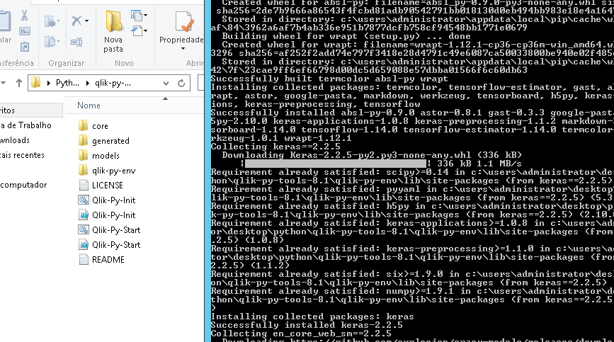

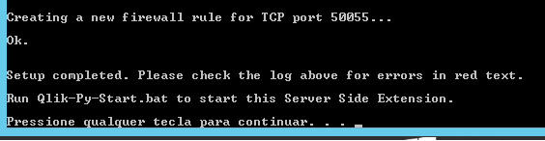

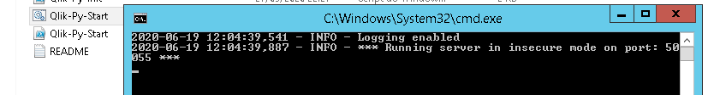

Conectar no serviço Analytics connections

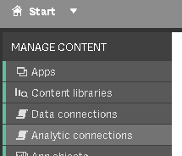



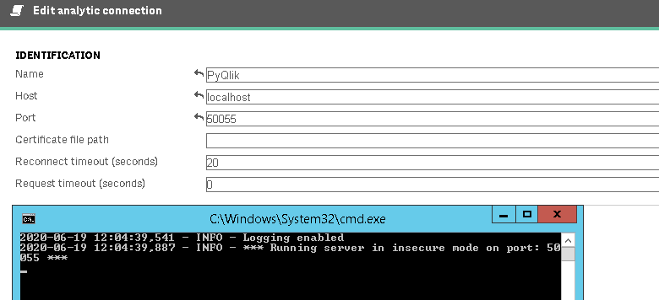

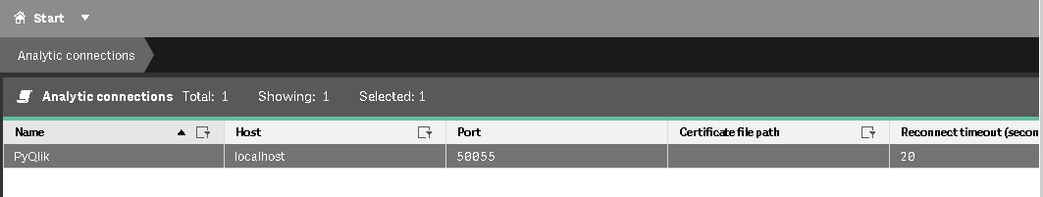

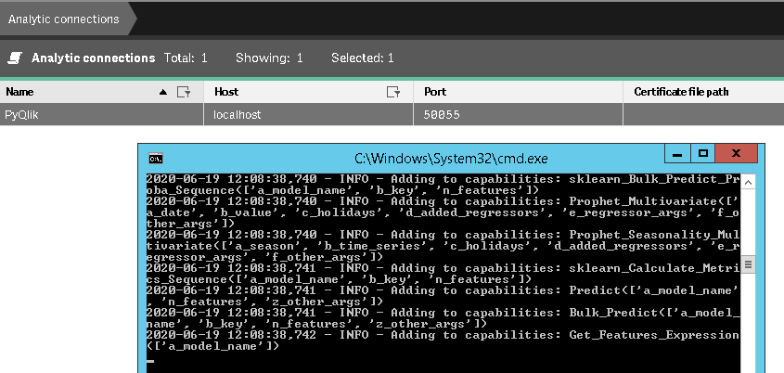

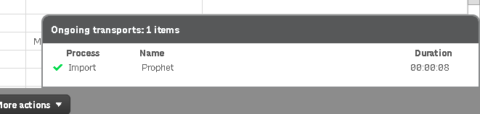

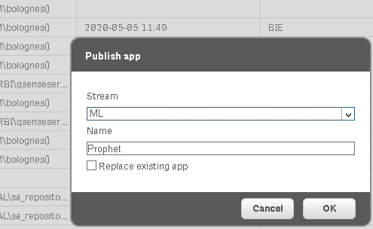

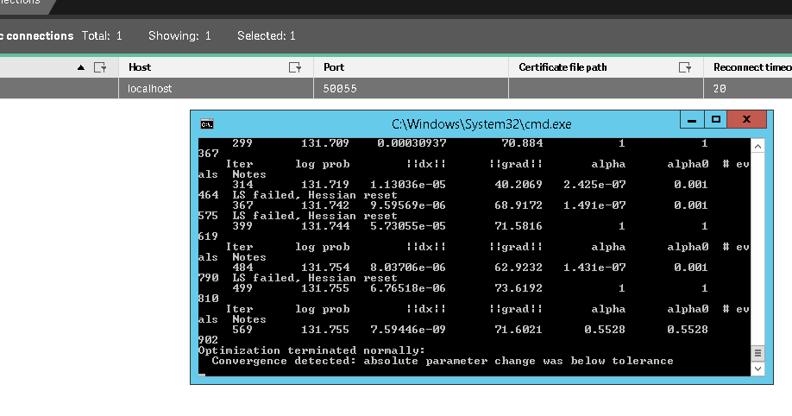

<https://github.com/nabeel-oz/qlik-py-tools>

<https://github.com/nabeel-oz/qlik-py-tools/blob/master/docs/Prophet.md>

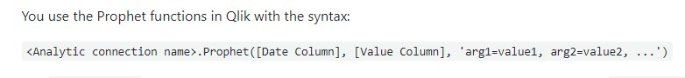

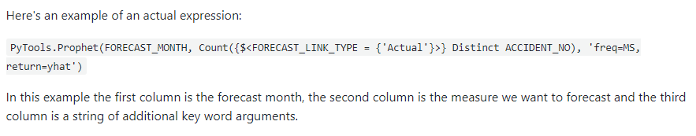



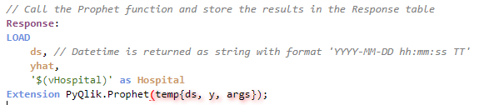

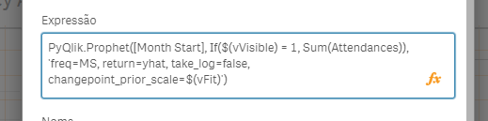

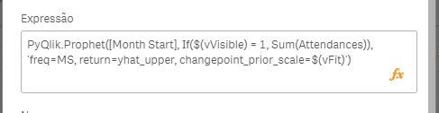

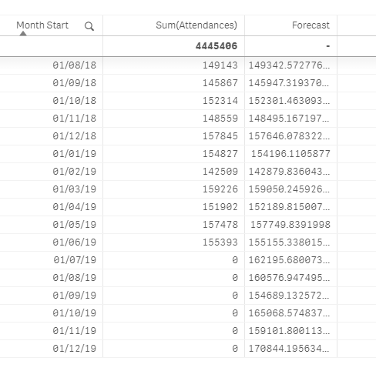

Na tabela inicial os campos a serem previstos devem ficar com 0

