**HUMAN BRAIN AND DIGITAL TECHNOLOGY**

**(ADVANTAGES AND DISADVANTAGES)**

**IMPLEMENTATION**

By

Evelina Bajrami

Dr.Bledar Kazia



A THESIS

Submitted to

**KOLEGJI UNIVERSITAR “Instituti Kanadez i Teknologjise”**

**CANADIAN INSTITUTE OF TECHNOLOGY**

**FACULTY OF ENGINEERING**

**DEPARTMENT OF SOFTWARE ENGINEERING**

In partial fulfillment of the requirements for the degree of:

Bachelor in Software Engineering

Submitted on: July 19, 2021

Bachelor in Software Engineering

Submitted on July 19, 2021

Approved :

Dr.Bledar Kazia (signature)

I understand that my thesis will be part of the collection of Canadian Institute of Technology. My signature below authorizes release of my thesis to any reader upon request. I also affirm that the work represented in this thesis is my own work.

Evelina Bajrami, Author (signature)

ii

|  |
| --- |
| **Title of thesis:** Human Brain and digital technology (advantages and disadvantages).  Implementation |
| **Abstract**: Since the final common precursor shared by present day people, chimpanzees and bonobos, the heredity driving to Homo sapiens has experienced a significant alter in brain estimate and organization. As a result, advanced people show striking contrasts from the living gorillas within the domain of cognition and phonetic expression. In this research, I surveyed the evolutionary changes that happened where the advanced human intellect may be conceived as a mosaic of characteristics acquired from a common parentage with our near relatives, together with the expansion of developmental specializations inside specific spaces and improvement of synaptic versatility of present-day human brains. At long last, the special brain development direction of cutting-edge people has made a critical commitment to our species’ cognitive and etymological capacities.  The human species advances the capacity not fair to communicate complex thoughts to one another but to hold such discussions from over the globe, utilizing farther gadgets constructed from substances that don't exist within the common world. Investing at the interface of brain research, science, human studies, prehistoric studies, and cognitive science is culminating in a progressively advanced understanding of how human insights evolved. Amid the past three decades, computerized innovation has changed our day by day lives. This innovation makes a difference for us to produce, store, and prepare colossal sums of data and associated with each other quickly and effectively. Since this change to a web world, neuroscientists have started centering their consideration on how computerized innovation may be changing our brains and behavior. The rising information recommends that steady innovation impacts brain work and behavior in both positive and negative ways. |

|  |
| --- |
| **Keywords:** Evolutionary, human intellect, synaptic versatility, brain development, science, innovation, behavior, impact. |

iii

# **Acknowledgment**

First of all, I would like to thank my family for always believing in me and supporting me in every decision I make! I love you and I hope this makes you proud! I feel grateful for having you as my family!

One special person who has inspired me, especially during these last month’s it’s Olsa, my dearest friend. I want to thank you for showing me that there is always light and hope during dark times!

It has been a long and awesome journey and I want to thank all my professors who have supported me and gave me courage to go on.

Especially:

I would like to start with professor Evis Plaku, who made me believe that if you have the passion and work hard you can achieve your dreams.

Professor Shefqet Meda who has the ability to create a special relationship with his students and make them feel comfortable with any possible challenge and succeed like it was so easy.

Professor Bledar Kazia- I feel honored that I was supervised by you for this final step on my academic journey, and I want to truly thank you from the deepest of my heart for the total trust that you gave me on this last task.

I have totally enjoyed it and you all have my deepest gratitude!

Noku

Thank you for your patience and the nerves spended with me.

Look - I made it!

Last but not least, the most important person who inspires and motivates me everyday to enjoy life, to take each step with a deep breath, supports me, loves me, and believes that I can reach the world if I want to. Jurgen, thank you!

iv

**Table of Content**

[**Chapter I. Methodology**](https://docs.google.com/document/d/1v82-5ujUFqNgGKaLI_fHlOcDJRkHqWGogx-OtrwQgPU/edit#heading=h.3dy6vkm)[**2**](https://docs.google.com/document/d/1v82-5ujUFqNgGKaLI_fHlOcDJRkHqWGogx-OtrwQgPU/edit#heading=h.3dy6vkm)

[1.1 Methodology used for the paper](https://docs.google.com/document/d/1v82-5ujUFqNgGKaLI_fHlOcDJRkHqWGogx-OtrwQgPU/edit#heading=h.1t3h5sf) [2](https://docs.google.com/document/d/1v82-5ujUFqNgGKaLI_fHlOcDJRkHqWGogx-OtrwQgPU/edit#heading=h.1t3h5sf)

[1.2 Web application methods](https://docs.google.com/document/d/1v82-5ujUFqNgGKaLI_fHlOcDJRkHqWGogx-OtrwQgPU/edit#heading=h.4d34og8) [2](https://docs.google.com/document/d/1v82-5ujUFqNgGKaLI_fHlOcDJRkHqWGogx-OtrwQgPU/edit#heading=h.4d34og8)

[1.3 Libraries and setup of the environment](https://docs.google.com/document/d/1v82-5ujUFqNgGKaLI_fHlOcDJRkHqWGogx-OtrwQgPU/edit#heading=h.2s8eyo1) [3](https://docs.google.com/document/d/1v82-5ujUFqNgGKaLI_fHlOcDJRkHqWGogx-OtrwQgPU/edit#heading=h.2s8eyo1)

[**Chapter II. BRAIN AND TECHNOLOGY**](https://docs.google.com/document/d/1v82-5ujUFqNgGKaLI_fHlOcDJRkHqWGogx-OtrwQgPU/edit#heading=h.ev8ztjdffsb1)[**3**](https://docs.google.com/document/d/1v82-5ujUFqNgGKaLI_fHlOcDJRkHqWGogx-OtrwQgPU/edit#heading=h.ev8ztjdffsb1)

[2.1 Human Brain](https://docs.google.com/document/d/1v82-5ujUFqNgGKaLI_fHlOcDJRkHqWGogx-OtrwQgPU/edit#heading=h.3rdcrjn) [3](https://docs.google.com/document/d/1v82-5ujUFqNgGKaLI_fHlOcDJRkHqWGogx-OtrwQgPU/edit#heading=h.3rdcrjn)

[2.2 The Geography of Brain](https://docs.google.com/document/d/1v82-5ujUFqNgGKaLI_fHlOcDJRkHqWGogx-OtrwQgPU/edit#heading=h.26in1rg) [4](https://docs.google.com/document/d/1v82-5ujUFqNgGKaLI_fHlOcDJRkHqWGogx-OtrwQgPU/edit#heading=h.26in1rg)

[2.3 Technology](https://docs.google.com/document/d/1v82-5ujUFqNgGKaLI_fHlOcDJRkHqWGogx-OtrwQgPU/edit#heading=h.lnxbz9) [5](https://docs.google.com/document/d/1v82-5ujUFqNgGKaLI_fHlOcDJRkHqWGogx-OtrwQgPU/edit#heading=h.lnxbz9)

[**Chapter III. ADVANTAGES AND DISADVANTAGES OF TECHNOLOGY USAGE**](https://docs.google.com/document/d/1v82-5ujUFqNgGKaLI_fHlOcDJRkHqWGogx-OtrwQgPU/edit#heading=h.mv1f4bupx1f5)[**7**](https://docs.google.com/document/d/1v82-5ujUFqNgGKaLI_fHlOcDJRkHqWGogx-OtrwQgPU/edit#heading=h.mv1f4bupx1f5)

[3.1 Brain Development](https://docs.google.com/document/d/1v82-5ujUFqNgGKaLI_fHlOcDJRkHqWGogx-OtrwQgPU/edit#heading=h.1ksv4uv) [7](https://docs.google.com/document/d/1v82-5ujUFqNgGKaLI_fHlOcDJRkHqWGogx-OtrwQgPU/edit#heading=h.1ksv4uv)

[3.1.1 Positive effects on early age](https://docs.google.com/document/d/1v82-5ujUFqNgGKaLI_fHlOcDJRkHqWGogx-OtrwQgPU/edit#heading=h.44sinio) [7](https://docs.google.com/document/d/1v82-5ujUFqNgGKaLI_fHlOcDJRkHqWGogx-OtrwQgPU/edit#heading=h.44sinio)

[3.1.2 Positive effect on adults](https://docs.google.com/document/d/1v82-5ujUFqNgGKaLI_fHlOcDJRkHqWGogx-OtrwQgPU/edit#heading=h.z337ya) [8](https://docs.google.com/document/d/1v82-5ujUFqNgGKaLI_fHlOcDJRkHqWGogx-OtrwQgPU/edit#heading=h.z337ya)

[3.1.3 Brain Functionality affected by the internet](https://docs.google.com/document/d/1v82-5ujUFqNgGKaLI_fHlOcDJRkHqWGogx-OtrwQgPU/edit#heading=h.3j2qqm3) [9](https://docs.google.com/document/d/1v82-5ujUFqNgGKaLI_fHlOcDJRkHqWGogx-OtrwQgPU/edit#heading=h.3j2qqm3)

[3.1.4 Memory Abilities](https://docs.google.com/document/d/1v82-5ujUFqNgGKaLI_fHlOcDJRkHqWGogx-OtrwQgPU/edit#heading=h.4i7ojhp) [12](https://docs.google.com/document/d/1v82-5ujUFqNgGKaLI_fHlOcDJRkHqWGogx-OtrwQgPU/edit#heading=h.4i7ojhp)

[3.1.5 Visual Absorption](https://docs.google.com/document/d/1v82-5ujUFqNgGKaLI_fHlOcDJRkHqWGogx-OtrwQgPU/edit#heading=h.z0bmjlw6rs0y) [13](https://docs.google.com/document/d/1v82-5ujUFqNgGKaLI_fHlOcDJRkHqWGogx-OtrwQgPU/edit#heading=h.z0bmjlw6rs0y)

[3.2 Negative Effect of Internet Usage](https://docs.google.com/document/d/1v82-5ujUFqNgGKaLI_fHlOcDJRkHqWGogx-OtrwQgPU/edit#heading=h.1ci93xb) [13](https://docs.google.com/document/d/1v82-5ujUFqNgGKaLI_fHlOcDJRkHqWGogx-OtrwQgPU/edit#heading=h.1ci93xb)

[3.2.1 Addiction](https://docs.google.com/document/d/1v82-5ujUFqNgGKaLI_fHlOcDJRkHqWGogx-OtrwQgPU/edit#heading=h.3whwml4) [14](https://docs.google.com/document/d/1v82-5ujUFqNgGKaLI_fHlOcDJRkHqWGogx-OtrwQgPU/edit#heading=h.3whwml4)

[3.2.2 Social Isolation](https://docs.google.com/document/d/1v82-5ujUFqNgGKaLI_fHlOcDJRkHqWGogx-OtrwQgPU/edit#heading=h.2bn6wsx) [15](https://docs.google.com/document/d/1v82-5ujUFqNgGKaLI_fHlOcDJRkHqWGogx-OtrwQgPU/edit#heading=h.2bn6wsx)

[3.2.3 Eyestrain](https://docs.google.com/document/d/1v82-5ujUFqNgGKaLI_fHlOcDJRkHqWGogx-OtrwQgPU/edit#heading=h.3as4poj) [15](https://docs.google.com/document/d/1v82-5ujUFqNgGKaLI_fHlOcDJRkHqWGogx-OtrwQgPU/edit#heading=h.3as4poj)

[**Chapter IV. IMPLEMENTATION “MENTAL HELP APP”**](https://docs.google.com/document/d/1v82-5ujUFqNgGKaLI_fHlOcDJRkHqWGogx-OtrwQgPU/edit#heading=h.1pxezwc)[**16**](https://docs.google.com/document/d/1v82-5ujUFqNgGKaLI_fHlOcDJRkHqWGogx-OtrwQgPU/edit#heading=h.1pxezwc)

[4.1 Database](https://docs.google.com/document/d/1v82-5ujUFqNgGKaLI_fHlOcDJRkHqWGogx-OtrwQgPU/edit#heading=h.49x2ik5) [16](https://docs.google.com/document/d/1v82-5ujUFqNgGKaLI_fHlOcDJRkHqWGogx-OtrwQgPU/edit#heading=h.49x2ik5)

[4.2 Quality Attributes that affect the architecture of the software](https://docs.google.com/document/d/1v82-5ujUFqNgGKaLI_fHlOcDJRkHqWGogx-OtrwQgPU/edit#heading=h.2p2csry) [18](https://docs.google.com/document/d/1v82-5ujUFqNgGKaLI_fHlOcDJRkHqWGogx-OtrwQgPU/edit#heading=h.2p2csry)

[4.3 Web App Functions](https://docs.google.com/document/d/1v82-5ujUFqNgGKaLI_fHlOcDJRkHqWGogx-OtrwQgPU/edit#heading=h.147n2zr) [18](https://docs.google.com/document/d/1v82-5ujUFqNgGKaLI_fHlOcDJRkHqWGogx-OtrwQgPU/edit#heading=h.147n2zr)

[4.4 General Constraints](https://docs.google.com/document/d/1v82-5ujUFqNgGKaLI_fHlOcDJRkHqWGogx-OtrwQgPU/edit#heading=h.3o7alnk) [19](https://docs.google.com/document/d/1v82-5ujUFqNgGKaLI_fHlOcDJRkHqWGogx-OtrwQgPU/edit#heading=h.3o7alnk)

[4.5 Interface features](https://docs.google.com/document/d/1v82-5ujUFqNgGKaLI_fHlOcDJRkHqWGogx-OtrwQgPU/edit#heading=h.23ckvvd) [20](https://docs.google.com/document/d/1v82-5ujUFqNgGKaLI_fHlOcDJRkHqWGogx-OtrwQgPU/edit#heading=h.23ckvvd)

[4.6 Testing Cases](https://docs.google.com/document/d/1v82-5ujUFqNgGKaLI_fHlOcDJRkHqWGogx-OtrwQgPU/edit#heading=h.ihv636) [23](https://docs.google.com/document/d/1v82-5ujUFqNgGKaLI_fHlOcDJRkHqWGogx-OtrwQgPU/edit#heading=h.ihv636)

[**Chapter V. Conclusions**](https://docs.google.com/document/d/1v82-5ujUFqNgGKaLI_fHlOcDJRkHqWGogx-OtrwQgPU/edit#heading=h.9lljjpp1uuf3)[**24**](https://docs.google.com/document/d/1v82-5ujUFqNgGKaLI_fHlOcDJRkHqWGogx-OtrwQgPU/edit#heading=h.9lljjpp1uuf3)

[5.1 Conclusions](https://docs.google.com/document/d/1v82-5ujUFqNgGKaLI_fHlOcDJRkHqWGogx-OtrwQgPU/edit#heading=h.41mghml) [24](https://docs.google.com/document/d/1v82-5ujUFqNgGKaLI_fHlOcDJRkHqWGogx-OtrwQgPU/edit#heading=h.41mghml)

[5.2 Future plans](https://docs.google.com/document/d/1v82-5ujUFqNgGKaLI_fHlOcDJRkHqWGogx-OtrwQgPU/edit#heading=h.2grqrue) [24](https://docs.google.com/document/d/1v82-5ujUFqNgGKaLI_fHlOcDJRkHqWGogx-OtrwQgPU/edit#heading=h.2grqrue)

[**Bibliography**](https://docs.google.com/document/d/1v82-5ujUFqNgGKaLI_fHlOcDJRkHqWGogx-OtrwQgPU/edit#heading=h.vx1227)[**25**](https://docs.google.com/document/d/1v82-5ujUFqNgGKaLI_fHlOcDJRkHqWGogx-OtrwQgPU/edit#heading=h.vx1227)

v

# **List of figures and tables**

Figure 1: Libraries imported Page 5

Figure 2: Human Brain Page 6

Figure 3: Presentation of brain area before and after training regarding internet Page 13

Figure 4: Demonstration of the increasing activity of the brain before and after Page 14

Figure 5: Mental Help Database Page 19

Figure 6: Registration step Page 22

Figure 7: Options to choose Page 22

Figure 8: Special Requests Page 23

Figure 9: Special Requests Filled Page 23

Figure 10: Book a meeting Page 23

Figure 11: Psychologist view Page 24

Figure 12: Postman API Page 24

vi

## INTRODUCTION

The effect of the technology over different perspectives of present-day society is evident. In any case, the impact that it may have on our brain structure and working remains a central theme of examination. Here we draw on later mental, psychiatric and neuroimaging discoveries to look at a few key speculations on how the technology may be changing our cognition. Particularly, we investigate how special highlights of the online world may be impacting:

* + attentional capacities, as the continually advancing stream of online data empowers our partitioned consideration over different media sources, at the cost of supported concentration;
  + memory forms, as this tremendous and omnipresent source of online data starts to move the way we recover, store, and indeed esteem information;
  + Social cognition, as the capacity for online social settings to take after and inspire real-world social forms, makes an unused exchange between the technology and our social lives, counting our self-concepts and self-esteem.

By and large, the accessible proof demonstrates that the internet can deliver both intense and supported modifications in each of these regions of cognition, which may be reflected in changes within the brain. In any case, a rising need for future inquiry is to decide the impacts of broad online media utilization on cognitive advancement in youth, and look at how this may contrast from cognitive results and brain effect of the technology within the elderly. As a conclusion demonstrating how internet investigation might be coordinated into broader inquiry about settings to ponder how this phenomenal modern feature of society can influence our cognition and the brain over the life course.

### **Purpose**

The main purpose of this study is to bring to attention the connection between the brain and technology, the way how this relationship is directly affecting our life minute by minute and the main advantages and disadvantages that comes with it.

Innovation is all over and our brains are exceptionally delicate to any kind of incitement from

vii

minute to minute, so think about it. The normal youthful individual spends at least nine hours a

day with their innovation. In the event that you include it all up, TV, smartphones, computers etc. Presently their brains are being uncovered to that innovation from minute to minute. What is happening is that we think that this unlimited information is really modifying the neurocircuitry within the brain. So, we have an unused era of what we call computerized locals. These youthful individuals develop up with the innovation, they adore it, they are awesome at it. But the drawback is they are not investing as much time talking face-to-face so there is concern that they do not see individuals within the eye when they have a discussion or they do not recognize unobtrusive, non-verbal signals. At that point if you think about years ago, it truly changed the era to what we call a brain crevice since our brains are wired in an unexpected way. So, what technology and brain together tries to do, is bridge this brain hole by attempting to update the tech abilities of us and offer assistance to more youthful individuals with their face-to-face human contact aptitudes.

### **Objectives**

Innovation, science and information are vital in advanced modern society. Fundamental questions incorporate the taking after

* How does science and innovation deliver unused items, better approaches of understanding, other ways of living and unused technology?
* Why is modern innovation and information so principal to us within the ways through which we envision the future?

Technology, information and science are crucial in cutting edge modern society. The understanding of how social, social and fabric components impact the generation of modern homes, better approaches of understanding

In this day and age, the portion of science and innovation is basic. We require Science and Advancement in each circle of our life to treat diseases like threatening development or indeed to book a taxi or train/flight ticket. Indeed, without advancement (joined with science), we can't

imagine our life in essence. Incorporated with Science Perhaps the most part of Science and

viii

Development is that it has a reply for the troublesome issues, the issues which can conceivably end up noteworthy bottlenecks to the common advancement of the nation.

Then once more, once directing courses of action are found for different issues, at that point the ensuing noteworthy issue is that a work in advance within the field of coherent examination and development that direct impacts the enhancement of the nation's economy, framework, advanced instruction, and a few of distinctive areas recorded underneath

* Advancement of nuclear innovation
* Protection innovation Advancement of satellites
* Biotechnology
* Meteorological science
* Space innovation etc.

### **Project Description**

This paper will consist of an introduction and five chapters.

1. Introduction. This chapter will talk about a brief explanation of how the paper will be structured and also the main purpose and objectives of this research.
2. Chapter 1, Methodology. This chapter will give information about the methods used to conduct this research and how the information gathered will be applied to create a web application.
3. Chapter 2, Brain and technology. This chapter will provide information about how the human brain works and a brief introduction to technology and the role that plays in our life.
4. Chapter 3, Advantages and Disadvantages of technology usage. This chapter describes the relationship between brain and technology and the direct effect that it causes in our life, positive and negative all together.
5. Chapter 4, Implementation “Mental Help App”. This chapter consists of the demonstration of the benefits we get from the technology and specifically on the web-app created by me.

ix

1. Chapter 5, Conclusions. This chapter will provide a brief conclusion on the results of this research paper. It will also state the possibilities on how the web application can be improved in the future.

## Chapter I. Methodology

This chapter will give an explanation about the methods used to conclude the research paper and the web application. It will describe how the environment to code the app will be set up and what libraries will be used.

### **1.1 Methodology used for the paper**

To write this paper has taken a huge amount of work in a long period of time. Since this paper is related to the customers directly, it is very important that the output of the application must be tested a lot before the public release. I have done a lot of research in the scholar articles and different scholar books to collect as much information as I could. After all the information had been collected there were approximately 2 to 3 weeks of work to separate the useful information from the ones that were not that much related. After that, I started to write the research paper and, in the meantime, to work with the web application as well.

### **1.2 Web application methods**

Making this web application was challenging work. In order to build this software, I had to learn a new framework, ‘Spring Boot’. It was really difficult for me at first as I had no knowledge in this field. But I decided to learn it and to build this application as it will not be useful only for me but I strongly think that this software will help a lot the ones that are in need for these hinds of services. After taking some online courses I was able to write my first lines of code in this

1

framework. I was very proud of myself. This gave me a lot of motivation to work even harder and built the perfect application. To build the database I used MySQL and the postman as an API to make the connection of the database to the software. The method I used was the CRUD (create, update, read, delete). It is the general method that all the big and successful software engineers use to make software in the most reliable and efficient way possible.

### **1.3 Libraries and setup of the environment**

In order to build the application, I had to set up the environment. The first work was installing an environment to run Java. I first installed IntelliJ as it is a very user-friendly environment. After installing the Spring Boot framework in the IntelliJ Idea Community, I started coding. As it is a framework of Java, I was familiar with it since throughout my university I studied this language for 2 years. Some of the most important libraries that I used are shown in the picture below.

***Figure 1****. Libraries imported*

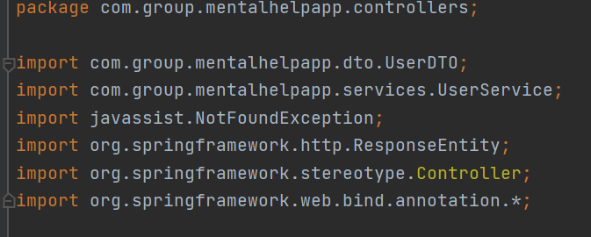

***Source:*** *Author*

2

## 

## Chapter II. BRAIN AND TECHNOLOGY

### **2.1 Human Brain**

The brain is the foremost complex portion of the human body. This three-pound organ is the situate of insights, translator of the faculties, initiator of body development, and controller of behavior. Lying in its hard shell and washed by defensive liquid, the brain is the source of all the qualities that characterize our humankind. The brain is the crown gem of the human body. For centuries, researchers and logicians have been intrigued by the brain, but until as of late they saw the brain as about unimaginable. Presently, in any case, the brain is starting to give up its insider facts. Researchers have learned more about the brain within the last 10 years than in all past centuries since the quickening pace of inquiry in neurological and behavioral science and the advancement of modern investigation strategies. [7]

***Figure 2.*** *Human Brain*

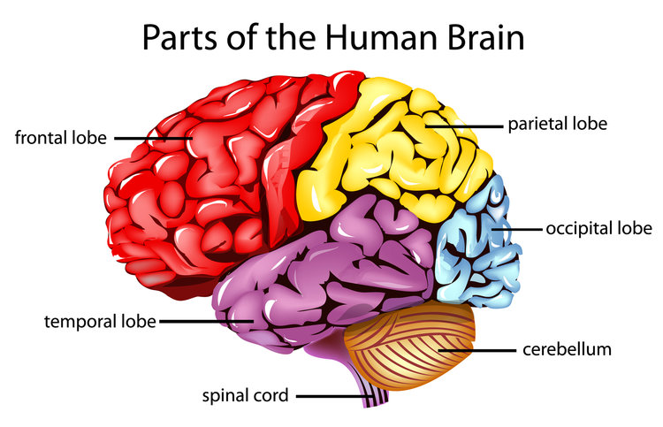

***Source:***  *https://www.ncbi.nlm.nih.gov/pmc/articles/PMC7366948/figure/d38e549/*

3

### **2.2 The Geography of Brain**

Each cerebral side of the equator can be separated into areas, or flaps, each of which specializes in several capacities. To understand each flap and its strength I am going to take a visit to the cerebral sides of the equator, starting with the two frontal projections, which lie straightforwardly behind the temple. After you arrange a plan, envision long haul, or utilize contemplated contentions, these two projections do much of the work. One of the ways the frontal projections appear to do these things is by acting as short-term capacity destinations, permitting one thought to be kept in intellect whereas other thoughts are considered. Within the rearmost parcel of each frontal flap could be an engine range, which makes a difference to control intentional development. An adjacent put on the cleared out frontal projection called Broca’s region permits considerations to be changed into words. When you appreciate a great meal-the taste, smell, and surface of the food-two segments behind the frontal projections called the parietal projections are at work. The forward parts of these projections, fair behind the engine ranges, are the essential tactile ranges. These regions get data around temperature, taste, touch, and development from the rest of the body. Perusing and number juggling are moreover capacities within the collection of each parietal lobe. As you see in the words and pictures on this page, two regions at the back of the brain are at work. These flaps, called the occipital projections, prepare pictures from the eyes and interface that data with pictures put away in memory. Harm to the occipital flaps can cause blindness. The final flaps on our visit to the cerebral halves of the globe are the transient projections, which lie before the visual regions and settle beneath the parietal and frontal projections. Whether you appreciate orchestras or shake music, your brain reacts through the action of these flaps. At the beat of each worldly projection is a region dependable for accepting data from the ears. The underside of each transient projection plays a pivotal part in shaping and recovering recollections, counting those related with music. Other parts of this flap appear to coordinate recollections and sensations of taste, sound, locate, and touch. [4]

4

### **2.3 Technology**

Technology makes a difference for us like producing, storing, and handling gigantic sums of data and associated with each other quickly and efficiently. Most grown-ups utilize the internet every

day, and about one out of four reports being online most of the time. Since this change to an internet world, neuroscientists have started centering their consideration on how advanced innovation may be changing our brains and behavior. The developing information recommends that steady innovation impacts brain work and behavior in both positive and negative ways. For example, more seasoned people enduring from cognitive decay seem to utilize the internet to get to data to assist them stay autonomous longer, in any case, numerous seniors with cognitive complaints are hesitant or incapable to embrace unused technologies. Essentially looking online may speak to a shape of mental workout that can fortify neural circuits. By differentiation, the determined multitasking that is characteristic of most innovation clients impedes cognitive execution. In this survey, we highlight a few of the inquiries about recommending potential benefits and conceivable dangers of utilizing computerized innovation.

Innovation influences the way people communicate, learn, and think. It makes a difference in society and decides how individuals are associated with each other on a day-by-day premise. Innovation plays a critical part in society nowadays. It has positive and negative impacts on the world and it impacts day by day lives. We are living in a time where mechanical propels are common. The web and cell phones are a few illustrations. Be that as it may, with mechanical progress, there’s a drawback to it all. One angle of innovation that has had an extraordinary effect on society is how it influences learning. It’s made learning more intuitive and collaborative, this makes a difference individuals way better lock in with the fabric that they are learning and have inconvenience with. Moreover, it gets you way better to get to assets. With the creation of the web, it gives us access to data at a twenty-four-hour rate and you have got to get to nearly anything online. With the creation of the web, it gives us access to data at a twenty-four-hour rate and you've got to get to nearly anything online. In expansion, it permits understudies to urge work done simpler. Understudies can take tests and exams more effortlessly, and instructors being able to hold online classes can be exceptionally successful. It too extends the boundaries of the classroom, empowering self-paced learning. Individuals can learn through YouTube and social media. This makes a difference understudies learn way better than sitting

5

down for addresses and perusing from reading material. These mechanical progressions made learning more fun and helpful. Another way innovation has affected society is through communication, how we converse and communicate with one another around the world.

Innovation brought numerous modern strategies of electronic communication. For illustration, there are emails, social organizing, you'll facetime an individual that lives on the other side of the world, and here’s video conferencing where you'll have conferences electronically. Finally, the innovative progressions that were made inside the wellbeing industry have made a difference to keep individuals secure and solid. There are numerous improved apps on phones that in spite of the fact that individuals can observe their weight, how many calories they intake, heart rate and other wellbeing properties any time of the day. There’s expanded availability of treatment accessible, there’s the alter in healthcare that includes benefits for the elderly, and healing centers utilizing progress innovation inside their surgical rooms. In any case, it appears that portable communication influences individuals in a negative way when it comes to being agreeable and making face-to-face contact. Versatile innovation can diminish communication and relations between individuals. There’s less individual time, where you discover that you just don't have sufficient time for yourself since you’re continuously in contact with somebody. There’s the misfortune of protection, since anybody can discover you anyplace, at any time of the day. In conclusion, all of these things affect how people act nowadays. Without innovative progressions, our way of life would not be as complex. Innovative impacts shape the way people act nowadays.[4] [8]

## 

## Chapter III. ADVANTAGES AND DISADVANTAGES OF TECHNOLOGY USAGE

### **3.1 Brain Development**

#### ***3.1.1 Positive effects on early age***

6

Screen time may moreover unfavorably affect cognitive and brain improvement. In a later survey made by the US National Institute of Health in April 2018, children beneath age 2 were detailed

to spend over 1 hour each day before a screen; by age 3, that number surpassed 3 hours.

Expanded screen time (and less perusing time) has been related with poorer dialect improvement and official working, especially in exceptionally youthful children, as well as poorer dialect improvement in a huge cohort of minority children. In newborn children, expanded screen time was one of a few variables that anticipated behavioral problems. For newborn children 6 to 12 months, expanded screen time was connected to poorer early dialect development. In children of preschool age and more seasoned, advanced media coordinated toward dynamic learning can be instructive, but as it were when went with parental interaction.

Later inquire about has inspected the impacts of media introduction on brain advancement. In a ponder of children matured 8 to 12 a long time, more screen and less perusing time were related with diminished brain network between locales controlling word acknowledgment and both dialect and cognitive control. Such associations are considered imperative for pursuing comprehension and recommend a negative effect of screen time on the creating brain. Basically, expanded screen time relates to diminished astuteness of white-matter pathways vital for perusing and language. Given the developing unmistakable quality of screen utilization among indeed exceptionally youthful children at stages when brain versatility is most noteworthy, there's critical concern about the cognitive and brain advancement of the current era of screen-exposed children that requires more noteworthy understanding. [5]

#### 

#### ***3.1.2 Positive effect on adults***

Useful neuroimaging permits researchers to watch territorial neural action amid different mental errands. Regarding the research made by the US National Institute of Health in April 2018 the primary issue was to investigate neural movement utilizing useful information whereas inquiring about volunteers performed recreated web searching. Past considerations proposed that rationally challenging errands, such as looking online, may advantage brain wellbeing and indeed delay cognitive decline. The main focus was centered on web looking since it is so common among individuals of all ages. Were surveyed designs of brain neural enactment in 24 cognitively

7

ordinary middle-aged and more seasoned grown-ups, ages of 55 to 76 old, where 12 of them had

negligible web look involvement (net-naive gather), and 12 of them had broad encounters (net-savvy bunch). In expansion to the internet-search errand, was utilized a control assignment of perusing content on a computer screen designed to mimic a printed book format.

Were found that content perusing enacted brain locales controlling dialect, perusing, memory, and visual capacities (cleared out second rate frontal, worldly, back cingulate, parietal, and occipital locales), and the size and degree of actuation were comparative within the net-naive and net-savvy bunches. Amid web looking, net-naive subjects showed enactment designs comparable to those watched whereas perusing content. In any case, net-savvy subjects illustrated noteworthy action in neural flags escalated in extra districts controlling decision-making, complex thinking, and vision (frontal shaft, front transient locale, front and back cingulate, and hippocampus). Amid the internet-search errand, the net-savvy gather showed a more than twofold increment within the degree of enactment within the major territorial clusters compared with the net-naive gather.

These discoveries recommend that looking online may be a frame of brain neural work out. Other investigations demonstrate that after a few months, every day computer-game playing leads to decreased cortical neural activity. Other research demonstrates that memory preparing, at the side of sound way of life behaviors such as physical work out, solid slim down, leads to decreased dorsal prefrontal cortical digestion system after 2 weeks. Such discoveries recommend that assignment reiteration over time leads to lower neural movement amid the errand, which seem to reflect more noteworthy cognitive effectiveness after mental preparation.

One show that seems to clarify such discoveries is that invigorating mental encounters, such as looking on the web, at first lead to negligible actuation. Sometime recently the internet client finds techniques for understanding the new mental challenge. After such bits of knowledge, a broader neural arrangement is locked in. After rehashed sessions, the first novel mental assignment gets to be scheduled and monotonous, now not posturing a mental challenge. The lower movement watched may hence reflect a more productive neural reaction. These come about moreover propose that past internet-search involvement may change the brain’s responsiveness in neural circuits controlling decision-making and complex thinking. The net-savvy volunteers appeared expanded enactment amid the internet-search assignment, which

8

recommends that internet looking may stay a novel and rationally invigorating handle indeed

after proceeding to practice. [3]

#### ***3.1.3 Brain Functionality affected by the internet***

Moreover, there were utilized tools to record brain neural movement amid recreated internet-search errands in 12 net-naive and 12 net-savvy subjects some time recently and after web training. Based on our past discoveries, it was hypothesized that net-naive volunteers would enroll in a bigger frontal flap arrangement after web preparation which net-savvy volunteers would appear either no increment or a diminish in enactment after preparing since of more noteworthy cognitive effectiveness due to preparing.

The preparation consisted of brief information on how to look online at the side practice sessions (1 hour per day for a week). To extend inspiration, members were told that they would be tested on their information of relegated look themes after the exploration.

Amid there to begin with session, net-naive subjects enrolled a neural organism that included the prevalent, center, and second-rate frontal gyri, as well as the sidelong occipital cortex and occipital post. Amid the moment session (after web preparing), extra locales within the center and second-rate frontal gyri were selected as they were within the net-naive gather. By differentiate, amid there to begin with the filter session, the net-savvy subjects enlisted a cortical organism that, in spite of the fact that covering with that of the net-naive subjects, appeared more broad locales of actuation (Figures 3 and 4). This cortical organization included locales that control mental exercises supporting errands required for web looks, counting decision-making, working memory, and the capacity to stifle non relevant data. In addition, net-savvy members created a design of actuation that was decreased after the preparation.

This lessening is steady with our speculation that the brain gets to be more productive and conceivably habituates to the web errand over time. By and large, these discoveries recommend that web looking for generally brief periods of time can alter brain-activity designs in middle-aged and more seasoned adults. Other bunches have investigated the impacts of internet-search preparing on brain structure and work. Associates examined the impact of short-term internet-search preparation on white-matter microstructure by means of dissemination

9

tensor imaging.

After 6 preparing days, they found that the 59 members, mostly age of 21 appeared to have expanded fragmentary anisotropy (dissemination tensor imaging looks) within the right prevalent longitudinal fasciculus and inside that locale, diminished spiral diffusivity. These discoveries recommend that short-term internet-search preparation may increase white-matter judgment within the right predominant longitudinal fasciculus, which may result from expanded myelination.

The associates surveyed the mental impacts of learning computer and internet-search strategies. They advertised a course to 22 adults more seasoned grown-ups (cruel age 80 a long time), who were compared with 26 members locked in in other exercises. The examiners detailed noteworthy advancements within the intercession gathered in measures of life fulfillment, discouragement, forlornness, and self-control after 4 months, while the control gather appeared in each of these measures. These discoveries propose that computer and internet preparation contribute to more seasoned adults' well-being and sense of empowerment. White and associates performed a randomized controlled trial surveying the psychosocial effect of web access to more seasoned grown-ups amid a 5-month period. The intercession gathered 9 hours of preparation (6 sessions over 2 weeks) and experienced less depression, less misery, and more positive states of mind toward computers than controls who were not standard internet users. [10]

***Figure 3.*** *Presentation of brain area*

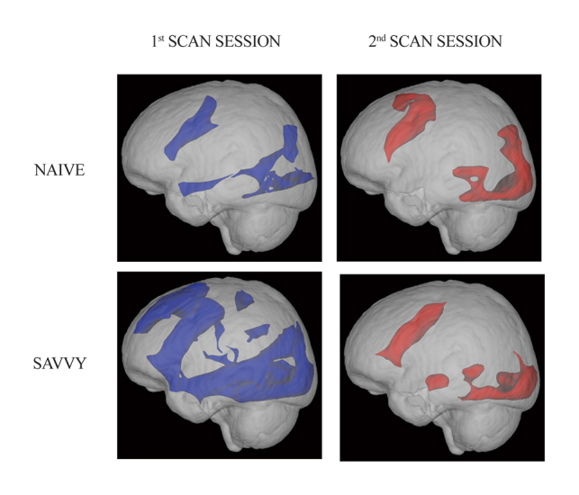

***Source:*** *https://www.ncbi.nlm.nih.gov/pmc/articles/PMC7366948/figure/d38e549/*

10

Presentation of brain area before and after training regarding internet-search.

Blue areas show the activation part and the red one are the patterns after the training.[6]

***Figure 4.*** *Demonstration of the increasing activity*

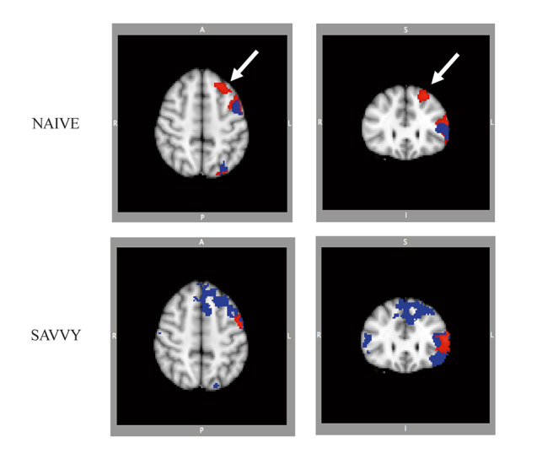

***Source:***[*https://www.ncbi.nlm.nih.gov/pmc/articles/PMC7366948/figure/d38e549/*](https://www.ncbi.nlm.nih.gov/pmc/articles/PMC7366948/figure/d38e549/)

Demonstration of the increasing activity of the brain before and after the training.

#### ***3.1.4 Memory Abilities***

Discoveries appearing that mental incitement and cognitive preparing progress in memory in more seasoned adults have driven the advancement of a few memory apps and computer diversions. Associates investigated whether computerized brain-training works out made strides

11

cognitive execution in more seasoned grown-ups without dementia (people of age 82). Subjects were randomized into a mediation bunch that utilized a computer program 5 days a week for 20 to 25 minutes each day, or a wait-list control bunch. Neuropsychological testing at standard, 2 months, and 6 months appeared that the mediation bunch made strides altogether in postponed memory, and the control bunch did not. In addition, members who played the computer program for at least 40 sessions over 6 months made strides in quick memory, postponed memory, and dialect. These discoveries point to the potential good thing about cognitive preparation employing a computerized, self-paced program.

In a meta-analysis of computerized cognitive preparation, agents found a by and large direct impact on cognition in gentle cognitive disability over 17 trials. Little to direct impacts were detailed for worldwide cognition, consideration, working memory, and learning capacities.[11]

#### ***3.1.5 Visual Absorption***

Visual abilities are one of the most delicate parts of our brains. This is because not everyone can focus easily and have great perception of visual memory.

A great example to demonstrate the positive effect that technology gives in order to increase the visual abilities are the games themself. The studies have shown that during the years the gamers have improved their visual abilities only by doing what they most enjoy: playing games.

People that spend four times a week (1 hour per day) for at least six months, have demonstrated better visual memory than those who play less or not at all.

An experiment was made from the US National Institute of Health. They inspected a potential interface between activity video gaming and laparoscopic surgical aptitudes and suturing. Specialists who played video games more than 3 hours each week made 37% less surgical mistakes, were 27% speedier in reaction times, and scored 42% way better in measures of laparoscopic and suturing abilities than specialists who do not play video games. Besides, the foremost experienced players in particular video games such as Super Monkey Ball 2, Star Wars Racer etc., made 47% less blunders and performed 39% quicker. These discoveries recommend that playing activity videogames can move forward cognitive and engine aptitudes that improve surgical abilities and lower mistake rates within the working room. [9]

12

### **3.2 Negative Effect of Internet Usage**

Nowadays we live in the world of technology, and everything around us is functioning because of technology, but this makes each of us exposed to the chronic negative influence that comes with it.

A big issue is also the time that babies spend in front of tv or other devices that might directly badly affect their health, that’s why parents should be aware to protect their kids from the exposure.

On the other hand, scientists have discovered that spending too much time in front of your computer or smartphone might affect your social intelligence, which means that you might not be able to express your verbal or nonverbal in a proper way. [2]

#### ***3.2.1 Addiction***

Intemperate and neurotic web utilization has been recognized as an internet compulsion, which offers highlights with substance-use clutters or neurotic betting. Common highlights incorporate distractions, disposition changes, advancement of resilience, withdrawal, and useful impairment. The worldwide predominance of internet habit is evaluated at 6%, but in a few locales such as the Center East the predominance is as tall as 11%.17 Understudies with internet enslavement are more likely to endure ADHD side effects than from other psychiatric disorders. More detailed example is that school children with internet enslavement experienced altogether more noteworthy indications of absentmindedness, hyperactivity, and impulsivity than non-internet-addicted understudies. More prominent ADHD indications in grown-ups matured 18 to 70 a long time with internet habit: indicators of compulsion included more youthful age, playing greatly multiplayer online role-playing diversions, and investing more time online. In spite of steady affiliations between ADHD side effects and internet compulsion, a causal relationship has not been affirmed. It is conceivable that individuals with ADHD side effects have a more prominent hazard for creating innovation enslavement, but an elective clarification is that broad innovation utilized from addictive behavior causes ADHD symptoms. [1] [2]

13

#### ***3.2.2 Social Isolation***

The studies found that the more time individuals spend on the internet, the less time they spend communicating with other individuals. Specifically, 27% of overwhelming internet clients report investing less time talking to companions and family over the phone. 15% report investing less time physically with companions and family, and 13% report investing less time going to occasions exterior the house. Leaving aside the truth that this implies that 85% of overwhelming Internet users do not report investing less time with companions and family, the genuine address is whether the consideration has a suitable definition of social isolation. Phone is considered a prevalent shape of social contact relative to the Web and its communication groups such as e-mail and social media. If some person had conducted a comparable study 100 years ago, they would without a doubt have claimed that phone calls were a cold medium that undermined conventional shapes of social contact suas going to individuals to have tea. In evaluating the effect of the internet, the address isn't whether it replaces a few other shapes of communication and social contact. Since the internet includes its claim unused shapes of communication and social contact. For example, individuals may possibly go to fewer gatherings and occasions outside the house and however feel associated with a community of others who meet on a much more customary premise online. [10]

#### 

#### ***3.2.3 Eyestrain***

Innovations, such as handheld tablets, smartphones, and computers, can hold a person’s consideration for long periods. This may lead to eyestrain. Symptoms of advanced eye strain can incorporate obscured vision and dry eyes. Eyestrain may lead to torments in other ranges of the body, such as the head, neck, or shoulders. Several mechanical variables may lead to eyestrain, such as: screen time screen glare screen brightness viewing as well near or as well distant away poor sitting posture underlying vision issues Taking standard breaks absent from the screen may diminish the probability of eyestrain. [4]

14

## Chapter IV. IMPLEMENTATION “MENTAL HELP APP”

“Mental Help” is a web application which consists of helping different patients that have difficulties in socializing and expressing their emotions or mental health issues such as depression, sadness or other issues with the same nature, to communicate with a psychologist only by using technology and its tools.

The main inspiration on creating this app began in the pandemic period of 2020 when all the world went into a lockdown because of Coronavirus. I suggest that everyone was feeling unhappy and unused to the situation and the need of adapting a new lifestyle was necessary.

The biggest impact was on our emotional health which directly affected most people's mental health.

Mental issues include different emotions, feelings, insecurities, but especially depression.

During these last year’s depression is increasingly fearsome and has begun to spread in the young ages too. The main issue is that it is difficult for human kind to understand and accept when and how to handle mental health, that’s why it is important to talk to a professional in order to get better help.

Creation of this app pretends to help people to feel more comfortable with the fact that it is okay not to be okay, to accept it and start working on yourself in order to have a better social life and enjoy life. All of this comes with the facility of doing this directly from your home or whenever you feel comfortable.

### **4.1 Database**

The database used for this web application is MySQL

15

***Figure 5.*** *Mental Help Database*

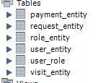

***Source:*** *Author*

There are six tables:

1. Payment entity which is used for the payment details or in other words the invoice of the patient.
2. Request entity is used for the patient's special requirements such as changing the meeting schedule or specific symptoms.
3. Role entity is used for the user application, which contains the user id and the name.
4. User entity contains the user id and a description of the role, the email address that is used to log in, the password, user’s real name and a username which might be any desirable username and the price of the visit.
5. User role contains the user id and role id and connects both tables together.

16

1. Visit entity is used for the invoice details such as date, price, user id etc.

### **4.2 Quality Attributes that affect the architecture of the software**

* Usability: The software is easy to use from all users and offers fast navigation.
* Security: The users will find a secure environment, where all the sensitive information will be not guarded and safe. For example, the user will have an id as a name, in order for his/her to feel protected.
* Maintainability: The software will be maintained and repaired if any future changes will happen or necessarily requirements are asked by the users. The purpose is to have easy and fast navigation and the necessary tools in order to have a splendid usage of the app.
* Affordability: The specialty of the app is that it is offered online, and beside the fact that you can get your service in a comfortable way, also you can have this service cheaper than going physically in your psychologist office.
* Responsiveness: The main focus is to deliver a great service that satisfies the patient and this can be achieved by being professional but especially taking care of patient requirements and necessities without them asking for.

### **4.3 Web App Functions**

Mental Help Application has the following functions performed by the users as specified below:

* Log in/Register

Unregister User

* Navigate through the page

17

* Browse About Us, Contact
* Contact Psychologist

Register User

* Browse through the page
* Contact Psychologist
* Sent special requests
* Book a meeting
* Change schedule
* Make payments
* Receive invoice

### **4.4 General Constraints**

Constraints are very important in building an application, because without them the application will not be working successfully and fulfill all the requirements in order to create an operational environment for the software to properly function.

To build this application on the back-end is used Java JDK 11 which is an open-source reference implementation of version 11 of Java SE Platform, Spring boot framework which helps in application development acceleration. When you start to create your own project in spring boot you use Spring Initializr, where you can add all your project details and download the options that you need. For the interface design is created through CSS, HTML, JQUERY, AJAX.

The application operates and runs successfully after it communicates with the MySQL database. It retrieves and sends different data. As API is used in Postman where you can make build testing and modify APIs, CRUDs in my case which stands for CreateReadUpdateDelete.

The app conventionally runs in different Operational Systems.

18

### **4.5 Interface features**

***Figure 6.*** *Registration step*

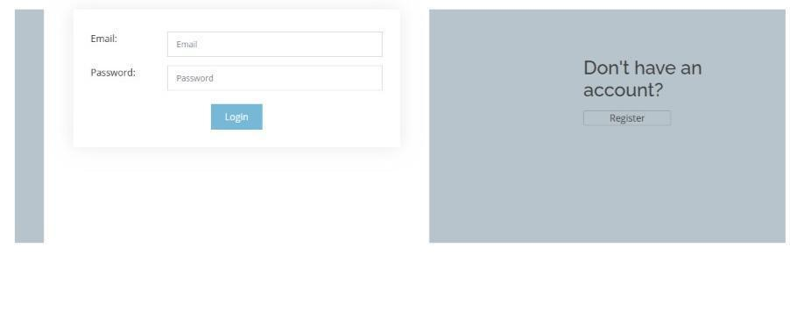

***Source:*** *Author*

***Figure 7.*** *Options to choose*

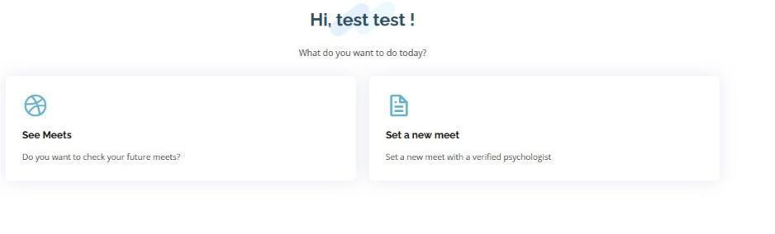

***Source: Author***

19

***Figure 8.*** *Special Requests*

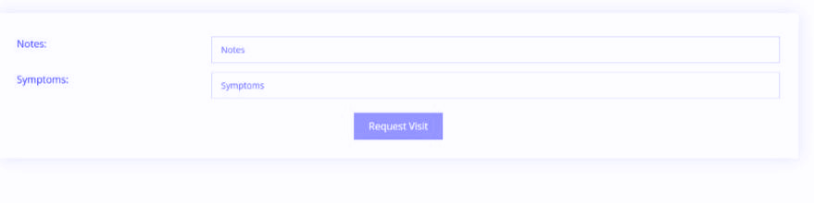

***Source:*** *Author*

***Figure 9.*** *Special Requests filled*

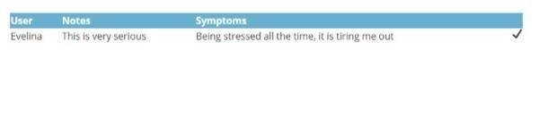

***Source:*** *Author*

***Figure 10.*** *Book a meeting*

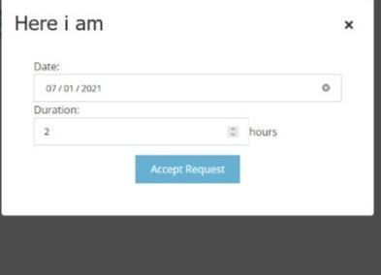 20

***Source:*** *Author*

***Figure 11.*** *Psychologist view*



***Source:*** *Author*

***Figure 12.*** *Postman API*

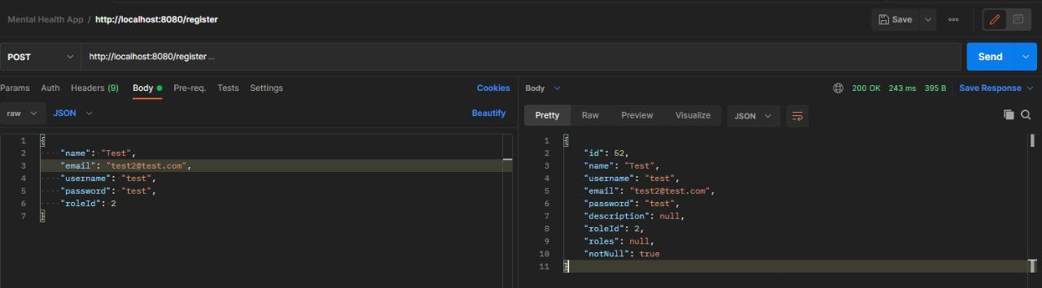

***Source:*** *Author*

21

### **4.6 Testing Cases**

#Test case 1. Testing the API with each run to check for compilation errors.

#Test case 2. Testing the API with Postman to check for runtime errors and to check if the code actually produces the required result.

#Test case 3. Writing the frontend HTML and CSS and checking if the elements are displayed right.

#Test case 4. Checking the functionality after writing the JavaScript for the elements to check if they behave in the desired way.

#Test case 5. Stress testing the application with pressing the button too many times and throttling the internet speed to check the behavior on very slow internet speeds.

#Test case 6. Checking the Network tab on the Firefox Developer Edition Dev Tools to check if the network requests are made in the right way.

#Test case 7. Running the code line by line in debugging mode to check in which line exactly does the program fail and why.

## 

## 

## Chapter V. Conclusions

### **5.1 Conclusions**

This research paper covers the main issues about the brain-health results of advanced innovation and is starting to explain how these novel gadgets and programs can both offer assistance and hurt brain work. Big usage utilizes increased ADHD side effects, meddling with enthusiastic and social insights, can lead to addictive behaviors, increments social separation, and meddling with brain improvement and rest. In any case, particular programs, video games, and other online devices may give mental works out that enact neural circuitry, progress cognitive working,

22

diminish uneasiness, increment relaxing rest, and offer other brain-health benefits. Future investigation must illustrate fundamental components and causal connections between innovation utilization and brain wellbeing, with a focus on both the positive and negative effects of advanced innovation utilization.

### **5.2 Future plans**

This thesis managed with the plan and advancement preparation of context-adaptive Web applications. Mental Help” app is an app that has big possibilities to expand and to add more tools. This step was very important on how to understand the process of building an application from scratch. The future steps consist of expanding in more adaptive and useful ways on fulfilling any kind of requirements that clients might have based on how the technology is advancing and new features are getting in the way.

People should be able to know how to use and what benefits to get from technology, and smart enough to know how to prevent the negativity that comes with it.

## 

## 

23

## Bibliography

[1]Amorim, L., Magalhães, R., Coelho, A., Moreira, P. S., Portugal-Nunes, C., Castanho, T. C., Marques, P., Sousa, N., & Santos, N. C. (2018). Poor Sleep Quality Associates With Decreased Functional and Structural Brain Connectivity in Normative Aging: A MRI Multimodal Approach. *Frontiers in Aging Neuroscience*, *10*.

<https://doi.org/10.3389/fnagi.2018.00375>

[2]Andreassen, C. S., Billieux, J., Griffiths, M. D., Kuss, D. J., Demetrovics, Z., Mazzoni, E., & Pallesen, S. (2016). The relationship between addictive use of social media and video games and symptoms of psychiatric disorders: A large-scale cross-sectional study. *Psychology of Addictive Behaviors*, *30*(2), 252–262. <https://doi.org/10.1037/adb0000160>

[3]Bohle, H., Rimpel, J., Schauenburg, G., Gebel, A., Stelzel, C., Heinzel, S., Rapp, M., & Granacher, U. (2019). Behavioral and Neural Correlates of Cognitive-Motor Interference during Multitasking in Young and Old Adults. *Neural Plasticity*, *2019*, 1–19. <https://doi.org/10.1155/2019/9478656>

[4]Branger, P., Arenaza-Urquijo, E. M., Tomadesso, C., Mézenge, F., André, C., de Flores, R., Mutlu, J., de la Sayette, V., Eustache, F., Chételat, G., & Rauchs, G. (2016). Relationships between sleep quality and brain volume, metabolism, and amyloid deposition in late adulthood. *Neurobiology of Aging*, *41*, 107–114. <https://doi.org/10.1016/j.neurobiolaging.2016.02.009>

[5]Cheung, C. H. M., Bedford, R., Saez De Urabain, I. R., Karmiloff-Smith, A., & Smith, T. J. (2017). Daily touchscreen use in infants and toddlers is associated with reduced sleep and delayed sleep onset. *Scientific Reports*, *7*(1). <https://doi.org/10.1038/srep46104>

[6]Dong, G., Li, H., & Potenza, M. N. (2017). Short-Term Internet-Search Training Is Associated with Increased Fractional Anisotropy in the Superior Longitudinal Fasciculus in the Parietal Lobe. *Frontiers in Neuroscience*, *11*. <https://doi.org/10.3389/fnins.2017.00372>

[7]Hedman, A., Lindqvist, E., & Nygård, L. (2016). How older adults with mild cognitive

24

impairment relate to technology as part of present and future everyday life: a qualitative study. *BMC Geriatrics*, *16*(1). <https://doi.org/10.1186/s12877-016-0245-y>

[8]Marshall, J. M., Dunstan, D. A., & Bartik, W. (2019). The Digital Psychiatrist: In Search of Evidence-Based Apps for Anxiety and Depression. *Frontiers in Psychiatry*, *10*. <https://doi.org/10.3389/fpsyt.2019.00831>

[9]Rosser, J. C. (2007). The Impact of Video Games on Training Surgeons in the 21st Century. *Archives of Surgery*, *142*(2), 181.

<https://doi.org/10.1001/archsurg.142.2.181>

[10]Stawarz, K., Preist, C., & Coyle, D. (2019). Use of Smartphone Apps, Social Media, and Web-Based Resources to Support Mental Health and Well-Being: Online Survey. *JMIR Mental Health*, *6*(7), e12546.

<https://doi.org/10.2196/12546>

[11]Tusch, E. S., Alperin, B. R., Ryan, E., Holcomb, P. J., Mohammed, A. H., & Daffner, K. R. (2016). Changes in Neural Activity Underlying Working Memory after Computerized Cognitive Training in Older Adults. *Frontiers in Aging Neuroscience*, *8*.

<https://doi.org/10.3389/fnagi.2016.00255>

25